June 20, 2014

Steven V. King, Executive Director and Secretary
Utilities and Transportation Commission
1300 S. Evergreen Park Dr. SW
P.O. Box 47250
Olympia, WA 98504-7250

RE: Washington Utilities and Transportation Commission v. Teltrust Corporation

Commission Staff’s Response to Application for Mitigation of Penalties UT-140924

Dear Mr. King:

On June 3, 2014, the Utilities and Transportation Commission issued a $1,000 Penalty Assessment in Docket UT-140924 against Teltrust Corporation for 10 violations of Washington Administrative Code (WAC) 480-120-382, which requires telecommunications companies to furnish annual reports to the commission no later than May 1 each year.¹

On June 9, 2014, Teltrust Corporation wrote the commission requesting mitigation of penalties (Mitigation Request).² In its Mitigation Request, Teltrust Corporation, Inc. does not dispute that the violation occurred. The company states, “It was mailed and returned due to no postage on the envelope.”

It is the company’s responsibility to ensure that the regulatory fee is paid and the annual report is filed by the May 1 deadline. On February 28, 2014, Annual Report packets were mailed to all regulated telecommunication companies. The instructions for annual report completion page of
the annual report informed the regulated company that it must complete the annual report form, pay the regulatory fees, and return the materials by May 1, 2014, to avoid enforcement action.

On June 9, 2014 Teltrust Corporation filed an incomplete annual report with no payment of regulatory fees received. The company was notified of the incomplete status on June 10, 2014 via email.³ As of the date of this notice, the company has not responded with the required information. The company has been active since July 21, 2009. Teltrust Corporation previously missed the deadline for filing its annual report and paying its regulatory fees in 2010. Due to the

UTC Annual Reports
June 20, 2014
Page 2

prior violations and the company not presenting any new or compelling information, staff does not support any mitigation.

If you have any questions regarding this recommendation, please contact Amy Andrews, Regulatory Analyst, at (360) 664-1157, or aandrews@utc.wa.gov.

Sincerely,

Sondra Walsh, Director
Administrative Services

ATTACHMENT A
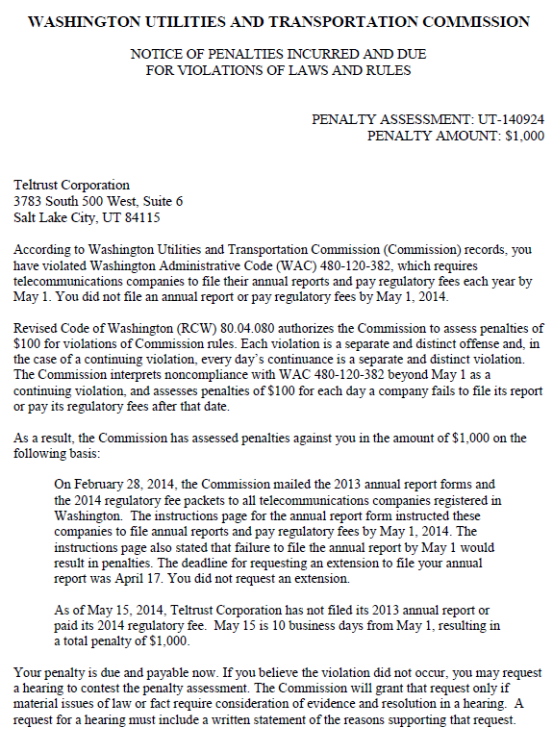

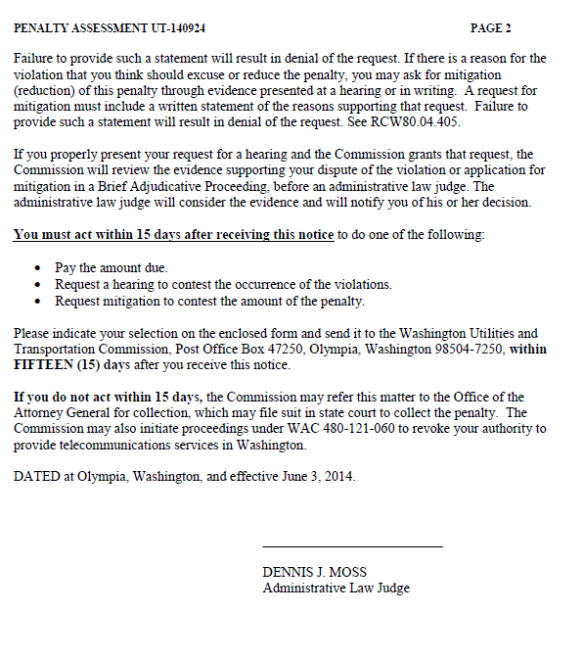

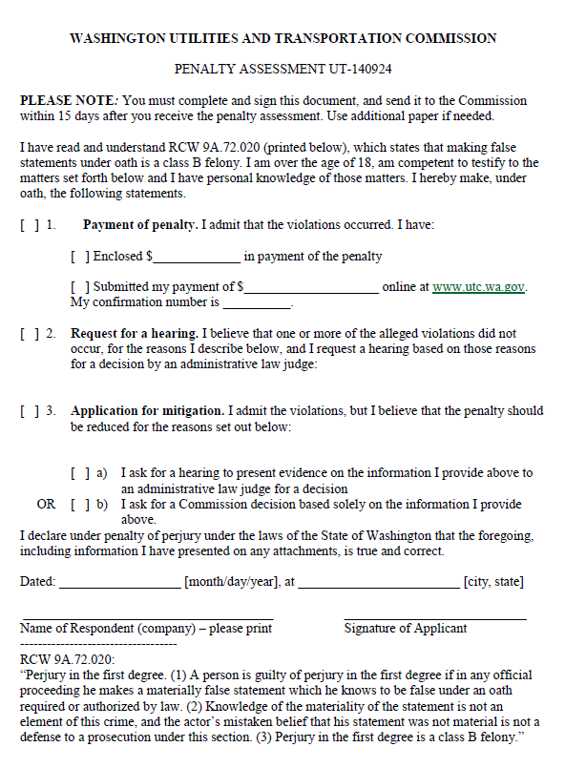

ATTACHMENT B
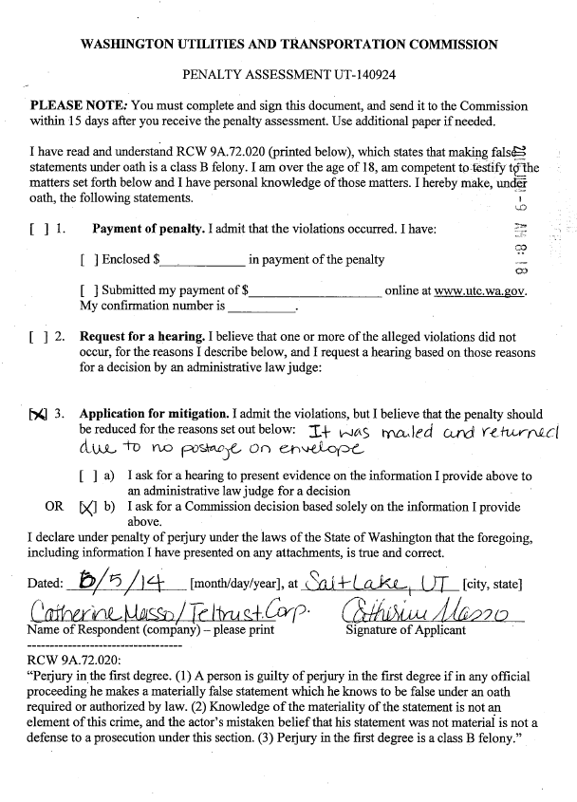

ATTACHMENT C
