BEFORE THE WASHINGTON STATE
UTILITIES AND TRANSPORTATION COMMISSION

In the Matter of Determining the Proper Carrier Classification of, and Complaint for Penalties against:  SMITH, JOEDY d/b/a THE MOVING GUYS  _____________________________________ | )  )  )  )  )  )  )  ) | DOCKET TV-130332  DECLARATION OF  MATHEW PERKINSON
Mathew Perkinson, under penalty of perjury under the laws of the State of Washington, declares as follows:

- I am employed by the Washington Utilities and Transportation Commission (Commission) as a Compliance Investigator in the Consumer Protection and Communications Section. As a Compliance Investigator, my responsibilities include conducting investigations regarding the business practices of regulated utility or transportation companies. As part of those duties, I investigate household goods carriers that may be operating without the required Commission permit.
- Travis Yonker began an investigation into the activities of Joedy Smith d/b/a The Moving Guys (The Moving Guys) in February 2010 because he received information from Sheri Hoyt who found advertisements indicating the company was conducting household goods moves within the state of Washington without a permit.
- On March 17, 2010, Mr. Yonker mailed a compliance letter to The Moving Guys, instructing it to remove any advertisements and cease operating as a household goods operator until it obtained a commission issued permit.
- On May 26, 2010, Mr. Yonker received a telephone call from The Moving Guys. The Moving Guys informed him that they were only providing pack and load services. Mr. Yonker advised The Moving Guys to obtain a commission issued household goods permit to avoid any risk of future penalties.
- On June 1, 2010, The Moving Guys emailed Mr. Yonker, informing him that it changed the advertisements located on www.craigslist.org, and it is only offering the labor to assist in moving.
- I conducted a follow-up investigation into the activities of The Moving Guys in November 2012 and found advertisements indicating the company is still conducting household goods moves within the state of Washington without a permit.
- I reviewed Commission records related to The Moving Guys to determine whether the company held a household goods permit. According to Commission records, as of March 7, 2013, there is no record of The Moving Guys now (or ever) holding a household goods permit.
- On November 28, 2012, I conducted an Internet search for advertising for The Moving Guys. I found advertisements on www.craigslist.org and www.yelp.com. The advertisement including moving services and the telephone number (206) 941-4499. The telephone number (206) 941-4499, is the same telephone number Mr. Yonker received a call from on May 26, 2010.
- On November 28, 2012, I called the telephone number (206) 941-4499, which was listed in the www.craigslist.org advertisement and spoke to a man who identified himself as Joedy. I asked Joedy how much The Moving Guys charge to move from a one bedroom apartment, in Belltown, WA, to a two bedroom apartment, about ten miles apart. Joedy replied the company charges $90 per hour, with a minimum of three hours, which includes two men and a truck.
DATED this 19th day of March, 2013, at Olympia, Washington.

______________________________________
MATHEW PERKINSON

Attachment A
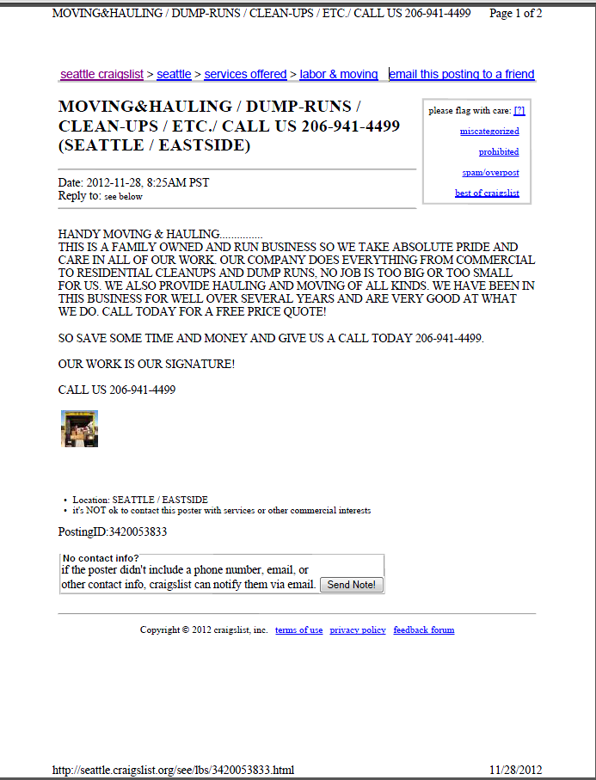
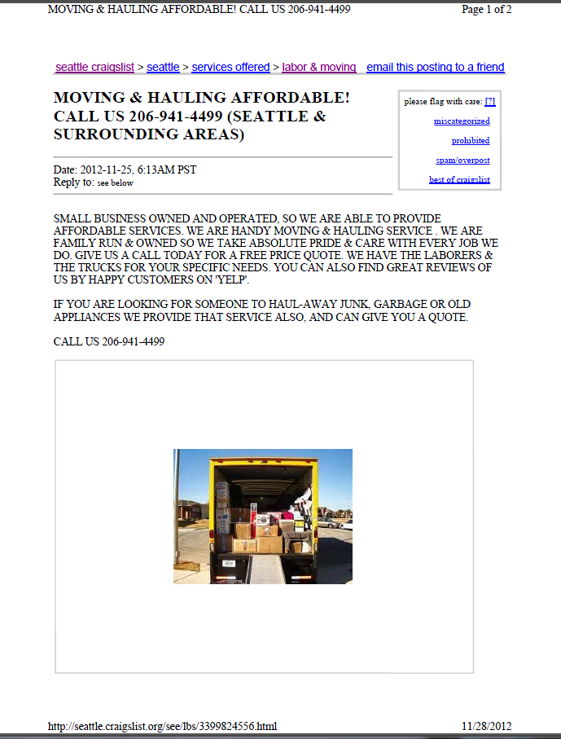

Attachment B
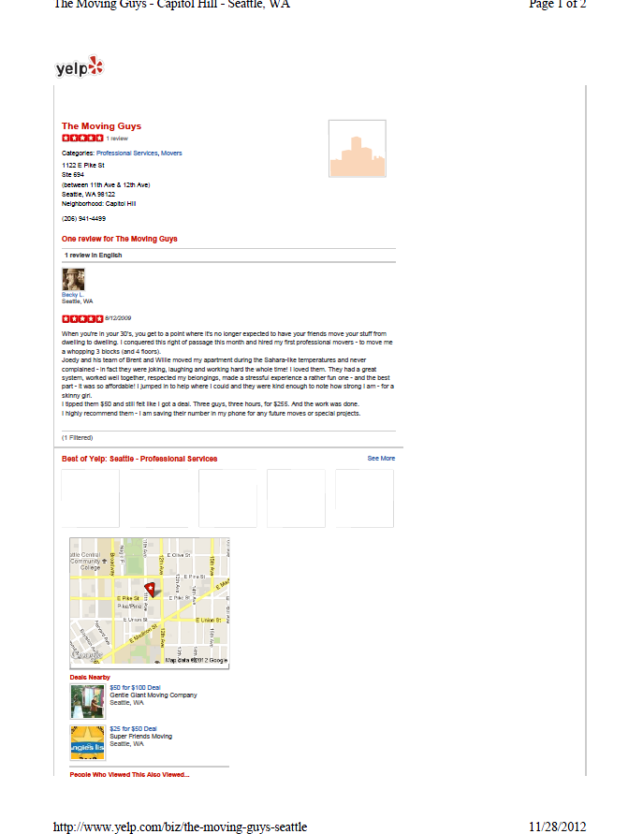

See Attachment A for a copy of the November 28, 2012, advertisements found at www.craiglist.org.
See Attachment B for a copy of the November 28, 2012, advertisement found at www.yelp.com.

