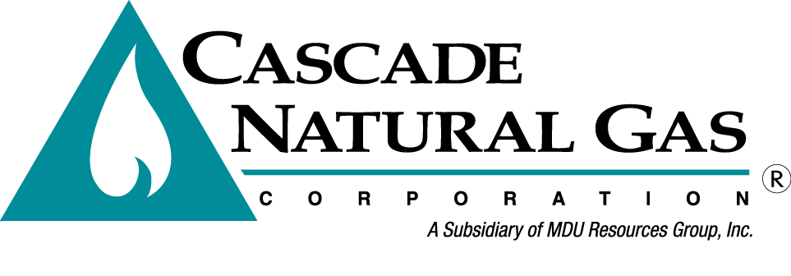 | 8113 W. GRANDRIDGE BLVD., KENNEWICK, WASHINGTON 99336-7166  TELEPHONE 509-734-4500 FACSIMILE 509-737-7166  www.cngc.com
VIA ELECTRONIC MAIL
records@utc.wa.gov

December 11, 2015

Records Center
Washington Utilities and Transportation Commission
1300 S. Evergreen Park Drive SW
Olympia, WA 98504

Re: UG-152286, Cascade Natural Gas General Rate Case Substitute Filing

Cascade Natural Gas Corporation (“Cascade” or “Company”) filed a General Rate Case on December 1, 2015, that is docketed as UG-152286. The Company now files for submission in the same docket, changes to three tariff sheets, an exhibit, and workpapers; Each substitution is identified below.

Attached are originals and two copies of the following replacement tariff sheets:

Third Revision Sheet No. 597
Fifty-Second Revision Sheet No. 570
Forty-Ninth Revision Sheet No. 577

Attached is an original and eight copies of the following revised exhibit:

UG-152286 Revised Exhibit No. ____(PJA-3)

Attached are three copies of the following workpapers:

UG-152286 Chiles Exhibit & Workpapers MAC-4 thru 8
UG-152286 Parvinen Exhibit & Workpapers MPP-2 thru 5

The corrections made to these substitutions are described below:

- The revision number for Sheet No. 597 is revised from Second to Third.
- Margin codes indicating an increase to the Basic Service Charges are added to Sheet Nos. 570 and 577.
- UG-152286 Substitute Exhibit No.___(PJA-3) is the compilation of all tariff sheets revised in this general rate case. The sheets being resubmitted filed in this filing are replaced accordingly in this exhibit.
- The workpapers are reformatted for improved printability.

Beyond these substitutions, no other changes are made to the Company’s initial filing docketed as UG-152286.

Please note that no legislative versions of the revised replacement sheets are herewith submitted because all changes made to tariff sheet included in this substitute filing are contained in the side margins or headers, and not in the body of the tariff sheet.

If you have any questions regarding this report, please contact me at (509) 734-4593.

Sincerely,

Michael Parvinen
Director, Regulatory Affairs

attachments

