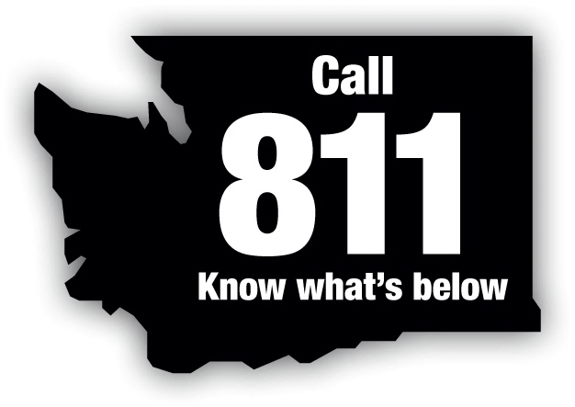
Washington State Dig Law Safety Committee
P.O. Box 734 • Poulsbo, WA 98370

Committee Members Represent:
Local Government
Natural Gas Utility
Contractors
Excavators
Electric Utility
Consumer – Owned Utility
Pipeline Utility
Insurance Industry
Utilities and Transportation Commission
Telecommunications Company
Three At – Large Positions

September 25, 2017
Steve King, Executive Director and Secretary
Members of the Commission
Utilities and Transportation Commission
1300 Evergreen Park Drive SW
Olympia, WA 98504-7250

Re: Review Committee Decision - Case Numbers 17-014 & 17-028 M&L Construction, Inc. vs Frontier Communication NW, Inc.

Dear Mr. King:

The Washington State Dig Law Safety Committee received complaints regarding a potential violation of the Washington State Dig Law RCW 19.122.030(4) for work performed on April 11, 2017 and on June 26, 2017.

On September 14, 2017, the Washington State Dig Law Safety Committee Review Board heard complaint Cases 17-014 and 17-028 M&L Construction, Inc. vs Frontier Communication NW, Inc.

The Review Committee determined that the respondent Frontier Communications NW, Inc. did violate RCW 19.122.030(4)(a) on case 17-014 by failing to reasonably locate facilities in advance of the excavator’s project but did not violate the dig law on case 17-028.

The Review Committee recommends the following penalty be assessed to the respondent:
- Case 17-014 $1000.00 for violating RCW 19.122.030(4)
- Case 17-028 no penalty assessed

The Safety Committee recommends that $1000.00 be deferred for one year, if Frontier incurs no additional violations of RCW 19.122.030(4) and that Frontier provides the Safety Committee and One Call Concepts accurate contact information that is kept up to date for use on all future locate tickets.

Please let me know if you have any questions regarding these cases. I can be contacted at 425.430.7212.

Sincerely,

Dave Christensen, Chair
Cc: Lynda Holloway, UTC
Frontier Communications NW, Inc.

