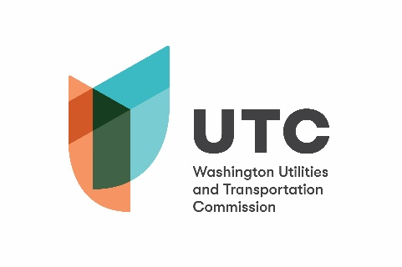

Memorandum
Jun. 6, 2019

To: File

From: Betty Young, Rail Safety Program Advisor

Subject: TR-180527 – City of Kent
Completion of Grade Crossing Protective Fund (GCPF) Project
Safety Fencing near South Willis Street

On Dec. 13, 2018, the Washington Utilities and Transportation Commission (UTC) awarded a GCPF grant totaling $10,000 to the City of Kent (City) for a project related to installing approximately 330 lineal feet of six-foot, chain link fencing in two locations approximately 100 feet south of the S. Willis Street crossing (USDOT 396581U). The actual cost of the project was $38,277.75.

On Jun. 4, 2019, the City submitted a request for reimbursement. Rail Safety staff inspected the fencing on Jun. 6 and confirmed that the installation was completed according to the specifications outlined in the order approving the grant.

Please close this docket.

