David T. Wissbroecker
dwissbroecker@rgrdlaw.com

January 9, 2018
Via ELECTRONIC FILING, U.S. Mail, and ELECTRONIC MAIL
Steven V. King
Executive Director and Secretary
Washington Utilities and Transportation Commission
1300 S. Evergreen Park Dr. SW
P. O. Box 47250
Olympia, Washington 98504-7250
Re: In the Matter of the Joint Application of Hydro One Limited and Avista Corporation for an Order Authorizing Proposed Transaction
Docket U-170970
Dear Mr. King:
Enclosed for filing is Lauren Fink and Chadwick L. Weston’s Notice of Appearance in the above-referenced proceeding.
Very truly yours,
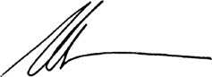
David T. Wissbroecker
DTW:vjr
Enclosure

