THE WASHINGTON State UTILITIES AND TRANSPORTATION COMMISSION

DOCKET PG-082253

Commission Staff Investigation Report on Explosion and Fire
206 North Birch Street; Odessa, Lincoln County
Avista Utilities
Primary Investigator: Al Jones, Pipeline Safety Engineer
May 13, 2010
TABLE OF CONTENTS
- INTRODUCTION

- OVERVIEW

A. Cause of the Explosion and Fire
B. Accident Summary

- INVESTIGATION AND ANALYSIS

A. The Incident Site
B. Chronology
C. Discussion
D. Persons Interviewed and Data Requests Issued

- PROBABLE VIOLATIONS AND RECOMMENDATIONS

A. Probable Violations
B. Recommendations

EXHIBITS
A – Site Map
B – Photo - Incident Site
C – Photo - Pipe In-Situ and Backfill Material
D – Photo - Failed Pipe Section
E – Jana Laboratories Inc. – Final Report (October 6, 2009)

I. INTRODUCTION
On December 26, 2008, a natural gas explosion and fire occurred at a home in Odessa, Washington. The incident involved gas plant owned and operated by Avista Utilities (Avista). Two people were injured in the incident: Mr. Reyes and Ms. McClure. Mr. Reyes sustained serious physical injuries. Extensive property damage also resulted.
The Washington Utilities and Transportation Commission (commission) has jurisdiction over the safety of the natural gas pipeline facilities at issue, pursuant to RCW 81.88. This report summarizes the investigation of this incident by the staff of the commission. Mr. Al Jones, commission pipeline safety engineer, is the primary investigator. This report determines the probable cause of the explosion, makes findings of probable violations of commission gas safety rules, and provides staff’s recommendations for further commission action.
II. OVERVIEW
A. Cause of the Explosion and Fire
Natural gas leaked from Avista’s two-inch gas main located in the alley behind the incident site. The pipe leaked gas because of a crack in the pipe, caused by an external load on the pipe, most likely due to rock impingement. The impingement caused a dent in the pipe with tensile stress on the inside surface, which then developed into a crack by a process called “slow crack growth.” The slow crack growth process eventually caused a through-wall fracture of the pipe (i.e., a crack). Gas migrated through this fracture into the surrounding soil. Gas eventually escaped from the ground into or near the secondary living quarters and garage at the incident site. The gas was ignited, causing an explosion and fire, which resulted in injuries to Mr. Reyes and Ms. McClure, as well as property damage and injury to an animal.
B. Accident Summary
On December 26, 2008, about 9:15 p.m., a natural gas explosion and fire injured Mr. Roger Reyes and Ms. Cassandra McClure. Mr. Reyes and Ms. McClure were visitors at the house located at 206 North Birch Street, which is Mr. Reyes’ family home. Mr. Reyes was taken to the Odessa Hospital, and then to Seattle Harborview Hospital Burn Center; Ms. McClure required out-patient care at the Odessa Hospital. They both survived the incident.
Immediately prior to the explosion, the couple had entered a detached garage next to the family home to smoke cigarettes. Gas ignited from an ignition source, most likely a match, lighter, or cigarette, but possibly an electrical light switch or static electricity. The ignited gas resulted in an explosion and fire.
In addition to the personal injuries to Mr. Reyes and Ms. McClure, the explosion and fire destroyed the detached secondary living quarters on the property as well as the detached garage. Also damaged was the back of the primary residence, and vehicles parked in and near the detached garage. A dog was also injured. The explosive effect of the gas and the resulting damage was reduced because a car in the garage displaced the same volume of compressible free space. (Mr. Goetz, a neighbor, reported a car was removed from the garage shortly after the explosion).
Avista has a gas main located in the alley behind the garage. When Avista excavated the gas main the morning after the incident, Avista found the pipe to be dented and cracked. The crack went through the pipe, thus permitting gas to leak into the soil surrounding the pipe. The distance between the ground surface and the top of the pipe was about 30 inches. The top 18 inches (approximately) of the ground was frozen. Most likely, the frozen ground prevented the gas from seeping upward above the crack and into the air above the alley. Instead, the gas migrated laterally through the soil and into cracks in the concrete basement foundation of the secondary living quarters and the connecting interior door between those living quarters and the garage.
III. INVESTIGATION AND ANALYSIS
A. The Incident Site
The incident site is the property located at 206 North Birch Street in Odessa, Washington. The property is located in a primarily residential neighborhood within the city limits. The property is the second lot south of Warren Street on North Birch. On the property is a house (primary residence) which faces North Birch Street. The property also has a detached, single car garage and a small living unit (called a “secondary living quarters” above). These structures are shown on the attached site map in Exhibit A.
The residents at 206 North Birch Street were not Avista gas customers at the time of the incident, and Avista may never have provided gas to their house; no gas service line (abandoned or otherwise) was discovered on the property.
Avista has three sections of gas main located near the incident site: under Warren Street, under North Birch Street, and under the alley behind the incident site. The gas main in the alley is two inches in diameter. At the time of the incident, this gas main was connected to the main located in Warren Street.
Avista installed the gas main in the alley in 1981, to serve the Odessa Grange property located south of the incident site. Odessa Grange was not an Avista gas customer at the time of the incident.
B. Chronology
April 1981
The pipe at issue was manufactured by DuPont. The pipe is two inches in diameter, and is made of Aldyl-A Polyethylene (PE); i.e., it is “plastic pipe,” not metallic pipe. According to the labeling on the pipe, DuPont manufactured the pipe in April 1981, in accordance with American Society for Testing and Materials (ASTM) Standard D2513 PE 2306 pipe.
August 1981
According to Avista records, in August 1981, Avista installed approximately 450 linear feet of pipe in the alley off Warren Street to serve a fertilizer storage building owned by the Odessa Grange. Avista connected the pipe to the gas main located in Warren Street. Avista had previously installed the Warren Street gas main in 1972. As noted above, at the time of the incident, Avista was not using the main in the alley to serve the Grange or any other customer.
Avista records show that before Avista placed the pipe in service, Avista pressure tested it to 90 pounds per square inch, gauge (psig), for a maximum allowable operating pressure of 60 psig. Avista controlled the pressure in the main from the City Gate Station using a pressure regulator set at about 40 psig.
May 21, 2007
Avista completed a leak survey in the area of the incident. (Commission rules require Avista to conduct a leak survey at least once every 5-years). The May 21, 2007, leak survey was the last survey Avista had conducted related to the incident site prior to the incident. According to that leak survey, Avista passed a gas detector device over the main in the alley; the instrument did not detect any gas leaks.
Friday, December 26, 2008
9:20 P.M. The Odessa Fire Department received notice of the explosion involving a garage/living quarters and two people.
9:30 PM. Odessa Fire Department personnel arrived at the scene and requested a second call for additional firefighters. The fire department crew returned to the fire station at 10:20 P.M. The Fire Chief reported that two people were transported by ambulance to the Odessa Hospital. After the Fire Department extinguished the flames, a volunteer fire fighter (who is also an Avista electrical employee), suggested to the Chief that he notify Avista about the incident and gas could possibly be involved. However, no such call was made, because as the Fire Chief explained, no one smelled natural gas at the site. His crew did not check for gas at the foundations of the homes in the neighborhood. The Fire Department’s report did not identify the fuel source of the explosion.
9:31 P.M. The 911 Lincoln County Operator called Avista Utilities regarding down power lines from a fire, and explosions. The downed power line was the service drop to the Reyes’ residence.
10:15 P.M. Avista Dispatch received a report of down power lines and an explosion and fire to a structure, and dispatched a crew to the scene.
11:30 P.M. The Fire Department was called back to the incident site to extinguish the fire that had resumed in the debris from the explosion and earlier fire.
11:45 P.M. Avista’s crew arrived at the scene and monitored gas readings in the soil at the footings of the three homes around the incident site. Avista placed bar holes in the soil near the foundation of these homes and used gas extraction tools to remove residual gas from the soil. Upon finding the presence of gas, Avista evacuated persons from the three homes.
Saturday, December 27, 2008
2:11 A.M. Avista employee Mr. Terry Barry notified the National Response Center (NRC) about an incident involving a gas explosion, fire, and injuries at 206 North Birch Street; Odessa, Washington. The NRC assigned the call #893436.
7:00 A.M. Avista excavated and exposed the gas main located in the alley and behind the incident site. The pipe was in the ground with about 30 inches of ground cover. The top 18 inches of ground was frozen (i.e., there were 12 inches of soil from the top of pipe to the frost line). Avista found a crack on the bottom of the pipe. To disconnect the pipe from the main located in Warren Street, Avista squeezed off the pipe approximately 30 feet from the Warren Street main, which stopped the flow of gas to the damaged section of pipe. Avista then removed the damaged section of pipe, and capped the end of the pipe that was still connected to the Warren Street main. Avista abandoned in place the pipe located downstream from the damaged section. (See exhibit C for details of pipe caps location and section of main removed). Avista transported the damaged section to Spokane and placed it in Avista’s secured storage facility.
8:15 A.M. Ms. Kimbra Davis of the Pipeline and Hazardous Materials Safety Administration (PHMSA) notified commission employee Mr. David Lykken of the incident.
9:15 A.M. Mr. Lykken assigned Mr. Al Jones, pipeline safety engineer, to investigate the incident. Because of extreme adverse weather conditions at the time, driving was slow and hazardous.
Sunday, December 28, 2008
10:30 A.M. Commission pipeline safety engineer Mr. Jones arrived at the incident site. Exhibit B is a photograph he took showing the condition of the property at the incident site at that time. He observed that Avista had excavated the alley behind the incident site and exposed the 2-inch main (except for the failed section of pipe, which Avista had removed and taken to Spokane the previous day).
Exhibit C is Mr. Jones’ photograph showing the trench and the remaining pipe. The material around the main was mostly smooth rock with some angular shaped rock varying in size, but mostly less than 6 inches in diameter. The fine material was consistent with volcanic ash-like soil. At each end of the open trench, where the soil was not disturbed, there was no evidence that Avista placed any sand or other non-native material under or around the main when Avista installed it in August 1981. Exhibit C also shows the typical material found on-site.
1:00 P.M. Avista allowed the residents of the evacuated homes to return to their homes.
Monday, December 29, 2008
10:00 A.M. Mr. Jones arrived at Avista’s facility in Spokane to visually inspect and photograph the failed section of pipe. He observed that the pipe was cracked longitudinally and was dented with abrasive marks, possibly from rock impingement against the pipe. Exhibit D is a photograph of the pipe section taken that day by Mr. Jones.
October 6, 2009
Jana Laboratories completed its analysis of the damaged pipe section and provided Avista and the commission its findings, which are contained in a report, entitled “Project 09-117 - Final Report - Failure Analysis of PE Gas Pipe,” dated October 6, 2009 (Jana Laboratories Report). Exhibit E is a copy of that report. That report is discussed in the next section.
C. Discussion
Staff conducted a detailed investigation of this incident. In addition to staff’s on-site investigation, and interviews with several persons present during the incident, staff reviewed Avista’s pipeline records related to the incident site, and evaluated Jana Laboratories Report.
Avista Maintenance Records
As noted in the Chronology section of this report, Avista last completed a leak survey in the area of the incident on May 21, 2007. Commission rules require Avista to conduct a leak survey every five years, so the next leak survey of the area likely would not have occurred until 2012. According to the May 21, 2007, leak survey, Avista passed a gas detector device over the main in the alley; the instrument did not detect any gas leaks. Staff’s review of other company records indicated that Avista had identified no leak repairs or issued any work orders for maintenance activity on the pipe at issue during the twelve months prior to the incident.
In sum, based on staff’s review of company records, prior to the incident, Avista had not received any report of a gas odor in the area, and Avista itself had not identified any safety-related conditions or other anomalies related to the pipe located in the alley behind the incident site.

The Jana Laboratories Report
As noted earlier, Avista retained Jana Laboratories, Inc., to make an independent determination of the root cause of the in-service fracture in the gas pipe which Avista had removed from the ground in the alley behind the incident site. Before Avista retained that firm, staff reviewed the proposed contract and confirmed the evaluating procedures, which were in accordance with ASTM testing standards.
According to the Jana Laboratories Report, the failed pipe showed evidence of external impingement in two locations, caused by rocks in the material around the pipe. The pipe had a through-wall fracture at one of these locations (Report at page 6, Figure 4), and a partial-wall fracture at the other location. Id. at page 7, Figure 5.
A through-wall fracture is a crack that extends through the wall, thus permitting a leak of gas. A partial-wall fracture is where the fracture does not extend entirely through the wall thickness; gas does not leak from a partial-wall fracture.
Jana Laboratories determined that the through-wall fracture was consistent with Slow Crack Growth (SCG) associated with PE pipe. Id. at page 1, Paragraph 4. The fracture initiated at the inside surface where the outside of the pipe was indented. Id. All other physical characteristics and properties of the pipe were within ASTM standards. Id. at page 1, Paragraph 2.
Staff’s analysis and conclusions
Based on its investigation, commission staff concludes that the explosion was caused by gas leaking from the pipe in the alley adjacent to the incident site. When an ignition source was supplied (most likely a cigarette or a match or lighter lighting the cigarette), the escaping gas caused an explosion and fire, resulting in significant personal injuries and property damage.
The leak was caused by a rock impingement on the pipe that initiated a process called “slow crack growth,” which eventually caused the pipe to crack, which allowed gas to leak. The soil surrounding the pipe at issue contained several large rocks. Staff’s conclusion is consistent with the conclusion reached by the Jana Laboratories Report. Staff reviewed that report and finds the report’s conclusions to be reasonable and consistent with staff’s investigation.
In staff’s opinion, the frozen ground surface likely prevented the leaking gas from venting to the atmosphere directly above the main. Instead, the frozen ground allowed the gas to migrate laterally to the incident site, and to the three homes Avista’s crew evacuated. The distance from the failed pipe to the incident site is approximately 60 feet; the maximum distance to the evacuated homes is approximately 150 feet.
When Mr. Jones first arrived at the site the day after Avista excavated the pipe, he immediately detected the strong odor of mercaptan in the air surrounding the exposed trench where the failed pipe was located. However, during staff’s interviews with emergency response personnel present at the site during the incident (Odessa Fire Chief, Mr. Steven J. Finkbeiner; Chief Finkbeiner’s successor, Odessa Fire Chief, Mr. Roger Sebesta; Odessa Marshal Mike Wren; and Lincoln County Undersheriff, Kelly Watkins), no one reported detecting the smell of natural gas at the site. In addition, Undersheriff Watkins said he interviewed one of the victims, Mr. Reyes, about two hours after the incident, at the Odessa Hospital. Undersheriff Watkins reported that Mr. Reyes said he went to the garage and an explosion occurred when he lit a cigarette. Mr. Reyes told the Undersheriff that he did not smell gas.
Consequently, staff was particularly interested in why no one at the site reported the odor of gas at the time of the incident. The gas should emit a strong “rotten eggs” smell, caused by the presence of an odorant called “mercaptan.” Commission rules require gas companies such as Avista to use an odorant as a method of warning the public of a gas leak.
Staff examined Avista’s records, which indicated that the company’s odorant system was operating correctly in the area of the incident. Mr. Jones confirmed the presence of the odorant when he smelled the mercaptan the day after the trench was exposed.
A plausible explanation why the odorant was not detected at the time of the incident is that the soil between the pipe and the houses filtered the odorant from the gas as the gas traveled horizontally under the frozen ground. When Avista excavated the pipe, the filtered odorant escaped into the air.
- Persons Interviewed and Data Requests Issued
Staff interviewed several people in the course of its investigation. Information from many of these interviews is reflected in other sections of this Report, and is referenced as such. That information is not repeated here. Other interviews or details are identified in this section.
Commission staff also issued requests to Avista seeking information applicable to the incident and what occurred afterward, such as Avista’s documentation of: security of the evidence, gas concentration in the soil, odorant level in main, gas pressure in the main, photographs, and exposed pipe condition including depth of cover, frost line and location of pipe failure. Avista responded to these information requests.
Mr. Justin Goetz: Neighbor and Eyewitness. Mr. Goetz lives across the street from 206 North Birch Street; the incident site. At the time of the incident, Mr. Goetz was standing on his front porch smoking a cigarette. He heard an explosion and saw a large fire ball behind the Reyes’ residence. He called the 911 operator to report the fire and explosion; he went across the street to the Reyes’ house and found Mr. Roger Reyes and Ms. Cassandra McClure walking away from the burning garage/living unit. Mr. Goetz said Mr. Reyes was severely burned on this face, hands, and arms with skin loosely hanging from his hands, and Ms. McClure’s hair was falling from her head to the ground. He said Mr. Reyes was transported by ambulance to Odessa Hospital and the next day transported by ambulance to Moses Lake, where he was airlifted to Harborview Hospital in Seattle. The adverse weather conditions prevented the airlift from Odessa.

Mr. Donald L. Hart: Neighbor. Mr. Hart lives in a house located on the north side of the incident site. On December 26, 2008, at about 9:30 A.M., his furnace stopped working. He did not immediately call Avista or a furnace company. When Avista’s crew arrived to investigate the incident late that evening, they found gas in the crawl space under Mr. Hart’s house. Avista evacuated Mr. Hart from his house. He said he did not want to leave the neighborhood, so Mr. Goetz offered him a place in his home. On Sunday afternoon, December 28, 2008, Avista permitted Mr. Hart to return to his home after his furnace was repaired. Avista’s crew told him his furnace needed cleaning; Avista restarted his furnace.

Mr. Mike Faulkenberry, Avista Chief Gas Engineer, Mr. William D. Baker, Avista Gas Training & Codes Coordinator, Ms. Dawn Donahoo, Avista Claims Specialist, Mr. Randy Chandler, Avista Operations Manager for Washington and Idaho.
Mr. Jones discussed the storage/security issues related to the pipe. He reviewed Avista’s most recent leak survey reports related to the incident site, and he informed Avista that staff would issue additional requests for information. Commission staff issued requests to Avista seeking information applicable to conditions in the area before the incident, such as Avista’s documentation of: any safety related conditions, odorant levels, odorant type, status of the odorant system, all 2008 Work Orders for the pipe located in the alley, pressure recording data, activities related to DuPont Aldyl A polyethylene material and components for gas material failure reports, list of historical services and/or main replacement because of failed DuPont Aldyl A pipe materials, and leak survey reports and repairs for the City of Odessa. Much of the information from the data requests and interviews is summarized in this report.
Steven J. Finkbeiner: Former Fire Chief, Odessa Fire Department. Mr. Jones interviewed former Chief Finkbeiner on April 16, 2009, at his home in Odessa and they reviewed the Odessa Fire Department’s report on the incident. Chief Finkbeiner was the fire chief at the time of the incident. He learned that natural gas caused the incident after Avista’s crew arrived at the scene a few hours after the incident. He assumed the area was safe when the fire was extinguished. Among other things, Mr. Jones and Chief Finkbeiner discussed the need for natural gas safety training of fire department volunteer personnel. Prior to this incident, Chief Finkbeiner attended an Avista gas presentation in Spokane. Chief Finkbeiner indicated that the presentation was provided to fire departments in Avista’s service area, and it included a review of safety precautions and properties of natural gas.

Roger Sebesta: New Fire Chief, Odessa Fire Department. Mr. Jones interviewed Chief Sebesta on March 17, 2010, at his office in Odessa. Chief Sebasta became the fire chief after the incident. Although he was not the fire chief at the time, he said he was a member of the fire department crew that responded to the incident the night of December 26, 2008. He said the crew discussed the possibility that natural gas was involved, but it was determined not to be a possible source of fuel for the explosion and fire because gas piping was not on the property and no one in the crew reported they detected the odor of natural gas in the area. Chief Sebesta said a member of the crew saw flames coming from a crack in the basement concrete foundation wall adjacent to the alley in the secondary living quarters. The Chief said the Fire Department does not have a gas detector or personnel trained in gas detection. He also said the Fire Department has requested Avista to provide training in Odessa during their regular monthly meeting. Avista provides such training in Spokane, but he said it is difficult for Odessa’s firefighters to take time off from their regular jobs to go to Spokane.

IV. PROBABLE VIOLATIONS AND RECOMMENDATIONS
Based on this investigation, commission staff makes the following findings of probable violations of commission gas safety rules, codified in WAC 480-93. While staff has no evidence that Avista’s gas system in the City of Odessa is unsafe (outside of the damaged pipe section that Avista has now removed), staff also recommends the commission require Avista to take certain actions to assure the safety of that pipeline system.
A. Probable Violations
1. WAC 480-93-185 - Gas Leak Investigation

(2) In the event of an explosion, fire, death, or injury, the operator must not remove any suspected gas facility until the commission or the lead investigative authority has designated the release of the gas facility.

Finding:

Avista violated WAC 480-93-185(2) because Avista removed the failed section of gas main before the commission designated the release of the pipe.

2. Former WAC 480-93-010 - Compliance with Federal Standards

Note: This violation relates Avista’s installation of the pipe at issue. Consequently, the rules cited are those in effect at the time Avista installed that pipe.

Gas distribution and transmission facilities shall be constructed…in compliance with the provisions of 49 CFR Part 192 – Transportation of Natural and Other Gas by Pipeline.

The pertinent requirement in 49 CFR Part 192 that was effect at the time Avista installed the pipe at issue was former 49 CFR Part 192.319:

Installation of pipe in a ditch:

b) Each ditch for a transmission line or main must be backfilled in a manner that – (1) Provides firm support under the pipe; and (2) Prevents damage to the pipe and pipe coating from equipment or from the backfill material.”

Finding:

Avista violated former WAC 480-93-010 because the material Avista placed next to the pipe at the time the pipe was installed did not provide a “firm support under the pipe,” nor did the backfill “prevent damage to the pipe.” Firm support should provide a uniform external load on the pipe and prevent damage from a point load or impingement. The gas main at issue failed due to impingement. Typically, impingement is from rocks that dent the pipe and eventually initiate a crack at the inside surface of the pipe. The photograph in Exhibit C shows several large rocks were present in the trench. Such rocks provide stress points or dents that cause slow crack growths to develop a through-wall fracture and eventually cause the pipe to leak.

B. Recommendations

Enforcement action:

Based on the above discussion of “probable violations,” staff recommends the commission take enforcement action against Avista for violation of commission rules.

Pilot project:

Staff recommends the commission direct Avista to complete a pilot project in the City of Odessa to evaluate the type of material around gas mains, and to test for slow crack growth associated with rock impingement in those mains. Further actions may be required based on the findings of the pilot project. The details of such a project would need to be worked out between Avista, the commission, and interested parties.

First responder training:

Staff recommends the commission direct Avista to provide the City of Odessa’s volunteer fire fighters with training on the properties of natural gas, gas-related investigative techniques and emergency procedures, to help ensure that people and property are protected in the event of a gas leak. This recommendation enforces the provision in 49 CFR Part 192.615, Emergency Plans:

(c) Each operator shall establish and maintain liaison with appropriate fire, police, and other public officials to:

(1) Learn the responsibility and resources of each government organization that may respond to a gas pipeline emergency;
(2) Acquaint the officials with the operator’s ability in responding to a gas pipeline emergency;
(3) Identify the types of gas pipeline emergencies of which the operator notifies the officials; and
(4) Plan how the operator and officials can engage in mutual assistance to minimize hazards to life or property.

Exhibit A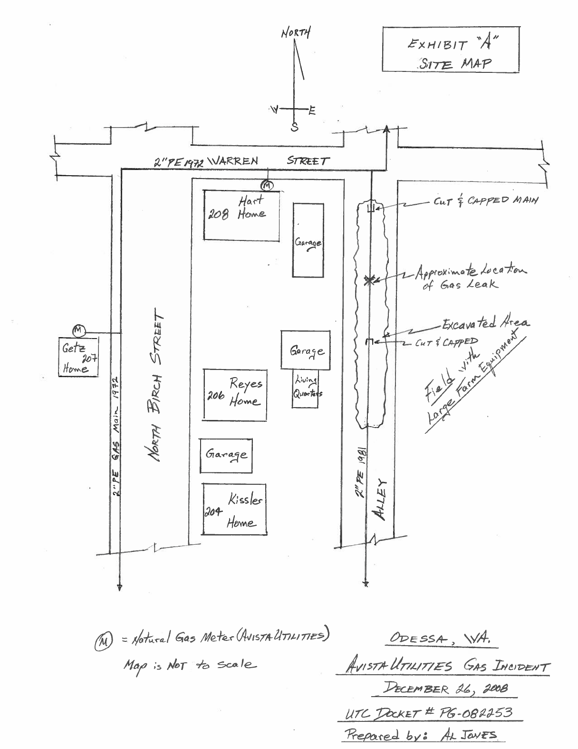
Exhibit B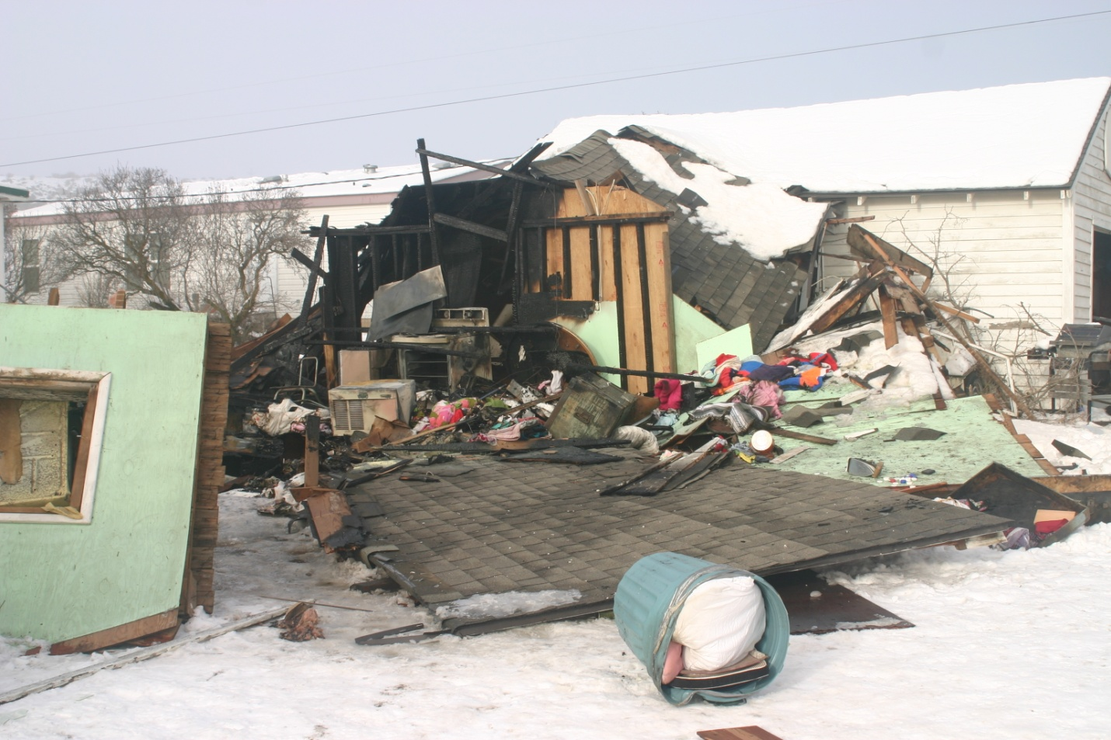
Location: 206 North Birch Street in Odessa, WA.
View: Looking to the northwest at the destroyed secondary living quarters and damaged attached garage (white structure in background). The gas most likely entered through cracks in the concrete basement foundation walls and entered the garage through an internal door connecting the two structures. The fire was confined mostly to the secondary living quarters.
Photo taken: 12/28/2008 by Al Jones

Exhibit C
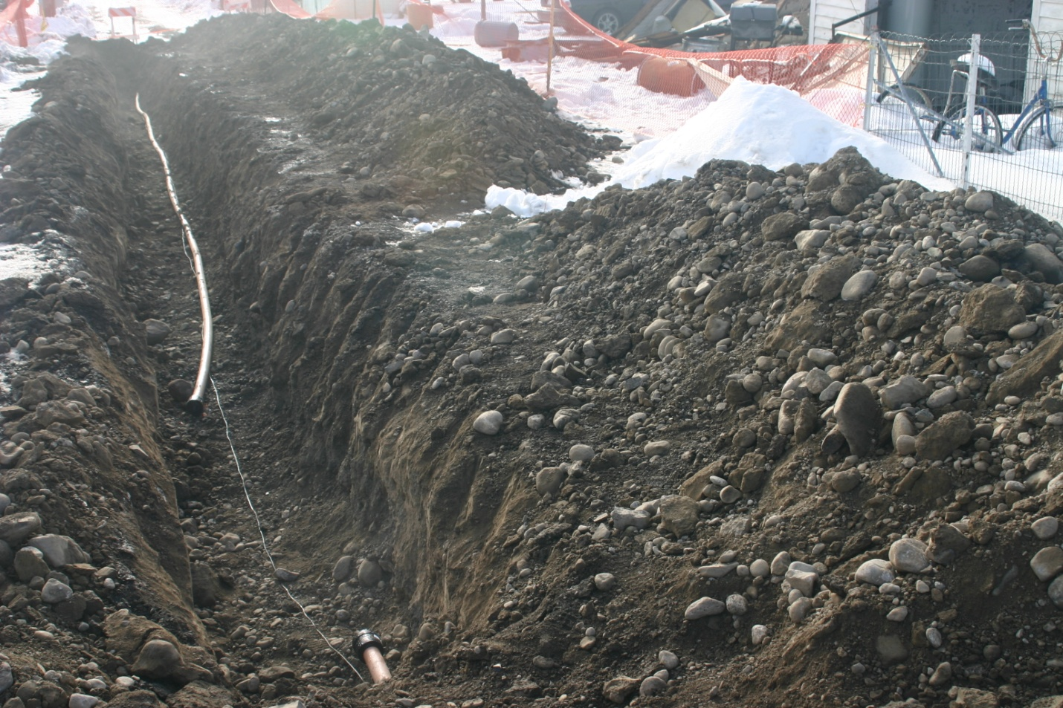
Location: 206 North Birch Street in Odessa, WA.
View: Looking south down the alley. The two inch diameter PE gas main is in-situ. The section of failed pipe has been removed. Avista removed that section of main and transported it to Spokane. Typical bedding and backfill material in the trench is mostly round, smooth rock and some fractured rock less than 6-inch in diameter. Dirt consists mostly of fine volcanic ash-type soil.
Photo taken: 12/28/2008 by Al Jones

Exhibit D
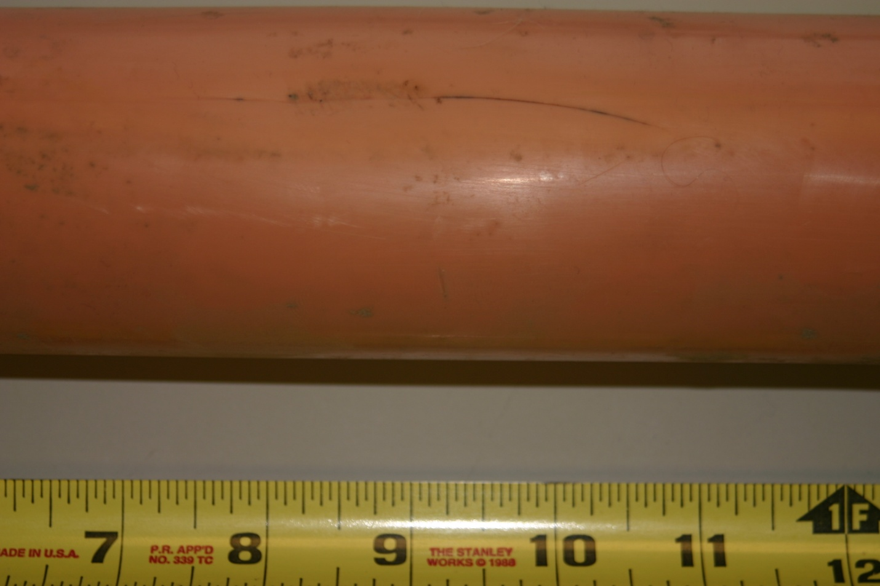
View of the 2-inch diameter PE main with longitudinal crack (dark line and scuff marks). This photo was taken at an Avista facility in Spokane.
Photo taken: 12/29/2008 by Al Jones

Exhibit E

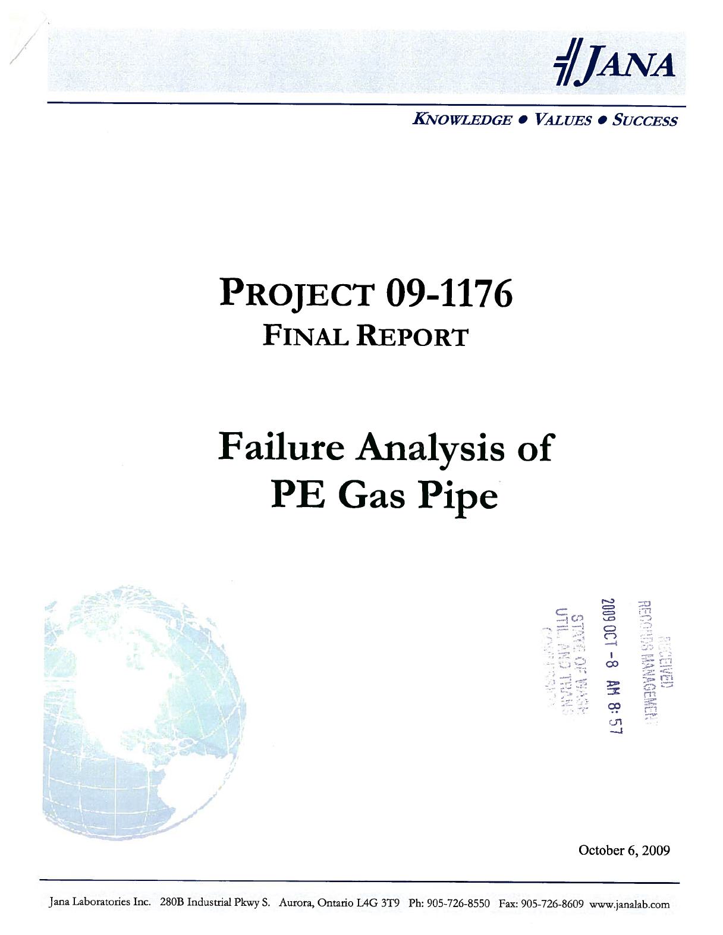

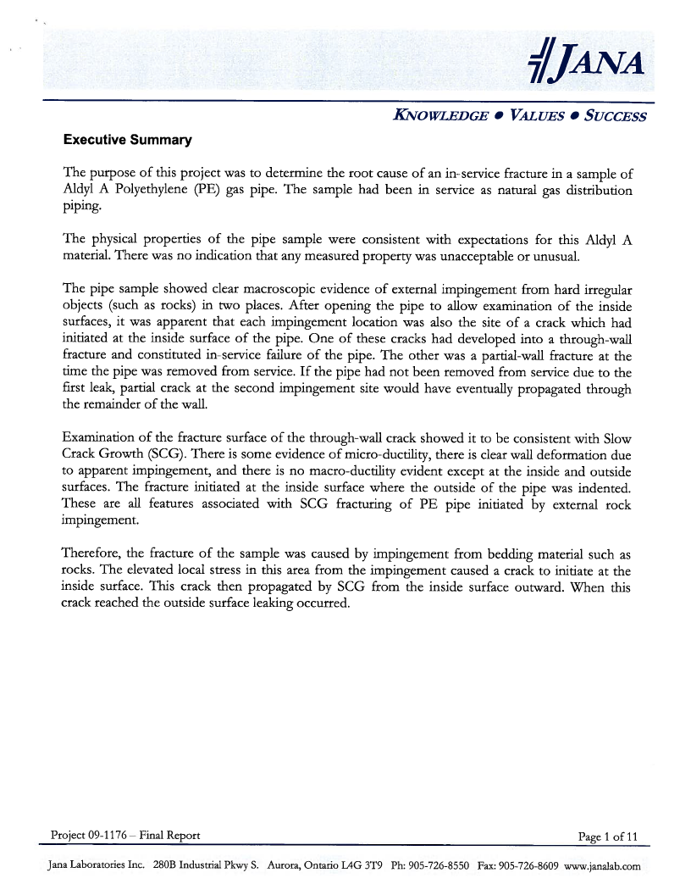

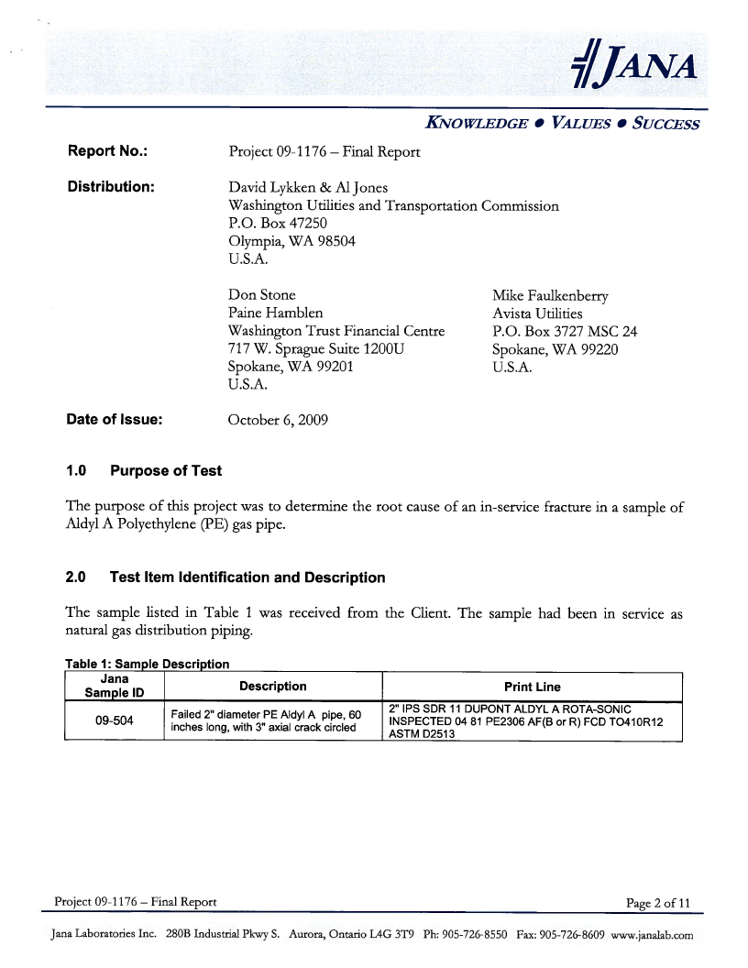

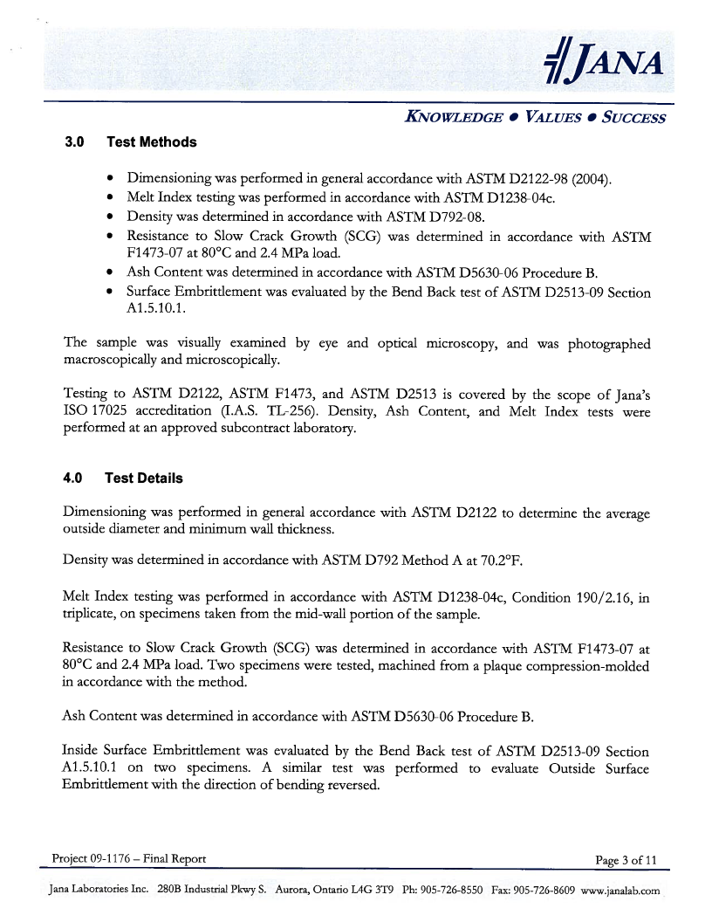

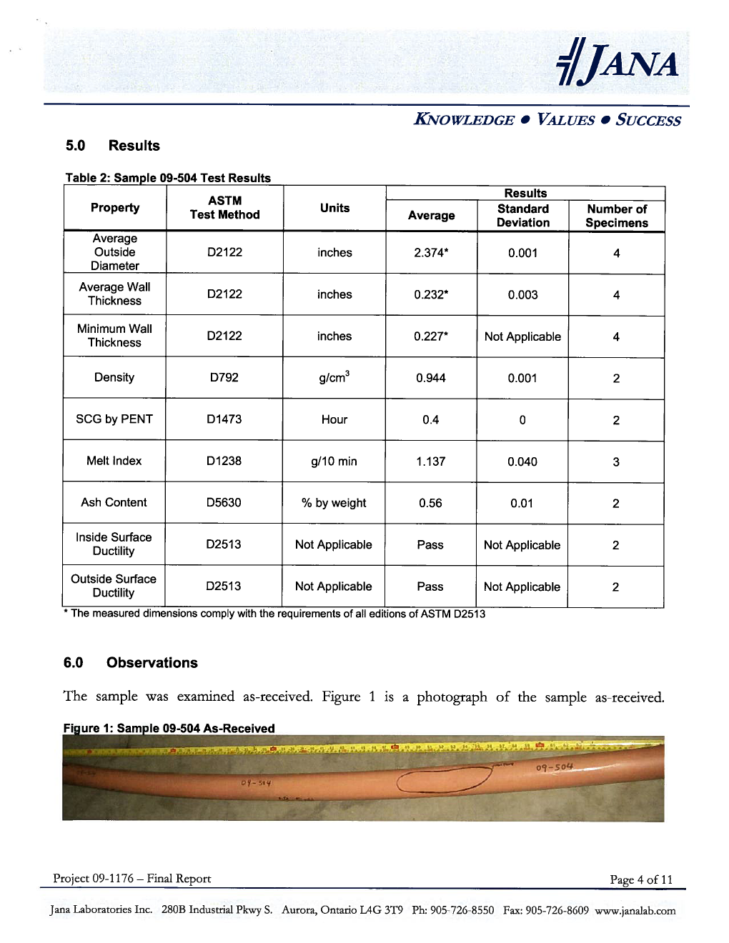

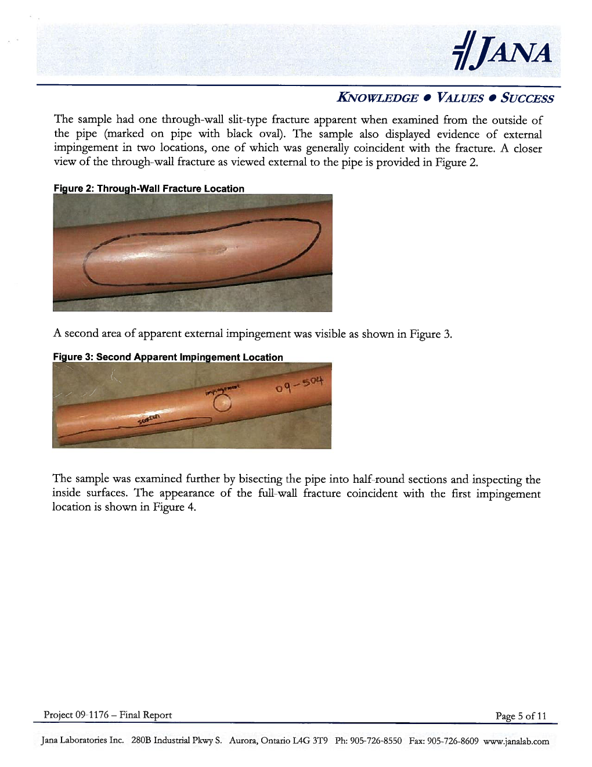

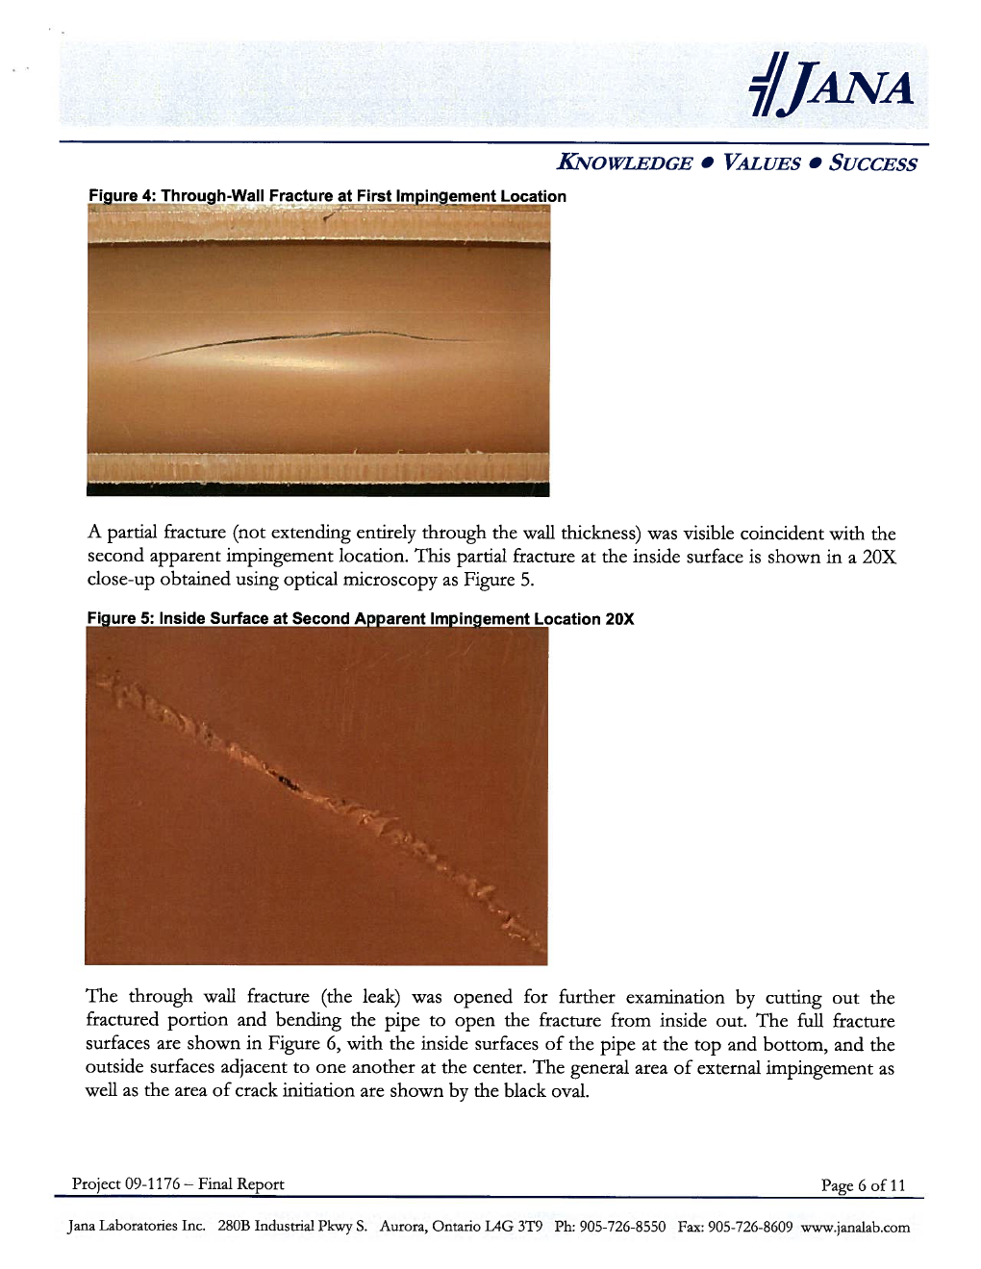

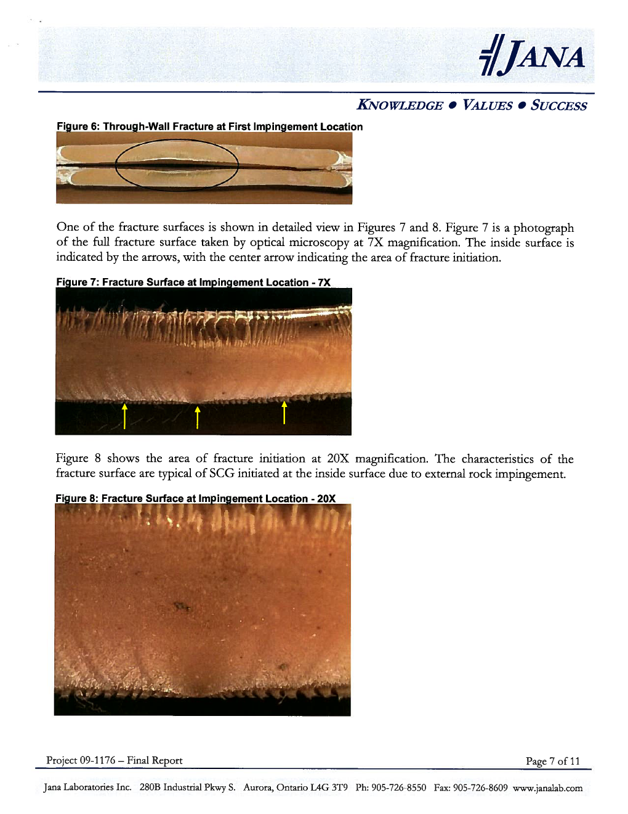

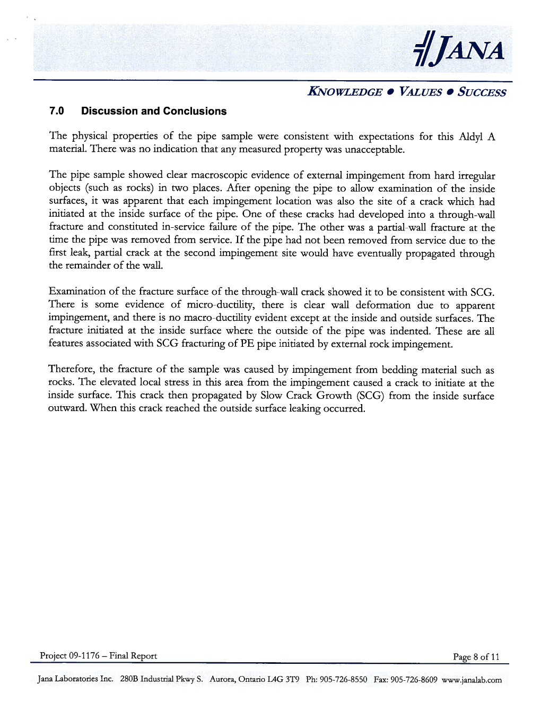

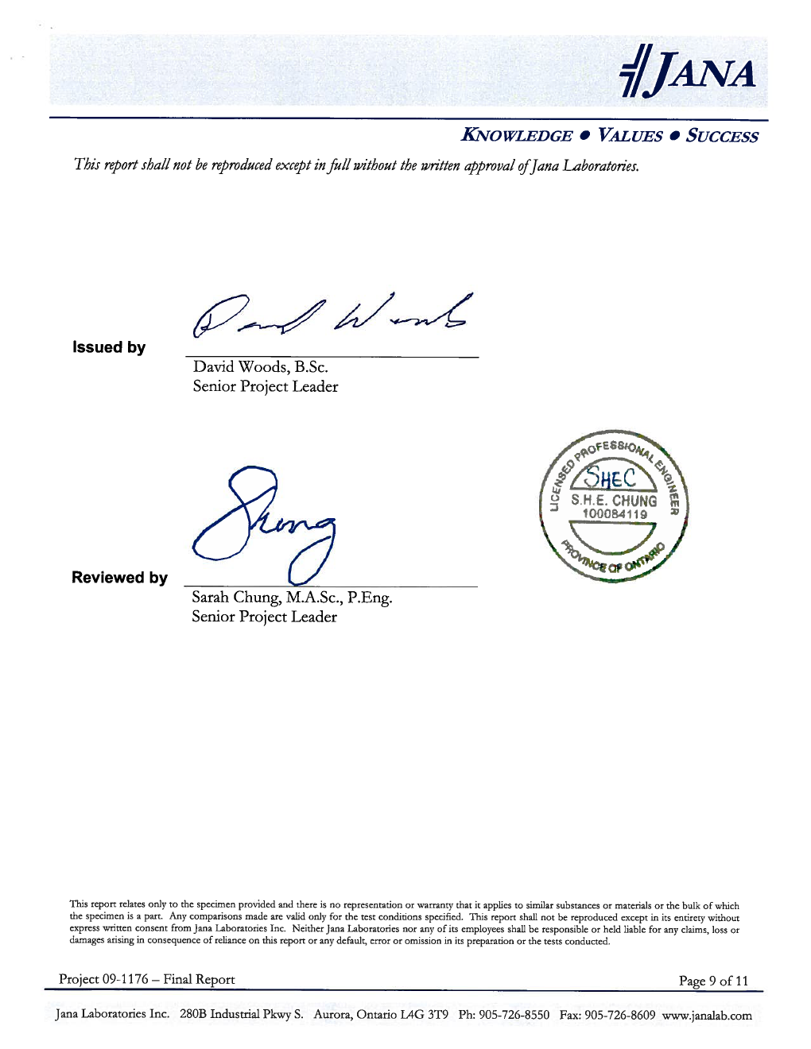

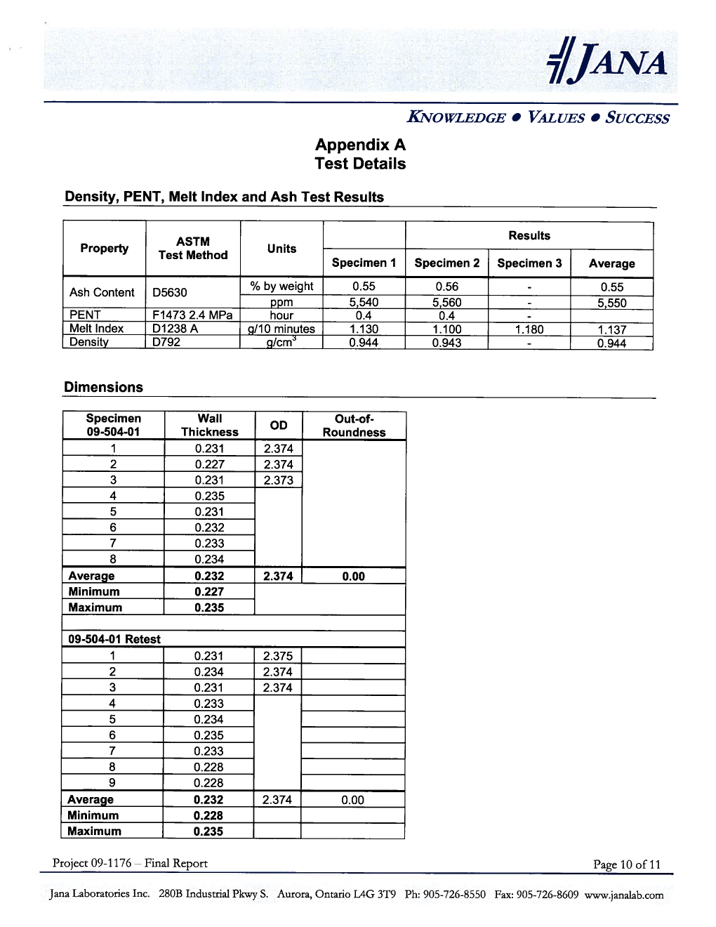

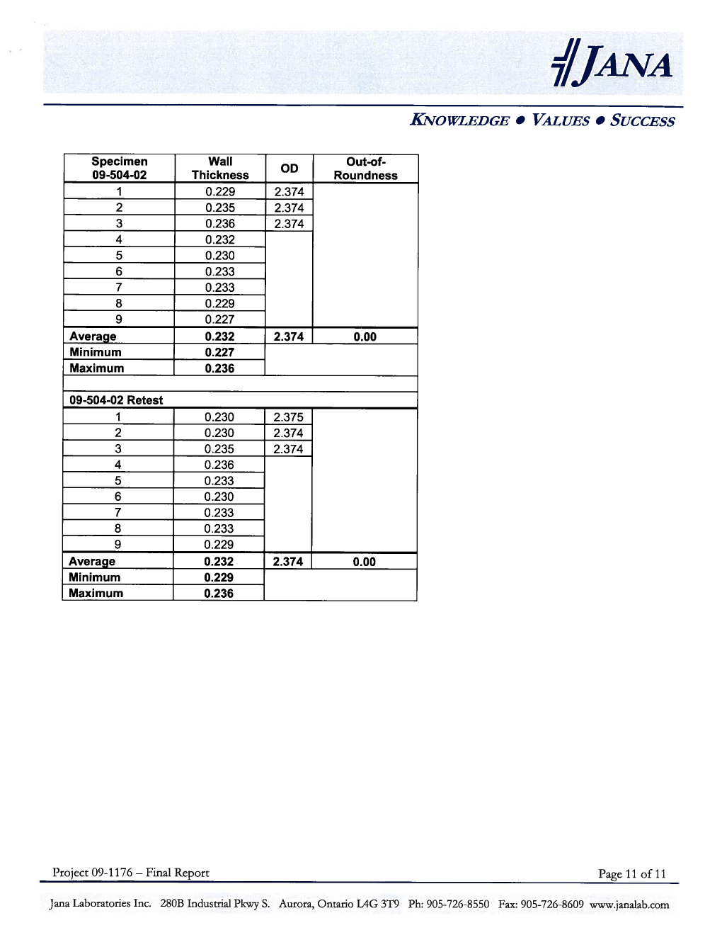

This report presents the findings, opinions, conclusions and recommendations of commission staff, and at this time, nothing in this report constitutes a finding, opinion, conclusion or recommendation of the commission. Commission staff understands the commission later will decide what regulatory action, if any, is appropriate. Nothing in this report reflects a finding or conclusion of commission staff that the gas system in the City of Odessa is unsafe.
Staff contacted Mr. Thomas Cordell, the attorney for the victims, Mr. Reyes and Ms. McClure. Staff requested to interview his clients about the incident. Arrangements were made for Mr. Reyes and Ms. McClure to answer written questions from staff. However, staff had not received those answers by the time this report was completed. If that information is supplied, staff will supplement this report. In staff’s opinion, it is almost always helpful to have information from the victims in incidents such as these. However, based on the other information staff has gathered, staff is confident in the conclusions and recommendations in this report.
This drawing was prepared by Mr. Al Jones of commission staff.
The information in the following paragraph is based on markings found on the pipe section removed and pipe placed in the exposed trench.
The full company name is E.I. DuPont de Nemours & Company.
From the last marking on the pipe (TO410R12), “401R” means “April 10, 1981.” Staff learned about these types of markings in a prior investigation involving this type of pipe. Other markings on the pipe section include: AFRF CD, SDR 11, and Rota-Sonic Inspected 04-81.
The information in the following three paragraphs is based on Avista’s Work Authorization Form which Avista prepared when it installed the pipe in question.
One neighbor, Mr. Hart, is an Avista gas customer, but his residence is connected to the Avista main located under Warren Street.
The information in the following paragraph is based on Avista’s Leak Survey Maps.
The information in this paragraph is based on the Odessa Fire Department report of the incident, Mr. Jones’ interview with Odessa Fire Department Fire Chief, Mr. Steven J. Finkbeiner, on April 16, 2009, at his home in Odessa, and recordings from the 911 Operator.
The arrival time is based on the recordings from the 911 Operator. The information in the rest of this paragraph is based on the Odessa Fire Department report of the incident, and Mr. Jones’ interview with Odessa Fire Department Fire Chief at the time of the incident, Mr. Steven J. Finkbeiner, on April 16, 2009 at his home in Odessa.
The information in this paragraph is obtained from the recorded 911 Operator conversation with the Avista Operator.
The information in this paragraph is based on Avista’s Incident Report to the commission (January 23, 2009).
The information in this paragraph is the Odessa Fire Department’s report of the fire.
The information in this paragraph is based on Avista’s Incident Report to the commission (January 23, 2009).
The information in this paragraph is based on Avista’s Incident Report to the commission (January 23, 2009).
NRC is operated by the federal Pipeline and Hazardous Materials Safety Administration (PHMSA).
The information in this paragraph is based on Mr. Jones’ interview with Mr. Richard Funge, Avista’s Utilities Gas Local Representative, on December 27, 2008.
The information in this paragraph is based on an email from Kimbra Davis to David Lykken.
The photographs described in this paragraph were taken by Mr. Al Jones of commission staff on December 28, 2008.
As discussed later, WAC 480-93-185(2), “Gas Leak Investigation” requires Avista to wait until the lead investigative authority (in this instance, the commission) designates the release of the pipe from the site.
The information in this sentence is based on Avista’s Gas Operating Order Report for December 28, 2008.
This filtering phenomenon is discussed in a study by Phillips Petroleum Company entitled: “Penetrabilities of Gas Odorant Compounds in Natural Soils.”

