February 22, 2017

Mr. Steven King, Executive Secretary
Washington Utilities and Transportation Commission
1300 South Evergreen Park Drive SW
Olympia, WA 98504-7250

Docket UT-170009

Re: WAC 480-123-130(1)(e) requiring all wireline communication providers that receive state USF program support to file copies of Form 477

Dear Mr. King:

Enclosed is a copy of our 477 summary as filed with the FCC period ended 12/31/2016.

Sincerely,

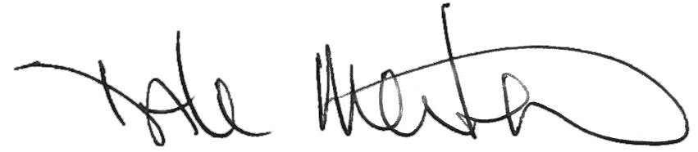

Dale Merten
Chief Operating Officer

