July 1, 2014

Steven V. King, Executive Director and Secretary
Utilities and Transportation Commission
1300 S. Evergreen Park Dr. SW
P.O. Box 47250
Olympia, WA 98504-7250

RE: Washington Utilities and Transportation Commission v. Big River Telephone Company, LLC

Commission Staff’s Response to Application for Mitigation of Penalties UT-140871

Dear Mr. King:

On May 30, 2014, the Utilities and Transportation Commission issued a $600 Penalty Assessment in Docket UT-140871 against Big River Telephone Company, LLC for 6 violations of Washington Administrative Code (WAC) 480-120-382, which requires telecommunications companies to furnish annual reports to the commission no later than May 1 each year.¹

On June 16, 2014, Big River Telephone Company, LLC wrote the commission requesting mitigation of penalties (Mitigation Request).² In its Mitigation Request Big River Telephone Company, LLC does not dispute that the violation occurred. The company states, “We actually filed our annual report on the due date of May 1st. On May 2nd we received a notice that we were missing the income statement and that we inadvertently marked the regulatory fee calculation sheet as Confidential.” The statement continues, “Unfortunately our unfamiliarity with the Washington annual report process, coupled with an administrative oversight caused the aforementioned troubles with our 2013 annual report.”

It is the company’s responsibility to ensure that the regulatory fee is paid and the annual report is filed by the May 1 deadline. On February 28, 2014, Annual Report packets were mailed to all regulated telecommunication companies. The instructions for annual report completion page of
the annual report informed the regulated company that it must complete the annual report form, pay the regulatory fees, and return the materials by May 1, 2014, to avoid enforcement action.

UTC Annual Reports
July 1, 2014
Page 2

On May 9, 2014 Big River Telephone Company, LLC filed its completed annual report with no regulatory fees due. The company has been active since February 16, 2007. Big River Telephone Company, LLC was previously delinquent in filing its annual report in 2011 due to missing financial statements and received an automatically mitigated penalty. Staff does not support the company’s request for mitigation due to prior violations of similar circumstance.

If you have any questions regarding this recommendation, please contact Amy Andrews, Regulatory Analyst, at (360) 664-1157, or aandrews@utc.wa.gov.

Sincerely,

Sondra Walsh, Director
Administrative Services

ATTACHMENT A
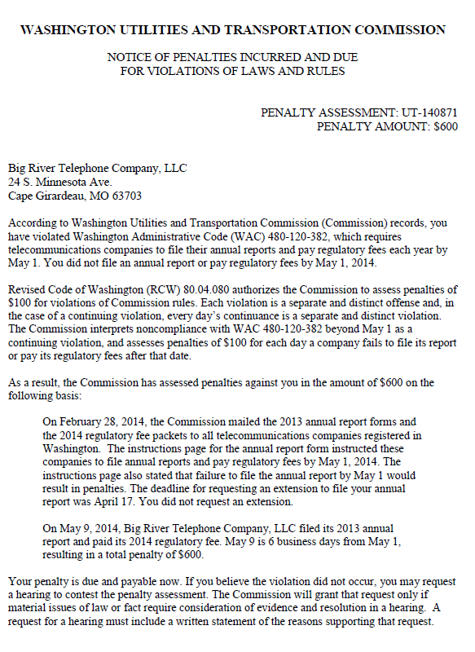

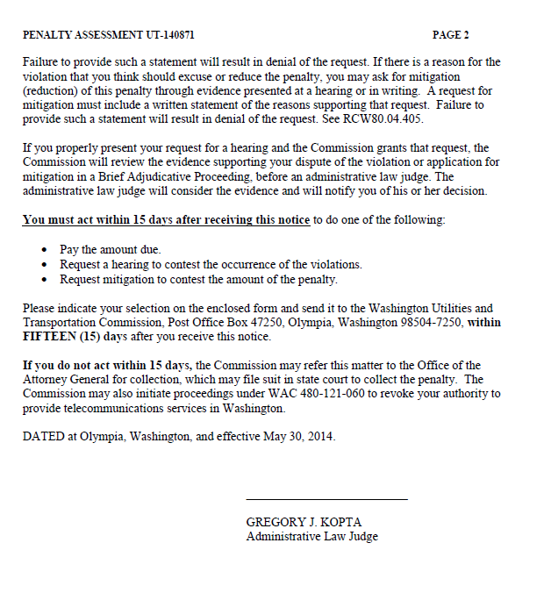

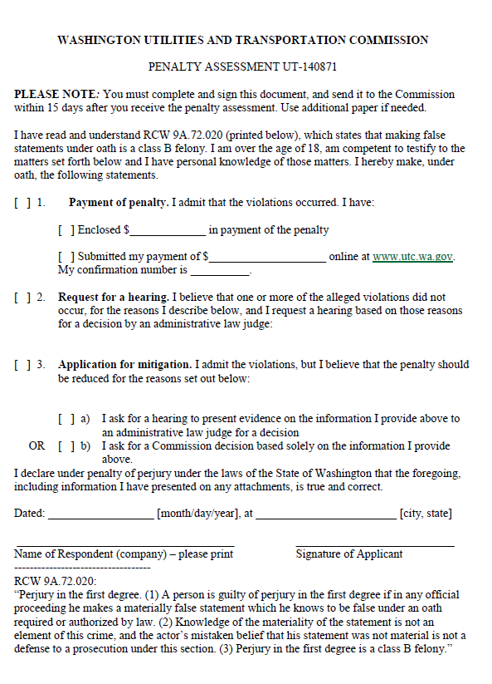

ATTACHMENT B
