BEFORE THE WASHINGTON UTILITIES AND TRANSPORTATION
COMMISSION

)
) DOCKET NO. UT-16_________
In the Matter of State )
Certification of Support as ) ANNUAL ETC CERTIFICATION AND
Required by 47 C.F.R. § 54.314 ) REPORT OF UNITED STATES
) CELLULAR CORPORATION
……………………………………... )

Pursuant to WAC 480-123-060, et seq., United States Cellular Corporation, 8410 West Bryn Mawr, Suite 700, Chicago, IL 60631 (“USCC”), seeks recertification as an ETC in the State of Washington based on the following:
1. USCC was designated as an eligible telecommunications carrier (“ETC”) by the Washington Utilities and Transportation Commission in Docket No. UT-970345 on December 23, 1997, as supplemented December 30, 1999 and January 27, 2000, May 14, 2008, and September 26, 2013.
2. During the calendar year 2015, USCC provided the services required by 47 U.S.C. § 214(e) consistent with the Commission Orders in Docket No. UT-970345. As certified in Exhibit A, funds USCC receives from the federal high-cost universal service support fund were and will be used only for the provision, maintenance and upgrading of the facilities and services for which the support was intended.
3. Exhibit B attached is intended to satisfy the requirements of WAC 480-123-070 (1) “Report on use of federal funds and benefits to customers”. The 4G LTE investments and expenses provide substantial benefits to consumers in the form of advanced wireless technology to significantly increase both the speed and capacity of mobile networks in USCC’s Washington ETC area. 4G LTE – the next generation of cellular technology – allows customers to surf the web, send and receive pictures, download music and watch videos at speeds up to 10 times faster than 3G. – Confidential
4. Exhibit C notes that there were no reportable service outages in 2015.
5. Exhibit D attached is intended to satisfy the requirements of WAC 480-123-070 (3) “Report on failure to provide service”. - Confidential
6. Exhibit E attached is intended to satisfy the requirements of WAC 480-123-070 (4) “Report on complaints per one thousand handsets or lines”. - Confidential
7. Exhibit F certifies USCC is in compliance with the CTIA Consumer Code for Wireless Carriers. This statement is made in response to WAC 480-123-070 (5) “Certification of compliance with applicable service quality standards”.
8. In 2015 USCC had a reasonable amount of backup power (fixed, portable or other backup power source) for its cell sites, and backup power for its switches is as prescribed in WAC 480-120-411(3). The certification of compliance in Exhibit G is made in response to WAC 480-123-070 (6) “Certification of ability to function in emergency situations”.
9. During the calendar year 2015, USCC advertised the availability of supported services and the charges for them as required by 47 U.S.C. § 214(e), and the Commission Orders in Docket No. UT-970345. Exhibit H certifies that USCC publicized the availability of supported services, including Lifeline Services and tribal outreach. Samples of advertising are attached as Exhibit I. This paragraph is in response to WAC 480-123-070(7).“Advertising certification, including advertisement on Indian reservations”.
10. Exhibit J, attached, details USCC’s intended investment and expenditures within its ETC boundaries in the State of Washington for the time period October 1, 2016 through September 30, 2017. The planned expenditures will benefit customers by ensuring continued and ongoing mobile voice and data services in high cost areas that otherwise might not be served or served as well without the federal support. This information is provided as a response to WAC 480-123-080. - Confidential
11. Exhibit K, is a .pdf map that shows the general location where USCC provides commercial mobile radio service signals in Washington. Due to the large file size, the same map in .shp format will be separately submitted on a CD. This information is provided as a response to WAC 480-123-080(3). - Confidential
Respectfully submitted this 30th day of June, 2016.
Lukas, Nace, Gutierrez & Sachs, LLP
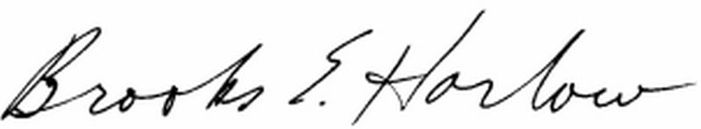
Brooks E. Harlow,
WSBA No. 11843

Attorneys for United States Cellular Corporation

