BEFORE THE WASHINGTON STATE
UTILITIES AND TRANSPORTATION COMMISSION

In the Matter of Determining the Proper Carrier Classification of, and Complaint for Penalties against:  JOHNSON, JEFFREY d/b/a JEFF’S EXPRESS MOVERS  _____________________________________ | )  )  )  )  )  )  )  ) | DOCKET TV-130327  DECLARATION OF  MATHEW PERKINSON
Mathew Perkinson, under penalty of perjury under the laws of the State of Washington, declares as follows:

- I am employed by the Washington Utilities and Transportation Commission (Commission) as a Compliance Investigator in the Consumer Protection and Communications Section. As a Compliance Investigator, my responsibilities include conducting investigations regarding the business practices of regulated utility or transportation companies. As part of those duties, I investigate household goods carriers that may be operating without the required Commission permit.
- I began an investigation into the activities of Jeffrey Johnson d/b/a Jeff’s Express Movers (Jeff’s Express Movers) in November 2012 because I found advertisements indicating the company was conducting household goods moves within the state of Washington without a permit.
- On December 12, 2012, I mailed a compliance letter to Jeff’s Express Movers, instructing it to remove any advertisements and cease operating as a household goods operator until it obtained a commission issued permit. The letter was returned to Sender on January 9, 2013. I mailed another compliance letter on January 10, 2013, to Jeff’s Express Movers at another address which I located in the Department of Revenue business records.
- On January 18, 2013, Jeffrey Johnson of Jeff’s Express Movers called me and said he received the compliance letter. Mr. Johnson said he is removing his advertisements and is going to operate as a labor only operation. I explained to Mr. Johnson that if he continues to operate as a household goods company, the commission would seek further enforcement action. Mr. Johnson said he did not have the money at that time, however he would like to eventually get a permit. Mr. Johnson said he does not have a truck. I requested Mr. Johnson email me his intent going forward. Mr. Johnson emailed me on January 18, 2013, stating he only intends to perform labor only jobs without a truck.
- I conducted a follow-up investigation into the activities of Jeff’s Express Movers in February 2013, and found advertisements indicating the company is still conducting household goods moves within the state of Washington without a permit.
- I reviewed Commission records related to Jeff’s Express Movers to determine whether the company held a household goods permit. According to Commission records, as of February 25, 2013, there is no record of Jeffrey Johnson d/b/a Jeff’s Express Movers now (or ever) holding a household goods permit.
- On February 14, 2013, I conducted an Internet search for advertising for Jeff’s Express Movers. I found advertisements on www.craigslist.org.
- On February 14, 2013, I responded via email and replied to the www.craigslist.org advertisement using an assumed name requesting a quote, including two men and a truck, from a two bedroom apartment to another two bedroom apartment, ten miles apart, in the Vancouver area. I received a response back from Jeff’s Express Movers LLC, at Movertrucks@yahoo.com, responding to staff’s email offering moving services at $70 per hour, with a three hour minimum including two men and a truck. The response also stated the company would only accept cash as a form of payment.
- On February 25, 2013, I conducted an Internet search for advertising for Jeff’s Express Movers. I found advertisements on www.jeffsexpressmoversllc.net, www.manta.com, www.merchantcircle.com, www.switchboard.com and www.umovers.com.
DATED this 19th day of March, 2013, at Olympia, Washington.

______________________________________
MATHEW PERKINSON

Attachment A

Attachment B

Attachment C

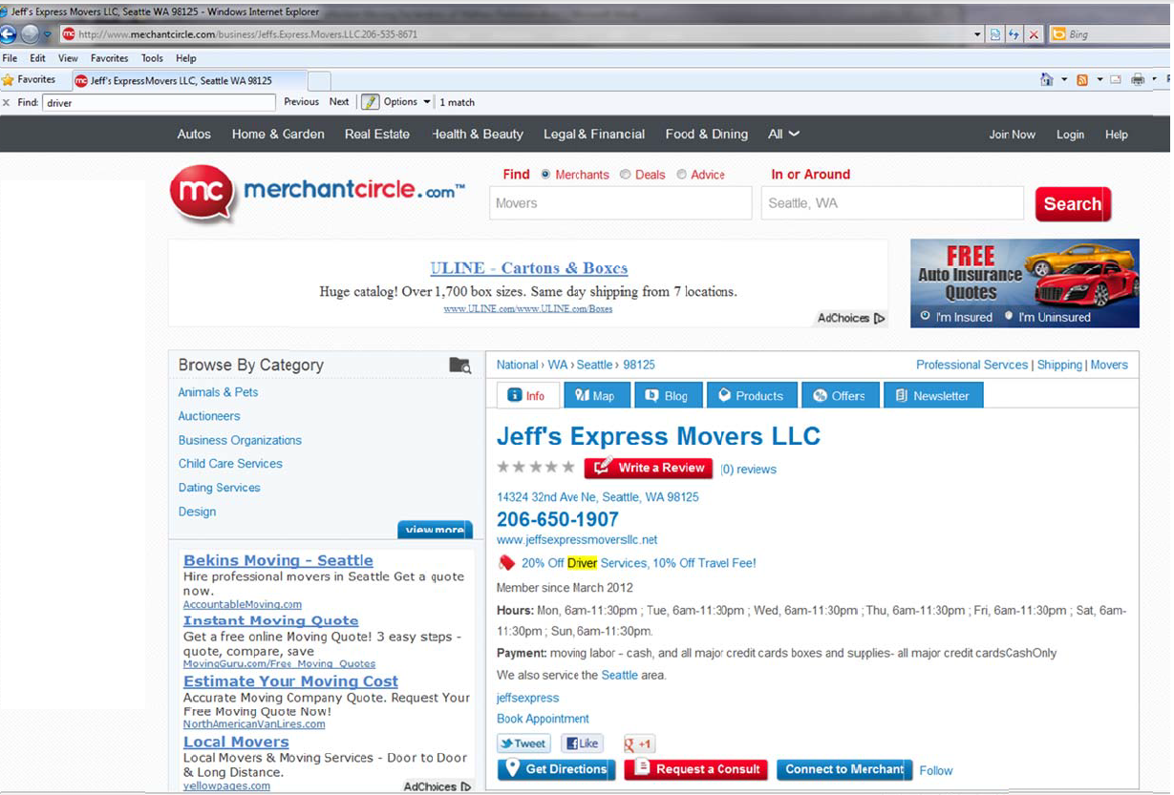

Attachment D

Attachment E

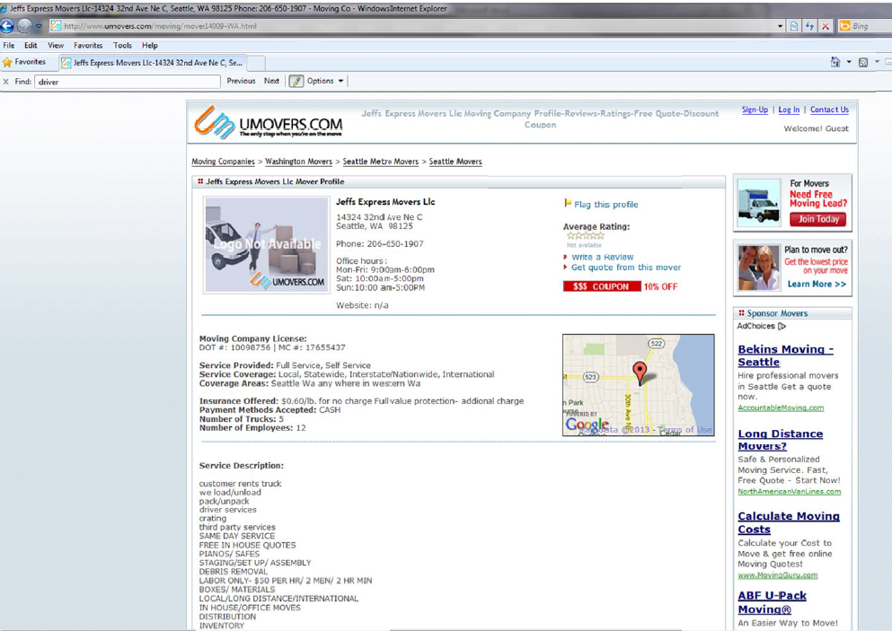

See Attachment A for a copy of the February 2013 advertisement found at www.jeffsexpressmoversllc.net.
See Attachment B for a copy of the February 2013 advertisement found at www.manta.com.
See Attachment C for a copy of the February 2013 advertisement found at www.merchantcircle.com.
See Attachment D for a copy of the February 2013 advertisement found at www.switchboard.com.
See Attachment E for a copy of the February 2013 advertisement found at www.umovers.com.

