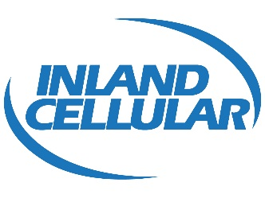

July 1, 2016

Via electronic filing

Mr. Steven V. King, Executive Director and Secretary
Washington Utilities and Transportation Commission
1300 South Evergreen Park Drive SW
Olympia, WA 98504-7250

Re: Docket UT-160030 – Copy of FCC Form 481- Carrier Annual Report

Dear Mr. King:

Attached is a copy of the Federal Communications Commission (“FCC”), Form 481 that was electronically completed and submitted to the Universal Service Administrative Company (“USAC”). This submission is for Inland Cellular LLC Study Area Code 529004 and includes all attachments that were submitted to USAC and the FCC.

I am requesting that the 5 year plan remain confidential pursuant to WAC 480-07-160 and I am submitting a redacted version of that document.

If you should have any questions, please call me at (509) 649-2500.

Sincerely,

Nathan Weis
President and CEO
Inland Cellular LLC

