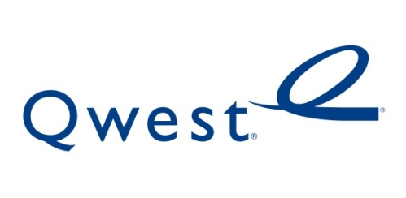

September 24, 2010

Advice No. 3669T

David Danner
Executive Director and Secretary
1300 S. Evergreen Park Dr. S.W.
P.O. Box 47250
Olympia, Washington 98504-7250

Dear Mr. Danner:

Qwest Corporation is forwarding for filing the sheets listed on Attachment A.

The purpose of this filing is to decrease the Federal Lifeline credit from $5.81 to $5.76. This change coincides with the decrease to the Federal Access Charge rate for residential primary line service in Washington that will become effective October 1, 2010. The FCC filing was made on September 16, 2010.

Qwest requests the effective date of October 1, 2010 in accordance with WAC 480-80-123, since the federal lifeline credit directly offsets the Federal Access Charge rate. There is no customer impact with this rate change. If you have any questions concerning this filing please contact Marie Larchick on (402) 422 7482.

Sincerely,

Mark Reynolds

Attachments

Attachment A
Advice No. 3669T

EXCHANGE AND NETWORK SERVICE
WN U-40

SECTION | SHEET | REVISION
5 | 48 | 9th
5 | 48.3 | 12th

