PacifiCorp and Columbia REA facilities are located along both sides of JB George. A county road widening job on JB George required both PacifiCorp and Columbia REA to work on facilities at the same time. At various times, PacifiCorp crews, Columbia REA crews and county road contractor were working within the road right-of-way at the same time.

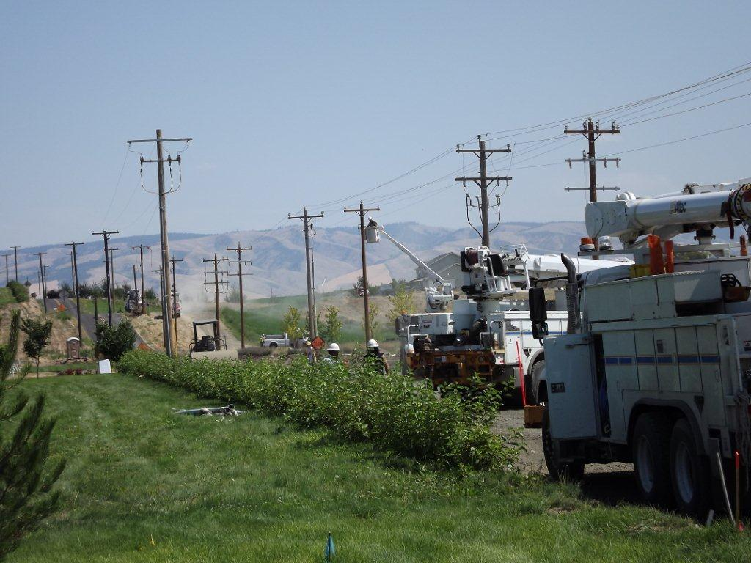
Columbia REA Facilities
PacifiCorp Facilities

Columbia REA trenched in close proximity of PacifiCorp anchors at Dell and Bowman. PacifiCorp was required to be on site to ensure pole did not fall.

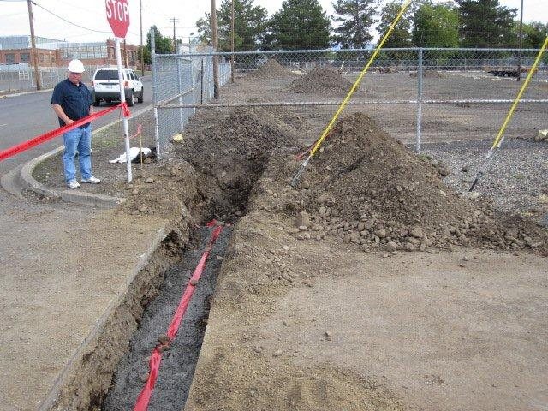
Columbia REA Trench
PacifiCorp Anchors

Example of Locate at Canberra: Locate performed by Columbia REA shows “No CREA”. Locate performed by Locate Inc. shows that there are PacifiCorp facilities present.

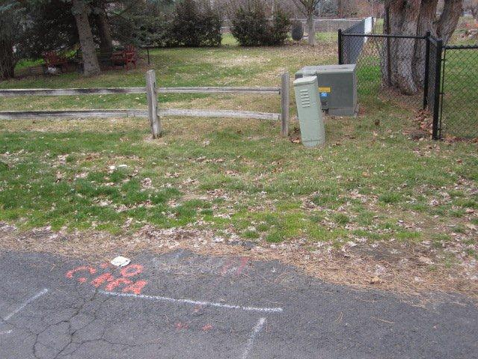
Columbia REA Locate
PacifiCorp Locate

Example of Locate at Cottonwood: Locate performed by Locate Inc. indicates “No PPL”. However, there is a Columbia REA vault present.

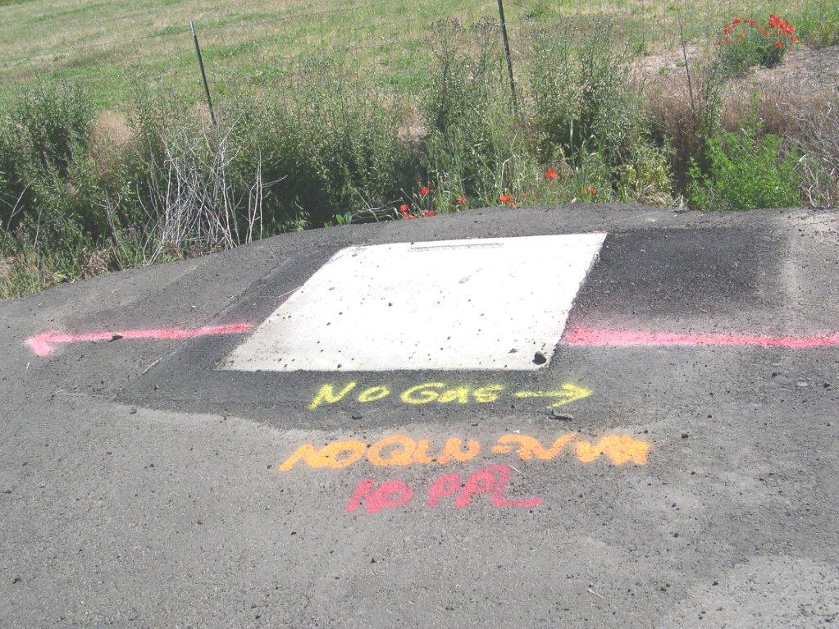
Columbia REA Vault

Columbia REA’s proposed underground line does not meet PacifiCorp’s six foot minimum clearance for separation of facilities. Columbia REA’s proposed primary underground line is staked to run between PacifiCorp’s pole and guy wire.

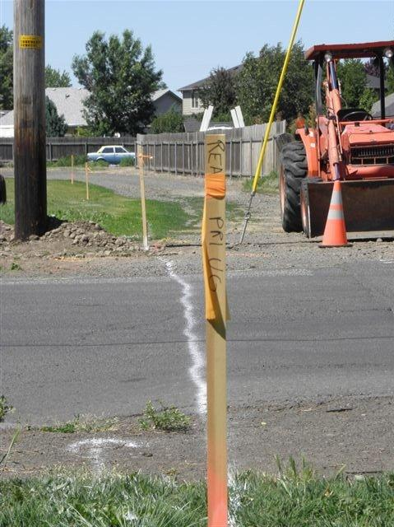
PacifiCorp down guy
PacifiCorp pole
Proposed location for Columbia REA primary underground line

CREA Conduits

Columbia REA bored conduit (six) between PacifiCorp’s and another utility’s facilities. In doing so, Columbia dug into PacifiCorp’s buried conduit, requiring PacifiCorp to make repairs.

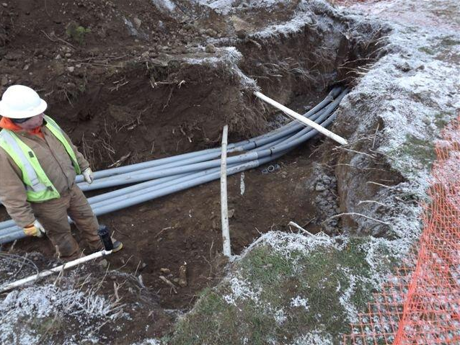
Columbia REA conduit
PacifiCorp conduit

Pine Street Trenching

Columbia REA is trenching within 6 feet of PacifiCorp’s facilities. Note the close proximity of the backhoe to PacifiCorp’s distribution pole.

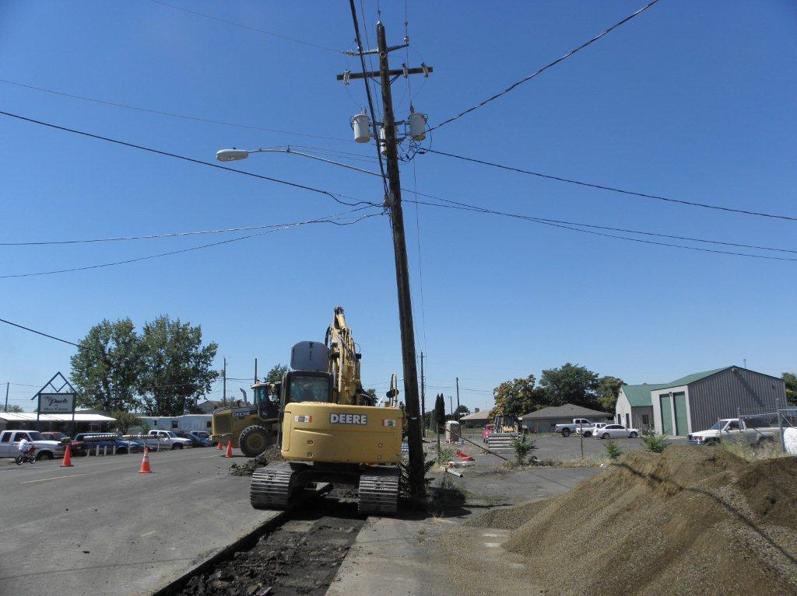
PacifiCorp facilities
Columbia REA trench

Pine Street (Looking West)

Columbia REA has staked a proposed location for their underground line and a junction box. Both are located within close proximity of PacifiCorp’s facilities.

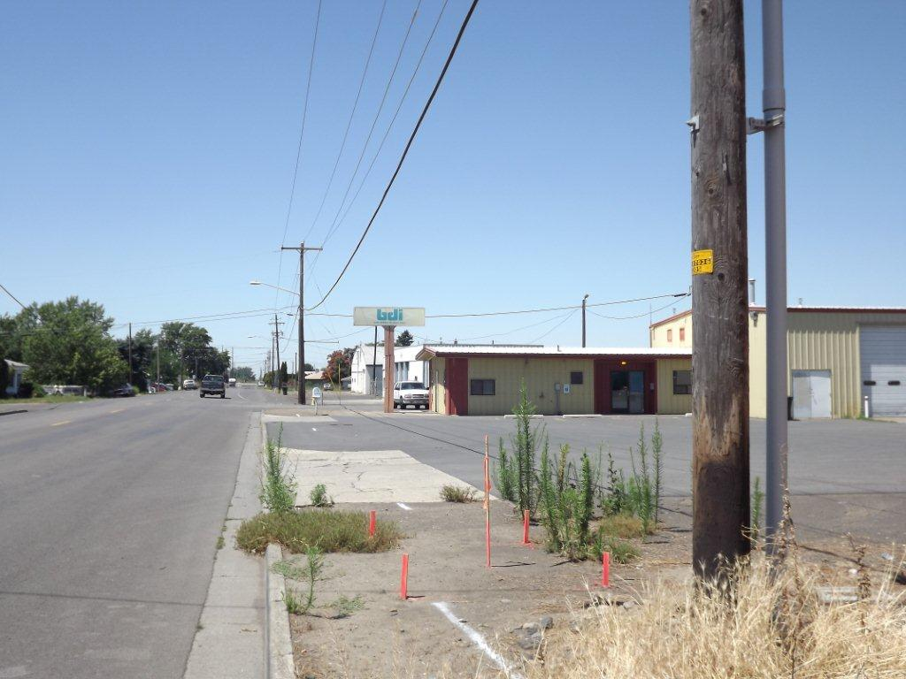
Proposed location of Columbia REA underground line
Proposed location of Columbia REA junction box
PacifiCorp overhead facilities

Columbia REA staked their primary line to be located approximately 2.5 feet from the locate mark of PacifiCorp’s facilities. Columbia REA was reluctant to move their line to provide at least 6 feet of separation from PacifiCorp’s facilities, stating that their proposed location met the minimum NESC requirements. After city and Labor and Industries were involved, Columbia REA moved the line and provided the 6 feet of separation.

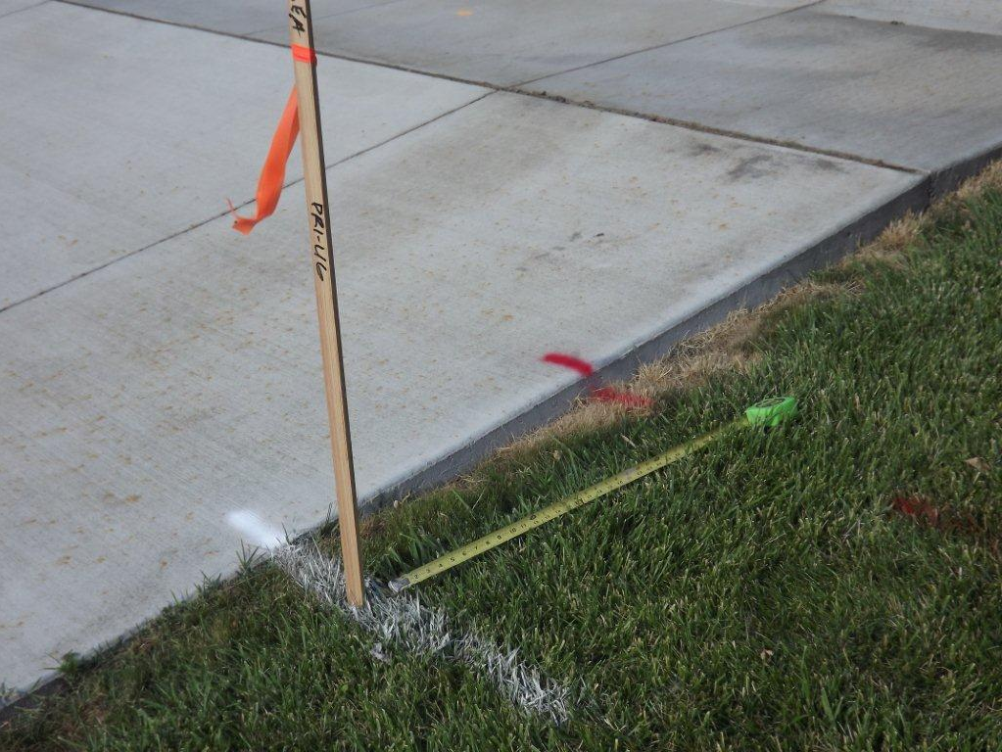
Approximately 2.5’
Location of PacifiCorp underground line
Proposed location of Columbia REA underground line

