September 23, 2013

FILED ELECTRONICALLY VIA WEB PORTAL
AND OVERNIGHT FEDERAL EXPRESS
Mr. Steven V. King
Executive Director & Secretary
Washington Utilities and Transportation Commission
Post Office Box 47250
1300 S. Evergreen Park Dr. SW
Olympia, Washington 98504-7250

Re: In the Matter of the Petition of United States Cellular Corporation for Conditional Designation as an Eligible Telecommunications Carrier for Purposes of Participating in the Tribal Mobility Fund Auction.
Docket No. ___________

Dear Mr. King:

Please find enclosed for filing the Petition of United States Cellular Corporation for Conditional Designation as an Eligible Telecommunications Carrier for Purposes of Participating in the Tribal Mobility Fund. As noted in the Petition, consideration before October 9, 2013 is requested. The original and 12 copies are being sent via overnight Federal Express.

If you have any questions please contact the undersigned.

Very truly yours,
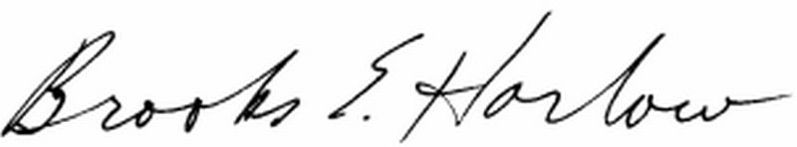
Brooks E. Harlow, P.C.
Enclosures

cc: Ms. Jing Liu

