November 8, 2012

David W. Danner, Executive Director and Secretary
Washington Utilities and Transportation Commission
1300 S. Evergreen Park Dr. SW
P. O. Box 47250
Olympia, Washington 98504-7250

RE: Washington Utilities and Transportation Commission v. Green Mountain H2O
Commission Staff’s Response to Application for Mitigation of Penalties
Docket UW-120865

Dear Mr. Danner:

On July 13, 2012, the Washington Utilities and Transportation Commission issued a $2,100 Penalty Assessment in docket UW-120865 against Green Mountain H2O (Green Mountain) for 21 violations of Washington Administrative Code (WAC) 480-110-505, which requires water companies to furnish annual reports to the commission no later than May 1 each year. The penalty assessment instructed Green Mountain to complete and sign the document, and send it to the commission within 15 days after receiving it. Green Mountain had until July 28, 2012 to file its response.

On October 18, 2012, Green Mountain wrote the commission requesting mitigation of penalties (Mitigation Request), which is 97 days past the service date of July 13, 2012. In its Mitigation Request, Green Mountain does not disputes the violations occurred and states, “I am asking for a waiver in regards to the assessed failure to file penalty for my 2011 Annual Report. The 2011 Annual Report is now filed and Green Mountain H2O should be current with all filings. I have been working with my accountant to make sure this will not happen again. We already have 3rd quarter amounts put together and plan to file 2012 Annual Report early in 2013. I appreciate you reviewing my assessment and hopefully you can waive the penalty. Due to the economic climate it would be very difficult to pay this penalty. Thank you!”

It is the company’s responsibility to ensure that the regulatory fee and the annual report are filed by the May 1 deadline. On February 29, 2012, Annual Report forms and Regulatory Fee packets were mailed to all regulated water companies. In addition to other information, the cover letter informed the regulated company it must complete the annual report form, pay any regulatory fees and return the material by May 1, 2012, to avoid enforcement action. The letter also stated a company may file a written request for an extension, however the request must be filed with the commission by April 24, 2012, and must state a valid reason for why the extension is needed, along with the date the report will be filed. The company did not file a request for an extension. On May 14, 2012, the commission mailed a letter to those companies that had not yet filed an annual report notifying them that, to date, they had incurred a penalty of $800. The letter went on to explain that companies who filed their annual reports no later than May 25, 2012, would receive mitigated penalties of $25 per day, with an additional $25 per day for each instance in the previous five years that the company received a penalty for filing a late report. The company had substantial time and sufficient notice to file its annual report, if not by the May 1 deadline.

Green Mountain filed its completed annual report on June 27, 2012. Green Mountain did not file its annual report by May 31, 2012, which is 21 business days past the deadline of May 1, 2012. The penalty is $100 per business day for a total of $2,100. Green Mountain became regulated in April 2009 and has never received a penalty for filing a delinquent annual report in the past.

Staff does not support mitigating the assessed penalty of $2,100. Green Mountain failed to file its response within the 15 day timeframe required for the commission to consider mitigation. In addition Green Mountain failed to establish any mitigating circumstances that explain or excuse its failure to submit its annual report. Staff recommends denying the mitigation request.

If you have any questions, please contact Mathew Perkinson, Compliance Investigator, at (360) 664-1105, or at mperkinson@utc.wa.gov.

Sincerely,

Sharon Wallace, Assistant Director
Consumer Protection and Communications
Attachment A

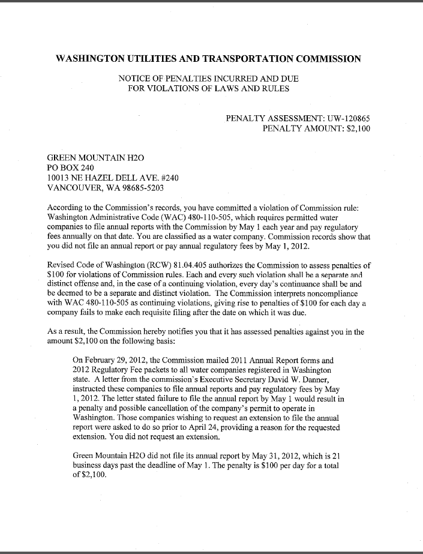
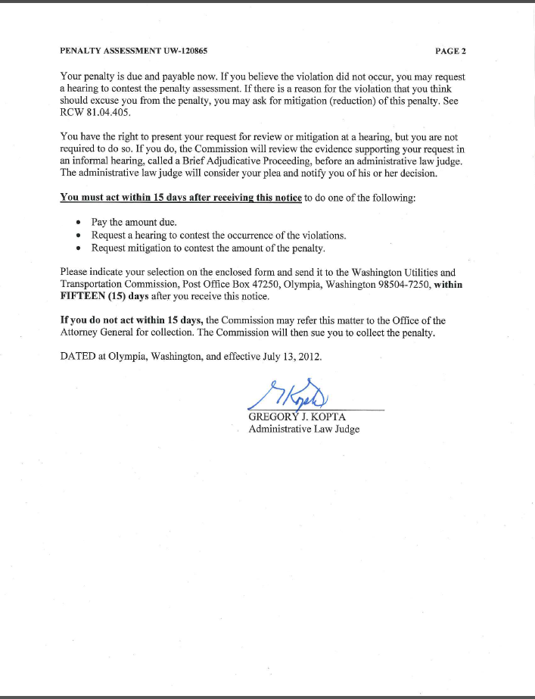

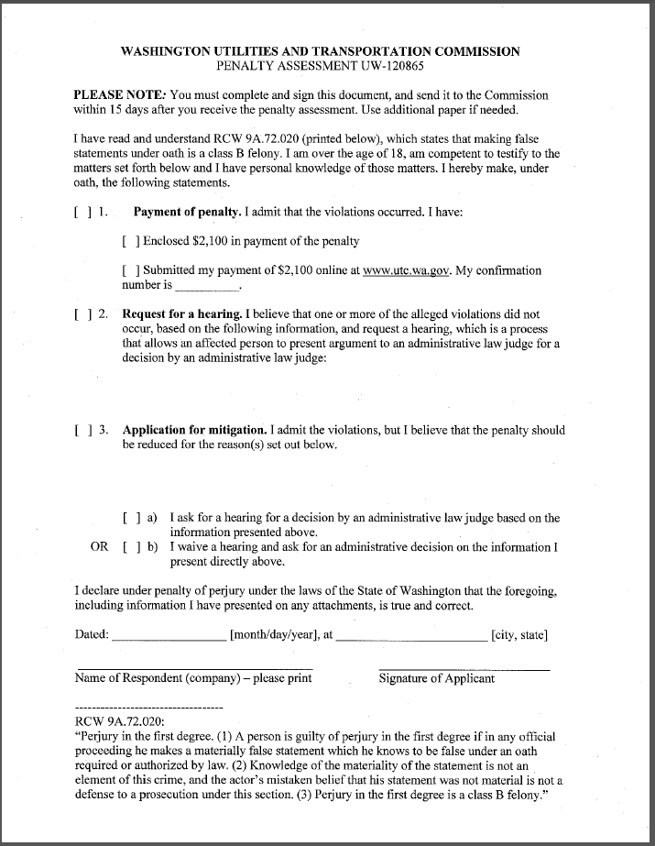

Attachment B

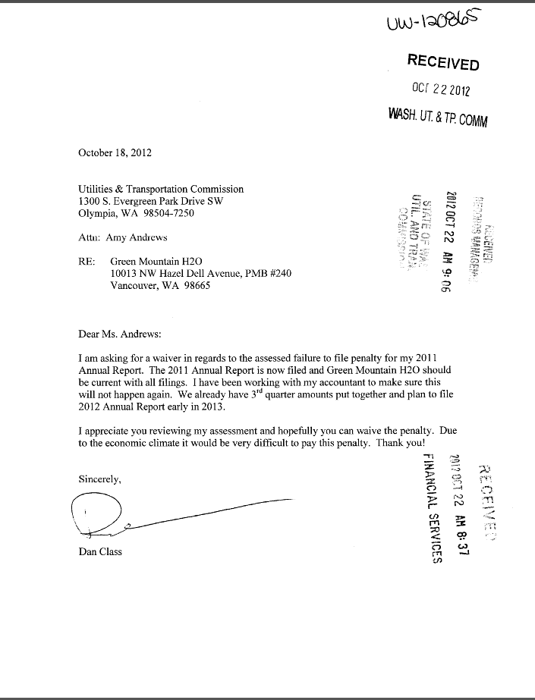

Attachment C

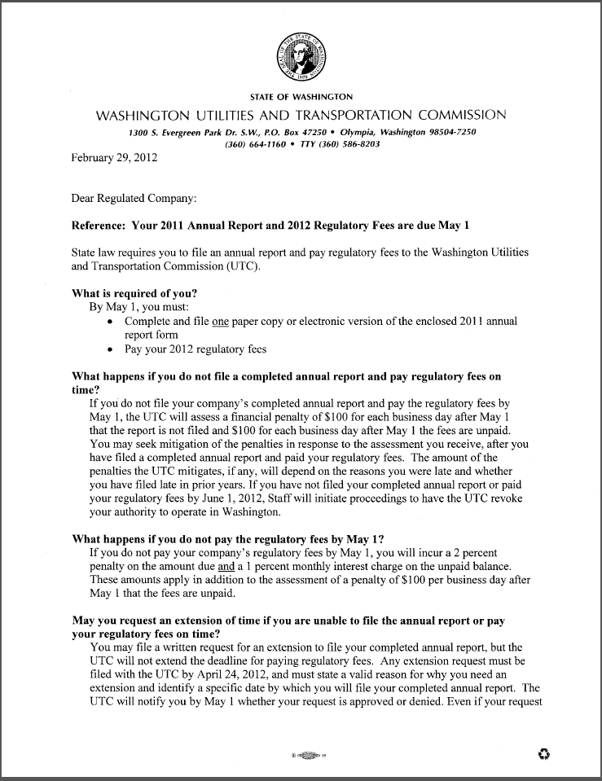
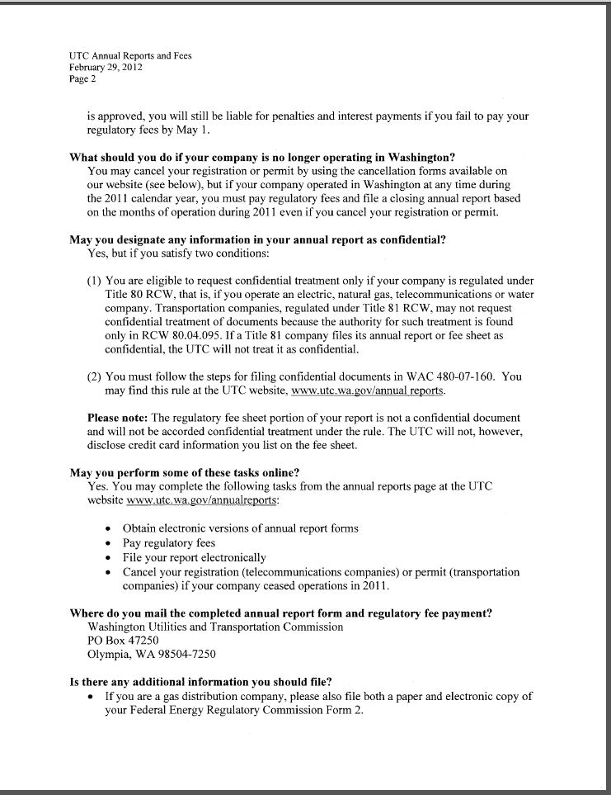
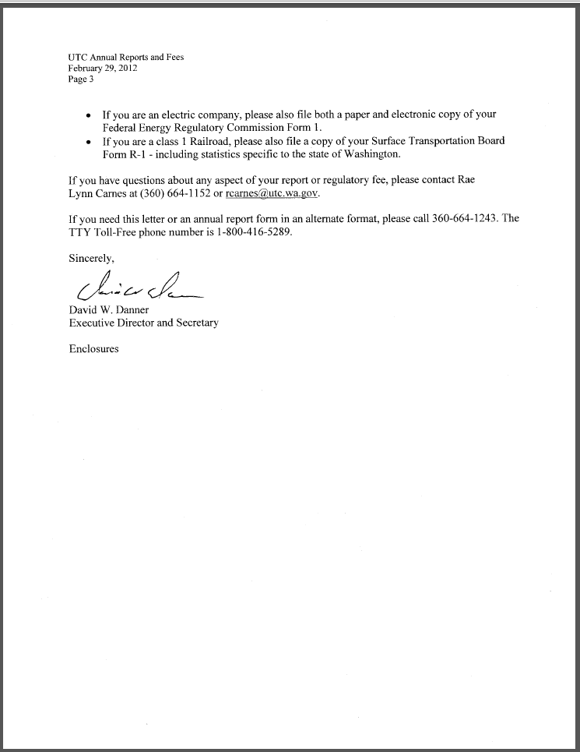

Attachment D

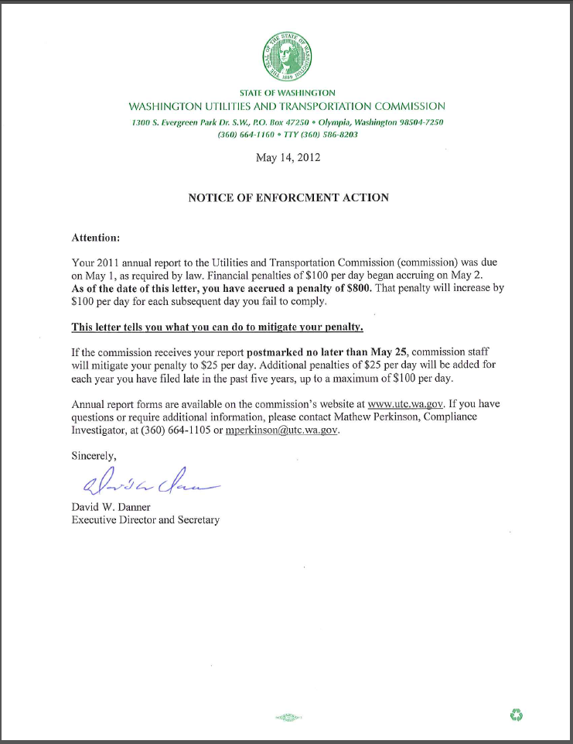

See attachment A for a copy of the penalty assessment sent on July 13, 2012 to Green Mountain.
See attachment B for a copy of Green Mountain’s Mitigation Request received by the commission on October 22, 2012.
See attachment C for a copy of the letter sent to all regulated companies on February 29, 2012.
See attachment D for a copy of the enforcement letter sent to the company of May 14, 2012.

