August 24, 2015

Steven V. King, Executive Director and Secretary
Washington Utilities and Transportation Commission
1300 S. Evergreen Park Dr SW
Olympia, WA 98504-7250
Re: Comments of PCIA – The Wireless Infrastructure Association and the HetNet Forum, a membership section of PCIA
Docket U-140621
Dear Mr. King:
Enclosed are Comments of PCIA – The Wireless Infrastructure Association and the HetNet Forum, a membership section of PCIA, in the above-referenced docket.
Very truly yours,
Davis Wright Tremaine LLP
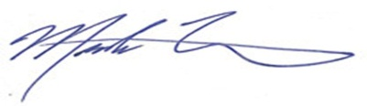
Mark P. Trinchero

MPT/jan

Enclosure

