July 11, 2014

Steven V. King, Executive Director and Secretary
Utilities and Transportation Commission
1300 S. Evergreen Park Dr. SW
P.O. Box 47250
Olympia, WA 98504-7250

RE: Washington Utilities and Transportation Commission v. Telmex USA, LLC

Commission Staff’s Response to Application for Mitigation of Penalties UT-140923

Dear Mr. King:

On June 3, 2014, the Utilities and Transportation Commission issued a $1,000 Penalty Assessment in Docket UT-140923 against Telmex USA, LLC for 10 violations of Washington Administrative Code (WAC) 480-120-382, which requires telecommunications companies to furnish annual reports to the commission no later than May 1 each year.¹

On July 3, 2014, Telmex USA, LLC wrote the commission requesting mitigation of penalties (Mitigation Request).² In its Mitigation Request Telmex USA, LLC does not dispute that the violation occurred. The company states, “Our long-time regulatory consultant – who was a sole practitioner – had not been working since the beginning of the year due to personal reasons and recently passed away. As a result, Corporate Counsel was handling all our company’s regulatory filings single-handedly while working to re-organize this function. My full intention was to remit the 2013 form on time but when we realized that a report was due; we completed it immediately and sent it off.”

It is the company’s responsibility to ensure that the regulatory fee is paid and the annual report is filed by the May 1 deadline. On February 28, 2014, Annual Report packets were mailed to all regulated telecommunication companies. The instructions for annual report completion page of
the annual report informed the regulated company that it must complete the annual report form, pay the regulatory fees, and return the materials by May 1, 2014, to avoid enforcement action.

UTC Annual Reports
July 11, 2014
Page 2

On May 16, 2014 Telmex USA, LLC filed its completed annual report with no regulatory fees due. The company has been active since May 16, 2005. Telmex USA, LLC was previously delinquent in filing the 2005, 2007, 2009 and 2011 year annual reports.

Staff does not support the company’s request to abate the penalty assessment due to prior violations of WAC 480-120-382. Despite Telmex USA, LLC’s history of non-compliance with the timely filing of the annual report, staff does support the company’s request mitigate the penalty due to the compelling circumstances provided in its written statement. Staff recommends mitigation of the penalty to $25 per day for a total assessed penalty of $250.

If you have any questions regarding this recommendation, please contact Amy Andrews, Regulatory Analyst, at (360) 664-1157, or aandrews@utc.wa.gov.

Sincerely,

Sondra Walsh, Director
Administrative Services

ATTACHMENT A
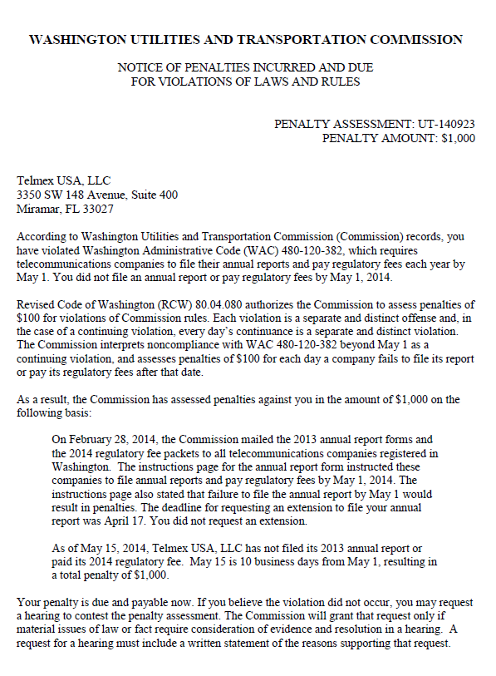

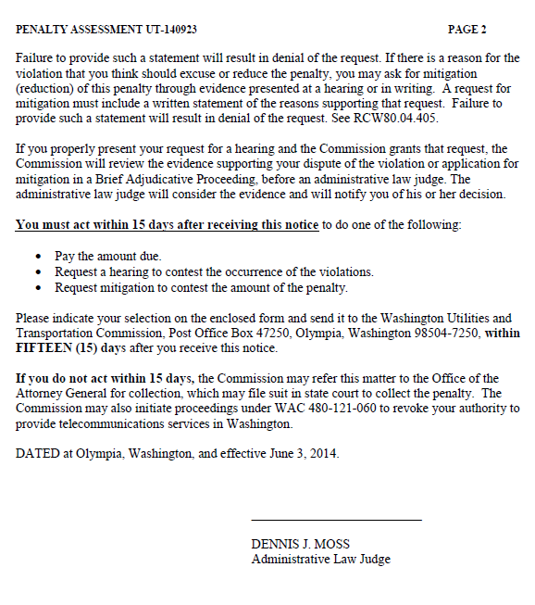

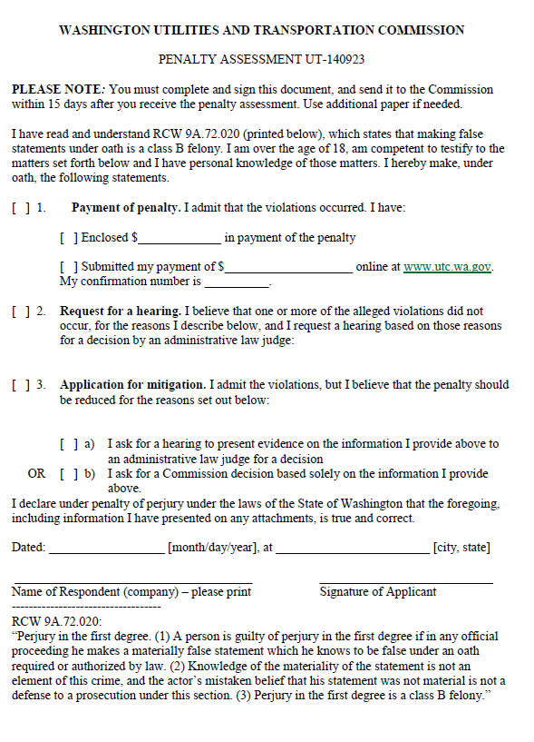

ATTACHMENT B
