June 30, 2016

FILED VIA WEB PORTAL AND FEDERAL EXPRESS

Mr. Steven V. King
Acting Executive Director & Secretary
Washington Utilities and Transportation Commission
Post Office Box 47250
1300 S. Evergreen Park Dr. SW
Olympia, Washington 98504-7250

Subject: United States Cellular Corporation – 2015 Annual ETC Recertification
Docket UT-16_______

Dear Mr. King:

Pursuant to WAC 480-123-070, et seq., U. S. Cellular Corporation ("USCC") hereby files its annual certifications and reports in Docket No. UT-16________, as follows:

ANNUAL ETC CERTIFICATION AND REPORT, with listed Exhibits -

Exhibit A Declaration Certifying Use Of Universal Service Funds

Exhibit B Report on use of federal funds and benefits to customers Confidential

Exhibit C Local service outage report (none to report this year)

Exhibit D Report on failure to provide service - Confidential

Exhibit E Report on complaints per one thousand handsets or lines Confidential

Exhibit F Declaration Certifying Compliance With Applicable Service Quality Standards and Consumer Protection Rules

Exhibit G Declaration Certifying Ability To Function In Emergency Situations

Exhibit H Declaration Certifying Lifeline Advertising

Exhibit I Samples of advertising and outreach materials

Exhibit J Annual plan for Universal Service support – Confidential

Exhibit K End of Year 2015 Coverage Map - Confidential

Pursuant to WAC 480-123-070, we are making this filing electronically. In the confidential portion of the filing, each electronic file will contain, as part of the file name, the word "CONFIDENTIAL." Additionally, each page in the confidential electronic and paper files will be labeled "Confidential Per WAC 480-123-070." A redacted copy of each confidential exhibit will also be filed electronically. Further, as requested by staff, we will be sending one hard copy in confidential and one hard copy in redacted form—if and as applicable—of the report and each exhibit. Please note that the map (Exhibit K) hard copy will be submitted on a CD-ROM and paper format. The CD will contain the map in a .shp format. Due to the very large file sizes of the .shp map, only a .pdf version of the map will be filed via the web portal.

Pursuant to RCW §80.04.095 enclosures designated as "confidential" contain valuable commercial information, including trade secrets and confidential marketing, cost, or financial information, or customer-specific usage and network configuration and design information. Accordingly, pursuant to RCW §80.04.095 such information should not be subject to inspection or copying under RCW Chapter 42.56. Moreover, the records designated as "confidential" contain valuable formulae, designs, and research data, the disclosure of which would produce private gain and public loss and should be exempt from public disclosure pursuant to RCW 42.56.270(1).

In addition to the undersigned, the following might be directly affected by disclosure of the confidential information:

U. S. Cellular Corporation
8410 West Bryn Mawr Avenue
Chicago, IL 60631
Phone: (773) 864-3167
E-mail: John.Gockley@uscellular.com
Attention: John C. Gockley

If you have any questions please contact the undersigned.

Very truly yours,
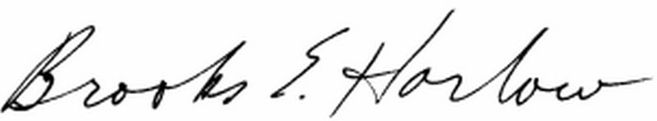
Brooks E. Harlow, P.C.
cc: Mr. Tim Zawislak
Ms. Stephanie Cassioppi

