September 30, 2014

Mr. Steven V. King, Executive Director and Secretary
Washington Utilities and Transportation Commission
1300 South Evergreen Park Drive SW
Olympia, WA 98504-7250

Re: UT-141541

Dear Mr. King:

After discussion with Commission Staff and a further review of the Company's financial status, ToledoTel is submitting revisions to Exhibits 3 and 4 in the above-referenced docket, which is the application for state universal service program funding. Included with this filing are copies of the Exhibits that the Company submits to replace the existing Exhibits 3 and 4.

Thank you for your attention to this matter.

Sincerely,
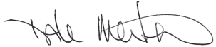

Dale Merten
Chief Operations Officer

RAF/cs
Enclosures

cc: Roger Hahn (via email)

