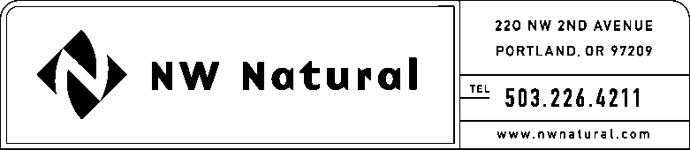
Mark Thompson
Rates and Regulatory Affairs
Tel: 503.706.0434
Fax: 503.721.2516
Email: Mark.Thompson@nwnatural.com

VIA ELECTRONIC FILING AND U.S. MAIL

June 17, 2016

Steven V. King, Executive Director and Secretary

Washington Utilities and Transportation Commission
1300 South Evergreen Park Drive SW
Post Office Box 47250
Olympia, Washington 98504-7250

Re: UG-____– CONFIDENTIAL PER WAC 480-07-160
MAY 2016 - MONTHLY GAS COST DEFERRED BALANCE ACCUMULATIONS / AMORTIZATIONS

Dear Mr. King:

Per WAC 480-90-233(5), enclosed are three confidential copies of the company’s Deferred Rate Making Accounts & JE 28 and JE 29 ledger entries for May 2016.

The information contained in the attached report is confidential pursuant to WAC 480-07-160(2)(c), as it contains financial information that has not yet been disclosed to the general public.

Please call or email me if you have any questions with respect to these materials.

Sincerely,

/s/ Mark Thompson

Mark Thompson
Sr. Director, Rates & Regulatory

MRT/sls

Attachment

