June 16, 2014

Steven V. King, Executive Director and Secretary
Utilities and Transportation Commission
1300 S. Evergreen Park Dr. SW
P.O. Box 47250
Olympia, WA 98504-7250

RE: Washington Utilities and Transportation Commission v. Agyen, Linda T.

Commission Staff’s Response to Application for Mitigation of Penalties TE-141046

Dear Mr. King:

On May 23, 2014, the Utilities and Transportation Commission issued a $1,000 Penalty Assessment in Docket TE-141046 against Linda T. Agyen for 10 violations of Washington Administrative Code (WAC) 480-30-071, which requires charter and excursion carriers to furnish annual reports to the commission no later than May 1 each year.¹

On June 6, 2014, Linda Agyen wrote the commission requesting mitigation of penalties (Mitigation Request).² In its Mitigation Request, Linda Agyen does not dispute that the violation occurred. The company states, “…I was very unclear about which forms where due from my company at the end of the year, and thought all forms were filled out when my annual fees were paid. In the past years before the fees the annual reports were done at the same time which led me to believe that thinks were still the same and I had fulfilled the requirement for the year by mistake.”

It is the company’s responsibility to ensure that the regulatory fee is paid and the annual report is filed by the May 1 deadline. On February 28, 2014, Annual Report packets were mailed to all regulated charter and excursion companies. The instructions for annual report completion page of the annual report informed the regulated company that it must complete the annual report form, pay the regulatory fees, and return the materials by May 1, 2014, to avoid enforcement action.

On June 6, 2014, Agyen, Linda T. filed the 2013 annual report and timely paid the required regulatory fees on December 26, 2013. The company has been active since October 29, 2012.
UTC Annual Reports
June 16, 2014
Page 2

No previous violations of WAC 480-30-071 are on commission record. The UTC also recently adopted new rules requiring the annual report to be filed by May 1 while the regulatory fees remained due on December 31. Despite the commission communication regarding these
filing changes to all regulated charter and excursion companies, commission staff supports the company’s request for mitigation. Staff recommends a reduced penalty assessment of $200.

If you have any questions regarding this recommendation, please contact Amy Andrews, Regulatory Analyst, at (360) 664-1157, or aandrews@utc.wa.gov.

Sincerely,

Sondra Walsh, Director
Administrative Services

ATTACHMENT A
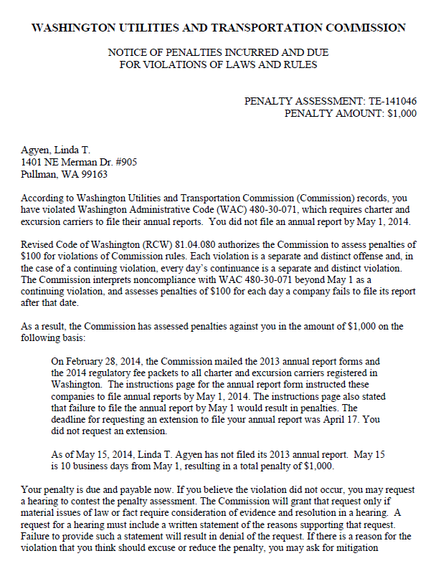
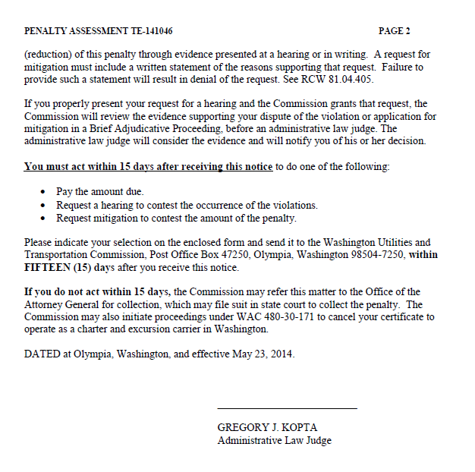

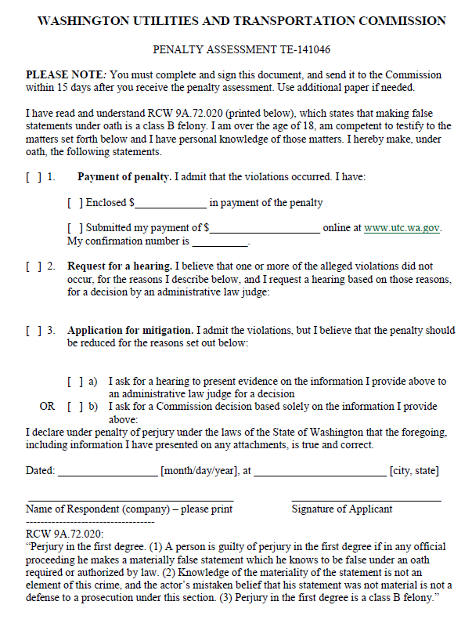

ATTACHMENT B
