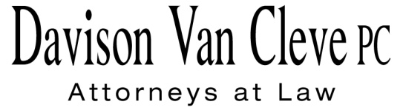
TEL (503) 241-7242 ● FAX (503) 241-8160 ● mail@dvclaw.com
Suite 400
333 SW Taylor
Portland, OR 97204

May 17, 2013

Via Electronic and U.S. Mail

Mr. Steven V. King
Executive Director and Commission Secretary
Washington Utilities & Transportation Commission
1300 S. Evergreen Pk. Dr. S.W.
P. O. Box 47250
Olympia, WA 98504-7250

Re: In the Matter of Rulemaking to Consider Possible Changes and Corrections to Rules in WAC 480-07, Relating to Procedural Rules
Docket No. A-130355

Dear Mr. King:

Enclosed for filing in the above-referenced docket, please find the original and twelve (12) copies of the Comments of the Industrial Customers of Northwest Utilities.

Thank you for your assistance, and please do not hesitate to contact our office if you have any questions.

Sincerely,

UU
/s/ Jesse Gorsuch
Jesse Gorsuch

Enclosures

