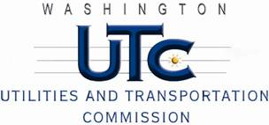

Memorandum
July 14, 2011

To: TR-110689 - File

From: Kathy Hunter, Deputy Assistant Director Transportation Safety

Subject: TR-110689 Cascade and Columbia River Railroad
Grade Crossing Protective Fund (GCPF) Project at the Intersection of
State Route 155 (SR-155) and Cascade and Columbia River Railroad’s Tracks in the City of Brewster

On April 29, 2011, the Washington Utilities and Transportation Commission (Commission) awarded a GCPF grant totaling $6,000 to install LED type flashing lights at the SR-97 crossing in the City of Omak. The USDOT number assigned to this crossing is 096305N

On July 14, 2011, the applicant, Cascade and Columbia River Railroad submitted a request for reimbursement pursuant to Commission Order. On July 12, 2011, Commission staff conducted a site visit and verified that the project is completed according to the specifications outlined in the order approving the grant.

Please close this docket.

