REPORT OF THE TOLEDO TELEPHONE CO., INC.UT- UNDER THE
WASHINGTON UNIVERSAL COMMUNICATIONS SERVICES PROGRAM
IN COMPLIANCE WITH WAC 480-123-130

June 5, 2018

Docket No. UT-170851

File electronically

- WAC 480-123-130(1)(a) - Access Lines Served [NECA 1.3 working loops]

January 1, 2017 December 31, 2017

Residential 747 305

Business 191 164

- WAC 480-123-130(1)(b) - Use of Support

The funds received by the Company from the universal communications services program in calendar year 2017 represent monies that the Company formerly received through the Washington Exchange Carrier Association (WECA) pooling process and the reduction of support under the Federal Communications Commission’s (FCC’s) Connect America Fund InterCarrier Compensation Fund (CAF ICC) program. As such, the funds from the universal communications services program contributed to defrayal of the ongoing operation and maintenance expenses of the Company. The funds from the universal communication services program are contributing to the Company's ongoing provision of high-quality basic telecommunications service to customers residing in the area the Company serves.

In December 2017, the Company received $349,869 from the universal communications services program for the fiscal year ending June 30, 2018.

During the first six months of 2018, the Company undertook sixteen new home sites requesting fiber optic service. Since December 2016, over forty new home sites have requested and / or been connected to fiber. All of these require additional construction including but not limited to: new vaults placed along main fiber routes, fiber drops to the home and new electronics. The funds received from the universal communications services program can be viewed as contributing to the Company's ability to perform that this unprecedented growth in our service area placing a heavy demand on Cap-Ex and including, without limitation, the repayment of loan funds. In the second half of 2018 the Company plans to see continued strong growth of new homes requesting service and project at least another forty new homes during FY 2018-2019.

- WAC 480-123-130(1)(c) - Unfilled Consumer Requests for New Basic Telecommunications Service*

None

* Service requests that are ongoing but still within normal processing times are not counted as unfulfilled.

- WAC 480-123-130(1)(e) - FCC Form 477

This form was previously filed on or about March 1, 2018 under Docket UT-180002.

- WAC 480-123-130(1)(f) - Report on Operational Efficiencies/Business Plan Modifications

The Company continually reviews its operations to determine if efficiencies can be achieved. The Company already has a plan in place to concentrate on improving broadband service while continuing to provide high-quality basic telecommunications service to the customers that are located within the area that the Company serves and currently is able to serve 100% of households, businesses, schools, libraries and medical facilities within our Exchange with fiber optics. The funds received from the universal communications services program can be viewed as assisting in the Company's efforts to obtain operational efficiencies.

- WAC 480-123-130(1)(g) and (h) - Other information

N/A

Certified Statement as required by WAC 480-123-130(1)(d):

I, Dale Merten am an officer of The Toledo Telephone Co., Inc. and upon personal knowledge and with responsibility therefor, hereby certify under penalty of perjury, that The Toledo Telephone Co., Inc. materially complied with Commission rules under Chapter 480-120 WAC that are applicable to the Company and its provision of service within the area for which the Company received universal communications services program support.

Signed at ToledoTel, Washington this 5th day of June, 2018.

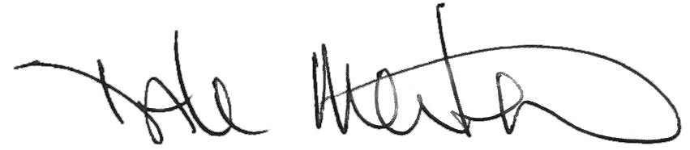
Title: VP/COO

