ONITA R. KING
Rates and Regulation
Tel: 503.721.2452
Fax: 503.721.2516
Email: ork@nwnatural.com

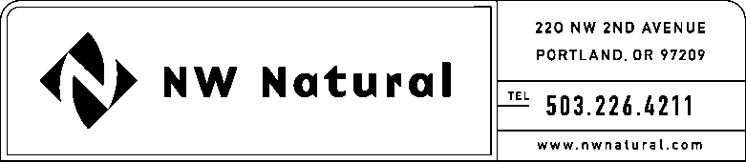

April 25, 2016

Steven V. King, Executive Director and Secretary
Washington Utilities & Transportation Commission
1300 S Evergreen Park Drive, SW

Post Office Box 47250
Olympia, Washington 98504-7250

Re: 2015 Essential Utilities Services Contracts Report

Pursuant to WAC 480-90-268, adopted by the Commission in Order No. R-518, dated February 28, 2005, the Company hereby submits its 2015 Essential Utilities Services Contracts Report, reporting that there were no vendor services contracts that exceed 1.5 percent of total Company sales in 2015.

Please contact me should you have questions or require additional information.

Sincerely,

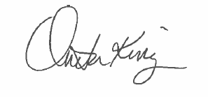

Onita R. King

Rates & Regulation

ORK/lsn

