Mr. Stephen V. King, Executive Director and Secretary
Washington Utilities and Transportation Commission
Attn: Records Center
P.O. Box 47250
Olympia, WA 98504

Re: Transmittal of SpeediShuttle Washington Tariff No. 1 2nd Revisions TC-160378

Dear Mr. King:

SpeediShuttle Seattle respectfully requests approval of the attached Tariff No. 1 revision to the Title Page with an effective date of May 4, 2016.

Respectfully submitted,
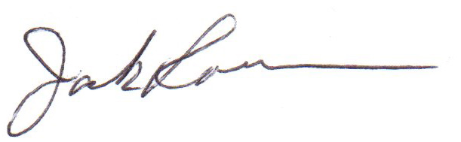
H. Jack Roemer
Chief Financial Officer

