July 7, 2014

Steven V. King, Executive Director and Secretary
Utilities and Transportation Commission
1300 S. Evergreen Park Dr. SW
P.O. Box 47250
Olympia, WA 98504-7250

RE: Washington Utilities and Transportation Commission v. Ludtke-Pacific Trucking, Inc.

Commission Staff’s Response to Application for Mitigation of Penalties TG-141168

Dear Mr. King:

On June 9, 2014, the Utilities and Transportation Commission issued a $1,000 Penalty Assessment in Docket TG-141168 against Ludtke-Pacific Trucking, Inc. for 10 violations of Washington Administrative Code (WAC) 480-70-071, which requires solid waste companies to furnish annual reports to the commission no later than May 1 each year.¹

On June 20, 2014, Ludtke-Pacific Trucking, Inc. wrote the commission requesting mitigation of penalties (Mitigation Request).² In its Mitigation Request, Ludtke-Pacific Trucking, Inc. does not dispute that the violation occurred. The company states, “In early 2014 our longtime in house accountant became ill and tried very hard to hide the illness by giving use the impression that all was well with reports etc. It wasn’t until we had to let her go that we discovered that she had missed all sorts of deadlines. We discovered the late filing of your report on May 1 and immediately gathered the information needed to support the fee associated with the revenue. We made the deadline for the payment and at the same time asked for an extension of the annul business report as we just did not have all the information needed to prepare an accurate accounting.”

It is the company’s responsibility to ensure that the regulatory fee is paid and the annual report is filed by the May 1 deadline. On February 28, 2014, Annual Report packets were mailed to all regulated solid waste companies. The instructions for annual report completion page of the annual report informed the regulated company that it must complete the annual report form, pay the regulatory fees, and return the materials by May 1, 2014, to avoid enforcement action.

UTC Annual Reports
July 7, 2014
Page 2

On May 1, 2014, Ludtke-Pacific Trucking, Inc. filed an extension request under Docket TG-140772. The request was denied on May 29, 2014 after consideration by the commission.

On June 6, 2014, Ludtke-Pacific Trucking, Inc. filed the 2013 annual report with the timely payment of regulatory fees on May 1, 2014. The company has been active since April 11, 2002. Ludtke-Pacific Trucking, Inc. previously missed the deadline for filing its annual report and paying its regulatory fees for the 2008 and 2012 reporting year. Staff does not support the company’s request for mitigation due to prior filing violations.

If you have any questions regarding this recommendation, please contact Amy Andrews, Regulatory Analyst, at (360) 664-1157, or aandrews@utc.wa.gov.

Sincerely,

Sondra Walsh, Director
Administrative Services

ATTACHMENT A
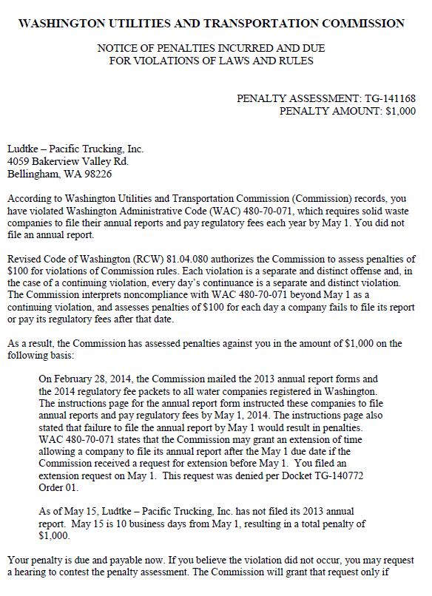

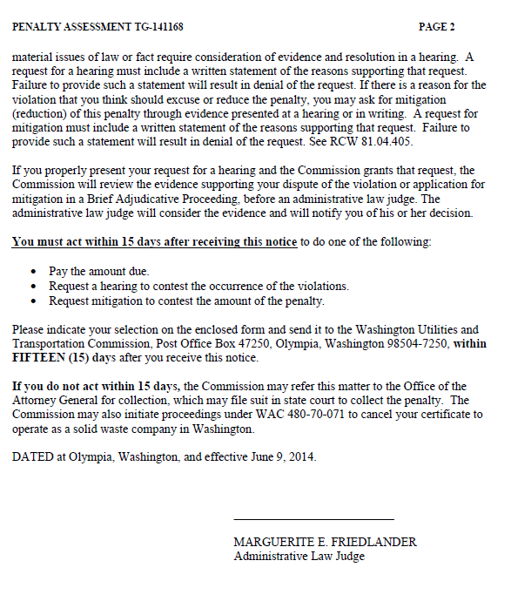

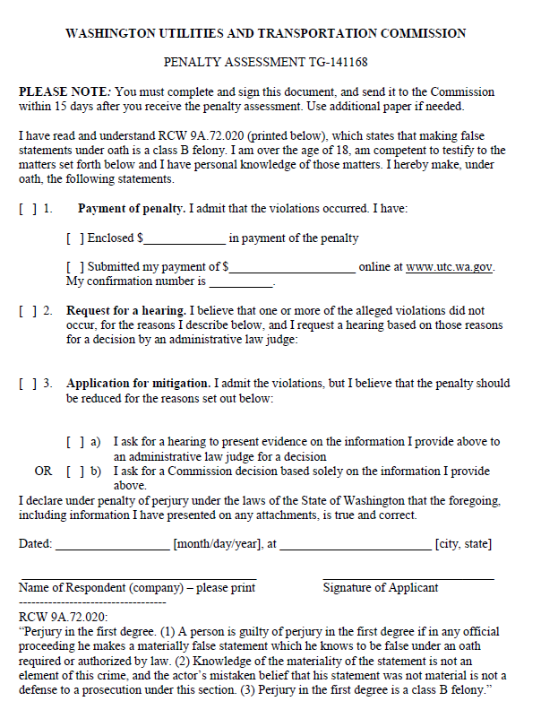

ATTACHMENT B
