www.FairPoint.com
908 W. Frontview
Dodge City KS 67801

December 17, 2015

Mr. Steven King
Executive Director and Secretary
Washington Utilities and Transportation Commission
1300 South Evergreen Park Drive SW
Olympia WA 98504-7250

RE: Tariff Update – WN U-4 – Ellensburg Telephone Company d/b/a FairPoint Communications

Dear Mr. King:

Enclosed for the Commission’s approval, Ellensburg Telephone Company d/b/a FairPoint Communications hereby submits the following tariff page with changes to be effective January 1, 2016:

Schedule No. 39, Original Sheet No. 283

The purpose of this filing is to offer a Business Customer Appreciation promotional offering for current Business customers who request a line disconnect but instead choose to retain the access line. These customers will be eligible to receive a monthly discount per month. The promotion will run for 90 days from January 1, 2016 to March 30, 2016. Discounts for eligible customers are as follows:

Business Customers $ 2.50 per line per month
Centrex Customers $ 1.75 per line per month
ISDN PRI Customers $17.75 per interface per month

Please contact Beth Westman at 207.535.4249 or bwestman@fairpoint.com with any questions or concerns regarding this filing.

Sincerely,
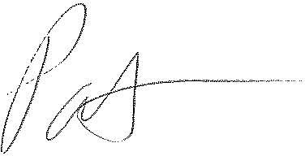
Patrick L. Morse
Senior VP Governmental Affairs
FairPoint Communications
P: 620-227-4409
F: 620-227-8576

