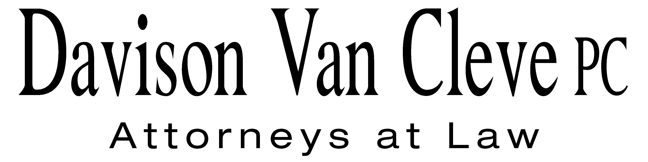
TEL (503) 241-7242 ● FAX (503) 241-8160 ● mail@dvclaw.com
Suite 400
333 SW Taylor
Portland, OR 97204

November 5, 2012

Via Email and U.S. Mail

Chair Jeffrey Goltz
Commissioner Phil Jones
Commissioner Patrick Oshie
Washington Utilities and Transportation Commission
PO Box 47250
1300 S Evergreen Park Drive SW
Olympia, WA 98504-7250

Re: Joint Petition of PSE and NW Energy Coalition for an Order Authorizing PSE to Implement Electric Decoupling Mechanisms
Docket No. UE-121697

Dear Commissioners:

The Industrial Customers of Northwest Utilities (“ICNU”) requests that the Washington Utilities and Transportation Commission (“WUTC” or the “Commission”) reject the joint petition of Puget Sound Energy (“PSE”) and the Northwest Energy Coalition (“NWEC”) (jointly, the “Petitioners”) requesting authorization for PSE to implement their decoupling proposal. In the alternative, ICNU requests the Commission suspend the filed decoupling mechanism pending further investigation.

The Commission should reject the Petition because this “full” decoupling proposal was not filed as part of a general rate case. The proposal contains numerous other provisions that both depart from the Commission’s policy guidance and would harm customers. ICNU supports cost effective conservation and energy efficiency programs, but opposes the mechanism filed by the Petitioners.

In its Report and Policy Statement on Regulatory Mechanisms, Including Decoupling (‘Policy Statement”), the Commission stated that “[a] utility’s request for a full decoupling mechanism must be made in its direct testimony of its rate case filing.”/ The Petitioners have presented this full decoupling mechanism outside the context of a general rate case, relying on the fact that, prior to the issuance of the Policy Statement, the Commission adopted a decoupling mechanism for Avista’s gas operations outside of a GRC./ Besides the fact that the Petition ignores the Commission’s more recent requirements for filing a decoupling proposal, it would be unfair to adopt a decoupling proposal outside of a GRC wherein all costs and revenues, as well as decoupling’s effect on rate of return (“ROR”) would be considered. The Petitioners suggest that, because PSE has completed a rate case relatively recently, this decoupling proposal should be accepted in a single-issue filing. This assertion ignores the fact that PSE’s current rates were set at a level appropriate for PSE in the absence of such a mechanism.

The Petitioners characterize their proposal as “very similar” to the NWEC decoupling proposal that was considered—but not adopted—in the last PSE generic rate case. A review of the current filing, however, indicates that the two proposals are drastically different, primarily because of the presence of what the Petitioners term a “K-Factor.” The K-Factor is a complex adjustment that appears to function similarly to a limited decoupling lost revenue adjustment mechanism, yet it is embedded within the full decoupling mechanism. According to the Petitioners’ filing, it serves as a “means for addressing part, but not all, of the Company’s earnings attrition problem.”/ In PSE’s rate case last year, the Commission pointed out that decoupling “was never intended to supplant other tools that deal with demonstrated earnings attrition.”/ Given that this decoupling mechanism, with the embedded K-Factor adjustment, attempts to remedy claimed attrition—rather than remove a financial disincentive to conservation, the filing should be rejected. If PSE believes that it is under-earning due to regulatory lag or attrition, a single-issue filing for a mechanism ostensibly meant to promote conservation is an inappropriate forum to consider such claims.

The Petitioners also argue that the Commission should permit PSE to implement the decoupling mechanism because the NWEC decoupling mechanism upon which it is partly based, largely complied with the Commission’s Policy Statement. This is not accurate. Even if it were, it is not a sufficient basis for adopting the Petitioners’ proposal. The Commission noted that a number of the features of the original NWEC decoupling proposal were inconsistent with the Policy Statement, including the Commission’s preference for: an earnings test, per class rather than per customer true-ups, consideration of off-system sales, and analysis of a potential reduction in ROE./ The decoupling mechanism presented in this filing appears to share these shortcomings. The Commission noted these deficiencies, but did not analyze them in the last general rate case because PSE’s opposition led to rejection of that mechanism. Now that PSE has dropped its opposition, such analysis is needed to ensure compliance with the Commission Policy Statement.

In addition to these issues, ICNU is concerned that the proposal’s use of arbitrary “groups” for true-up classes, the lack of sufficient accounting for off-system sales and avoided costs, as well as the K-Factor discussed above may make the mechanism unfair to customers and will likely result in yearly rate increases.

While ICNU believes this Petition should be rejected, if the Commission does not agree, the filing should, at a minimum, be suspended. The Petition raises a wide array of complex issues that must be subject to discovery and further review by all parties. ICNU respectfully recommends that the Commission suspend the filing and hold hearings, if necessary, to determine whether the proposed mechanism will result in rates that are fair, just, and reasonable.

Sincerely yours,

Melinda J. Davison

cc: Sheree Strom Carson
Simon ffitch
Don Trotter
Tommy Brooks
Todd True

/ Re WUTC Investigation into Energy Conservation incentives, Docket No. UE-100522, Report and Policy Statement on Regulatory Mechanism, Including Decoupling at ¶ 28 (Nov. 4, 2010) (“Policy Statement”).
/ Re PSE, Docket No. UE-121697, Exh. No. TAD-1T at 6 (Oct. 25, 2012).
/ Re PSE, Docket No. UE-121697, Exh. No. JAP-1T at 18 (Oct. 25, 2012).
/ WUTC v. PSE, Docket Nos. UE-111048/UG-111049, Order 08 ¶ 455 (May 7, 2012).
/ Id. at n. 605.

