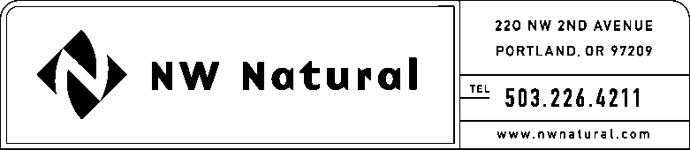

KELLEY C. MILLER
Tariff and Regulatory Compliance
Tel: 503.226.4211 ext. 3589
Fax: 503.721.2516
email: kelley.miller@nwnatural.com

April 24, 2012 NWN Advice No. WUTC 12-3

VIA ELECTRONIC FILING

Dave Danner, Secretary and Executive Director
WASHINGTON UTILITIES &
TRANSPORTATION COMMISSION
1300 S Evergreen Park Drive, SW
Post Office Box 47250
Olympia, Washington 98504-7250

Re: Docket UG-120369 Supplemental Filing
Schedule G, Energy Efficiency Services and Programs – Residential and Commercial

Northwest Natural Gas Company, dba NW Natural (“NW Natural” or “Company”), files the following correction to the cover letter of NWN Advice No. WUTC 12-3, Docket UG-120369, filed March 19, 2012.

Advice No. WUTC 12-3 included Sheet G.1 correctly identified as the Seventh Revision, but the Company erroneously stated in the cover letter that it was the First Revision of Sheet G.1. The tariff sheet should have been listed as follows:

Seventh Revision of Sheet G.1,
Schedule G,
“Energy Efficiency Services and Programs – Residential and Commercial.”

Please call me if you have any questions.

Sincerely,

/s/ Kelley C. Miller

Kelley C. Miller
NW Natural

