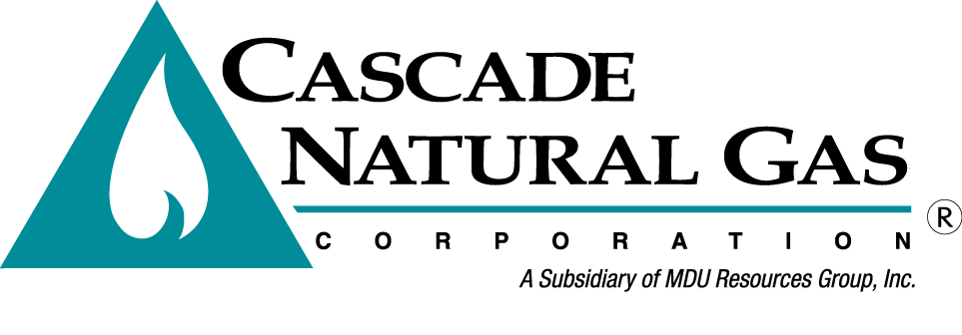
4th External TAG Meeting
Date & time: 09/14/2016, 09:00 AM – 12:20 PM
Location: Seattle Airport Conference Center
Presenters: Mark Sellers-Vaughn, Chris Bolton, Brian Robertson & Devin McGreal
In attendance: Mark Sellers-Vaughn, Brian Robertson, Devin McGreal, Chris Bolton, Chris Robbins,
Called in: Bob Morman, Garret Senger, Mike Parvinen, Pam Archer, Eric Wood, Carolyn Stone, Laura Flanders - NWP, Chad Luginbill, Josh Romine, Mark Chiles, Deborah Reynolds, Jeremy Twitchell – WUTC, Jim Abrahamson, Alison Spector, Tom Pardee, Cooper Wright – WUTC,
Minutes by: Carolyn P Stone
Mark began the meeting by welcoming everyone. Mark then went over some safety items for those attending the meeting in person and today’s the Agenda.
Brian Robertson then discussed Cascade’s New IRP Webpage, see link below:
https://www.cngc.com/rates-services/rates-tariffs/integrated-resource-plan

Presentation #1 – Chris Bolton
Distribution System Planning

- Chris started by going over his presentation outline then did a CNG distribution system overview. Chris stated that there are many factors that go into planning any changes to the current system or adding a new station. For example, you must be aware of residential development growth or additions.
- Chris explained that the Geographic Information System (GIS) helps engineering look at what is currently in place and helps them create system “models”. Using GIS and other input data they can create their models using a program called “Synergi”. Slide #12 shows a model.
- Data is gathered from many sources. CC&B gives customer billing information, showing “usage”. Resource Planning provided growth and historical weather data. SCADA data provides historical flow. Peak Heating Degree Day is calculated as follows HDD = 60 - day max + day min/2, then they matches weather data to zones.
- Loads are applied to each customer on Page #20, 40 DD is load. The Peak design day model gives peak load, 58 DD. Synergi compiles customer data, pressures and flows. The model has many benefits in planning and optimization.

Question: Mark asked if most LDC’s use Synergi?
Answer: Yes!

- Chris stated that all customer data is loaded based on trend. IRP growth data helps to predict next year’s load growth. The model shows the worst case scenario.
- Next few slides show the PROS and CONS of various enhancements and upgrades. There are many CONS associated with replacement of a Compressor Station. Chris stated CNG only has 1 and upgrading this wouldn’t increase capacity!
- On Page 31 shows the Project Process Flow from data inputs to considerations & plans to schedules.
- On Page 33 there is an area of potential growth in the NE and shows the Stanwood Project.
- On Page 37, the Walla Walla project shows potential growth in the SE. This upgrade will add capacity!

Presentation #2 – Mark Sellers-Vaughn
Sendout Optimization Modeling

- Mark started out by stating that Brian Robertson and Devin McGreal have had the monumental task of modeling in Sendout. They started from scratch and there is quite a bit more to do. Our ABP Vendor was very helpful also! KUDOs were also given to Mark for his work on the IRP. It is a huge project and everyone is impressed with where we are at this time.

- Mark stated that the Sendout is optimization modeling using base case scenarios.

- Brian Robertson continued stating the model includes transport and storage contract information. It uses linear programming. It is a good tool to use but not the final answer! It is very powerful and complex.

  - They started by using the PGA portfolio data
  - There are 66 delivery locations
  - Transportation contracts & rates are included
  - Includes rates
  - Contractual information can be overly restrictive
  - Operational can be overly flexible!

Modeling Challenges, Page 44:

- We have more delivery rights than receipt rights!
- Sendout has perfect knowledge

Question: What does that mean “Perfect Knowledge”?
Answer: It means that Sendout has complete knowledge of data but we have to apply our knowledge of the “real world” in order to make good decisions!

Page 45, Monte Carlo Simulations

- Mark reminds that there are 200 simulations, 100 of each are combined, using variable & Fixed costs
- Mark also stated that this piece of Sendout is not yet completed. It won’t be until the end of the month and is to be presented at TAG #5.

Question: Have you found that there is a correlation between weather and price?
Answer: Generally, we don’t see this correlation.

Page 47, Base Case Inputs

- Supply (from AECO, Sumas, PAL, uses current, 1st year contracts)
- Storage
- Transport
- Demand
- Price Forecast
- Weather – Normal

Page 50, Supply Base & Fixed:

Question: How many times have we contracted for peak day resources?
Answer: For peak days we either use contracts designated as peak day supply OR storage.

Page 63, Storage

- This page shows a storage example from the Sendout. JP has 4 contracts and Plymouth 2
- Storage targets are:
  - 35% for the end of June
  - 80% end of August
  - 100% at the end of September
- Northwest Pipeline tariff requires the above breakdown
- Information that is PUBLIC is shown only

Page 68, Delivery Rights vs Receipt Rights

- Cascade has more delivery rights than receipt rights, 457K Dth f Delivery Rights and 360K Dth of Receipt rights. Page 69 shows the flexibility we have because of the increased Delivery Rights. Page 70 shows the inflexibility with Delivery Rights using CNG’s NWP contract #135558.

Question: What is the value of getting more granular from Gate Station to Climate Zone?
Answer: To help avoid future costs and pressure problems.

Question: Is the analysis disaggregated such that the City gates are not serving multiple communities?
Answer: It is set up as a “Demand Center”

Page 81, Weather

Question: Why did you pick “normal” weather data to use?
Answer: We will get an explanation of the reason for this for you.

Page 88, Major Resource issues on the Horizon

NWP limitations…

Question: Is the NWP I-5 expansion off the table?
Answer: The naming convention of this project has changed but it is NOT off the table.

Currently there is nothing concrete in the works for Biofuel at this time.
We are still considering storage options.

Question: Ryckman Creek?
Answer: Still considering it.

Page 91, Avoided Cost Overview (costs avoided via conservation)

- Costs include the long term gas price forecast
- The above, is the majority of costs!
- There is a 10% adder for environmental benefits.
- Carbon price
- Storage variable/fixed costs
- Transmission costs

Question: The Washington State Dept. of Ecology issued a new carbon rule. This could create obligations for the future. Should it be factored into this calculation?
Answer: Mark stated that it could be a big deal.

Question: How would we model it?
Answer: Factor CO² into Avoided Costs. In the sensitivities analysis (page 89) we pick that up a bit…

Question (directed to Staff): What is your comfort level in modeling the new carbon rule?
Answer (from Staff): Don’t sweat it too badly. In the future you can model this more accurately.

- Mark stated that the tight timing for the IRP won’t allow us to do this right now.
- It might be put into the “Clean Power Plan”. It directly affects power.
- It begins in 2017, 7% per year 2017, 2018 & 2019
- The first demonstration of compliance has to happen in 2020.
- It could be litigated!

Question: At least we should acknowledge the rule is in place and posit some assumptions or impact?
Answer: We will put it into future IRP’s

Question: Should we create a supplemental filing?
Answer: It doesn’t really have an impact. The Carbon cap reflects costs for emissions. Costs to the customer – they will pay for emissions. Avoided costs and conservation costs will increase.

Page 94, System Avoided Costs Layers (dollars in therms)

- Avoided costs are still subject to change depending on when we lock in storage & transport.

- Monica Cowlishaw stated that she will use the numbers she has now to run the TeaPOT model.

Page 98, Current & Proposed Storage Demand & EST Transport Per Unit Cost

- Mark states that Ryckman looks the most attractive here!

Page 100, 2020 Potential Unserved

Question: Is it possible to highlight the Washington points on this chart?
Answer: YES!
Page 104, Preliminary Scenario NPV

- 3.8 billion over 20 years!
  - Includes some combination of NWP & GTN
  - Includes a portion of Ryckman Storage
  - Options of transport but none clearly stand out
  - Some concerns as follows:
    - Ryckman would primarily be used to Oregon’s benefit.
    - Ryckman has reliability concerns. We need to address whether to decide for Oregon now or wait until the Oregon IRP?

Question: What are the implications??
Answer: The model wants Rickman, NWP & GTM, 100m over 20 years! California transport will be needed for using Ryckman. The Base Case assumes Ryckman Creek, NWP & GTN.

Question: What about the expansions cost?
Answer: The cost is reasonable to the rate payer. Is resource reasonableness outside of cost?

Question: If just considering cost, then the answer is obvious? Is the opportunity closed?
Answer: Mark states that credibility of the party is at issue. Senior management (GSOC) has a cautious viewpoint! Washington would end up paying for it.

Question: The IRP gives indication to a likely direction but doesn’t hold you to that option?
Answer: Yes, senior management makes a reasonable decision. If the Commissioners agree, then OK. If you don’t look at all the factors in this choice you could be penalized!

Questions &
Discussion: Mark states that if we were to mention the subject to Oregon we could do so in a conceptual viewpoint. Right now we have an aggressive timeline. We don’t want to expose ourselves to issues that will come back to “bite” us later. Mark asks for another day to do additional work on the additional resources. The draft is due on Saturday. We could include NWP and GTN in our preliminary scenario and put in draft that we are talking about the NEXT resource.
Answer: Mark states that is already identified.

- Garret stated he liked the discussion today and will be at TAG #5.

- Mark thanks everyone and said the new guidance is extremely helpful!!

