EXHIBIT NO. ___( AF-1T )
DOCKETS UE-151871/UG-151872
PSE LEASING TARIFF
WITNESS: AHMAD FARUQUI, PhD

BEFORE THE
WASHINGTON UTILITIES AND TRANSPORTATION COMMISSION

WASHINGTON UTILITIES AND  TRANSPORTATION COMMISSION,  Complainant,  v.  PUGET SOUND ENERGY,  Respondent. |  | Dockets UE-151871  UG-151872

PREFILED DIRECT TESTIMONY OF

AHMAD FARUQUI, Ph.D.

ON BEHALF OF PUGET SOUND ENERGY

February 25, 2016
REVISED April 25, 2016
model to quantify the benefits that PSE’s Lease Solutions will provide to both participating and non-participating customers. The leasing service will ensure that newer and more efficient units are installed in customer’s premises, and accelerate the replacement of older, less-efficient equipment that would continue to be operated in a world without Lease Solutions. Benefits to all customers include conservation of both electricity and natural gas, reduced greenhouse gas emissions and pollution, and deferred capacity investments. Benefits to participating customers include lower utility bills, increased comfort and quality of life due to better equipment performance, peace of mind due to the maintenance feature of Lease Solutions, and greater control over their energy usage. I have used my model to quantify several of these benefits and found that in the first 20 years of existence, Lease Solutions would likely yield the following benefit streams:
- Over 321,000 153,000 MWh of electric energy conservation (equivalent to powering over 1,300 600 homes each year for twenty years).
- Nearly 190 180 million therms of gas energy conservation (equivalent to fueling over 11,500 11,000 homes each year for twenty years).
- 1.3 1.15 million tons of carbon dioxide (CO₂) emissions avoided (equivalent to taking over 12,500 11,100 cars off the road).
- $5.5 3.2 million in avoided generation and distribution capacity costs.
- $144 127 million saved in lower utility bills for participating customers.

Equipment is not run 24 hours a day and a disproportionate amount of the proposed lease equipment’s usage falls during the peak system hours. Usage during these hours drives capacity investment. By reducing capacity requirements (measured in kW and therms/hour) during peak hours, the utility can defer future capacity investments.
Finally, using the dollar values of wholesale energy, avoided capacity and avoided greenhouse gas emissions, we can obtain the pecuniary benefits to society stemming from PSE’s Lease Solutions.
Q. Can you provide an illustrative example of how the model works?
A. Yes. Take for example the residential gas furnace product. As described above, I calculate the annual realizable market size for this equipment to be around 6,000 units. I assume that this value includes people replacing their equipment on time and those who have accelerated their replacement due to Lease Solutions.
All customers leasing equipment receive an efficiency benefit from replacement equal to the difference in usage between PSE’s efficient equipment and that which they would have purchased in the absence of Lease Solutions. A leased gas furnace saves 119 110 therms annually44 compared to furnaces that have efficiency levels at code.
Additionally, customers who accelerate replacement for equipment that is beyond its useful life get an incremental benefit for those years of early replacement. In
the absence of hard data, I am assuming that an old furnace past its useful life has efficiency savings that are 20 percent greater than the units that would have been replaced at the end of their useful life.45
Survey data indicates that 22 percent of residential customers with a natural gas furnace have kept their furnace past the useful life, and that 15 percent of these customers would be likely to accelerate their replacement under a leasing option.46 This results in around 200 furnaces replaced early each year,47 out of the 6,000 units in the realizable market. Survey data also shows that among the 22 percent of furnaces older than the 17-year useful life, the median age is 23 years old.48 Therefore, I assume that these 200 customers replace their gas furnaces six years earlier than they would have otherwise, saving an incremental 24 22 therms per year.49 After six years, the furnace would have been replaced anyway, so there are no more incremental savings to those which Lease Solutions already provides.

Therefore, the 6,000 new units each year will save approximately 719,000 664,000 therms each year for the first six years and about 714,000 660,000 therms each year for the last 11 years of units’ useful lives.50
Q. How does the model value the benefits of Lease Solutions based on a forecast of deployments and the associated energy savings?
A. The model values avoided energy costs by multiplying a forecast of wholesale energy prices by the energy savings in each year. For example, if 6,000 residential gas furnace leases save 719,000 664,000 therms in a year and the wholesale gas price is $0.40 per therm, the avoided energy costs are almost $300,000 270,000. 51 Similarly, the model evaluates bill savings with a forecast of retail energy prices. If the retail price is $1.35 per therm, then the bill savings are over $970,000 890,000.52
Avoided electricity capacity costs are based on the coincidence of the product’s demand curve with the generation and distribution peaks. The model only considers electricity capacity savings, so in the example of gas furnaces, there are no capacity savings.

Finally, the emissions savings are based on forecasts of CO₂–equivalent prices where are all emissions are converted into carbon dioxide equivalents. Each therm of natural gas releases 0.01 ton of CO₂.53 If CO₂ is valued at $13.31 per ton, then the 6,000 residential gas furnace leases generate over $95,000 88,000 in carbon savings benefits for the first six years of their useful lives.54 Savings from other emissions types, methane and nitrous oxide, would be fairly negligible.
Q. What are the public benefits of the proposed leasing program?
A. In the first 20 years, Lease Solutions is estimated to result in over 321,000 153,000 MWh of electric energy conservation, which is equivalent to powering over 1,300 600 homes each year for 20 years.55 Figure 2 shows the estimated electric energy conservation over the first 20 years of Lease Solutions.

Figure 2: Avoided Energy Savings (kWh) (REVISED)
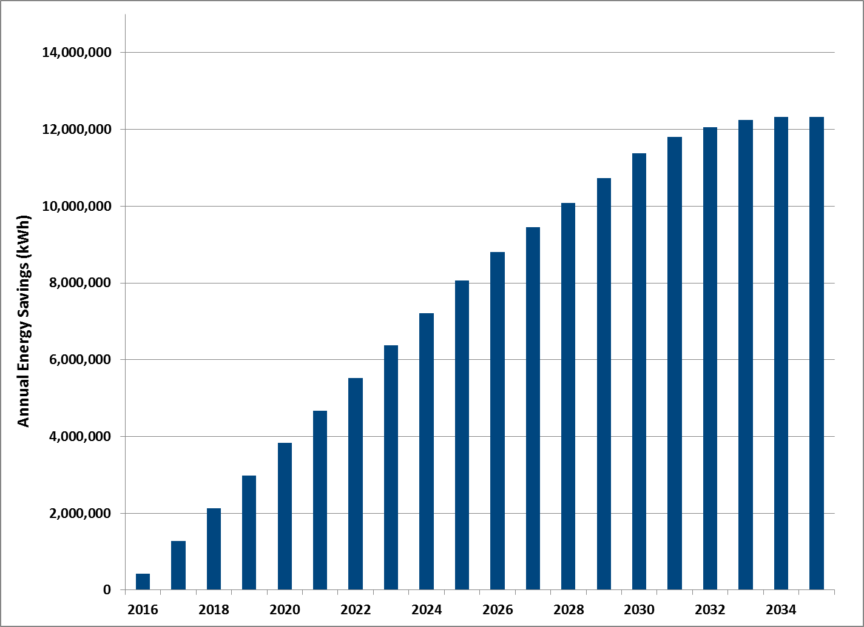
After the first 17 to 18 years, the ramp-up of public benefits associated with the program reaches a steady-state as the total realizable market is reached and customers continue to renew lease terms at the end of the useful life of their product.
Lease Solutions is also estimated to result in over 190 nearly 180 million therms of gas energy conservation in the first 20 years, which is equivalent to fueling over 11,500 11,000 homes each year for 20 years.56 Figure 3 shows the estimated gas energy conservation over the first 20 years of Lease Solutions.

Figure 3: Avoided Energy Savings (Therms) (REVISED)
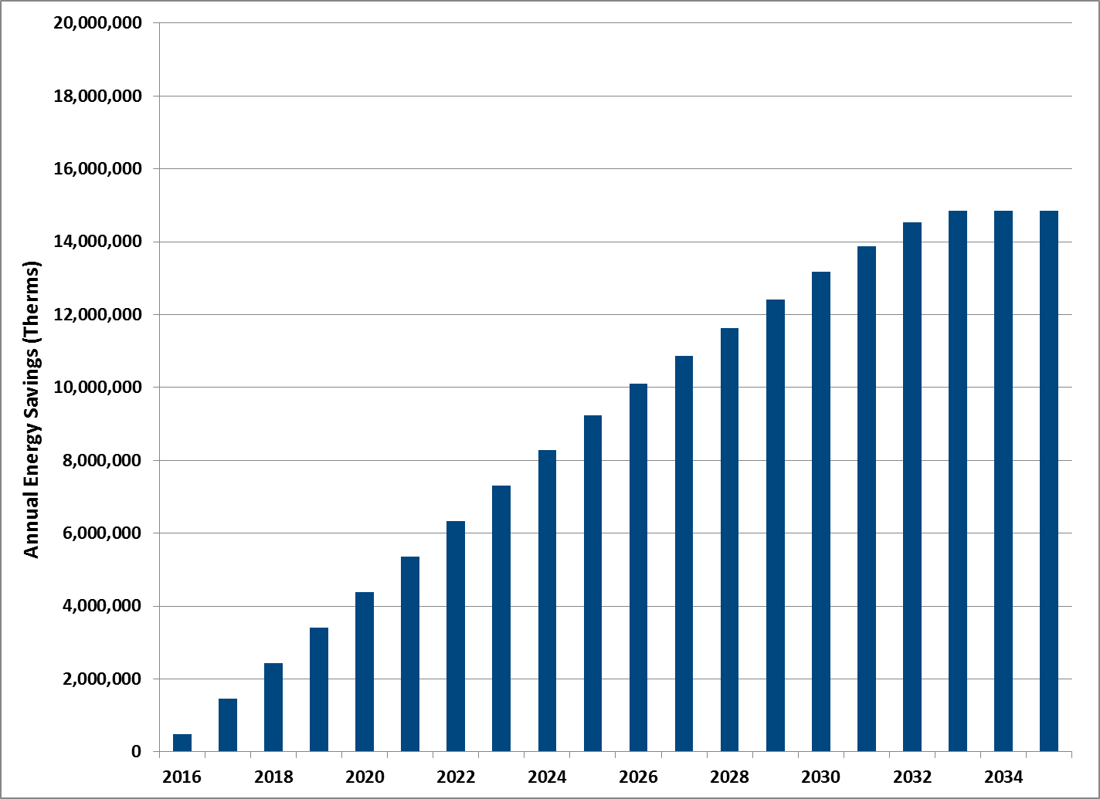
These energy savings results in 1.3 1.15 million tons of CO₂-equivalent emissions avoided, which is equivalent to taking over 12,500 11,100 cars off the road.57 Figure 4 shows the avoided CO₂-equivalent emissions over the first 20 years of Lease Solutions.

Figure 4: Avoided Emissions Savings (Tons of Carbon Equivalents) (REVISED)
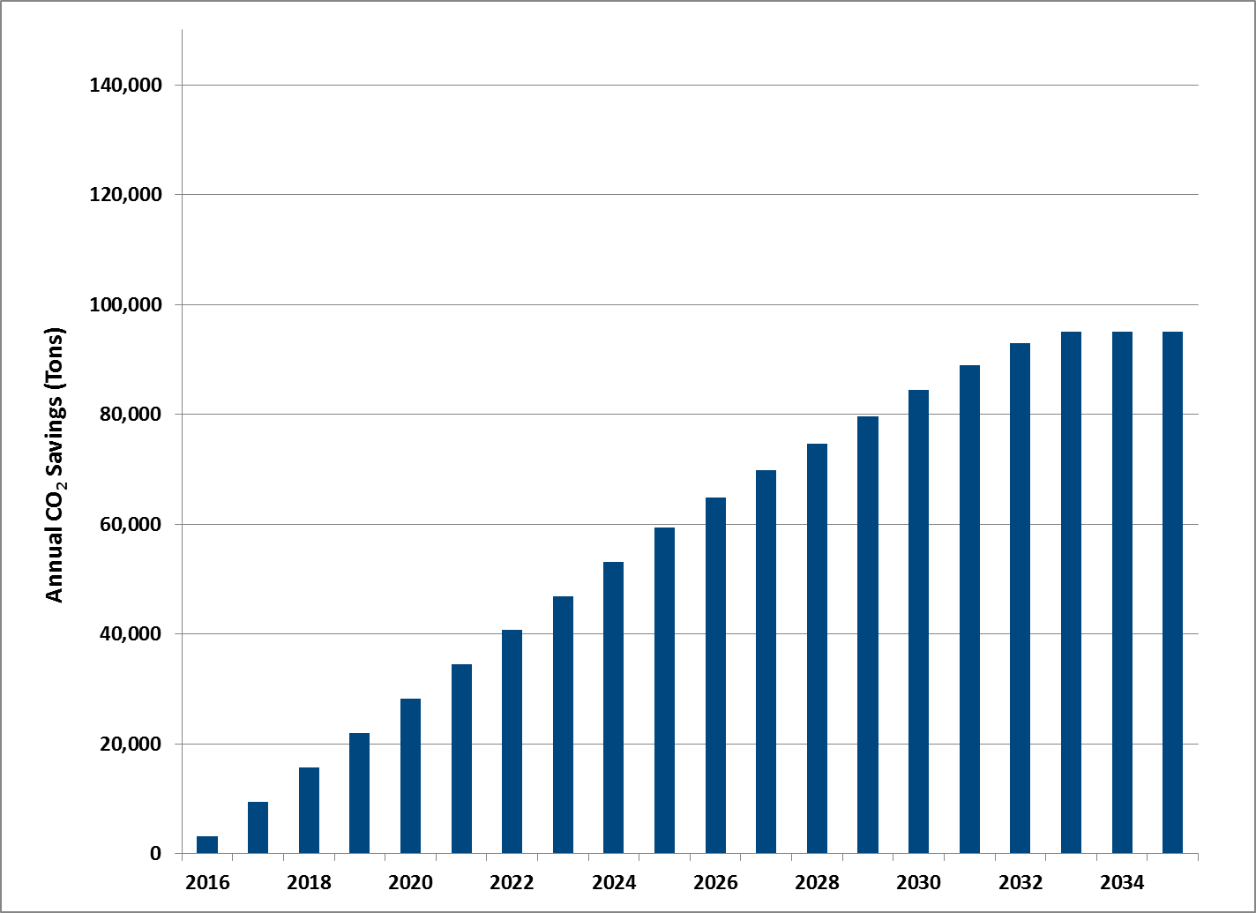
The leasing program is also estimated to result in $5.5 3.2 million in avoided generation and distribution capacity costs and $144 127 million in utility bill savings for participating customers over the first 20 years.
Figure 5 depicts the present value of estimated savings in the first 20 years of the service by the source of the savings, and Figure 6 presents annual savings in 2016 dollars over the first 20 years of the service. These charts illustrate that the bulk of Lease Solutions’ public benefits come in the form of avoided energy costs, followed by avoided greenhouse gas emissions.

Figure 5: Net Present Value for First 20 Years of the Program (REVISED)
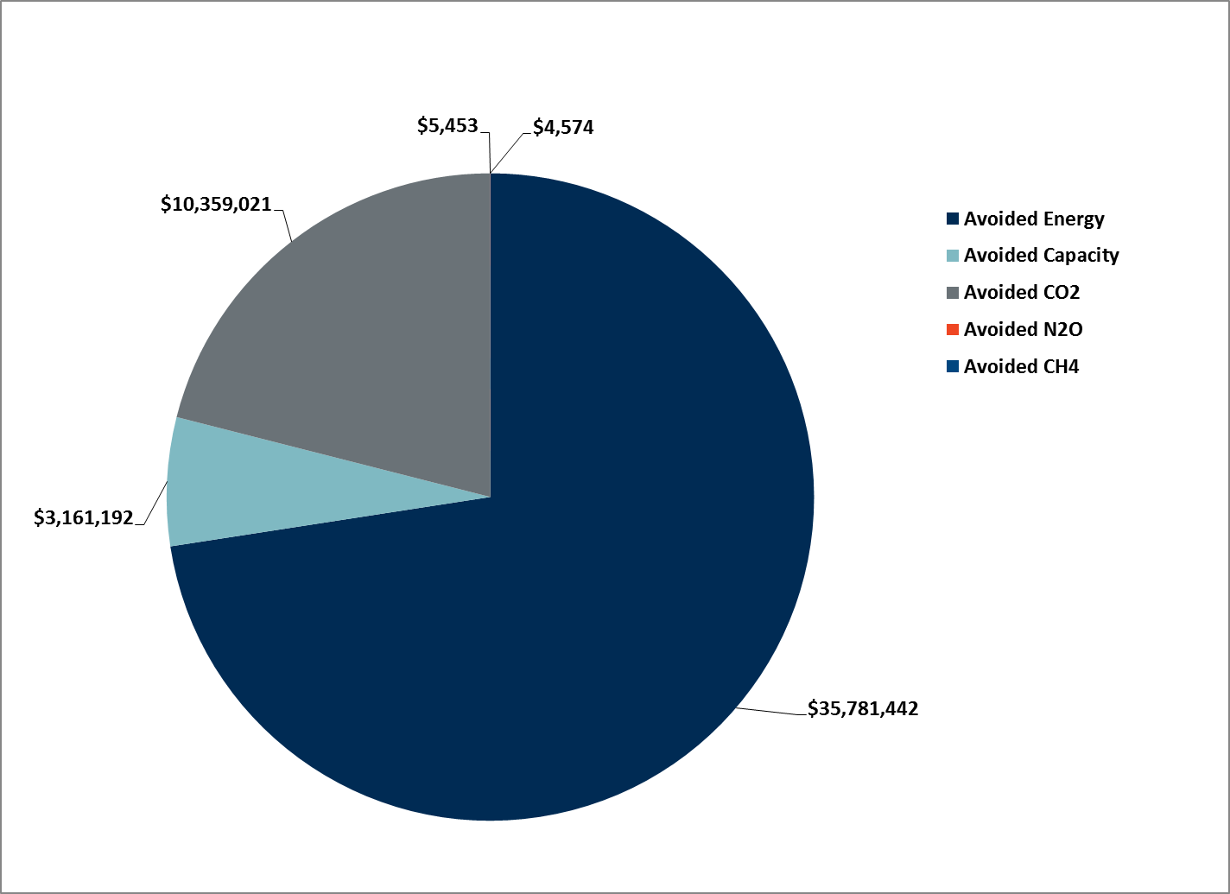
Figure 6: Annual Savings By Avoided Cost Category (2016 $) (REVISED)
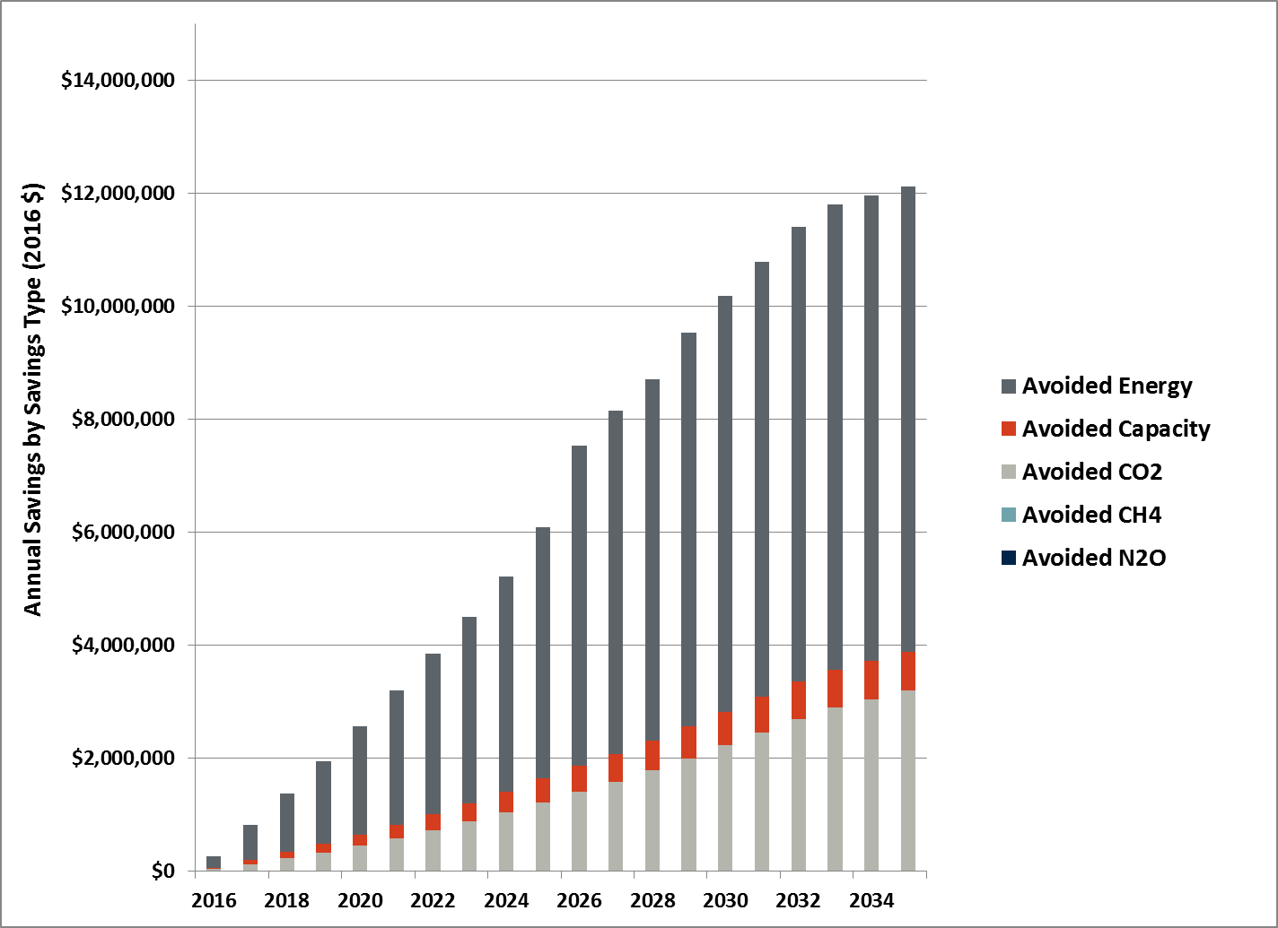

Figure 7 shows annual savings in 2016 dollars, broken out by the end-use equipment being leased. Residential gas furnaces make up the largest source of savings.
Figure 7: Annual Savings by Program (2016 $) (REVISED)
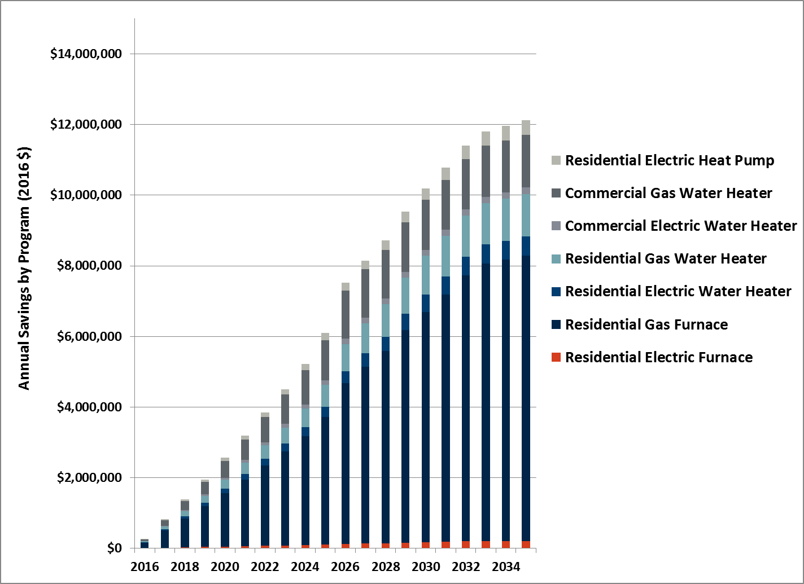

VI. CONCLUSION
Q. What is your conclusion?
A. The proposed PSE Lease Solutions addresses key barriers to customer adoption of new, efficient products by making the purchasing and maintenance process easier and more attainable, and is a compliment to the Company’s existing energy efficiency programs. I expect that the PSE Lease Solutions will sign up thousands of customers and result in the installation of energy efficient equipment, at a more accelerated pace in some instances, that otherwise would not have been installed.

44 PSE’s 2016-2017 approved conservation plan.
45 I assume that additional savings of 20 percent applies to all accelerated units, not just to furnaces.
46 The estimate of 15 percent is calculated by looking at the probability of acceleration in the survey of customers conditional on their equipment age. I prorated the number of units in the 16-20 year group in order to only include those units which were over the useful life of 17 years. See Exhibit No. ___(AF-3) Puget Sound Energy Equipment Leasing Survey, Table Q12 Page 12. See “3.Equipment Leasing Crosstab Banner 2.rtf.”
47 (6,001 units) * (22%) * (15%) = 198 units.
48 Puget Sound Energy, Figure: Northwest Energy Efficiency Alliance’s 2012 residential Building Stock Assessment, Letter to Washington Utilities Transportation Commission, “Docket No. UE-151871 (Advice 2015-23) Substitute Tariff Filing,” November 6, 2015, p. 2.
49 (119 110 therms) * (20% additional efficiency savings for replacement of aged equipment) = 23.8 22 therms.
50 (6,001 units) * (119 110 therms) = 714,119 660,110 therms for 17 years, the full useful life of residential gas furnaces. (198 units) * (22 23.8 therms) = 4,712 4,356 therms for six years, the additional years of benefits due to accelerated replacement. 714,119 660,110 + 4,712 4,356 = 718,831 664,466 therms for the first 11 years.
51 ($0.40/therm) * (718,831 664,466 therms) = $287,532 265,786.
52 ($1.35/therm) * (718,831 664,466 therms) = $970,422897,029.
53 Factor developed by the Environmental Protection Agency for the Mandatory Reporting Rule (40 CFR Part 98).
54 (718,831 664,466 therms) * (0.01 tons CO₂ per therm) * ($13.31 per ton of CO₂) = $95,676 88,440.
55 PSE assumes average residential use of 1,000 kWh per month. See: https://pse.com/savingsandenergycenter/tips-tools-ideas/Pages/Energy-Cost-Guide.aspx, accessed February 25, 2016.
56 PSE assumes average residential use of 68 therms per month. See: https://pse.com/savingsandenergycenter/tips-tools-ideas/Pages/Energy-Cost-Guide.aspx, accessed February 25, 2016.
57 EPA estimates that the average passenger vehicle emits 4.7 metric tons of carbon dioxide per year. See: https://www3.epa.gov/otaq/climate/documents/420f14040a.pdf, accessed February 25, 2016.

