SECTION 7

DEMAND SIDE MANAGEMENT

Overview
Demand Side Management (DSM) s refers to resources acquired through the reduction of natural gas consumption due to increases in efficiency of energy use and/or load management. Unlike supply side resources, which are purchased directly from a supplier, demand side resources are purchased from individual customers in the form of energy that remains unused as the result of energy efficiency. The Washington Utility and Transportation Commission requires gas utilities to consider cost-effective DSM resources in their energy portfolio on an equal and comparable basis with supply side resources. In the gas industry, DSM resources are conservation measures that include, but are not limited to ceiling, wall and floor insulation, higher efficiency gas appliances, insulated windows and doors, ventilation heat recovery systems and weather stripping. By prompting customers to reduce their demand for gas, Cascade can displace the need to purchase additional gas supplies, displace or delay contracting for incremental pipeline capacity, and possibly displace or delay the need for reinforcements on the Company’s distribution system. It’s also important to acknowledge that the Company can prompt and encourage customers to reduce their use, but ultimately it’s up to the end user to elect to reduce their usage and recognize the values inherent in energy efficiency, ultimately resulting in reduced consumption and load management.

There are two basic types of demand side resources: baseload resources and heat sensitive resources. Baseload resources displace the need for baseload supply-side resources. They will offset gas supply requirements throughout the year, regardless of the weather and outside conditions. Baseload DSM resources include high efficiency water heaters, higher efficiency cooking equipment and Ozone Injection Laundry systems. Heat sensitive DSM resources are measures whose therm savings increase during cold weather (meaning the measure is used more often during colder weather). For example, a high efficiency furnace will lower therm usage in the winter months when the furnace is utilized the most and will provide little if any savings in the summer months when the furnace is rarely used. Examples of heat sensitive DSM measures include ceiling, floor, and wall insulation measures, high efficiency gas furnaces, and improvements to duct work and air sealing. These types of heat sensitive measures offset more of the peaking or seasonal gas supply resources, which are typically more expensive than baseload supplies.
To provide some background on how Cascade has traditionally addressed our DSM program development, it’s important to recognize this 2016 IRP is the first iteration of the DSM chapter where the majority of the program planning has transitioned to a standalone Conservation Planning document released annually to the Commission in December. In December 2015, the Company provided its first dedicated report – the 2016 Washington Conservation Plan, and committed to transitioning to an executive summary of the planning process in future submissions of the IRP. Several Conservation Advisory Group (CAG) meetings have been held in the past year to clarify the elements of the Company’s DSM efforts that stakeholders would like to see addressed in the IRP, and those which are more appropriately housed within the Conservation Plan.
Please note Conservation efforts for the Company’s Oregon customers are offered through the Energy Trust of Oregon.
Conservation Planning
The Conservation Plan for 2017 will include the same elements as the 2016 iteration with an elaboration on the current outreach efforts and possible avenues to increase awareness in future years. These elements include the Program Goals and Budgets, discussions around program cost effectiveness, the existing portfolio of measures, emerging technologies, the possibility of introducing additional DSM measures into the portfolio of offerings and their associated costs, incentive levels, targets, possible updates to Washington’s Low Income Weatherization Programs to increase participation, outreach communications plans and a close look at the short term goals and actions in the next 2 years for implementation of the programs, as well as the longer term, 10-year outlook.
The Company’s conservation program offerings are based on a carefully selected assortment of high-efficiency upgrades and envelope improvements designed to reduce natural gas consumption by our residential, commercial and industrial customers on qualifying rate schedules. The portfolio of measures is chosen based on a variety of elements - primary among them being the cost effectiveness of the upgrade, but also based upon regional market availability and administrative feasibility, just to name a few. Further elaboration on the current portfolio of offerings will be housed in the Conservation Plan, as will discussions on potential additions to the existing portfolio and options for increasing incentive levels to improve uptake, although we will touch base on these aspects in this IRP.

DSM Incorporation into the IRP
One of the elements noted as a priority for this 2016 IRP by the Company’s Conservation Advisory Group, and the Commission, was a desire to more thoroughly integrate the elements of the Company’s Demand Side Management programs into the full IRP planning process. The DSM chapter has habitually operated as a stand-alone process wherein the Company reduces consumption in the near term through the existing programs, and the conservation team then forecasts savings potential into the 20-year horizon at a state level. Once the savings potential forecasts are available at a statewide level those inputs are provided to the supply resource planning group in the final stages of the load forecast, where they are subtracted from the long term load forecast.

When viewing overall supply requirements for the 20-year forecast, the impact from conservation and energy-efficiency efforts appears to have a modest impact. However, when approached from the standpoint that every therm saved is one less to acquire, the conservation programs do have the opportunity to significantly impact the Company’s future planning. With that mindset in place the Company has approached this revised format for the IRP as it was originally intended, as a planning tool, i.e. how might the Company increase its ability to reduce consumption and demand in the long term?
Pathways to achieve Goals for the next 10 years
One of the most pertinent questions that comes to mind when exploring more thorough fusion of the DSM efforts into the Company’s resource planning processes is how will the Company incorporate the savings goals from its Conservation Programs into its resource allocation planning, i.e. load management? Future IRPs will have an expanded Plan development arc that will allow for better collaboration and alignment of conservation goals and traditional supply resource alternatives.
Calendar Year 2016 has been a transition year for the Conservation Department as the Company set the stage to increase program accomplishments commensurate with the achievable potential indicated by the Nexant TEA-Pot model (see section Technical Economic Achievable Potential Modeling tool for further detail into the calculated Conservation potential). Significant steps have been taken to encourage a steady increase in program related activities with the associated development of improved administrative processes and additional internal staffing to set the groundwork for expansion of program savings into the next 10 years.
For the past two years, the residential programs were delivered through a mix of third party implementation and internal program oversight. In an attempt to pursue a long-term, sustainable, affordable and simplified delivery model the Company began exploring internal program implementation options for our residential program in the summer of 2015 knowing the existing vendor contract would expire by the end of the year. Internal delivery provides the Company with greater oversight and management of the customer rebate experience, smoother and shorter rebate processing from start to finish, and direct control over data quality and data management – meaning tailored reporting and tracking ability.
The second step taken by the Company was to recognize that administrative funding and budgets for program implementation needed to increase. While discussing 2016 options with the existing vendor the Company also understood the expenses for implementation would increase for 2016 as initial estimates of administrative costs for delivery of the CNGC residential rebate programs were not adequate to cover the vendor’s costs. While transitioning to an internal delivery model was not a lower cost option (especially as an upfront cost), (the move necessitated adding two additional internal staff to support residential rebate processing and Trade Ally management) it did provide continuity and data management security in future years with the use of an internal software solution.
Recognizing the need for technical support of an internal delivery model, the Company submitted a proposal to obtain a software package to support rebate processing and allow customer submission via an online rebate portal. Throughout the summer of 2015 Cascade contacted various software implementation companies to discuss cloud based software for internal residential program delivery.
In late summer the Company engaged in conversations with its Conservation Advisory Group (CAG) about proposed program delivery changes and advised it would send out an RFP for software support. The software package vendor was chosen in November 2015 and work started immediately to customize the Nexant Inc. iDSM Central and iTrade Ally product to Cascade’s needs. The program’s residential delivery vendor (EGIA) agreed to continue processing residential rebates and working with the company through the first few months of CY 2016 as their program delivery ramped down and the new software and commensurate internal delivery processes ramped up.
As the Company has spent the last 10 months delivering the residential programs it has become apparent that internal implementation of the programs has allowed a greater insight into areas to improve the experience for the customer. The easier the process to apply, the more likely he or she is to recall the programs positively when making future home and business energy choices, and consequently the more likely to choose higher-efficiency upgrades. We have thoroughly reviewed and revised our residential applications and program requirements to remove barriers while increasing ease of submission and maintaining program integrity. Improvements to the process include removal of the “Paid in full” requirement (which allows and encourages equipment financing when appropriate for the customer) as well as increased messaging to contractors to include all relevant install data on the invoice, negating the need for repeat data entry by the customer.
One additional item to note as a step the Company has taken toward reaching the increased goals in the next 10 years is recognition of the improvements to the program in reviewing and processing applications with missing data – thereby reducing the amount of “Disqualified” applicants. The last estimate was a reduction of nearly 66% of the previously DNQ’d projects, which could reflect the reality that two-thirds of the projects previously disqualified between May 2013 and January 2016 could have been approved if some additional follow-up had been performed. Previously, the vendor administering the residential programs did not allocate adequate resources toward project follow up, resulting in a significant portion of the residential rebates sitting in limbo awaiting additional data from either contractors or customers to allow the program to either approve or disqualify the submissions. While it is important to acknowledge the onus is ultimately on the customer to provide all required data, it’s also important to contribute to their success and help with what can be a confusing application process (when feasible within administrative budgetary constraints).
Upon transition of the existing files to the Company it was determined that a significant portion of the pending applications could be processed and approved if additional administrative time was allocated to the process. While this effort did require a significant amount of time and effort from the internal team to resolve the missing data projects, and unfortunately caused a backlog of newer projects in the process, it has allowed the program to more accurately portray savings associated with equipment and weatherization measures that had already been installed and should be counted toward the program achievements.
During the residential program transition planning phase the Company also began to alter a few key elements of the program administration to increase the timeliness of reporting related to program accomplishments. Supporting the capacity to create a timelier snapshot of current program accomplishments would allow the Company to more nimbly pivot efforts as the need arose and better enable the Company to react to market trends in building construction and efficiency. One of the elements explored was altering the reporting methodology from tracking per paid date versus install date.
Historically the Company tracked rebate submissions by the date the measure or upgrade was installed at the premise. CAG members requested the Company pursue tracking via the date a rebate was paid rather than the previous install date method to help reduce lag-time in reporting savings. The Company agreed to transition the program reporting model to track savings based on the date the rebate was paid, which makes annual reporting more straightforward and allows us to accommodate the earlier submission deadline for the June 1st to the Commission each year.

The Company also altered the requirement for submission of rebates to require they be sent to the utility within 90 days of install (as opposed to previous requirements to submit by March 1 of the following year after install). The combination of these two changes should help the programs avoid the standard influx of rebate applications in the following year thereby enabling us to have greater transparency into program accomplishments throughout the year.

As the tracking method was changing for 2015, the Annual Report released in 2016 reporting 2015 savings showed a reflection of savings by paid date in calendar year (CY) 2015. We included a graph noting the variations for the first year of reporting in this manner and how it compared to the therm savings totals if tracked by install date for 2015.

All program updates and changes have an effect on the savings the Company is able to achieve. These noted changes allow Cascade staff to focus more time on implementing the program and looking toward future outreach opportunities to bring in additional savings.

Outside of the significant updates to the residential program in the past year aimed at achieving increased savings goals, Cascade also increased its administrative support for the Commercial and Industrial Conservation Incentive Program. While the internal staff have been increasing efforts and support, Lockheed Martin, the Commercial program delivery vendor, has significantly increased its support of the program as well by performing additional outreach to commercial and industrial Trade Ally Contractors, and implementing a marketing and outreach campaign to notify customers of available offers while highlighting success stories in the local communities to encourage additional uptake. This is an ongoing effort and will be discussed further under the Outreach section in this chapter. It’s also relevant to note the increased support on the residential side internally from the Company, as well as our investment in the internal software package, positions us to grow the commercial program into the future in a variety of ways whether through the existing vendor or through a combination of more robust internal support paired with the expertise of the external vendor’s experience and known achievements.

Where do we need to go from here to reach our goals? As is often the case, there is always room for improvement. Programs are constantly evolving to meet the Company needs, Commission directives, market changes, technological improvements, policy changes and a vast array of externalities.
As has been the case for the past year, the Company will complete its work with Nexant Inc. related to the software product for the remainder of 2016 and the first quarter of 2017. Once the product is fully functional (it is currently in use for the programs, but the reporting processes and Trade Ally functionality are still in development, as is the Low Income program element and the EM&V – or evaluation, measurement and verification portion) then the Company will use the advanced reporting ability to develop further plans on key areas of the territory to concentrate additional efforts.
One of the additional steps the Company is in the process of taking involves the Low Income Weatherization Incentive Program alterations required as part of our recent settlement agreement UG-152286. The Company is currently working with its CAG to alter Schedule 301 to increase customer assistance and participation through the Community Action Agencies for Cascade’s most vulnerable customer base, hopefully having the ability to see an impact in program participation as early as this heating season.
We will be increasing general messaging and outreach to the local communities above and beyond existing levels to reach those customers who have yet to engage in the Conservation Incentive Programs (CIP). We will take the opportunity to partner with other utilities, and community programs, as appropriate and available, to promote a more widely understood goal toward high-efficiency uptake and energy conservation in our service territory.

Motivators
Multiple contributing factors motivate the Company to engage in DSM efforts. One such reason stems from a need to meet o the Washington Utilities and Transportation Commission directives and settlement agreements including Docket UG-152286 whereby “The Parties state that the conservation commitments in the Settlement solidify the conservation efforts that Cascade is already undertaking and add structure and accountability”.
Another contributing factor stems from State and federal Policy and possible future greenhouse gas emissions parameters – see chapter 5.
The Company recently received approval to implement a decoupling mechanism in Washington. This allows the Company to “decouple” or disassociate recovery of its revenue requirement with volumetric gas sales. As gas sales fluctuate up or down due to conservation or weather, the decoupling mechanism ensures the company will recover the costs it needs to do business, making it indifferent to conservation. The Company was already committed to its conservation programs prior to the approval of the decoupling mechanism (and previously had decoupling in Washington), but it further cements the Company’s ability to support and grow its Conservation Incentive Programs.
Additionally, the conservation programs allow the Company a chance to demonstrate its commitment to responsible environmental stewardship along with it desire to assist our customers while ensuring customer satisfaction. If the Company encourages efficient and wise use of natural gas, its customers not only receive the most value from their investment, but reduce their expenses in the future, and the groundwork is set for future conscientious choices related to energy consumption.
Progress Report – Where we’re going and where we’ve been
As mentioned earlier in the chapter, this IRP and its relation to the Company’s DSM efforts represents a slightly altered approach to resource planning with a concerted effort made toward incorporation of the conservation efforts as a true resource toward planning to meet future demand. From a pragmatic perspective, the format of the DSM chapter in this document is different from past submissions in that it represents a transition to an executive summary versus the full conservation planning document. This IRP also attempts to add a level of transparency and granularity to the Company’s planning process since the conservation potential for this IRP is calculated through the Nexant TEA-Pot model separated into three different areas and savings assumptions (heat-sensitive resources have different savings potential by area) by reviewing them at the climate zone level. Further elaboration is provided below on this process. These inputs at the zonal level are provided by resource planning and are integrated into the forecasting model.
Company therm savings achievements for the past two years compared to the 2012 IRP and the 2014 IRP goals are noted in the chart below. Please note totals for 2016 accomplishments will not be available until the Annual Report is filed in June 2017.

Table 7-1 Recent IRP Goal to Actual Therm Accomplishments
 | Year | Goal | Actual | Difference
2012 IRP | 2013 | 510,511 | 471,431 | -8%
 | 2014 | 566,150 | 641,615 | 13%
2014 IRP | 2015 | 584,449 | 831,501 | 42%
 | 2016 | 620,020

The Nexant study estimated energy efficiency savings developed into three types of potential: technical potential, economic potential, and achievable potential. Market penetration rates associated with each potential were estimated and included in this assessment. Nexant analyzed this potential via a customized modeling tool based from a Microsoft Excel-based modeling tool, TEA-Pot (Technical/Economic/Achievable Potential) for the Cascade Conservation Potential Assessment. This modeling tool was built on a platform that provides the ability to run multiple scenarios and re-calculate potential savings based on variable inputs such as sales/load forecasts, natural gas prices, discount rates, and actual program savings. This model provides Cascade with the utmost transparency into the assumptions and calculations for estimating market potential.
While technical and economic potential are both theoretical limits to efficiency savings, achievable potential embodies a set of assumptions about the decisions consumers make regarding the efficiency of the equipment they purchase. Cascade’s conservation program adopted the Achievable Potential to set goals under an array of possible future conditions.
Please note, the Company maintains the Achievable potential (with administrative costs included) will still be an aspirational goal (especially as it relates to the residential program) and believes it does not provide the same level of refinement to goal setting as can be performed at a program implementer level (as seen in the following graphs).
The following section elaborates on the methods used by the TEA-Pot model to develop the three levels of Potential for the programs and subsequent creation of the Company’s 2-year short-term plan.
Industry standard cost effectiveness tests were performed to gauge the economic merits of the portfolio. Each test compared the benefits of the energy efficiency metric to their costs defined in terms of net present value of future cash flows.

Utility Cost Test (UCT). The benefits in this test are the avoided energy costs and avoided capacity costs for the lifetime of the measure. The costs in this test are the program administrator’s incentive costs and administrative costs.

Market Segmentation Findings: An important first step in calculating Cascade’s energy efficiency potential estimates is to establish baseline energy usage characteristics and disaggregate the market by sector, segment, and end use.
It is important to recognize the Technical, Economic, and Achievable potential represented within Cascade’s Washington service territory does not represent the “on-the-ground” conservation potential. Furthermore, the high-level screens provided in the Nexant report represent the savings potential available if every cost-effective measure identified under the Achievable screen could be integrated into the Company’s conservation program portfolio. In other words, the summary pages of the study provide a high-level view into what would be theoretically possible.
It is not uncommon for a utility to set programmatic goals below achievable potential findings. Many utilities utilize potential studies to inform the direction of goals and help design programs to capture untapped end use/technology potential. In the most recent IRP the Company established a separate programmatic level of potential for a variety of reasons as noted above, but primarily because administrative costs were not calculated into the program at the Achievable level through the TEA-Pot model. The Achievable potential also assumes savings are captured in all end uses in all market segments. It’s rare for utilities to develop DSM programs that address all segments simultaneously as they tend to be more strategic in where they focus their resources.

As recognized by Nexant, a more nuanced approach is required in order for the Company to create a realistic portfolio of conservation measures that pass programmatic screening and offer realistic conservation benefits to customers.

Therefore, the Company treated the Base Case findings as a high-level assessment of potential, and then utilized the TEA-Pot model to create dynamic, focused portfolios and subsequent targets for use in the IRP and for program planning.
A summary of the program planning and TEA-Pot modeling scenarios used by the Company for its Conservation Incentive Program portfolio in the 2016 IRP is included here. Following is a visual representation of the process of narrowing down potential from the Technical potential level to the Achievable level employed by the Company.
Figure 7-1 Savings Potential Process
Technical Potential
Technical Potential represents a substitution by the end user of all technically feasible measures at the end use level
Economic Potential
Economic considers the most efficient measures that pass economic screening tests and is a subset of Technical Potential
Achievable Potential
Achievable embodies a set of assumptions about the decisions consumers make regarding the efficiency of the equipment they purchase to simulate a realistic estimate of real-life conditions

TEA-Pot provides the Company with a much more nuanced and manageable method to developing our portfolio than was used in the past.
The Company’s objectives in developing its rebate offerings center on the desire to:
- Maximize the inclusiveness of viable, industry-acknowledged conservation measures
- Maintain incentive levels that send meaningful price signals to consumers to upgrade to high-efficiency natural gas equipment and energy saving measures
- Remain cost effective at the Company’s most recently acknowledged avoided costs
We set an administrative budget in order to plan and operate programs. This budget must ensure an acceptable ratio of costs balanced with therm savings achievements. Since therm savings offset the costs of administrative investment, the greater the achievement, the more cost-effective our programs. If the budget or therm savings upon which the portfolio is built are unrealistic, we risk developing a scale-dependent portfolio unable to maintain cost effectiveness.
Targets
TEA-Pot generated targets will be acknowledged in the conservation plan as aspirational targets and those we will aggressively strive towards throughout the year. However, the programs will be built in a way that ensures cost-effectiveness can be maintained even if we fall short of that target. See Section 2016-2017 targets for additional details.
Below is a brief list of what has been altered in this iteration of the conservation forecast from previous IRP submissions:
- Divided Demand Side Management forecast into Climate Zones instead of Statewide
- Incorporated Administrative Costs into the model so that the Achievable forecast yields more realistic results
- Aligned the long term discount rate across the IRP
- Updated all model inputs, which are discussed in depth below, under the Technical Economic Achievable Potential Modeling tool section
- Included all measures over the full forecast, as noted in the 2014 IRP (page 57 of the DSM Chapter) reviewed in Nexant’s 2014 Conservation Potential Study in both the Residential and Commercial/Industrial modeling such that the Commercial/Industrial program’s prescriptive measures and custom projects would fully be recognized while allowing for a first quarter of 2017 deep discussion with the CAG to explore changes to the Residential Conservation Incentive Program’s offerings.
- Split all measures for each customer class between the 30% and 50% of incremental costs rebate levels in order to maximize uptake and thereby increase therm savings potential over the forecast

Conservation Potential
In the following sub-sections, the Company will elaborate on its modeling processes, modeling tool and provide an analysis of the future potential as well as opportunities for increased participation and briefly discuss some of the steps to aim for the aspirational goals.

Climate Zone centered modeling

Figure 7-2 Cascade Conservation Climate Zones
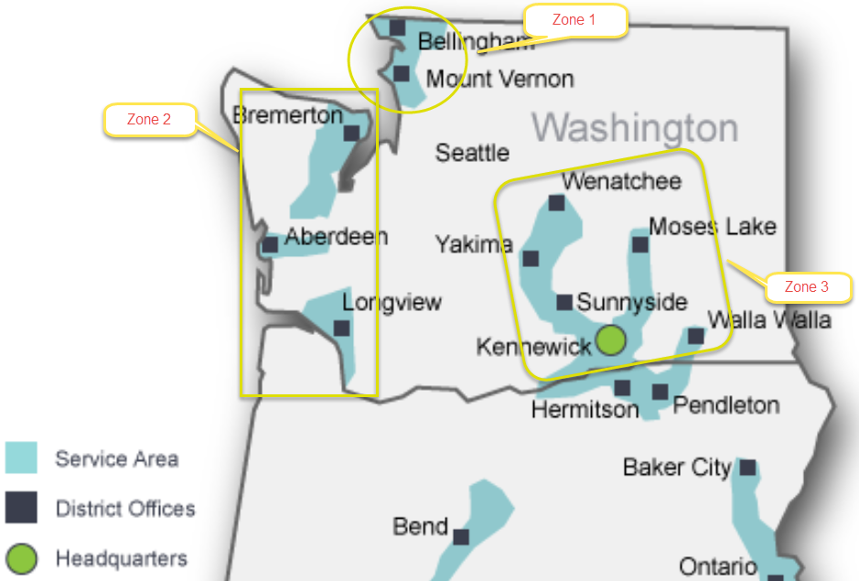

As noted for the first time, the Conservation Forecast was run at the climate zone level of granularity instead of state wide. By tailoring the inputs, each of the three climate zones was able to reflect its technical, economic and achievable potential individually. This will allow program administrators to tailor outreach to specific, potentially underperforming areas and mimic other areas’ successful marketing campaigns that have surpassed their noted potential.
The unique inputs used were customer count and volume growth rate forecasts by customer class, Residential, Commercial, and Industrial, and the avoided costs. All

other factors were held constant across each Climate Zone’s scenario, such as the inflation rate, long term discount rate, load profile, transmission loss rate, cost effectiveness threshold, which measures were left at the 30% of incremental costs incentive level or bumped to the 50% level, and the administrative levelized costs per therm. All factors of the model, as well as other changes introduced for the first time in this year’s IRP, are discussed further in depth in the following Technical Economic Achievable Potential Modeling tool section.
The results of both the Residential and Commercial/Industrial Incentive Programs’ climate zone level potential are summarized in the graphs below.

Figure 7-3 Zone 1 Achievable Conservation Forecast Potential by Customer Class
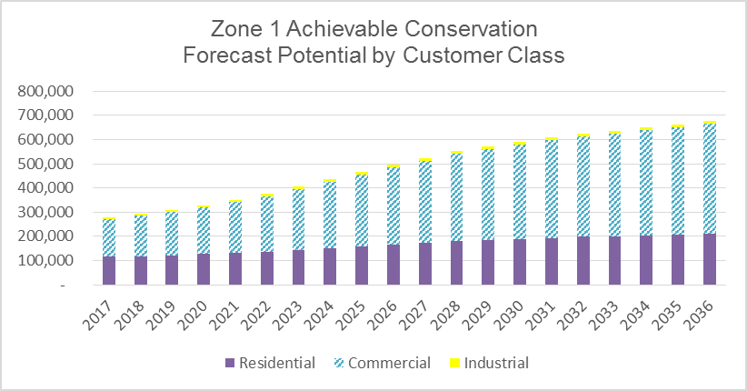

Figure 7-4 Zone 2 Achievable Conservation Forecast Potential by Customer Class
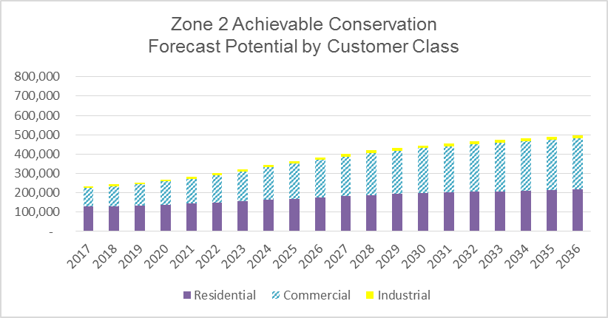

Figure 7-5 Zone 3 Achievable Conservation Forecast Potential by Customer Class
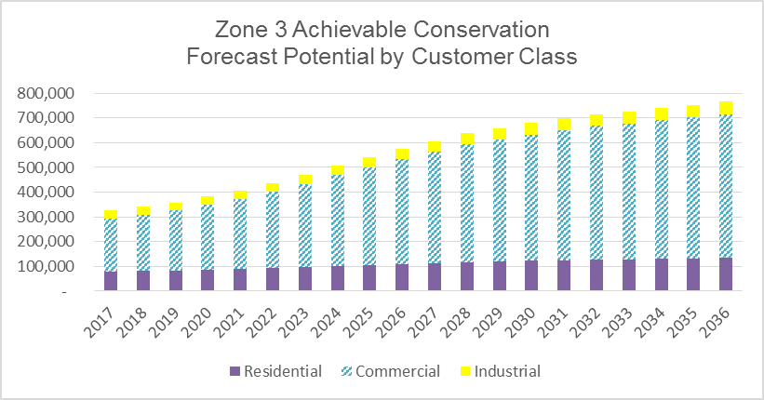

One interesting piece to note about Climate Zone 3’s forecast, above, is the Industrial customer class’s highest potential. Large Industrial customers’ projects are not available every year, but when they are, they have a large impact on the Commercial & Industrial program’s annual achievements and full program portfolio’s cost effectiveness.

The Total CIP Forecasted Potential by Zone graph below demonstrates Climate Zone 2’s lower potential compared to Climate Zones 1 and 3. The reason is its significantly lower customer counts and volume inputs, which are partially offset by the lowest avoided costs in both the near and long term time horizons.

Figure 7.6 Total CIP Forecasted Potential by Zone

Assessing Future Potential
Analysis of the WA territory Assessment via the Technical Economic Achievable Potential Modeling tool
Cascade hired Nexant to produce a Conservation Potential Study and Technical, Economic, and Achievable Potential (TEA-Pot) model in 2013. Nexant also performed a selection of EM&V in the final report released at the beginning of 2014. The study’s analysis was based on the calendar year 2012 and tailored to Cascade’s distinct service territory.
Since then, Cascade has returned to Nexant to update the TEA-Pot model. Most noteworthy was the unlocking of Administrative Costs for incorporation into the model in order to allow the forecasted Achievable level to more accurately reflect programs’ realistic therm savings potential.
Cascade utilizes the Utility Cost Test (UCT) screen to measure the programs cost effectiveness. The Utility Cost Test is the optimal vehicle for valuation of these measures since it is a straightforward and clean calculation of the utility’s investment in Demand Side Management and does not penalize customers for making independent determinations regarding the cost-benefit of an energy efficiency upgrade. The UCT instead treats the rebate from utility run natural gas efficiency programs as a leveraged partnership that drives positive market change and the installation of measures with the potential for long-lived and deeper energy savings.
Cascade’s methodology has also changed in two key ways. First, on the Commercial and Industrial side of the program, all measures from the study are used for all years of the time horizon instead of prescriptive only measures offered under the current tariff in place at the time of writing. This accounts for capturing the savings inherent in the custom project avenue, in addition to the prescriptive measure offerings, accurately without applying a subjective percentage (based on historic performance) of custom project therm savings on top of the simulated savings. Second, for both the Residential and Commercial/ Industrial programs, measures deemed cost effective at the 50% level of incremental costs were run through the model at the higher incentive level. A higher incentive level yields a higher adoption curve because installation of the measure becomes more cost effective and thus more appealing to participants. In return, a higher level of potential therm savings becomes possible. A full list of included measures’ cost effectiveness and incentive levels by customer class are available in Appendix D.
Below is a summary of the other model inputs, updated from the last IRP:
- Inflation rate decreased from 2.00% to 1.00% and is in line with the remainder of the IRP. It was also applied to the Administrative Costs per levelized therm by end use, based on 2015 Annual Report achievements. Thus, the decrease in inflation rate helped decrease the long term Administrative Costs’ forecast, and brought down the overall costs needed to acquire therm savings, thereby increasing the Benefit-Cost ratios for measures to pass cost-effectiveness.
- Transmission Loss rate decreased from 0.1959% to 0.1348%
- Long Term Discount rate decreased from 4.17% to 3.52%, aligned with the rest of the IRP chapters’ models. Note, the lower the long term discount rate, the higher the therm savings potential because future years’ therm savings’ avoided cost values are discounted less, and thus more of the avoided costs can be included, thereby allowing the Benefit-Cost ratios for measures to pass the 0.90 cost-effectiveness threshold.
- Administrative Costs increased, as discussed in section Pathways to Achieve Goals for the Next 10 Years, to bring the Residential program administration in house, thereby increasing accuracy of reporting and improving control of the customers’ rebate processing experiences. It also allowed expansion of Commercial and Industrial CIP outreach. The 2017 budget was set at $550,000 for the Residential program and $1 million for the Commercial/Industrial to accommodate the additional outreach efforts. Note while this may appear to have a negative impact on the benefit-cost ratio for each measure, and raises the costs needed to acquire therm savings it is necessary to accommodate higher therm savings goals.
- Avoided Costs were updated per Appendix H and divided by Climate Zone – Note, the higher the Avoided Costs, the higher the therm savings potential because Avoided Costs under the Utility Cost Test increase the benefit-cost ratio to allow more measures to be considered cost-effective. Conversely, the lower the avoided costs, the lower the therm savings potential forecasted.
- Load Profile system wide and Customers and Volume, divided by Climate Zone were updated per the Demand Forecast chapter.
Nexant’s model provides three levels of potential: Technical, Economic, and Achievable:
Technical Potential: An estimate of all energy savings that could theoretically be accomplished if every customer that could potentially install a conservation measure did so without consideration of market barriers such as cost and customer awareness
Economic Potential: The most efficient measures that pass economic screening tests and is a subset of Technical Potential. Because measures’ cost effectiveness differs by Climate Zone, market segmentation, and vintage, Cascade implements a 0.90 cost-effectiveness threshold in order to be able to include the largest breadth of measures feasible
Achievable Potential: Embodies a set of assumptions about the decisions consumers make regarding the efficiency of the equipment they purchase to simulate a realistic estimate of real-life conditions
As mentioned in the previous section, the model was run individually by Climate Zone in order to provide increased granularity. The outcomes shown in that section are by Climate Zone, whereas the summary of the model’s output below combines Technical, Economic, and Achievable therm savings potentials, in addition to the past three years’ programs’ performance for perspective. Note, 2016 figures are not available at time of writing because the program year has not ended, January 1, 2016 through December 31, 2016. Further breakdown of these numbers can be found in Appendix D.

Figure 7-7 Technical, Economic, Achievable 20 year potential snapshot
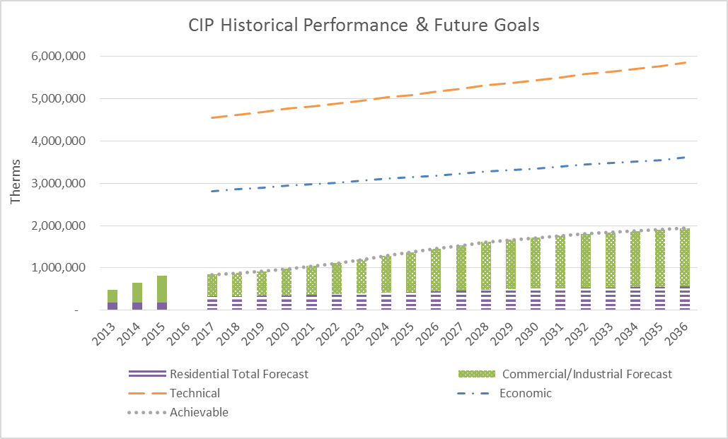

Conservation Two Year Action Plan
Based on the above noted potential and goals for the Conservation Incentive Programs the Company will be centering on a few areas as part of a two- year action plan leading into the long term programmatic goals.
- Increase Incentives to a level that maintains the cost effectiveness of the programs but increases program uptake commensurate with customers receiving additional funds for their efforts (going beyond 30% levels where appropriate)
  - This will be accomplished by having run the TEA-Pot modeling tool with varying levels of 30% and 50% incentives dependent on individual measures
  - Propose updates by the end of Q1 2017
  - Updates will be discussed with the CAG.
- Explore the full breath of measures included in the Nexant model for inclusion into the Company’s portfolio of measures
  - Currently the full breadth of cost-effective commercial and industrial measures noted in the study are included under the “Custom” custom option for the Cascade CIP. The company will review the equipment and non-equipment measures on a regular basis for potential inclusion into the portfolio, keeping in mind cost-effectiveness (based on current avoided costs), and administrative cost parameters, on- the ground realities, and changes in technology and the potential for market transformation in our territory.
- Increase engagement in the Northwest Energy Efficiency Alliance (NEEA) Natural Gas Market Transformation Collaborative over the next 2 years with a focus on Cascade’s territory and viable increases in availability of the pilot efforts (including the high-efficiency commercial rooftop unit).
  - In 2017 engage fully with the Gas Technology Institute Emerging Technologies group through the NEEA membership to explore new technology opportunities
  - The Company will also leverage our Collaborative membership in Q3 2017 and into 2018 by exploring the study possibilities related to the residential and commercial building stock assessments created by NEEA. These studies can provide a snapshot of specific stock and can tell about gas service percentages in portions of our territory where they overlap with electric providers who engage with NEEA although there is no gas metering data. NEEA has offered to provide some recommendations and assistance with exploring what else from the data can be extrapolated specific to Cascade as a gas utility. Note – the Company had a service territory specific potential study performed by Nexant Inc. in 2013/2014 which incorporated similar data to the NEEA information. There is opportunity for the Company to explore updating the individualized potential study in the latter half of 2018 if deemed necessary.
- Work with Nexant Inc. throughout Q1 and into Q2 2017 to fine tune reporting availability for EM&V related tracking through iDSM platform.

While addressing the items above the Company will consistently monitor the state of natural gas conservation technologies within its service territory and make adjustments commensurate with evolving ENERGY STAR® standards and code requirements. In line with these efforts the Company in October 2016 updated its offerings to remove an upgrade to a 95% furnace for the whole home ENERGY STAR incentive to align with altered ENERGY STAR standards and added the Demand Control Ventilation measure to its commercial offerings as noted in the 2016 Conservation Plan.

The Company is also monitoring the residential natural gas furnace code standards as well as water heater criteria and will alter the program offerings as standards and building codes change in the next few years.

Paths to increase conservation forecast precision
The Energy Efficiency and Outreach Department at Cascade is exploring opportunities to increase precision of the Demand Side Management forecasting. Examples include:
- Update the building stock used in the TEA-Pot model’s market segmentation and end use to reflect potentially changing trends over the last five years, such as by using NEEA’s study mentioned above.
- Update the incremental costs based on Nexant’s EM&V portion of the current Residential software packaging contract. Recognizing prices have likely changed since 2012’s figures, Cascade ensured the 2015 Request for Proposal included EM&V and has since worked closely with the software developers to build a system that captures the costs associated with installing the measures offered. Further analysis will require surveying Cascade’s service territories to determine accurate installation pricing for standard models before the incremental costs can be recalculated based on collected data on the customers’ applications and their invoices.
- Discussing with the Conservation Advisory Group during the first quarter of 2017, which measures in the full Nexant portfolio are viable considering the customer base, costs to install versus rebate amounts able to be offered, and contractors available for installation with adequate knowledge, experience, and licensing. Considerations must be made for Cascade’s unique service territory which includes areas that are sparsely populated and remote, and, therefore, lack an adequate market for contractor availability.
- Exploring ways of recalculating the Administrative Costs per therm by climate zone instead of a flat average. This could include weighting by premise count or throughput or by past annual conservation achievements, for example.

Importance of Outreach and Increased Messaging
One of the steps the Company is engaging in to increase its savings achievements toward its noted potential is to commit more fully in Outreach and Community engagement. There is a direct link between customer participation and service territory message saturation. The Energy Efficiency Department consistently reaches out to the Company’s customers through the following means:
- Bill inserts to all qualifying rate schedule Washington customers
- Radio campaigns in select territories to promote the CIP and general low cost/no cost options for reducing natural gas consumption
- Leveraged messaging with Community Organizations and other Utilities as applicable
- Community Project engagement
- Home Builder’s Association directories, Tours of Homes and Home and Garden Show participation
- Business Exposition tabling and exhibition
- Targeted direct mail efforts
In addition to the standard practices above, the Company notes where additional efforts that are above and beyond standard messaging are underway to help increase program uptake in the near future.
Community Energy Program Partnerships
Cascade has partnered with local community based energy programs for years to both support their reduction accomplishments and leverage the opportunity to provide messaging about the CIP to the general public. A few of the programs the Company has directly supported include Sustainable Connections, Sustainable Living Center and the Community Energy Challenge.
Additional support efforts for the past two years have included assisting three of our local Washington service territory towns (Bellingham, Walla Walla and Anacortes) with their engagement in the Georgetown University Energy Prize Competition – which promotes the goal to raise awareness of energy-efficiency in communities by local governments, communities and utilities working together to develop and implement plans for innovative, replicable, scalable and continual reductions in their per capita energy consumption from both natural gas and electric providers. Cascade has served an integral part in these efforts including helping the Georgetown group develop the data management and release processes for the national prize competition, meeting all data release requirements associated with the efforts and has worked with each of the towns to assist with their unique efforts as applicable.
In line with the Company’s commitment to community engagement and the desire to increase awareness of its conservation programs staff have also partnered with the Western Washington University Institute for Energy Studies to provide guest lectures on DSM and conservation in CY 2015 and CY 2016 and has fully supported and engaged with the Women in Energy Mentoring Network.
Regional Efforts and Long Term Benefits
The efforts noted above relating to community engagement in tandem with regional efforts like the NEEA Natural Gas Market Transformation Collaborative have longstanding effects on future savings accomplishments. As mentioned previously, the Company has elected to partner through NEEA with other gas utilities in the region to engage in the first Regional Gas Market Transformation Collaborative in the nation. The goal is to increase market adoption of energy-efficient natural gas products and practices in the future. As part of the project the Collaborative pilots five distinct technologies by increasing their uptake and availability in the joint service territories to improve cost effectiveness of these natural gas technologies. The five year effort began in 2015 and should result in increased savings, if not immediately, then as the technology is adapted and uptake increases in future years. Company investment in the Collaborative is noted below.
Table 7-2 Cascade NEEA Collaborative Funding Commitment

Year | Cascade’s Washington Commitment at 9.3% of total budget for 5-year pilot
2015 | $145,848
2016 | $244,956
2017 | $313,122
2018 | $452,211
2019 | $548,712
Total | $1,704,849

Targeted Outreach
The CIP has noted some areas below where it will be targeting outreach activities into CY 2017. These potential audiences offer a new opportunity for efficiency messaging and continued partnerships.
Cascade will increase its direct outreach and program material availability to the Hispanic speaking Community housed within its service territory. Review of the service territory has indicated a need to provide more tailored program materials readily accessible to this community as well as in person presentations to explain program offerings and provide general support.
The Company plans to tailor presentations and messaging to the real-estate community as many customers seeking to purchase a home are best able to consider efficiency upgrades in line with that new home purchase or sale. Along with the real-estate outreach, the program will engage in conversations and provide program materials to the banking community within our towns (namely the property loan departments) as financing of homes allows for an opportunity to tailor messages relevant to efficiency when the purchaser is thinking of overall costs of home ownership and future expenses.
Another element of program outreach involves messaging up the value chain to trade allies and contractors – those individuals who are in the home with the customers and are helping them make the decision whether or not to install high-efficiency or standard efficiency equipment. The program has always worked within a TA network, but the purchase and availability of the iTrade Ally software through Nexant Inc., in collaboration with internal coordination of the TA program by Company staff who are both familiar with the programs and have the technical expertise, will greatly increase the programs reach and acceptance by Trade Allies. The Company is also working through its Commercial and Industrial delivery vendor to create a second tier of Trade Allies uniquely poised to work with the commercial and industrial customers in helping to promote higher-efficiency commercial installs, in addition to increased engagements with manufacturers.
Lockheed Martin is also on a path to increased program communications and marketing about the Commercial and Industrial CIP. Implemented as of mid-2016 and beyond the goal is to highlight customer success stories as samples of projects that other customers may wish to emulate and provide a well-reasoned and represented return on investment opportunity for high-efficiency upgrades to business owners. The Lockheed Martin team has placed program specific articles in chamber of commerce publications, industry publications and has provided press releases and public recognition to highlight successful projects. Additional insight into marketing plans can be reviewed in the 2017 Conservation Plan.

Washington Utilities and Transportation Commission Docket UG-152286 Order 4, Final Order Approving Settlement Agreement. Page 3-4
Washington Utilities and Transportation Commission Docket UG-152286 Order 4, Final Order Approving Settlement Agreement. Page 3-4
See the Cascade Natural Gas Corporation Assessment of Achievable Potential & Program Evaluation Volume 1-3 dated February 25, 2014.

