June 13, 2014

Steven V. King, Executive Director and Secretary
Utilities and Transportation Commission
1300 S. Evergreen Park Dr. SW
P.O. Box 47250
Olympia, WA 98504-7250

RE: Washington Utilities and Transportation Commission v. Stillaguamish Senior Center

Commission Staff’s Response to Application for Mitigation of Penalties TN-141041

Dear Mr. King:

On May 22, 2014, the Utilities and Transportation Commission issued a $300 Penalty Assessment in Docket TN-141041 against Stillaguamish Senior Center for 3 violations of Washington Administrative Code (WAC) 480-30-080, which requires nonprofit special needs transportation provider companies to furnish annual reports to the commission no later than May 1 each year.¹

On June 3, 2014, Stillaguamish Senior Center wrote the commission requesting mitigation of penalties (Mitigation Request).² In its Mitigation Request, Stillaguamish Senior Center does not dispute that the violation occurred. The company provided a statement outlining significant medical issues which required the staff member responsible for completing report to be the primary caretaker. The company states, “I returned on May 5, 2014 and it was done and submitted by May 6, 2014. I appreciate your consideration of my request for reduction in penalties.”

It is the company’s responsibility to ensure that the regulatory fee is paid and the annual report is filed by the May 1 deadline. On February 28, 2014, Annual Report packets were mailed to all regulated nonprofit special needs transportation provider companies. The instructions for annual report completion page of the annual report informed the regulated company that it must
complete the annual report form, pay the regulatory fees, and return the materials by May 1, 2014, to avoid enforcement action.

UTC Annual Reports
June 13, 2014
Page 2

On May 6, 2014, Stillaguamish Senior Center filed the 2013 annual report and paid the required regulatory fees. The company has been active since May 11, 2009. No previous violations of WAC 480-30-080 are on commission record. Staff supports the company’s request for mitigation. Staff recommends the assessed penalty be waived due to the significant extenuating circumstances and history of past filing compliance.

If you have any questions regarding this recommendation, please contact Amy Andrews, Regulatory Analyst, at (360) 664-1157, or aandrews@utc.wa.gov.

Sincerely,

Sondra Walsh, Director
Administrative Services

ATTACHMENT A
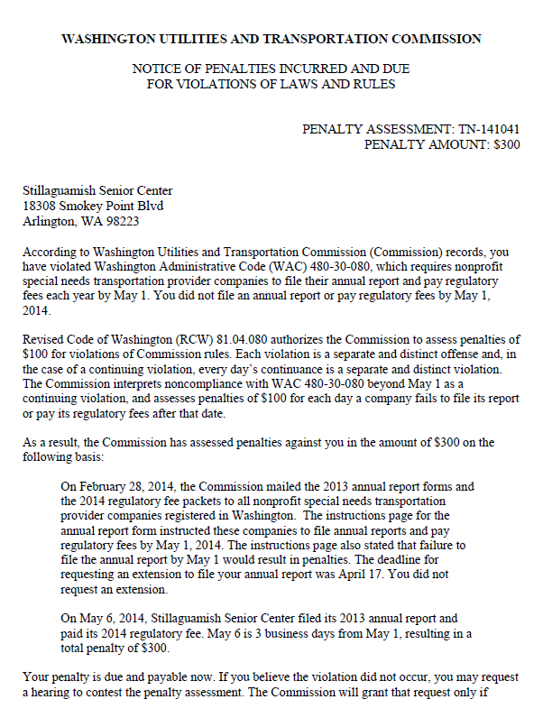

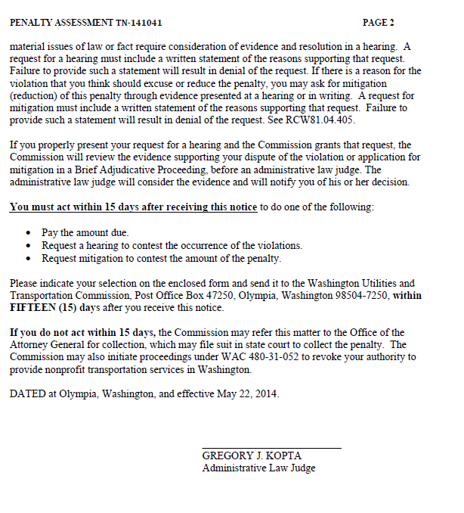

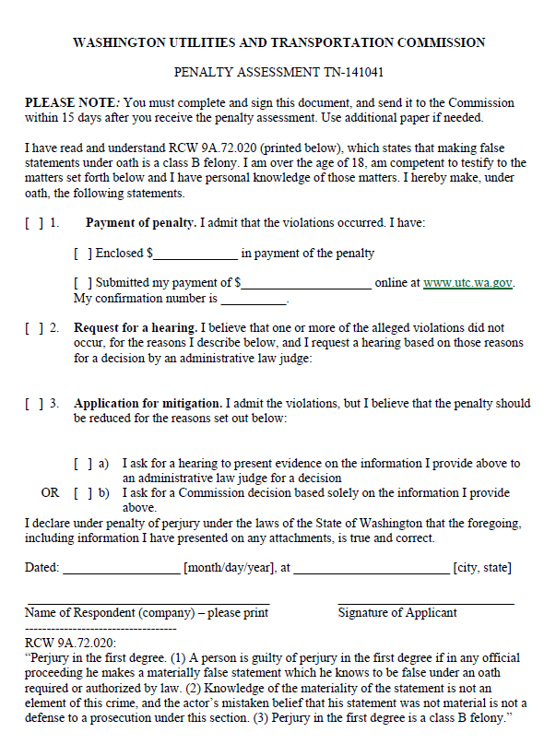

ATTACHMENT B
