Exhibit No. DJP-1T
Docket UE-161204
Witness: David J. Panco

BEFORE THE WASHINGTON UTILITIES AND TRANSPORTATION COMMISSION

WASHINGTON UTILITIES AND TRANSPORTATION COMMISSION,  Complainant,  v.  PACIFIC POWER & LIGHT COMPANY,  Respondents. | DOCKET UE-161204

TESTIMONY OF

David J. Panco

STAFF OF
WASHINGTON UTILITIES AND
TRANSPORTATION COMMISSION

Testimony in Opposition to Approval of Pacific Power & Light’s
Proposed Tariff Revisions

April 21, 2017

TABLE OF CONTENTS

I. INTRODUCTION 1

II. SCOPE AND SUMMARY OF TESTIMONY 3

III. THE METAPHOR OF THE REGULATORY COMPACT 5

IV. WASHINGTON ELECTRIC SERVICE PROVIDERS 6

V. ORIGINS OF PACIFIC POWER’S DISCONNECTION AND
REMOVAL PROCEDURES 8

VI. PACIFIC POWER’S PROPOSED REVISIONS TO ITS PERMANENT
DISCONNECTION AND REMOVAL RULES 13

VII. PACIFIC POWER’S COMPETITIVE POSITION IN ITS
WASHINGTON TERRITORY 23

VIII. RECOMMENDATION 25

LIST OF EXHIBITS

Exhibit No. DJP-2: Pacific Power’s Response to Staff Data Request 2

Exhibit No. DJP-3 Pacific Power’s Cost Of Service Results

I. INTRODUCTION

Q. Please state your name and business address.
A. My name is David J. Panco. My business address is 1300 S. Evergreen Park Drive S.W., P.O. Box 47250, Olympia, WA 98504.

Q. By whom are you employed and in what capacity?
A. I am employed by the Washington Utilities and Transportation Commission (Commission) as a Regulatory Analyst in the Energy Regulation Section of the Regulatory Services Division. Among other duties, I am responsible for financial and economic analysis, auditing of regulated companies, and providing support to general rate cases.

Q. How long have you been employed by the Commission?
A. I have been employed by the Commission since November 2015.

Q. Would you please state your educational and professional background?
A. My formal education includes a Master of Business Administration and a Master of Marine Affairs, essentially applied resource economics and public policy, both from the University of Washington in 1989.

Q. Would you please describe your relevant work experience?
A. Relevant work experience includes bookkeeping and accounting for medium-sized produce and seafood operations in the Pacific Northwest, Alaska, and New England from 1980 through 1986, and various assignments from 1987 through 2008 with Weyerhaeuser Company. These assignments included product development, environmental project management, facility planning and risk management for major manufacturing sites, and new venture development as part of the company’s corporate research and development efforts.

Q. Would you please list any training you have received to help you carry out your duties as a regulatory analyst?
A. I completed the New Mexico State University’s rate case basics workshop in May 2016.

Q. Have you previously submitted testimony to the Commission?
A. No, but I have prepared pre-submission analysis and draft testimony regarding major capital projects for Cascade Natural Gas’s 2015 general rate case (UG-152286); and have provided documented analysis for affiliated interest, certificate of public necessity and convenience, and tariff modification filings.

II. SCOPE AND SUMMARY OF TESTIMONY

Q. Please describe the scope of your testimony.
A. My testimony responds to a proposed revisions by Pacific Power & Light Company (Pacific Power, or the Company) to its tariffs governing permanent disconnection and removal procedures. Pacific Power proposes two significant revisions: (1) to require the departing customer to either purchase stranded facilities or pay for their removal; and (2) to require the departing customer to pay a Stranded Cost Recovery Fee to mitigate cost shifts from disconnecting customers to remaining customers.
The Company argues that revenue losses from permanent disconnections has “skyrocketed” and that the two proposed revisions are necessary to “to eliminate confusion and avoid cost shifting to remaining customers when departing customers opt to permanently disconnect from the Company’s system and receive service from another electric service provider.”

Q. How did you arrive at your recommendations?
A. I reviewed the Company’s testimony and exhibits, responses to data requests from the parties, regulatory literature, and government data sources.

Q. Please summarize your recommendation.
A. I recommend that the Commission reject the proposed revisions to Pacific Power’s tariffs governing permanent disconnection and removal procedures. My review shows that trends in reported permanent disconnections remain relatively insignificant in comparison to overall operations. The Company’s current procedures appear to effectively discourage permanent disconnection. The Company’s two proposed revisions may have some conceptual merit; however, I take issue with the practicality of their implementation and administration, and with the magnitude of the costs that would be assessed as stranded costs. Ultimately, the proposed revisions are inappropriate solutions to the competitive challenges the Company is facing.
I recognize there has been a history of failed attempts to establish service territory boundaries in the region, even though that would appear to offer the most comprehensive resolution to the underlying issues presented by the Company. Absent an agreement between Pacific Power and its neighboring electric service providers, the Company may wish to consider banded rates as a possible way to address the competition that exists.

Q. Have you prepared any exhibits in support of your testimony?
A. Yes, I have two exhibits.

III. THE METAPHOR OF THE REGULATORY COMPACT

Q. What is the regulatory compact?
A. The “regulatory compact” is a metaphor that describes the traditional utility business model of regulated monopoly service and provides context for state regulation as a substitute for competition. The metaphor is based on the concept that utility service can best serve the overall public good as a natural monopoly regulated by a state commission to ensure the utility’s rates and practices are just, reasonable, and not discriminatory. In return for the privilege of protected monopoly status and the opportunity to earn a reasonable return on its capital investments, the utility has an obligation to provide services reasonably demanded by all customers within its exclusive territory.

Q. Does the regulatory compact have legal effect in Washington?
A. No. The regulatory compact is only a metaphor—it does not accurately describe regulated utility service in Washington or capture how that traditional model is evolving. The regulatory compact is not fully implemented in Washington law because there is no statutory provision for exclusive service territories. To the extent that they exist, service territories are based on informal agreements and past practices or established by bi-lateral contracts between neighboring utilities.

Q. How is the regulatory compact evolving in Washington?
A. In addition to its incomplete implementation in Washington, “In recent years, the compact has been evolving as some utilities have had to adjust their traditional business models to address lower load growth due to conservation, changes in technologies, distributed generation, and changing customer expectations.”

IV. WASHINGTON ELECTRIC SERVICE PROVIDERS

Q. What are the types of entities that provide electrical service in Washington?
A. In addition to private, investor-owned utilities (IOUs) regulated by the Commission, Washington providers of electric service include public utility districts (PUDs), municipalities, and electric service cooperatives (collectively known as consumer-owned utilities or “COUs”). COUs have their own governance structures—they are not subject to the Commission’s regulation.

Q. What are the Commission’s core regulatory duties?
A. The legislature charged the Commission with regulating in the public interest, as provided by the public service laws, the rates, services, facilities, and practices of persons or entities providing utility services to the public for compensation. With regard to electrical companies, the Commission must ensure that rates and practices are fair, just, reasonable, and sufficient, and not unjustly discriminatory or unduly preferential. As the Commission has itself put it, it must “ensure regulated companies provide safe and reliable service to customers at reasonable rates, while allowing them the opportunity to earn a fair profit.”

Q. Do Washington’s public service laws recognize that regulated utilities may face competition?
A. Yes. The public service laws recognize that utilities regulated by the Commission may compete with each other and with entities not subject to the Commission’s jurisdiction in at least three places.
First, RCW 80.04.110 provides for a complaint process where “two or more public service corporations,” meaning utilities regulated by the Commission, engage in competition and one believes the other has violated the provisions of Title 80 RCW, Title 81 RCW, or any order or rule of the Commission.
Second, RCW 54.48.030 authorizes the Commission to approve service-area boundary agreements between public service corporations and cooperatives, which are exempt from the Commission regulation. The legislative intent section included with this provision sets out the legislature’s desire to minimize the uneconomic and potentially hazardous duplication of the electric lines and service.
Finally, RCW 80.28.075 also recognizes that regulated electric utilities may compete with unregulated entities. The statute allows gas and electric companies to file “banded rate tariffs for any nonresidential gas or electric service that is subject to effective competition from energy suppliers not regulated by the commission.”

Q. Can the Commission order Washington service providers to enter into boundary agreements?
A. No. The Commission cannot order Washington service providers to enter into a boundary agreement, but the Commission must approve any boundary agreement entered into by an IOU subject to its jurisdiction.

V. ORIGINS OF PACIFIC POWER’S
DISCONNECTION AND REMOVAL PROCEDURES

Q. What is the historical relationship between Pacific Power and the Columbia Rural Electric Association (CREA)?
Pacific Power, an IOU subject to Commission regulation, has its origins in four small electric companies in Astoria and Pendleton, Oregon and Walla Walla and Yakima, Washington (WA). Columbia Rural Electric Association (CREA), a member-owned cooperative, was formed under the auspices of the Rural Electrification Administration in Dayton, WA. Commission record shows that Pacific Power and CREA have, over time, failed to negotiate service territory agreements and now provide service to overlapping territories in and around Walla Walla, WA.

Q. What is the origin of Pacific Power’s disconnection and removal procedures?
During the 1990s, as regional growth in population occurred, CREA began to provide service in areas that overlap traditional service areas of Pacific Power. In late 2000, Pacific Power initially sought to add language to its tariff to require customers that requested disconnection from Company facilities to switch to another electric utility to pay for the estimated net removal cost of those facilities no longer used for service.
The Commission suspended the procedural schedule in that docket while the parties attempted to negotiate a service territory agreement. Pacific Power also received Commission approval for an Interim Service Territory Agreement in October of 2001, which was intended to provide the two companies an opportunity to negotiate a long-term boundary agreement.

Q. Why did Pacific Power and CREA engage in negotiations to produce a long-term boundary agreement?
A. As Commission Staff put it at the time, “absent a service area agreement, there is a likelihood of persistent litigation involving the situation that currently exists” and “[i]t is probable that a service area agreement will be in the best interests of ratepayers, and consistent with the policies stated in 54.48.RCW.”

Q. Did Pacific Power and CREA agree on a permanent service territory agreement?
A. No. The parties attempted to negotiate a permanent service territory agreement between themselves, but those negotiations failed to produce a boundary agreement. The Interim Agreement expired on December 31, 2001.
Ultimately, the initial tariff disconnect provisions became effective January 1, 2003. These provisions allowed the Company to charge a customer the Company’s net cost of removing facilities when a customer requested permanent disconnection of service, the Company’s facilities were not likely to be re-used at that location, and their removal was necessary for safety and operational reasons.

Q. Did Pacific Power and CREA make subsequent attempts to come to a boundary agreement?
A. Yes. Pacific Power and CREA resumed service territory negotiations from May 2003 through July 2004, which again resulted in no agreement. The parties also reportedly attempted to resume discussions about a boundary agreement in 2007 and 2013, to no avail.

Q. Have the initial tariff disconnect provisions ever been modified prior to this docket?
A. Yes. In Docket UE-120846, Pacific Power relocated the tariff provisions to a more appropriate location in the Company’s tariff structure, added clarity to the method employed to calculate net removal costs, and added time for the Company to complete the reconciliation of estimated to actual costs. The resulting provisions with regard to permanent disconnection and removal of company facilities are primarily contained in WN U-75, Rule 6, and corresponding charges are listed in Schedule 300.
Pacific Power proposed additional modifications to its tariff as part of its 2013 general rate case, Docket UE-130043. It subsequently withdrew those proposed modifications in order to “gather additional data and analysis demonstrating the actual costs of Schedule 300/Rule 6 services to inform and support future revisions to the tariffs.” Later in 2013, the Commission required the Company to produce “a thoroughgoing report detailing its experience applying Schedule 300 and Rule 6 since inception.” The report was to include costs of actual removal of facilities, and other information deemed useful in future consideration of Schedule 300 and Rule 6.

Q. Has Pacific Power’s disconnection tariff been the subject of litigation?
A. Yes. In Docket UE-143932, the Walla Walla Country Club (the Country Club) filed a formal complaint alleging that Pacific Power’s treatment of the Country Club’s request for disconnection violated the Company’s tariff rules. The Commission sustained that complaint, leading to this filing, which appears aimed in part at addressing issues raised during the adjudication of the Country Club’s complaint.
The issues in Docket UE-143932 concerned the proper interpretation of the wording in the Company’s Net Removal Tariff, Rule 6; and changes in the Company’s internal policy with regard to transfer of ownership of facilities when a customer wished to change service providers.
The Commission found that the Company “failed to demonstrate that safety or operational reasons justify the removal of the empty vaults and conduit at issue in [the] case.” Testimony in the case also included discussion of potential excavation risks, duplicate facilities, and National Electric Safety Code requirements with regard to abandoning or transferring ownership of facilities used to provide electric service.

VI. PACIFIC POWER’S PROPOSED REVISIONS TO ITS PERMANENT DISCONNECTION AND REMOVAL RULES

Q. Please summarize Pacific Power’s proposed tariff revisions?
A. The proposed revisions include: (1) requiring the departing customer to either purchase any stranded facilities or have them removed, and (2) requiring the departing customer to pay a Stranded Cost Recovery Fee designed to mitigate cost shifting from disconnecting customers to remaining customers.

Q. Why does Pacific Power believe the proposed tariff revisions are necessary?
A. The Company states that its primary reasons are “to eliminate confusion and avoid cost shifting to remaining customers when departing customers opt to permanently disconnect from the Company’s system and receive service from another electric service provider,” and additionally “to govern the sale of underground conduit and vaults upon permanent disconnection.”

Q. Have you examined any data concerning the number and types of customers that Pacific Power has lost each year since 1999?
A. Yes. In addition to reviewing Mr. Dalley’s testimony, I reviewed the parties’ responses to data requests, annual compliance reports from UE-001734, and U.S. Energy Information Administration Electric Form EIA-861 data.

Q. What does that data show about the number and types of customers that are choosing to disconnect?
A. Pacific Power has lost only 67 of its approximately 129,000 Washington customers since 1999. My compilation of the data underlying Mr. Dalley’s Exhibit No. RBD-3, which details the Company’s cumulative annual revenue loss by class since 1999, indicates that:
- prior to 2010, residential and irrigation customers accounted for 23 of 26 customers lost;
- from 2010 through 2016 commercial and industrial customers accounted for 22 of 41 customers lost;
- there are no reported residential customers lost since 2013; and
- the years from 2010 through 2013 account for 33 of the 67 total lost customers since 1999.
Pacific Power has approximately 129,000 customers in Washington, and had approximately 117,000 in 1999.

Q What lessons do you draw from the Company’s customer disconnect data?
A: The classes of customers choosing to disconnect has shifted from dominantly residential and irrigation to significantly commercial and industrial, and there was a peak in disconnects between 2010 and 2013. However, the overall magnitude of disconnections compared to total customers is modest.

Q. Have you examined whether customers who request disconnection actually follow through with the disconnection?
A. Yes. I reviewed the annual Report on Costs Associated with Permanent Disconnection and Removal of Facilities, which was required by the Commission in Docket UE-001734 for each year from 2003 through 2016. Beginning with the report for 2013, these reports list both removals and customer accounts requesting estimates of removal costs, subsequent estimate amounts, payment and completion dates for disconnection of facilities.

Q. What does that data show about whether customers actually follow through with disconnection?
A. Most customers who inquire about disconnection ultimately choose not to disconnect. Compilation of data from these annual compliance filings indicates that:
- from 2013 through 2016, a total of 60 different customers requested estimates of permanent disconnection fees for 117 separate accounts, of which 35 different commercial customers accounted for 75 of the separate accounts for which estimates were requested;
- during this same period from 2013 through 2016, annual compliance filing reports indicate permanent disconnect fees were paid by 11 different customers for 15 separate accounts;
- both requests for estimates and completed disconnects peaked in 2013, but have continued and are increasingly dominated by commercial accounts.

Q: What lessons do you draw from the data about customers that follow through with disconnection?
A: The majority of customers choose not to disconnect after having requested and received disconnect cost estimates from the Company. Commercial customers remain the most interested in pursuing disconnect cost estimates, but again the overall number of commercial customer disconnections is modest.

Q. How does the Company characterize the resulting revenue loss from theses disconnecting customers?
A. Mr. Dalley states, “Between 2010 and 2016, the Company’s per year revenue loss skyrocketed from $411,026 to $1,872,445.”

Q. How does this revenue loss compare to the Company’s total sales of electricity in Washington?
A. The Company’s reported 2009 sales to ultimate customers in Washington of $284,100,835 with that reported sales figure increasing to $343,273,558 in 2015. The cumulative annual revenue loss increase to nearly two million dollars represents approximately one half of one percent (0.5%) of the Company’s reported Washington sales.

Q. Please characterize the broader market trends within which these requests and disconnections have occurred.
A. Based on compilation of retail electric power sales data from U.S. Energy Information Administration Form EIA-861s for both Pacific Power’s and CREA’s operations in Washington:

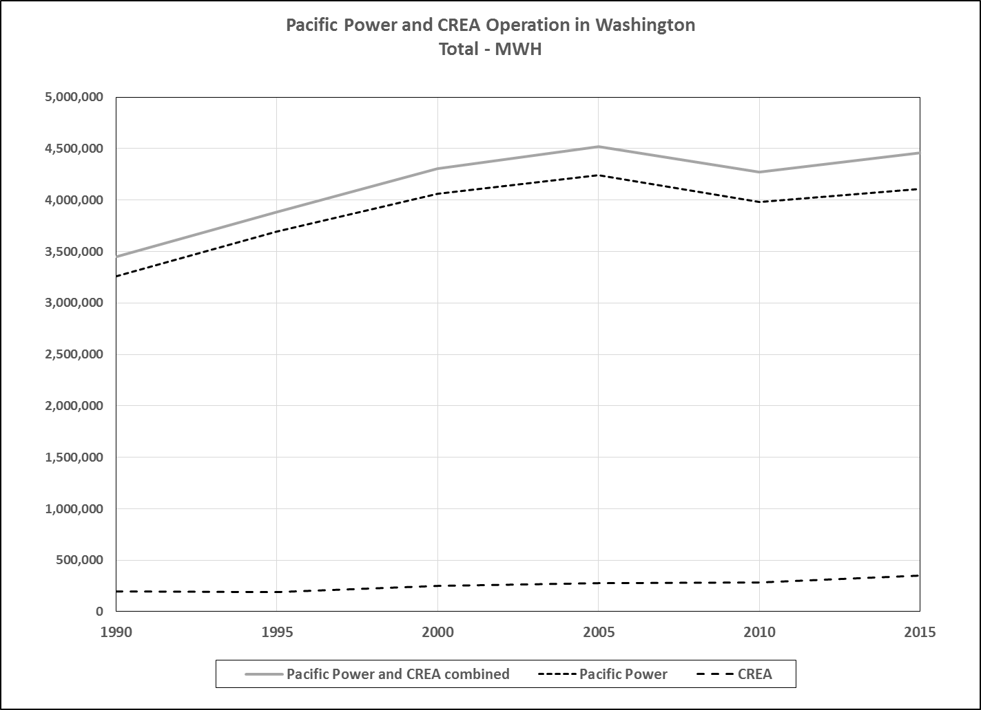

- combined load of both providers across all customer classes grew by an average of 2.1% per year from 1990 through 2005, and then flattened from 2005 through 2015;
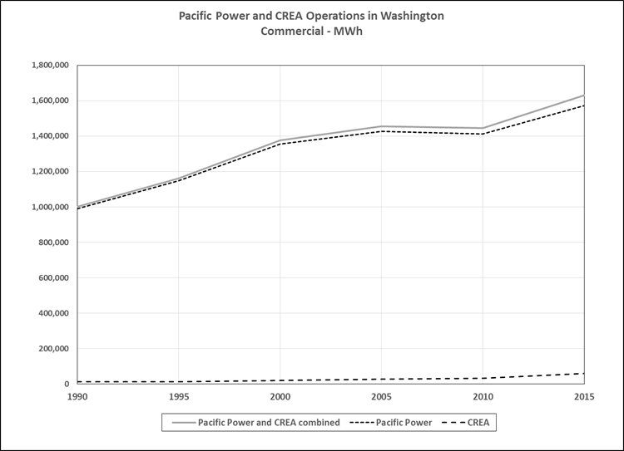

- combined commercial load of both providers increased by an average of 3.0% per year from 1990 through 2005, flattened from 2005 through 2010, and then grew by an average of 2.6% per year from 2010 through 2015;
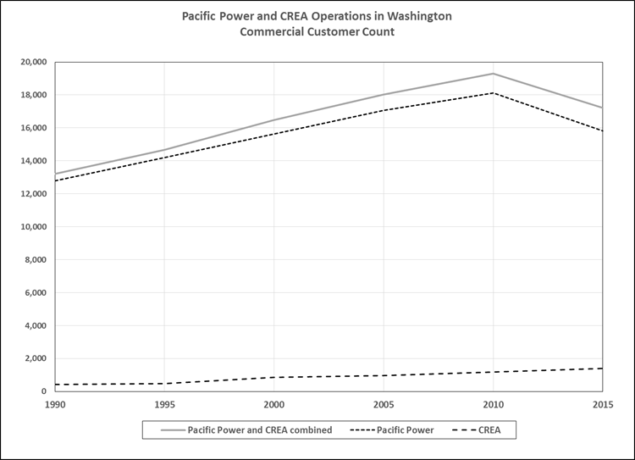

- an average annual decrease of 2.1% in the combined commercial customer counts of both providers through the same period, 2010 to 2015, indicates that the average load per commercial account is growing.

Q. What did you learn from that market data?
A. The commercial class appeared to represent the most significant opportunity for load growth in the service areas, and both the Company and CREA appeared to share that growth.

Q. Based on your analysis, what is your opinion about the proposed tariff revisions?
A. The proposed tariff revisions unfairly favor protecting the traditionally defined utility business model over allowing customer choice. They impose disconnection related fees that are substantially higher than those under the current tariff, even though the current provisions appear to be effective. I do not believe the Company’s proposed revisions will suffice to allow it to respond to the broader competitive challenges it faces in a way that is fair to both the remaining customers and those that choose to disconnect.

Q. Do you find the revisions to Rule 6, which would require the departing customer to either purchase stranded facilities or pay for their removal, to be fair, just, and reasonable?
A. Not exactly—I believe the options have conceptual merit, but I am concerned about how they would be implemented. I find that providing customers who choose to disconnect from the Company’s system with the option to either: (1) pay the cost of removing or decommissioning the facilities used to serve them, or (2) purchase those facilities at fair market value with the proceeds allocated to remaining customers, to be conceptually, a fair balance between the interests of remaining customers and the interests of departing customers. However, I am concerned about the practicality of their implementation and administration.

Q. What is your concern with regard to the method of establishing fair market value?
A. As defined in the proposed Third Revision of Rule 1, “Fair Market Value” would be “as determined by the Company or a Company requested third part appraisal.” I do not find that this approach assures a fair determination of fair market value to a customer who chooses to leave the Company’s system. Additionally, I can see a possibility of ongoing dispute in that the concept of fair market value is intended to apply to establishing a price between willing buyers and sellers within a broadly defined market. The market for installed distribution facilities instead provides a probability of unique, one-off transactions. Ultimately, the transfer of property might raise concerns that would (or should) be subject to Commission review under the transfers of property statutes and rules.

Q. Do you find the proposed revisions to Schedule 300, which would require a departing customer to pay a Stranded Cost Recovery Fee, to be fair, just, and reasonable?
A. No. Pacific Power takes an overly broad view of the costs shifts caused by a disconnecting customer (the costs are not “stranded” from recovery) and it fails to account for the various ways it could mitigate the potential cost shifts that would take place between departing and remaining customers. For instance, Pacific Power includes an allocation of revenue based on generation and transmission costs over a ten-year time horizon. But, it fails to consider the mitigating effect of that capacity being absorbed by growth throughout the Company’s western states or the potential for the capacity to be sold in the wholesale market or to other customers in its multi-state system.
With regard to “stranded” distribution costs, it appears that the basis for these costs may include compensation for the same customer-specific facilities that are either purchased or removed at the departing customers cost under the proposed modifications of Rule 6. Moreover, the Company’s planning cycle for distribution asset and expense planning is a more appropriate time horizon over which any such share of costs should be discounted. This is the most relevant time period to the services provided and their replacement cycles.

VII. PACIFIC POWER’S COMPETITIVE POSITION
IN ITS WASHINGTON TERRITORY

Q: Is Pacific Power’s competition with CREA limited to the issue of losing its current customers to CREA?
A. No. CREA appears to be well positioned to capture growth along the developing edges of the Walla Walla and College Park communities. The areas depicted on the maps in RBD-2 appear to be where new growth is occurring.

Q: Does CREA appear to be targeting certain types of customers?
- Possibly. Based on these maps indicating reported historical service territory expansion by CREA, and on cursory observations of what appear to be recent developments in the area, several of these locations appear to include large, big-box retail establishments.

Q: Do the customers CREA targets appear susceptible to CREA’s offers?
A. To the extent that customer disconnections are occurring, the commercial accounts are the most active in pursuing alternate service providers.

Q. Have you examined any data that might explain why commercial accounts are most susceptible to CREA’s offers?

A. Yes, I have examined the tariffs established in Commission orders, testimony, and exhibits from the Company’s last two rate cases, Dockets UE-152253 and UE-140762.

Q: What does this information show?
A. The cost of service by rate schedule shows a spread in rate of return index between rate schedules ranging from 0.59 for residential customers on schedule 16 to 1.82 for commercial customers on schedule 24. This indicates that commercial customers are providing revenue in excess of their costs, and may well contribute to providing CREA with opportunities to succeed in attracting certain new customers in areas typically served by Pacific Power.

Q. Mr. Dalley testified that Pacific Power is essentially unable to compete with CREA because it must charge tariffed rates approved by the Commission. Do Commission rules provide Pacific Power with any means of competing for customers?
A. Yes. As mentioned earlier, under RCW 80.28: “Gas and electric companies may file banded rate tariffs for any nonresidential gas or electric service that is subject to effective competition from energy suppliers not regulated by the commission.” WAC 480-80-112 established the requirements for a banded rate tariff filing. These banded rates allow public service corporations to compete against unregulated entities.

Q. Has Pacific Power availed itself of those means?
A. No.

Q. Do these provisions appear to be possibly applicable in to the current situation?
Yes.

VIII. RECOMMENDATION

Q. What is your recommendation?
A. I recommend that the Commission reject the proposed modifications. The existing tariff conditions appear to be adequate to prevent a substantial migration of customers from Pacific Power to alternate electric service providers.
To the degree that it might be possible, the Commission should continue to encourage a service territory boundary agreement as the best means to avoid infrastructure duplication and to provide the most economically rational solution from the perspective of maximizing overall public good.
To the degree that Pacific Power desires to compete for both the retention of existing customers and new customer growth, the Company should consider banded rates as a tool for enhancing its ability to compete.

Q. Does this conclude your testimony?
A. Yes.

Dalley, Exh. No. RBD-1T at 2:5-10.
Id. at 5:18.
Id. at 9:15-18.
Walla Walla Country Club v. Pacific Power & Light Co., Dtk. UE-143932, Order 5, Separate Statement of Chairman Danner ¶ 3 (May 5, 2016).
Laws of 1931, ch. 1, §6(d); Inland Empire Rural Elec. V. Dep’t of Pub. Serv., 199 Wash. 527, 92 P.2d 258 (1939).
RCW 80.01.040(3).
RCW 80.28.010, .020, .090. 100.
Regulated Industries, Utilities: Energy, Wash. Utils. & Transp. Comm’n (last visited Apr. 21, 2017) available at https://www.utc.wa.gov/regulatedIndustries/utilities/energy/Pages/default.aspx.
RCW 54.48.020 provides: Legislative declaration of policy. The legislature hereby declares that the duplication of the electric lines and service of public utilities and cooperatives is uneconomical, may create unnecessary hazards to the public safety, discourages investment in permanent underground facilities, and is unattractive, and thus is contrary to the public interest and further declares that it is in the public interest for public utilities and cooperatives to enter into agreements for the purpose of avoiding or eliminating such duplication.
RCW 54.48.030.
Wash. Utils. & Transp. Comm’n v. PacifiCorp, Dkt. UE-001734, Eighth Supplemental Order, ¶¶ 9 -13 (Nov. 27, 2002); In the Matter of PacifiCorp, Dkt. UE-132182, Report on Permanent Disconnection and Removal of Facilities, at 5-6 (Nov. 27, 2013).
Wash. Utils. & Transp. Comm’n v. PacifiCorp, Dkt. UE-001734, Eighth Supplemental Order, ¶ 3 (Nov. 27 2002).
For an Order Approving an Interim Service Territory Agreement Between PacifiCorp and Columbia Rural Electric Association, Dkt. UE-011085, Order Approving PacifiCorp’s Participation in an Interim Service Territory Agreement, ¶ 6 (Oct. 24, 2001) .
Wash. Utils. & Transp. Comm’n v. PacifiCorp, Dkt. UE-001734, Third Supplemental Order, ¶ 5 (Aug. 10, 2001).
Wash. Utils. & Transp. Comm’n v. PacifiCorp, Dkt. UE-001734, Ninth Supplemental Order, ¶ 4 (Dec. 30, 2002).
Wash. Utils. & Transp. Comm’n v. PacifiCorp, Dkt. UE-001734, Eighth Supplemental Order, ¶ 1 (Nov. 27 2002).
In the Matter of PacifiCorp, Dkt. UE-132182, Report on Permanent Disconnection and Removal of Facilities, at 6 (Nov. 27, 2013).
Wash. Utils. & Transp. Comm’n v. PacifiCorp, Dkt. UE-130043, PacifiCorp's Motion to Withdraw Tariff Filing, ¶ 1 (July 11, 2013).
Wash. Utils. & Transp. Comm’n v. PacifiCorp, Dkt. UE-130043, Order 04, ¶ 15 (July 29, 2013).
Walla Walla Country Club v. Pacific Power & Light Co., Dtk. UE-143932, Order 5, ¶¶ 10-24 (May 5, 2016).
Id. at ¶ 25.
Dalley, Exh. No. RBD-1T at 2:5-10.
Id. at 9:15-16.
Id. at 9:19-20.
Panco, Exh. No. DJP-2, (Pacific Power’s Response to Staff Data Request 2).
Pacific Power’s Washington Supplement to FERC Form 1 (data available from excel file titled “Combined Electric Annual Statistics – 2015” on UTC website: Financial Data For Regulated Electric Companies, Annual Statistics of Electric Companies: 1978 -2015, Wash. Utils. & Transp. Comm’n (last visited Apr. 21, 2017) available at https://www.utc.wa.gov/regulatedIndustries/utilities/energy/Pages/financialDataForElectricCompanies.aspx).
Dalley, Exh. No. RBD-1T at 5:17-18.
Pacific Power’s Washington Supplement to FERC Form 1 (data available from excel file titled “Combined Electric Annual Statistics – 2015” on UTC website: Financial Data For Regulated Electric Companies, Annual Statistics of Electric Companies: 1978 -2015, Wash. Utils. & Transp. Comm’n (last visited Apr. 21, 2017) available at https://www.utc.wa.gov/regulatedIndustries/utilities/energy/Pages/financialDataForElectricCompanies.aspx).
Electric Power Sales, Revenue, and Energy Efficiency Form EIA-861 Detailed Data Files, U.S. Energy Information Administration (release date October 6, 2016) (Final 2015 Data) available at https://www.eia.gov/electricity/data/eia861/.
See RCW 80.12; WAC 480-143.
Dalley, Exh. No. RBD-2.
Id.
Panco, Exh. No. DJP-3 (Pacific Power’s Cost of Service Results).
Dalley, Exh. No. RBD-1T at 8:2-3.

