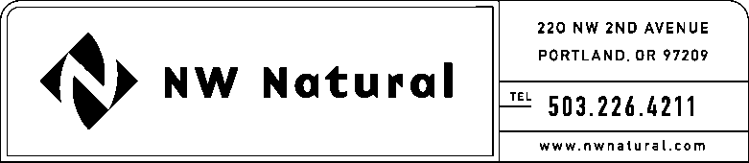
Shawn M. Filippi
Vice President, Chief Compliance Officer
and Corporate Secretary

Tel: 503.220.2435

Fax: 503.220.2584

e-mail: Shawn.Filippi@nwnatural.com

November 15, 2016
VIA ELECTRONIC FILING AND US MAIL
Steven King
Washington Utilities and Transportation Commission
1300 So. Evergreen Park Drive SW
P.O. Box 47250
Olympia, WA 98504-7250

Re: Docket UG-_______: NW Natural’s Statement Establishing Compliance and Request for Written Order Establishing Compliance with RCW 80.08.040 With Respect to the Proposed Issuance and Sale of Up to $225,000,000 of First Mortgage Bonds in one or more tranches
Transmitted herewith for filing with the Washington Utilities and Transportation Commission (the “Commission”) is a Statement Establishing Compliance complying with RCW 80.08.040 and WAC 480-90-242, and a Request for a Written Order confirming such compliance by Northwest Natural Gas Company (the “Company”) with respect to the proposed issuance and sale of up to $225,000,000 Principal Amount of First Mortgage Bonds in one or more tranches. Please note that the Company is not able to submit a native (WORD) version of Exhibit B (Registration Statement on Form S-3), Exhibit C (Prospectus Supplement), Exhibit H (Restated Articles of Incorporation) or Exhibit I (Bylaws) because such documents were filed through the Securities and Exchange Commission’s EDGAR filing system; the Company is not able to submit a native (WORD) version of Exhibit D (Mortgage) because it is a document from 1946, before WORD was available; and The Company is not able to submit a native (WORD) version of Exhibit E (Indenture) or Exhibit F (Distribution Agreement) because these documents are controlled by third parties. Please also note, the Company hereby requests confidential treatment with respect to Exhibit G of the submitted Statement Establishing Compliance.
Also transmitted herewith is a draft proposed order of the Commission for use in connection with the processing of the Company’s Statement Establishing Compliance and Request for Written Order.
If you have any questions, or if you require additional information in support of this Statement Establishing Compliance and Request for Written Order, please contact me at
503-220-2435 or email at smf@nwnatural.com.
Upon completion, please forward to me at this address, five certified copies of the Order of the commission in this Docket along with an electronic copy at the above email address.
Very truly yours,
/s/ Shawn M. Filippi
Shawn M. Filippi
Enclosure

cc w/Encl: Brody J. Wilson
Mark Thompson

