https://www.seattletimes.com/seattle-news/politics/coronavirus-crisis-could-knock-210-million-to-300-million-hole-in-seattles-budget-city-says/

Seattle projects coronavirus crisis could knock $210M to $300M hole in city budget
April 21, 2020 at 2:29 pm Updated April 22, 2020 at 11:36 am
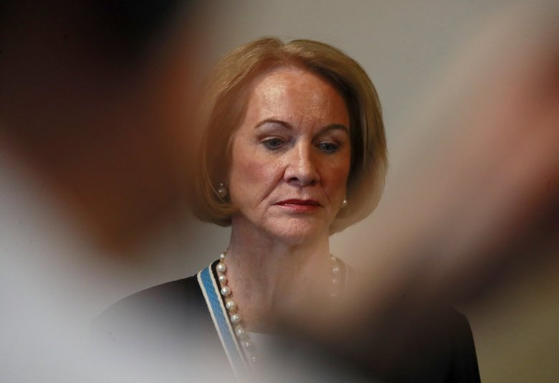Seattle Mayor Jenny Durkan says the coronavirus crisis may cause Seattle to collect $210 million to $300 million less than expected in tax revenue... (Erika Schultz / The Seattle Times) More
By
Daniel Beekman
Seattle Times staff reporter
New projections say the coronavirus crisis may cause Seattle to collect $210 million to $300 million less than expected in tax revenue this year, knocking a gaping hole in the city’s budget, Mayor Jenny Durkan announced Tuesday.
The city’s general fund, which pays for basic services such as parks, libraries and police, could be hit by as much as $186 million, while some other revenue sources that pay for related services could be rocked by up to $114 million.
Seattle’s total budget is $6.5 billion this year, including $1.5 billion in general-fund spending, up from $5.9 billion in 2019. Large amounts of money outside the general fund can only be raised and spent by the city’s utilities, and on construction inspections and road projects.
The new projections are worse than a month ago, when the budget office predicted a $110 million general-fund shortfall.
“This probably will be the toughest economic climate our city has faced in multiple generations,” Durkan said during an online news conference. “What the city is going to have to do is going to be very tough.”
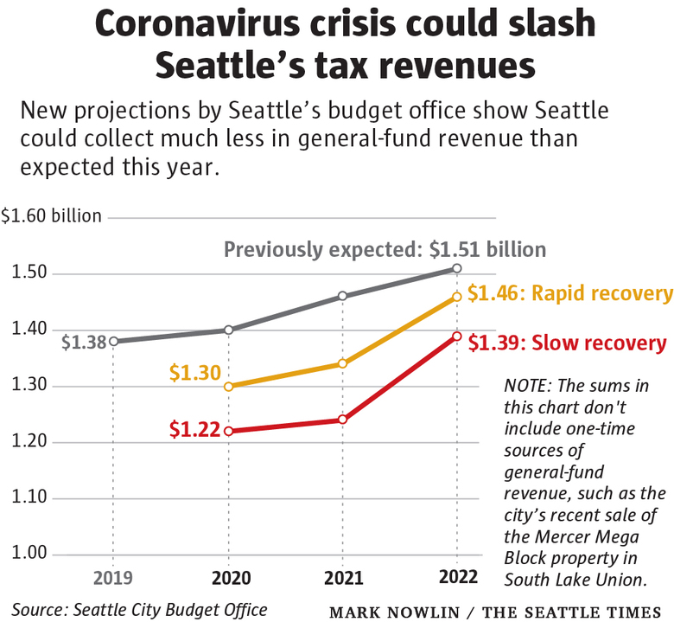
Tuesday’s projections are based on “rapid recovery” and “slow recovery” economic forecasts that indicate the Seattle region could see 65,000 to 170,000 “jobs lost” and reach 8% to 18% unemployment this year, according to a presentation by the city’s budget office.
ADVERTISING
In either case, impacts are likely to linger into 2024, budget director Ben Noble said in the news conference.
Seattle’s general fund relies heavily on property tax, sales-tax and business-tax revenue. Property tax collections should remain more stable (though some homeowners may struggle to pay), but sales- and business-tax collections are expected to plunge this year, as are real estate excise-tax collections.
In the slow-recovery scenario, according to the budget office, the city could collect: $65 million less than expected in sales tax; $58 million less in business tax, $34 million less in court and parking fees and fines; $23 million less in parks fees and $34 million less in real estate excise tax, among other reductions.
Seattle sucks up large amounts of sales tax from the city’s construction and retail-entertainment sectors, which have been kneecapped during the pandemic. People are still buying groceries, but those are exempt from sales tax, Noble noted. Construction projects already underway are likely to continue. But new projects may be less likely now, he said.
The city’s taxes on event admissions, short-term rentals and sugar-sweetened beverages, collected outside the general fund, are smaller sources of revenue. But they could see particularly dramatic shortfalls because the pandemic has nearly shut down tourism, restaurants and bars. For example, Seattle could collect 70% less admissions tax than expected, according to the budget office.
Economic conditions are uncertain and still changing rapidly, Noble said. The city is relying on models at this point because taxes are collected monthly, annually or twice a year.
ADVERTISING
“We don’t actually, as we sit here, have any meaningful revenue data from the crisis period,” Noble said. “We’re working in the dark.”
Yet the models are reliable enough to cause major concern, he added.
Seattle leaders are trying to decide how to bridge the city’s growing budget gap, but there are a lot of moving pieces, Durkan and Noble said.

Sign up for Evening Brief
Delivered weeknights, this email newsletter gives you a quick recap of the day's top stories and need-to-know news, as well as intriguing photos and topics to spark conversation as you wind down from your day.
Sign up

Seattle has about $67 million in an emergency fund (designated for surprise expenses) and about $61 million in a revenue stabilization account sometimes referred to as the “rainy day fund” (kept for shortfalls), according to the budget-office presentation.
The city could try to plug its budget gap by reallocating some property-tax levy dollars and by seeking additional state and federal assistance. Tuesday’s projections account for some help already on the way, including allocations expected through Coronavirus Aid, Relief and Economic Security Act passed by Congress, Noble said. But the city is lobbying for more relief. Seattle already has shelled out $15 million for emergency shelter, meals, hygiene services and other urgent needs, and it intends to spend much more and hopes to have those expenses mostly reimbursed.
Last month, Durkan instructed her departments to stop spending on travel, training and consulting projects; to stop hiring; and to curb spending not related to the coronavirus crisis, she said.
ADVERTISING
Seattle isn’t allowed to engage in deficit spending but may lean more on debt to cover capital expenses, Durkan and Noble said. No city-employee layoffs are planned at this point, the mayor said.
“We’re not at a juncture yet where we’d reduce the workforce, but we’re looking carefully” at the budget projections while talking with union representatives, she said.
City Councilmembers Kshama Sawant and Tammy Morales have proposed a new payroll tax on large businesses, saying the measure could raise as much as $500 million a year. The council’s budget committee is scheduled to discuss that proposal Wednesday.

Most Read Local Stories
- Coronavirus daily news updates, May 18: What to know today about COVID-19 in the Seattle area, Washington state and the nation
- Inslee announces dentists, doctors can reopen offices using guidance to prevent spread of coronavirus
- Fishing boat returns with tons of tuna, but there’s no restaurant market — so they’re selling to the public VIEW
- UW Medicine furloughs 1,500 staffers, with more on the table; could $500 million shortfall hamper coronavirus response? VIEW
- When did coronavirus really hit Washington? 2 Snohomish County residents with antibodies were ill in December
Sawant and Morales have said their tax couldn’t be collected right away but could underwrite $200 million in coronavirus relief payments to Seattle households this year, were the city to initially borrow from levy funds.
Durkan sought to throw cold water on that idea Tuesday.
“The payroll tax that is being considered right now by the City Council is not available in any way, shape or manner to address our budget shortfalls this year or next year,” she said. “There are no ways or mechanisms or tricks to somehow magically have money appear.”
Seattle’s tech industries are holding up better than many others. Stay-home orders are keeping Amazon busy during the pandemic.
The downturn could catch up with the tech sector as consumers tighten their belts, and some companies in Seattle may allow more remote work when the public-health emergency is over, Durkan said.
“Seattle is going to have to fight to get those people back into Seattle doing their work,” she said.

Daniel Beekman: 206-464-2164 or dbeekman@seattletimes.com; on Twitter: @dbeekman. Seattle Times staff reporter Daniel Beekman covers Seattle city government and local politics.

