Avista Corp.
1411 East Mission P.O. Box 3727
Spokane, Washington 99220-0500
Telephone 509-489-0500
Toll Free 800-727-9170

February 27, 2015

Via Electronic Mail

Steven V. King
Executive Director and Secretary
Washington Utilities & Transportation Commission
1300 S. Evergreen Park Drive S. W.
P.O. Box 47250
Olympia, Washington 98504-7250

Re: Docket No. U-140621 - Comments of Avista Utilities

Avista Corporation, dba Avista Utilities (“Avista” or “Company”), submits the following comments in accordance with the Washington Utilities and Transportation Commission’s (“Commission”) Notice of Opportunity to Respond to Written Comments (“Notice”) issued February 10, 2015 in Docket U-140621.
Avista appreciates the opportunity to provide the following comments in this proceeding:

APPLICABILITY OF RULES TO “RIGHTS-OF-WAY”
PCIA, the Broadband Communications Association of Washington (“BCAW”), and T-Mobile have requested that the term “right-of-way” be reinstated throughout the rules, so that other utilities and licensees would be granted access rights not only to utility poles, ducts and conduits, but also to utility “rights-of-way.”
Avista objects to this proposed change. To the extent that this change is designed to allow attaching entities to “piggy-back” on electric utility easements granted by private property owners, such an added burden on private property owners may violate express terms of the easement. Even if express terms of the easement are not violated, the relationship between landowners and Avista might be changed with the introduction of third party communications attachments, particularly wireless attachments, on landowner property. Communications companies are perfectly capable of obtaining their own easements with private property owners.
As for public rights-of-way granted by municipal, county, and state governments, those rights-of-way are granted as part of a process allowing these government entities to monitor and approve equipment installed in rights-of-way and to require appropriate compensation for the use of public property. Communications attachers should be subject to the same oversight and approval process and should therefore be required to obtain their own right-of-way.
The fact that communications attachers are entirely capable of obtaining their own easements and rights-of-way is confirmed by BCAW’s own February 6, 2015 proposed change to Draft Rule 480-54-020’s definition of “Attachment” to include installations in any “telecommunications, electrical, cable television, or communications right-of-way.”
The Commission should also recognize that Washington State property law rulings should control the interpretation of any easement or right-of-way. Finally, consistent with Avista’s February 6, 2015 comments that transmission facilities should not be subject to these rules, the Commission should clarify that any “rights-of-way” at issue are not those used for transmission facilities.

480-54-010 PURPOSE AND INTERPRETATION
BCAW requests that Draft Rule 480-54-010(2) be modified to require the Commission to consider Federal Communications Commission (“FCC”) pole attachment orders, “including the rate formula herein.”
In its October 8, 2014 Comments in this proceeding, Avista explained that the FCC’s pre-2011 Order Telecom Rate provides more equitable allocations of pole costs among attaching entities than the Cable-only rate proposed in the Initial Draft Rule 480-54-060(2). Avista explained that the FCC’s pre-2011 Order Telecom Rate is particularly an improvement with respect to attachments by ILEC and Electric utilities to each other’s poles pursuant to joint use arrangements.
For the reasons explained in its October 8, 2014 Comments, Avista repeats its requests that the Draft Rules establish a presumption that the rates, terms and conditions of existing joint use agreements are reasonable. Avista explained that ILECs operating pursuant to joint use agreements have considerable advantages over cable television and CLEC attachers, so that granting them the same low rate that cable companies and CLECs pay would be unfair.
In a recent order released February 11, 2015, the FCC confirmed these advantages and dismissed Verizon’s (and ILEC) complaint over pole attachment rates paid to Florida Power and Light, (and electric utility) on that basis:
21. Although the 2012 Agreement Rate exceeds the Old and New Telecom Rates, this fact alone does not establish that the Agreement Rate is unjust and unreasonable. We find that Verizon has failed to meet its burden of proof that the rate is unjust and unreasonable for three reasons. First, because Verizon has received, and continues to receive, unique benefits under the Agreement, we find that Verizon is not similarly situated to competitive ILECs and therefore is not entitled to pay the New Telecom Rate. In the Pole Attachment Order, the Commission repeatedly noted that joint use agreements are not analogous to lease agreements between competitive LECs and electric utilities because (a) unlike competitive LECs, incumbent LECs have no statutory right of access to utility poles; and (b) incumbent LECs receive unique benefits under joint use agreements that are not available to competitive LECs.

As is clear from the findings in this FCC Order, the joint use relationship between ILEC and electric utility pole owners is completely different from third party licensee arrangements between ILEC/Electric pole owners and cable companies or CLECs and should not be entitled to the same rate.
Like the FCC, the Commission should presume that existing joint use agreements were negotiated fairly and not disturb existing rates, terms, and conditions of those agreements. Should an ILEC seek lower rates, it should be required to file a complaint with the Commission, to allow the Commission to determine which rate may be appropriate.

480-54-020 DEFINITIONS

The “Carrying Charge” Definition Cannot Preclude Pole Owner Recovery of Out-of-Pocket Expenses

Draft Rule 480-54-020(2) currently defines “Carrying charge” to mean, in relevant part, ownership and maintenance costs without regard to attachments, “including the owner’s administrative, maintenance, and depreciation expenses, commission-authorized rate or return on investment, and applicable taxes.” Frontier and BCAW propose to replace the word “including” to “which are limited to” or “and are comprised of,” respectively.
Avista does not oppose this change, as long as the definition remains limited to ownership and maintenance costs “without regard to attachments,” and as long as there is no confusion that the pole owner’s out-of-pocket expenses associated with attachments are also recoverable. Once the pole owner must begin processing attachments, numerous additional costs must be separately recovered, including costs associated with contract negotiation, application processing, engineering and design work, preparing make-ready estimates, make-ready construction, attachment transfers, pole replacements, audits and inspections, and other out-of-pocket costs that encumber pole owner resources.
Draft Rule 480-54-020(2) should therefore be clarified to add a sentence to the end that reads: “All out-of-pocket expenses the owner incurs with respect to attachments may be recovered separately.” This change would be consistent with pole attachment regulations across the nation, including the FCC and Oregon, all of which allow pole owners to recover out of pocket expenses separately.

Attachment Rights Should Not Extend Beyond Cable and Telecom Companies
Draft Rule 480-54-020(8) was revised so that any entity authorized to be in the public ways has a right to attach to electric utility poles and ILEC poles. As explained by Avista, pole space is limited on electric utility and other poles, and providing rights of access to every entity requesting access is an inefficient use of that space, increases safety risk, and ties up electric utility resources.
Google requests that any further changes to the Draft Rules establish that all broadband providers have equality of access. Avista requests instead that the universe of entities entitled to demand access be limited, and proposes that they be limited to those entities providing cable television service or voice telephone service.

FERC and ARMIS Accounts Need Not Be Specified in the “Net Cost Of a Bare Pole” Definition

Frontier proposes to clarify the definition of “Net cost of a bare pole” in Draft Rule 480-54-020(10) so that the figures for original investment in poles minus cross arms and appurtenances should be derived from FERC Account 364 for electric utilities and ARMIS Account 2411 from telecommunication companies. These accounts, however, specify amounts that include cross arms and appurtenances. FCC rules specify how the formula should be calculated and there is no need for confusing additional details in this definition.

Cell Tower Poles Should Be Subject to Nondiscriminatory Access Rules
T-Mobile and AT&T propose to exclude Commercial Mobile Radio Service providers from the Draft Rule 480-54-020(14) definition of “Owner,” so that cell towers owned by these entities would not be subject to pole attachment regulations.
Avista is aware that the FCC does not regulate attachments to cell towers owned by Commercial Mobile Radio Service (“CMRS”) providers, but does not understand the public policy justification for T-Mobile’s and AT&T’s proposed change. The proposed regulations would cover distribution facilities owned by electric utilities and ILECs, and dictate who has access, how fast access must be granted, what needs to be done to accommodate attachers, and how much can be charged for those attachments. The Draft Rules therefore benefit T-Mobile and AT&T Wireless, to the detriment of electric utility and ILEC pole owners. It is curious why T-Mobile and AT&T would not want such regulations imposed on their own cell tower poles that might benefit the general public.
Avista is not proposing that the Commission begin regulating attachments to cell towers. However, Avista would like to take this opportunity to underscore that considerable benefits are being proposed for communications companies by these rules at the considerable inconvenience of electric utility and ILEC pole owners.

“Pole” Regulations Should Apply to Distribution Facilities, Not Transmission Facilities
In its February 6, 2015 Comments, Avista acknowledged that the definition of “Pole” in Draft Rule 480-54-020(15) is limited to structures used to attach electric distribution lines, but noted that in some cases distribution lines are underbuilt below transmission lines. Avista explained that this “distribution under-build” does not change the fundamental character of the transmission facility and it should still be considered a transmission pole. Avista explained that transmission towers and poles are on average much taller than distribution poles, carry electric conductors of much higher voltage, are not commonly used for communications attachments, are regulated by the Federal Energy Regulatory Commission (“FERC”), and are subject to entirely different set of FERC Uniform System of Accounts than distribution facilities.
Furthermore, outage coordination on transmission systems necessitated by pole modifications or replacements is a complicated process and directly affects the reliability of our system. Many outages cannot be taken approximately six months of the year due to electric loads. Scheduling of outages must be planned to that they do not result in system operating limit exceedance, required by the western Reliability Coordinator and based on power flow studies. This is to avoid shedding load in any scenario. As a result, scheduling and coordinating transmission outages is a very difficult process that does not need to be made vulnerable by maintenance or make-ready required by antennas and other related communication facilities.
PCIA has now proposed to revise the Draft Rule 480-54-020(15) definition of “Pole” to include transmission poles that contain distribution facilities. Avista reiterates its concern with this suggestion and believes that mandatory access to distribution facilities is sufficient to enable adequate communication infrastructure. Avista and other electric utilities should not also be forced to grant access to transmission facilities for some of the same reasoning the Commission will likely consider in deciding not to regulate attachments to cell towers owned by PCIA’s CMRS and other members.
Avista therefore respectfully requests that the Commission modify the second sentence of the Definition for “Pole” to read as follows: “When the owner is an electrical company as defined in RCW 80.04.010, ‘pole’ is limited to structures used to attach distribution lines and having a voltage rating of or below 34.5 kV.”

Entities Without Permission to Use Public Rights-of-Way Should Not Be Allowed to Tie up Utility Resources
Google suggests that the Draft Rule 480-54-020(16) definition of “Requester” be modified so that any entity, not just a “licensee or utility,” can apply to an owner to make attachments. Google is concerned that entities without franchises, licenses or other authorizations to use public rights-of-way may be disadvantaged.
Avista objects to this proposal because it is too broad in nature and would require utility pole owners to redirect resources to accommodate attachment requests by any entity that may or may not be able to secure rights to use the public rights-of-way. Genuine work for other attaching entities might be postponed to accommodate new entities seeking attachments with no legitimate right to be on the poles located in the public rights-of-way. This proposal would be unfair not only because it would unnecessarily burden electric utility and ILEC pole owners, it would also be unfair to the other attachers whose legitimate requests would be delayed. It is also important to note that when the pole owner’s facilities are located within public rights-of-way, all proposals by utilities and licensees to attach to those facilities should coordinate with the local authorities to obtain the same rights. Otherwise, it may put the pole owner’s own franchises at risk.

Utilities Should Be Able to Reserve Space for Emergencies and Future Utility Uses
CenturyLink proposes to modify the Draft Rule 480-54-020(18) definition of “Usable Space” to clarify that a utility may designate duct capacity for maintenance or emergency use.
Avista supports a proposal that would allow utility owners to reserve capacity in ducts and conduits, as well as on poles, for future emergency use or for future maintenance and upgrading of facilities.
Electric utility duct banks usually install enough ducts to carry electric facilities and then extra ducts to enable restoration or future capacity. In the event of damage to an existing electric cable, a spare duct allows the utility to restore service right away, simply by installing a new electric cable in the spare duct while it repairs the damaged facilities. The damaged facilities may also have destroyed the original duct, making it unusable.
Investing and reserving spare duct directly impacts the reliability an electric company provides to its customers. If a communications company were occupying the only available spare duct, then restoring service following damage to an existing electric cable would be more expensive and significantly extend outage time. The National Electrical Safety Code (“NESC”) does not allow communications cables to share the same conduit as electric companies for safety reasons but they are allowed to share the same duct bank with certain safety provisions. Availability of duct capacity needs to be determined by the owners of those facilities and decisions made in the interests of its own customers. As stated previously, Avista has a highly successful, mutually beneficial sharing of duct space in our downtown network located under the City of Spokane, and wants to continue to manage the safety and reliability factors associated with that program..
For capacity expansion reasons, electric utilities like Avista need to be able to reclaim space on poles that may have become occupied by communications companies. When commercial or residential neighborhoods grow in size, or as properties develop, their needs for electricity grow with it. To accommodate that growth, utilities must attach transformers, service conductor drip loops and other apparatus on poles that previously did not require such facilities. Electric utility poles were installed to serve electric utility customers as their needs arise now and in the future. Space is currently reserved on Avista’s poles to address those future needs.
To address these emergency and capacity expansion requirements, Avista proposes that Draft Rule 480-54-030(1) be revised to add two new sentences at the end which read: “Notwithstanding anything in this section to the contrary, an electrical company owner may reserve space on its poles, or in its ducts or conduits, for emergencies or for future electric utility capacity expansions or upgrades. An electrical company owner reclaiming such space shall not be liable for the cost of existing attachers to vacate the space reclaimed.”

MAKE-READY WORK

Utilities Should Not Be Required to Replace Existing Poles with Taller Poles
Draft Rule 480-54-030(1) revisions require pole owners to replace existing poles with taller poles as long as the new attacher is willing to pay the cost. Google supports these revisions and proposes the addition of deadlines for such pole replacements.
Avista objected to this proposed requirement to replace poles and for the same reasons objects to Google’s additional changes. As explained in Avista’s February 6, 2015 Comments, the requirement to replace poles is a forced expansion of capacity that is inconsistent with FCC rules, a burden on electric utility personnel and resources, and ignores that attaching entities have alternatives to pole replacements.
Replacing poles with taller poles simply to accommodate communications attachers is a time-consuming process that utilities have historically been willing to allow, as long as electric utility operations and other considerations are not adversely affected. While historically this has not been an issue, it is becoming a real issue now that wireless companies have begun seeking access.
Private land owners and the general public do not want to see out-of-place, oversized and incompatible single pole structure placed on or near their property. Wireless companies request such drastic increases in pole size simply because if they can place antennas on taller poles they may be able to install fewer antennas than if they were required to use existing 35- and 40-foot poles. Efficient utility operations and the interests of the general public should be considered well before the interest of wireless companies with other options available to them.

There Should Be No Requirement to Expand Utility Duct and Conduit Capacity
XO Communications also supports the Draft Rule 480-54-030(1) revisions, which would require pole owners to replace existing poles with taller poles. It seeks to extend that requirement to conduits, so that access to conduits cannot be denied based on insufficient capacity “if, with reasonable effort and expense, capacity in such conduit can be made available.”
XO’s proposal would require owners to expand conduit capacity to accommodate communications attachers but does not explain how this would be achieved. Avista objects to this forced expansion of conduit capacity for the same reasons it objects above to the forced expansion of pole capacity. In addition, as explained in Avista’s October 8, 2014 Comments, the complexities and potential dangers inherent in energized conduit construction requires that the management of energized conduit and duct capacity owned by electric utilities continue to be managed by electric utilities, without the constraints and potential liabilities associated with ill-fitting regulatory requirements, including capacity expansions. Avista’s management of conduit access has worked safely, effectively and economically for a long time.
For the reasons explained in Avista’s October 8, 2014 Comments, the regulation of utility ducts and conduits (at least the energized ducts and conduits owned by electric utilities) should be removed entirely from the Draft Rules.

Make-Ready Contractors Hired by Communications Companies Must Be Restricted to the Communications Space

Draft Rule 480-54-030(6)(a)(v) would allow a requester to hire a contractor from a list maintained by owner to perform make-ready work within the communications space if make-ready work therein is not completed by the date set by the owner. In its comments, Google repeats its request that it be allowed to hire such a contractor at the outset.
Avista’s February 6, 2015 Comments noted that this Draft Rule and Draft Rule 480-54-030(10) are limited to hiring contractors to work in the communications space, and stressed the importance of revising the definition of “make-ready work” in Draft Rule 480-54-020(9) to comport with this communications space restriction.
Google’s request that it be entitled to hire a contractor immediately without giving existing communications attachers a chance to move their facilities is heavy-handed. As explained previously, Avista has created successful procedures allowing for a new attacher to work directly with other entities on the pole with existing attachments. This process has encouraged fewer trips to the pole and resulted in faster performance of make-ready work than what the Commission’s proposed timelines would require, at least with respect to the usual size attachment requests that Avista has received.
Avista does not currently have a list of contractors that work in the communications space on the pole. The contractors Avista hires work only in the electric space. Avista therefore requests clarification that the owner may maintain a list of contractors qualified to work in the communications space, but in the absence of such a list, the requester can hire a contractor of its own to perform communications space work. In addition, Avista requests that the rules be clarified to add a provision specifying that the requester, not the owner, is responsible for any actions or inactions of any contractor hired by the requester, regardless of whether the owner has authorized the contractor to work on its poles.
Proposed Changes to the Make-Ready Deadlines Exceed what Neighboring States Require

Draft Rule 480-54-030(7) was modified to apply make-ready timelines to projects of 100 poles instead of 300 poles, and removed the provisions from 300 to 3000 poles entirely. PCIA, Integra and Google have requested that the original Draft Rule be restored.
The original Draft Rule was unworkable as the Commission recognized. In a given month, Avista typically reviews requests to attach to about 300 poles spread across our entire system, and the make-ready deadlines currently proposed for that number are manageable, at least if no pole replacements are required. Requiring the same deadlines for larger requests is problematic. Avista believes the deadlines associated with the current Draft Rules are appropriate, as long as pole replacements and the inherent delays associated with pole replacements are not required. However, Avista could live with a modified proposal to apply the timelines to projects of 300 poles, but again only if such projects do not involve pole replacements. There should also be a provision that timelines can be suspended in cases of emergencies, natural disasters and severe storms.
Other states have much more lenient make-ready deadlines than what PCIA, Integra and Google propose. In Oregon, for example, if make-ready work requires more than 45 days to complete or if there are more than 50 poles in an application, the parties must negotiate a mutually acceptable longer period to complete the work.
In Utah, pole owners must provide make-ready estimates for applications of 20 poles or less within 45 days, and must complete make-ready work within 120 days after the initial payment of the make-ready estimate. For applications greater than 20 poles but less than 300 (or .5% of the owner’s poles in Utah, whichever is lower), the make-ready estimate is due within 60 days and construction must be completed 120 days after payment. For applications greater than 300 (or .5%) but less than 3,000 (or 5%, whichever is lower), the make-ready estimate is due in 90 days and the time for construction is extended to 180 days after payment. For applications greater than that, the timeframes are negotiated. All applications within a single month are counted as a single application, and the pole owner has the flexibility of justifying longer timelines based on anticipated delays.
Vermont provides for a sliding scale that begins with at least 180 days to complete the make-ready estimate and perform make-ready work, “unless otherwise agreed by the various parties, and except for extraordinary circumstances and reasons beyond the Pole-Owner’s control.”
The New Hampshire PUC adopted pole attachment regulations that require most make-ready work to be completed by pole owners within 150 days following pre-payment of make-ready estimates, while the estimates themselves (for 200 poles or less) must be provided within 45 days after application.
These states, two of which neighbor Washington, have taken more reasonable approaches to make-ready deadlines than PCIA, Integra and Google propose.

OVERLASHING
Draft Rule 480-54-030(11) would allow attaching entities to overlash existing attachments with very little oversight, in effect treating overlashing as if it imposes no additional burden on the pole and does not affect existing use of the pole. As Avista and Puget Sound Energy explained in their February 6, 2015 Comments, this is not the case.
Overlashing creates additional wind and ice load on the poles and must be evaluated by pole owners prior to attachment, just as the pole owner would do if they were expanding the capacity of their own facilities. In addition to adding further loading and tensions on the pole and anchors, overlashing creates additional sag mid-span, particularly during storms and extreme temperature conditions. In the interest of protecting the entire utility infrastructure the NESC contains midspan sag clearance requirements that must be evaluated using worst case conditions. Overlashing often includes the installation of riser cables extending from the communications space attachments to underground facilities, which affects the climbing space on poles. Also, without sufficient oversight and approval, cables that are dead and no longer used are typically left in place when they are overlashed and should be removed.
The process of evaluating proposed overlashing takes far longer than the seven days specified in Draft Rule 480-54-030(11). In order to safely manage and protect the precious limited space on poles for the benefit of all, it is imperative very important that main line cable overlashing require a Route Application and design prior to construction in the same manner as new wireline construction. Avista therefore recommended that overlashing be subject to the same application and approval process as other attachment requests, consistent with Avista’s current practice.
Showing little understanding of the impact of overlashing, Google proposes that no notification at all should be required prior to overlashing. BCAW, for its part, misleadingly asserts that the FCC does not require notice prior to overlashing. These arguments are poorly considered.
The FCC has never specifically addressed what kind of application or notice requirements a utility pole owner can require for an entity overlashing its own facilities. The FCC understands, however, that overlashing raises safety, reliability and engineering issues. BCAW cites out of context an FCC decision regarding third party overlashing. In those FCC rulemaking proceedings, certain commenters had urged that third party overlashing be subject to additional regulation. The FCC declined to impose additional regulation on third party overlashing beyond what was already required for overlashing one’s own attachment, except to require that the utility be notified that a third party had overlashed. The Commission stressed that third party overlashing is subject “to the same safety, reliability and engineering constraints that apply to overlashing one’s own attachments.”
In the fourteen years since the FCC analyzed third party overlashing, it has become more apparent what a burden overlashing really is. Communications attachers have experienced a continual need to expand capacity by bundling one overlashing on top of another. Early on, 48-fiber strand fiber optic cables were sufficient to overlash earlier, outdated coaxial cable or copper wires. Then 96-fiber cables were required. Then 144-fiber cables were required. And now 288-fiber cables are being overlashed. All the while, existing coaxial and fiber optic cables, which may no longer are needed or used, have been kept in place in overloaded bundles, presumably because it is too much of an inconvenience and expensive costs too much money to pay someone to remove the unused cables. As a result, very thick bundles of overlashing depicted in the photos provided by Avista are creating more and more midspan clearance violations and ice- and wind-loading concerns.
The very nature of fiber contributes to the overlash problem. Fiber generally serves a dual hybrid system of fiber/coax or fiber/copper, meaning some fiber supports the coax or copper, while other fiber cables are for the end use commercial customer. Avista has seen requests for overlashing increase substantially in the last three years alone, growing from 1094 poles in 2012, to 1495 poles in 2013, to 2087 poles in 2014. As more capacity is needed and more customers are connected, fiber overlash bundles will continue to grow at an alarming rate year after year.
In addition to the photographs that were included in Avista’s February 6, 2015 Comments, the following are just a few more examples of the problems that can be caused by unvetted overlashing on Avista’s system:
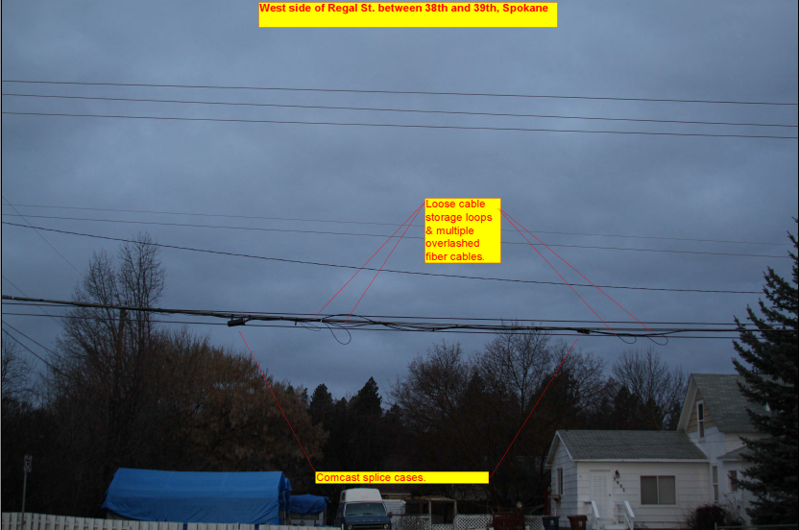

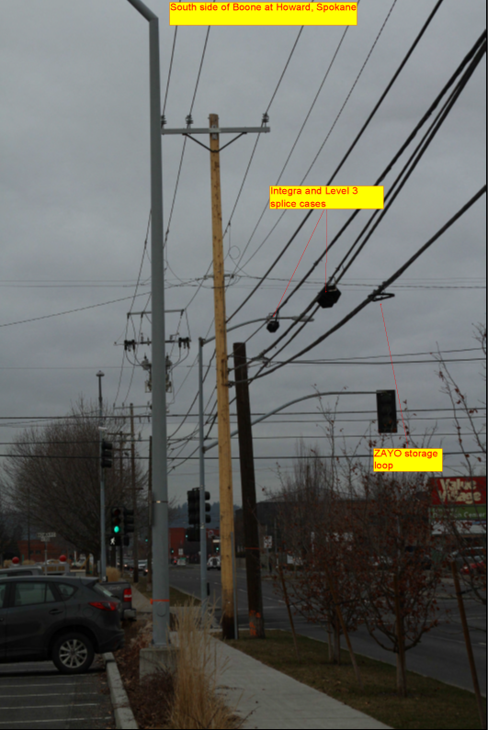

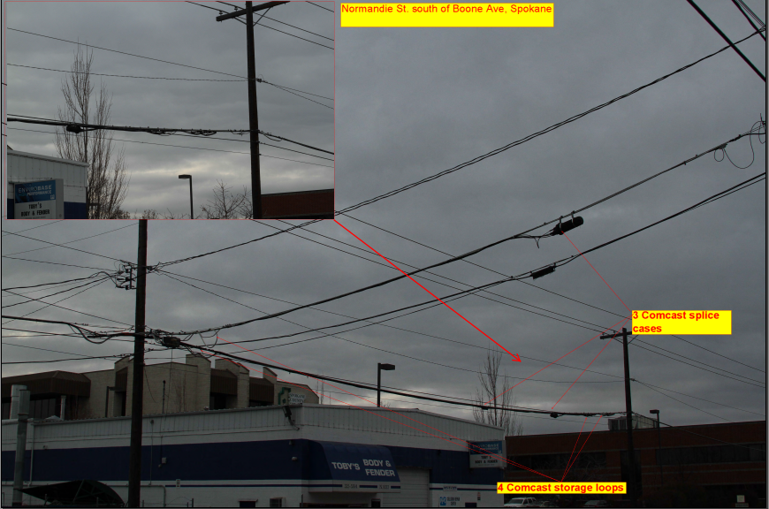

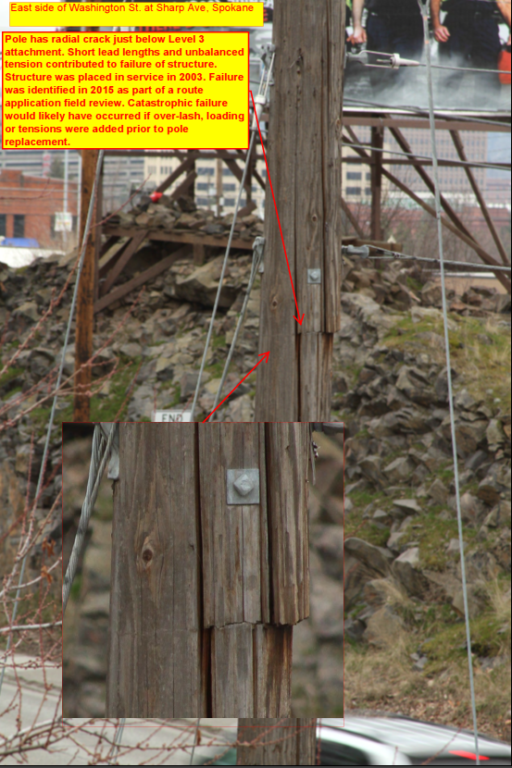
BCAW proposes that pole owners not be allowed to “thwart” or “delay” the overlashing practices of BCAW members by requesting anything more than the pole location or additional communications wires the attacher seeks to overlash. But the limited data offered by BCAW would make it more time-consuming, not less time-consuming, to evaluate the proposed overlashing if they do not provide adequate information for analysis. It has been Avista’s experience that communication companies are not expert at NESC code and electric construction joint use standards. They may be expert in communication infrastructure, but not in issues related to the electric system. As a rule, these design contractors hired by these companies do not have a firm grasp of what a code-compliant attachment is and generally fail to recognize attachments that are non-compliant with codes and standards. The greatest risk comes when one is not even aware that a safety issue exists. In order to properly evaluate the impact of overlashing to existing facilities, Avista has specific design guidelines for communication designers to follow so that the existing attachments can be ferreted out to ensure compliance, and to study the impact of the additional cable diameter and weight, along with changes in the associated sags and tensions.
BCAW also proposes a change to Draft Rule 480-54-030(11) that would make it more difficult to correct pre-existing safety violations on the pole and would allow BCAW members to overlash their facilities to exacerbate pre-existing violations. BCAW’s proposed new addition to Draft Rule 480-54-030(11) reads: “The owner shall be prohibited from requiring the occupant to incur any make-ready costs that are not solely necessitated by the proposed overlash request.” But a pole must be looked at in its entirety. If one communication attachment has violated the safety zone, for example, then each party below it does not have adequate separation from energized facilities because the required safety zone has been breached. There then needs to be a cooperative effort to make the pole safe by modifying the attachments. The location of existing attachments at the pole, including those of BCAW members, may already violate NESC spacing requirements by being located too close other attachments, and of particular concern, too close to the energized conductors of Avista. Existing cable bundles may not be compliant with existing codes and standards. Even without the additional sag created by the new overlashed cable; they may violate the NESC’s mid-span sag limitations.
As with any attachment request, requests to overlash require an analysis of pole conditions to determine whether the pole is suitable for the new burden. New attachment requests provide an opportunity for those attached to the pole to assess the attachment conditions on the pole and to make any changes necessary to ensure the pole is safe and reliable for the benefit of all attachers and the general public. Every pole on which pole owners cannot reasonably make this assessment and correct existing safety and reliability problems is a pole that will continue to have safety and reliability problems, which unsupervised overlashing will exacerbate.
Avista does not want to “thwart” or “delay” overlashing any more than it wants to thwart or delay new attachments, but responsible management of pole plant requires overlashing requests to be evaluated like other attachment requests. In fact, Avista prides itself on meeting reasonable timelines for the review of overlashing requests over the last several years, even though we have seen these requests multiply several times over.
It may be taxing in some cases for all parties on the pole to comply with safety standards, but compliance with safety standards remains the responsibility of all attaching entities. The fully-constructed distribution pole system to which communications facilities are attached contain potentially hazardous energized facilities and were constructed by Avista to provide safe and reliable electricity. There is no room for attaching entities to be cavalier about overlashing or any attachment requirements.
The benefits of maintaining a safe and reliable pole plant come to light when there is a major storm. NESC requirements often address worst-case scenarios and are based on extreme conditions. Avista and other pole owners should be allowed to continue requiring applications and advance approval for overlashing. Our hands should not be tied simply to save communications companies a little money and inconvenience. Communications companies plan their overlashing projects well in advance and yet are asking permission to provide pole owners sometimes only the minimum notice of a pending project. They should be required to do the right thing and apply in advance, as the Louisiana PSC recently required.

MODIFICATION COSTS
BCAW proposes to modify Draft Rule 480-54-050(2) so that existing attachers would not be required to pay to rearrange or replace their preexisting attachments if the rearrangement or replacement is caused by creating capacity for an additional attachment or the modification of an existing attachment sought by another attacher. Google proposes that if a pole has been “improperly maintained by the Owner” (whatever that means) or has been damaged, then the Owner should pay for any necessary pole replacement or repairs.
Avista objects to these proposals. Google’s idea could conceivably require electric utilities to pay to fix all safety violations no matter how they got there. And BCAW would have electric utility pole owners pay for rearrangements or replacements of existing attacher facilities that are necessitated by the addition of facilities by owner.
As explained above, to address the emergency and capacity expansion requirements of electric utility pole owners, Avista proposes that Draft Rule 480-54-030(1) be revised to add two new sentences at the end which read: “Notwithstanding anything in this section to the contrary, an electrical company owner may reserve space on its poles, or in its ducts or conduits, for emergencies or for future electric utility capacity expansions or upgrades. An electrical company owner reclaiming such space shall not be liable for the cost of existing attachers to vacate the space reclaimed.”
This change should be accompanied by a change to Draft Rules 480-54-050(1) and (2) that makes modification costs or the costs to rearrange or replace an occupant’s attachments subject to the ability of the pole owner to reclaim space as provided for in Avista’s proposed change to Draft Rule 480-54-030(1).
Without these changes, electrical company pole owners would be required to pay for space they need that already exists on their own poles.
In addition, the rules should be clarified to require existing attachers to pay their own costs to transfer their facilities to new poles in the event of routine pole replacements because of the age, size or condition of the pole. In the event a government entity or private landowner requires the removal or relocation of a pole or a line of poles the existing attachers may seek reimbursement from those parties if they elect to do so, but should not be able to charge the pole owner.
For costs associated with the correction of safety violations, Avista proposes a “but-for” test, so that Avista would not bear any of the costs to correct safety violations that would not have occurred but for the attachment of communications facilities. A utility that has borne the time and expense to construct a pole distribution system to accommodate its electric facilities should not have to incur expenses that would not have existed but for the presence of communications companies that have opted to “piggy-back” on the electric utility’s poles.
In the alternative, safety violations should be corrected by whichever entity caused the violation, and the burden should be on the communications attacher(s) that is out of compliance to prove who caused the violation. It is otherwise too easy for communications attachers to disclaim responsibility for causing violations and to argue that the pole owner should bear the cost.

RATES
CenturyLink proposes a change to Draft Rule 480-54-060 which would allow CenturyLink wants to allow a pole rate based on the gross cost of bare pole if the net cost is negative “due to depreciation, etc.”
Avista recognizes that the FCC allows gross costs to be used in such instances but does not agree with that decision. CenturyLink and other ILECs have “super-depreciated” their pole plant over the years so that their plant has a negative value. This “super-depreciation” was performed presumably for tax reasons, for which the ILECs received significant tax advantages. They should not be allowed now to charge attachment rates based on pole plant that essentially has no value. Allowing some fraction of gross pole costs to be used would be more appropriate.

COMPLAINT PROCEDURES
Several parties have proposed changes to Draft Rule 480-54-070 that would result in more numerous and burdensome pole attachment complaint procedures.
Draft Rule 480-54-070(1) would require the Commission to make a determination within 360 days of the date a complaint is filed. T-Mobile and AT&T ask for the same modification to require the Commission to “expedite” this determination if a denial of access is alleged.
Avista would not object to expedited Commission consideration of such a complaint if the circumstances warranted such expedited action. Denial of access disputes might be fact intensive and complicated, however, and not lend themselves to expedited decision making. Avista therefore supports granting the Commission discretion to resolve these matters in a reasonable amount of time as the circumstances require.
Frontier proposes a helpful change to Draft Rule 480-54-070(4) to require complaints be filed within six months of parties reaching an impasse in negotiations, but then seeks to have all remedies “relate back to the effective date” of the new rules. The Commission should be left to determine whatever remedy it believes to be appropriate under the circumstances. A rate refund, for example, might not reasonably be required to date all the way back to the effective date of the rules. Frontier also wants to remove the requirement to have “executive level” negotiations prior to filing a complaint. These higher level negotiations, which are consistent with FCC rules, require greater scrutiny of disputes and another chance to resolve them before complaint can be filed. Avista supports retaining this requirement.
In Draft Rule 480-54-070(4), PCIA seeks to replace the 6-month period within which to file a complaint with a 12-month period, and AT&T requests an 18-month period. The basis for these proposed changes is that some problems may not be readily apparent until later. Avista prefers a six-month period for filing complaints, but if this period is extended, it should apply only to disputes regarding a rate, term or condition of pole attachments that is not specifically identified in the agreement itself. There is no reason to delay the filing of a complaint regarding a contract term that is plain on its face.
In Draft Rule 480-54-070(6), PCIA, BCAW and AT&T request in general that the burden of proof be reversed, so that the owner must prove that a rate, term or condition is fair, just, and reasonable, rather than requiring the utility or licensee attacher to prove that a rate, term or condition is not fair, just, and reasonable. It is much more reasonable for the party initiating the complaint process to have the burden of proof. The entity requiring both the Commission and the respondent to devote their resources to resolving the complaint should be required to have a very good reason for filing the complaint. It is not too much to require the complainant to have a convincing case.
For Draft Rules 480-54-070(7) and (8), AT&T proposes that language be added specifying that nothing in these sections precludes other remedies available under applicable law. This proposed change implies that a decision by the Commission will not fully resolve the dispute. Avista does not believe that the Commission should accept AT&T’s proposed change, which may send an inaccurate signal to courts that the Commission has not fully resolved the matter.

CONCLUSION
Protecting the public and all line workers (power and communications alike) is one of Avista’s primary goals and responsibilities. We strongly believe that in order to accomplish this, utilities need to maintain control over the safety, engineering and reliability of their facilities, and the Commission’s pole attachment regulations should promote that objective.
Avista appreciates the opportunity to provide these comments, and we look forward to participating in any future workshops or discussions. If you have any questions regarding these comments, please contact me at 509-495-4975 or at linda.gervais@avistacorp.com.

Sincerely,

/s/Linda Gervais/

Manager, Regulatory Policy
Avista Utilities
linda.gervais@avistacorp.com
509-495-4975

PCIA- The Wireless Infrastructure Association and the HetNet Forum Comments on Second Draft Rules to Implements RCW Ch. 80.54, Commission Docket No. U-140261, at 2 (Feb. 6, 2015) [hereinafter, PCIA’s Comments]; Comments of the Broadband Communications Association of Washington, Commission Docket No. U-140261, at 3 (Feb. 6, 2015) [hereinafter, BCAW’s Comments]; T-Mobile West LLC’s Comments on Revised Draft Rules, Commission Docket No. U-140261, at 4 (Feb. 6, 2015) [hereinafter T-Mobile’s Comments].
BCAW’s Comments Exh. A, at 1.
See Comments of Avista Utilities, Commission Docket No. U-140621, at 2 (Feb. 6, 2015) [hereinafter Avista’s Feb. 6, 2015 Comments].
BCAW’s Comments at 3.
Comments of Avista Utilities, Commission Docket No. U-140621, at 2 (Oct. 8, 2014) [hereinafter Avista’s Oct. 8, 2014 Comments]; Draft Rules Governing Access to Utility Poles, Ducts, Conduits, and Rights-of-Way, Docket No. U-140621, at 9 (Sept. 8, 2014) [hereinafter Initial Draft Rules].
See Avista’s Oct. 8, 2014 Comments at 5.
Verizon Florida LLC v. Florida Power and Light Co., Memorandum Opinion and Order, FCC Docket No. 14-216, at 9 (Enf. Bur. Feb. 11, 2015) (citations omitted) (attached hereto as Exhibit A).
As explained, this approach would also be consistent with the approach recently taken by the Public Utilities Commission of Ohio (“PUCO”), which issued new pole attachment regulations on July 30, 2014. In Re Adoption of Chapter 4901:1-3, Finding and Order, Case No. 13-579-AU-ORD, available at http://dis.puc.state.oh.us/TiffToPDf/A1001001A14G30B60416E87231.pdf.
Comments of Frontier Communications Northwest Inc. to Second Draft Rules Governing Access to Utility Poles, Ducts, Conduits and Rights-of-Way, Commission Docket No. U-140621, at 1 (Feb. 6, 2015) [hereinafter Frontier’s Comments]; BCAW’s Comments at 4.
See Adoption of Rules for the Regulation of Cable Television Pole Attachments, Memorandum Opinion and Second Report and Order, 45 RR 2d 1005, 1979 FCC LEXIS 374, at ¶29 (1979). (permitting recovery of out-of-pocket costs “that are expended by the utility to prepare utility poles for CATV attachments,” and providing as examples “pre-construction, survey, engineering, make-ready, and change-out (non-betterment) costs.”); Oregon Administrative Rule 860-028-0110(3) (“The rental rates referenced in section (2) of this rule do not include the costs of permit application processing, preconstruction activity, post construction inspection, make ready work, and the costs related to unauthorized attachments. Charges for activities not included in the rental rates will be based on actual costs, including administrative costs, and will be charged in addition to the rental rate.”).
Avista’s Feb. 6, 2015 Comments at 2.
Comments of Google Inc. on Second Draft Rules, Commission Docket No. U-140621, at 3 (Feb. 6, 2015) [hereinafter Google’s Comments].
Google is correct that the FCC appears ready to extend federal pole attachment rights to broadband providers (See Google’s Comments at 3), but that incidental result would occur only because the FCC otherwise wants to reclassify broadband service as a telecommunications service so that it can impose certain access requirements on Internet service providers.
Frontier’s Comments at 2.
T-Mobile’s Comments, at 2; Comments of AT&T, Commission Docket No. U-140261, at 2 (Feb. 6, 2015) [hereinafter AT&T’s Comments].
PCIA’s Comments at 1.
Google’s Comments at 5.
CenturyLink’s Third Set of Comments on Draft Rules, Commission Docket No. U-140621, at 1-2 (Feb. 6, 2014) [hereinafter CenturyLink’s Comments].
Google’s Comments at 5-6.
Avista’s Feb. 6, 2015 Comments at 4-5.
Comments of XO Communications Services LLC Regarding the Commission’s Revised Draft Rules, Commission Docket No. U-140621, at 3 (Feb. 6, 2015).
Google’s Comments at 3.
Avista’s Feb. 6, 2015 Comments at 6. As Avista explained, it is inappropriate and potentially dangerous to allow a communications attacher, even though a qualified contactor, to make determinations about the capacity and integrity of an electric utility facility to support its communications attachments, or to rearrange, relocate or transfer potentially hazardous electric distribution facilities.
See Avista’s Oct. 8, 2014 Comments at 14.
PCIA’s Comments at 2-3; Written Comment of Integra, Commission Docket No. U-140621, at 3 (Feb. 6, 2014) [hereinafter Integra’s Comments]; Google’s Comments at 6.
Oregon Administrative Rules §§ 860-028-0020(32), 860-028-0100(5), (7).
Utah Administrative Code, § R746-345-3.C.
Vermont Public Service Board, Rules 3.708 (B)(2), (C) and (E).
New Hampshire Code of Administrative Rules Sections Puc 1303.12 and 1303.04.
Avista’s Feb. 6, 2015 Comments at 10; Comments of Puget Sound Energy, Inc. on Proposed Rules Rulemaking Relating to Attachment to Transmission Facilities, Commission Docket No. U-140621, at 2-3 (Feb. 6, 2015) [hereinafter PSE’s Comments].
Google’s Comments at 7.
BCAW’s Comments at 5.
FCC rules recognize the potential burdens associated with overlashing and require attachers to pay for any make-ready costs associated with overloaded poles or excessive mid-span sagging: “For example, if the addition of overlashed wires to an existing attachment causes an excessive weight to be added to the pole requiring additional support or causes the cable sag to increase to a point below safety standards, then the attacher must pay the make-ready charges to increase the height or strength of the pole.” In the Matter of Amendment of Commission’s Rules and Policies Governing Pole Attachments, Consolidated Partial Order on Reconsideration, 16 FCC Rcd 12103, at ¶77 (2001). It is not possible for Avista to perform a loading study and analyze mid-span sags in a short-period of time, and that is why Avista requires parties requesting overlashing to follow the same application process as for new attachments.
Id., at 5 n. 8.
In the Matter of Amendment of Commission’s Rules and Policies Governing Pole Attachments, Consolidated Partial Order on Reconsideration, 16 FCC Rcd 12103 (2011), at ¶¶ 73-75 (“[I]n the Telecom Order, we declared our continued approval of, and support for, third party overlashing, subject to the same safety, reliability, and engineering constraints that apply to overlashing one’s own pole attachment …. We did not require the host attaching entity or the third party overlasher to obtain the consent of the utility beyond the consent already acquired for the host attachment although the utility is entitled to notice of the overlashing… We clarify that third party overlashing is subject to the same safety, reliability, and engineering constraints that apply to overlashing the host pole attachment. We affirm our policy that neither the host attaching entity nor the third party overlasher must obtain additional approval from or consent of the utility for overlashing other than the approval obtained for the host attachment.”) (footnotes omitted).
BCAW’s Comments at 6.
Id. Exh. A, at 7.
See Louisiana Public Service Commission, Docket No. R-26968 (General Order approved August 6, 2014), slip Op. at 13, pole attachment rule 7 (Overlashing). Consistent with the importance of this practice, the Louisiana rules devote an entire section to overlashing, with provisions covering application, pre-construction inspections, denials of overlashing requests, cost reimbursement, and rental charges. Subsection (a) explains the application process as follows: a. Any Attacher wishing to overlash facilities must provide a Pole Owner with reasonable notice of its intent to overlash facilities by filing a written request with the Pole Owner identifying what existing and proposed facilities are to be attached and/or overlashed, all entities served by the overlash, all design information to perform pole loading analysis, where such facilities will be attached and/or overlashed, and when such facilities will be attached and/or overlashed. In the event of an emergency where a line must be replaced or repaired to restore service to customers and advanced notice is not feasible, the Attacher shall provide notice of overlashing as soon as reasonably practical.
BCAW’s Comments Exh. A, at 8.
Google’s Comments at 6-7.
CenturyLink’s Comments at 2.
T-Mobile’s Comments at 3; AT&T’s Comments at 3.
Frontier’s Comments at 6.
Id., at 2.
See 47C.F. R. § 1.404(k) (“The complaint shall include a certification that the complainant has, in good faith, engaged or attempted to engage in executive-level discussions with the respondent to resolve the pole attachment dispute. Executive-level discussions are discussions among representatives of the parties who have sufficient authority to make binding decisions on behalf of the company they represent regarding the subject matter of the discussions. Such certification shall include a statement that, prior to the filing of the complaint, the complainant mailed a certified letter to the respondent outlining the allegations that form the basis of the complaint it anticipated filing with the Commission, inviting a response within a reasonable period of time, and offering to hold executive-level discussions regarding the dispute. A refusal by a respondent to engage in the discussions contemplated by this rule shall constitute an unreasonable practice under section 224 of the Act.”).
PCIA’s Comments at 3; AT&T’s Comments at 5.
PCIA’s Comments at 4; BCAW’s Comments at 10; AT&T’s Comments at 5.
AT&T’s Comments at 5.

