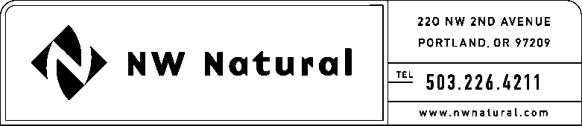

ONITA R. KING
Tariffs and Regulatory Compliance
Tel: 503.721.2452
Fax: 503.721.2516
email: ork@nwnatural.com

February 8, 2016 NWN Advice No. WUTC 16-01

VIA ELECTRONIC FILING

Steven King, Executive Director and Secretary
Washington Utilities and Transportation Commission
1300 S. Evergreen Park Drive, S.W.
P.O. Box 47250
Olympia, Washington 98504-7250

RE: General Rule 11: Gas Quality Standards and Determination of Thermal Units

Northwest Natural Gas, dba NW Natural (“NW Natural” or the “Company”), files herewith the following revisions to its Tariff WN U-6, stated to become effective with service on and after March 11, 2016:

Second Revision of Sheet 11.2,
General Rules and Regulations,
General Rule 11 “Gas Quality Standards and Determination of Thermal Units.”

The purpose of this filing is to revise the weather station identification reference for the Hood River weather station as reflected on Sheet 11.2. The Company obtains daily temperature data from a Hood River weather station for use in the calculation of thermal units for customers located in Eastern Skamania County and Klickitat County. It recently came to the Company’s attention that the tariff did not reflect the weather station that is the current source for this daily temperature data.

The proposed revisions are housekeeping in nature. There is no effect on customer rates or on Company revenues as a result of these revisions.

The Company respectfully requests that the tariff sheets filed herein be approved to become effective with service on and after March 11, 2016.

As requested by WAC 480-80-103(4)(a), I certify that I have authority to issue tariff revisions on behalf of NW Natural.

A copy of the filing is available for public inspection in the Company’s main office in Portland, Oregon and on its website at www.nwnatural.com.

Please address correspondence on this matter to me with copies to the following:

eFiling
NW Natural Rates & Regulatory Affairs
220 NW Second Avenue
Portland, Oregon 97209
Telecopier: (503) 721-2516
eFiling@nwnatural.com

Sincerely,

NW NATURAL

/s/ Onita R. King

Onita R. King
Rates & Regulatory Affairs

