Smart Meters

How They Work, Why They Are Harmful

- Introduction
- Smart Meter Radiation
  - How Often Do Smart Meters Really Transmit?
    - Are There Really Only 6 Transmissions Per Day?
    - Do Transmissions Really Average 45 Seconds Per Day?
    - The FCC Limits Are Well Above Even Peak Transmissions, So Why Does Any of This Matter?
    - Very Important: How Smart Meters Transmit and Why This Matters
- Smart Meter Dirty Electricity (Electromagnetic Interference)
  - What Is Dirty Electricity?
  - Dirty Electricity and Health
- Health

Introduction
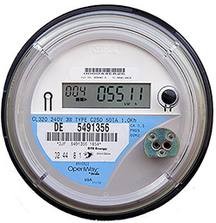
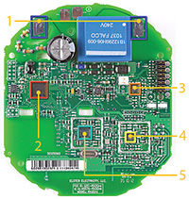
What is a smart meter? Smart meters are computerized electric meters that that transmit electricity and gas usage to the utility using radio-frequency (RF) communication. These are the same waves that cell phones emit, but smart meters broadcast 24/7 at a power density 100 to 160 times that of a cell phone. (Smart meters are also known as advanced meters, and companies like DTE insist on using this term because of the negative publicity smart meters have gotten ever since they started making people sick. They call the installation of a smart meter
a “meter upgrade.”). Smart meters can record your electrical usage in fine detail. Because of this, smart meters generate dirty electricity (line noise), which is as harmful to health as the wireless radiation the meters emit.
Analog meters do not require electricity to run. That makes them much more energy-saving than a smart meter. Analog meters can’t be hacked. Analog meters do not generate harmful dirty electricity, unlike most—or perhaps all—digital meters.
The electromagnetic frequencies generated by smart meters harm the health of humans, animals, and insects (including bees) by disrupting cellular communication, promoting stress hormone production, and disrupting many other biological processes in the body. You can read more about this below and also on our Health pages, which you can find under The Issues tab.
Smart meters enable the ability to collect and store data to see what appliances you own, when you use them, and how long you use them for, which raises privacy concerns. The new meters are causing electrical issues in homes, both new and old, including fires and appliance short-outs. In some homes and neighborhoods, they are interfering with AM/FM radios and with other wireless devices (Comcast customers are experiencing numerous problems due to the smart meters).
Smart meters allow the utility to shut off your electricity without sending someone to your home (remote shut-off). The Zigbee wireless network they contain allows the utility to shut off new smart-chipped appliances whenever they want. One of the main reasons the utilities are deploying smart meters is because these meters will allow them to charge time-of-use rates (peak pricing), which means you will be paying way more for electricity when you most need it. Smart meters put meter readers out of jobs, something the utilities are promoting as a positive change.
Smart meters put meter readers out of jobs.
Gas smart meters are also causing severe health problems for some people, including stroke-like symptoms and insomnia. Learn how to keep the gas smart meter off your home. See our page Do I Have a Smart Meter? to learn what a gas smart meter looks like and what it does.

Smart Meter Radiation
The electromagnetic spectrum is divided up into a number of categories. The wireless radiation emitted by smart meters is known as radiofrequency radiation (RF) or microwave radiation. Smart meter radiation falls near cell phone radiation on the electromagnetic spectrum. At the left end, you find what is known as extremely low frequency, or ELF, radiation.
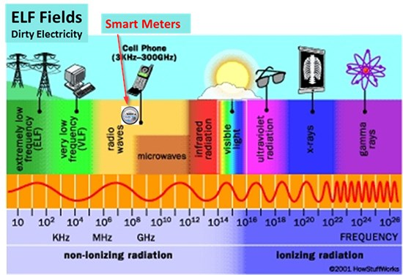
This is the radiation that our cells use to communicate with each other and that is used in nerve transmission. The 60 Hertz of your home wiring is ELF radiation, and is generally a continuous, smooth wave. The dirty electricity that is generated by smart meters is also ELF radiation, but this ELF radiation is pulsed and spiky rather than continuous and smooth.
Our bodies communicate thru electromagnetic and chemical signals, so the electromagnetic spectrum matters. We didn’t evolve to handle these smart-meter frequencies, especially not in huge 24/7 amounts.
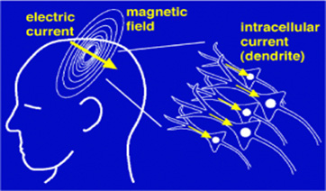

How Often Do Smart Meters Really Transmit?
Are There Really Only 6 Transmissions Per Day?
DTE and other utility companies will tell you that their smart meters transmit only 6 or so times a day. Take a look at the picture below. This is a graph of just a half hour of smart meter transmissions. Does this look like 6 transmissions per day? No. This data was captured by engineers working for EPRI, the Electric Power Research Institute, a group that is a strong proponent of smart meters. It records the transmissions of Itron smart meters, which are the meters used by DTE. Read the full report.
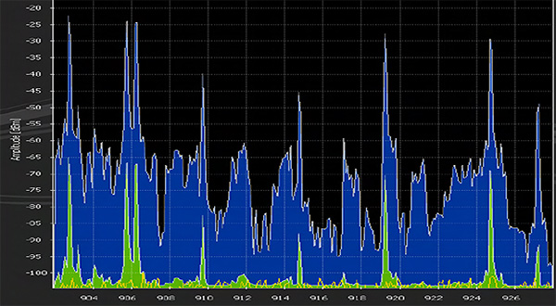
The truth is, smart meters transmit pulses of wireless radiation between 9,600 to 190,000 times per day. If you call up DTE or Consumers Energy and ask them how often their smart meters transmit, they will tell you something like “6 times a day.” This is what all the utility companies say, and they are lying. PG&E, the California equivalent of DTE, publicly stated in all its materials that its meters transmit only 6 times a day. When the court ordered it to submit data on the actual number of transmissions, the utility had to admit that its smart meters transmit 9,600 to 190,000 times per day!
Here is the chart PG&E submitted to the court:
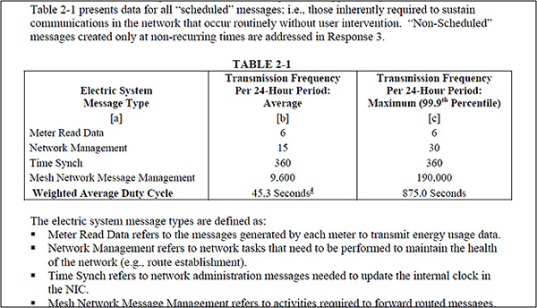
In the chart, you will see the line “Meter read data.” This refers to the number of times readings are sent to the utility. That is where the utilities get “6 transmissions per day.” But take a look at the second-to-last line: “Mesh network message management [transmissions].” These transmissions are up to 190,000 times per day. One hundred ninety thousand times is the maximum number of times a single meter sends messages to all the other meters in its area. Think about how many meters are within a two-mile radius of your home and multiply 190,000 by that number.

Do Transmissions Really Average 45 Seconds Per Day?
What the utilities will tell you is, 9,600 to 190,000 transmissions per meter per day is no big deal. If you average all the transmissions, a single smart meter is transmitting 45 seconds per day (see the last line in the chart). There are 86,400 seconds in a day. Forty-five seconds per meter per day times even a very conservative estimate of 1000 meters within a mile of your home means that half the day is spent on smart meter transmissions. But this isn’t the full picture. Each meter is transmitting in millisecond blasts 24/7. There are 1000 milliseconds in a second. You are being bombarded every half second to every few seconds with smart meter radiation. And actually even more, because it’s not just your smart meter that’s transmitting. Multiple 190,000 by the number of meters in a 2-mile radius—thousands if you live in a city—and you have a realistic picture of how many radiation pulses your body is really experiencing.
Your body experiences every single hit. The utility statements are like time-averaging the blows from a jackhammer. Even though most of the time a jackhammer is on, it’s not hitting something (but rather travelling toward its destination), when it hits, it hits hard. If you time-averaged jackhammer blows, you’d believe a jack hammer didn’t have enough strength to break concrete. But it does. Pulsed radiation, just like pulsed jackhammer blows, are harmful.
You might say, “Well, there are so many other wireless devices and radio-frequency waves in the environment nowadays.” That’s true. And they are also harmful to health. But smart meter radiation is far and beyond the radiation from other devices, both because of the microwave radiation and the dirty electricity it generates. Let’s take another look at the EPRI chart we presented above.
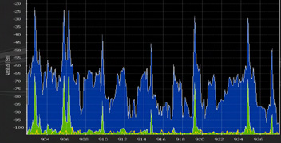
The blue represents peak smart meter frequencies within a half-hour period. (Note that this chart does not represent all the transmissions within a half-hour period, as the transmissions come so quickly and so often that the meters used to measure transmissions cannot capture them all.) The green represents the averaged smart meter frequencies, which, as you can see, are much lower. That is what averaging does. And you might just be able to make out at the bottom a yellow line. That barely discernible line represents the background radiation from all other sources (Wi-Fi, cell towers, etc.). That amount has increased strikingly since the EPRI report was issued in 2010, but even if it has doubled, it does not even begin to touch the smart meter frequencies. Here are two blow-ups of a portion of that chart, so that you can better see the non-smart-meter radiation:
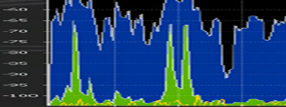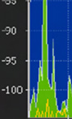

The FCC Limits Are Well Above Even Peak Transmissions,
So Why Does Any of This Matter?
The FCC limits for smart meters—and every other kind of radiation—look only at the average over time, not the “peak pulses.” So when the utilities say their smart meter emissions fall within the FCC limits, all that means is the average pulse does not exceed the FCC limits. But consider this. The FCC limits were designed for a half-hour one-time exposure to radio-frequency by a six-foot tall, 200-pound man. They were designed only to prevent his tissue from being over-heated in a half hour. They did not take into account the biological effects on cells and on organs like the heart, the brain, and the gastro-intestinal system. These guidelines were not designed for repeated exposure, and they were certainly not designed for continuous, 24-hour exposure. The European Union has stated that the exposure limits are too high. The U.S. Department of the Interior stated in 2014 that cell-phone tower emissions are harming wildlife. Humans are also animals.

How Smart Meters Transmit and Why This Matters
Hot Spots and Amplification
Here is a picture of what most people think of when they think of smart-meter signaling. One meter on a house, a little burst a few times a day that travels in a straight line. This is the kind of thing the utility companies show you, convincing you, “Oh, it’s just one little meter. No big deal.” In fact, the meters do not spread the radiofrequency waves in a straight line, as this picture would imply. Rather, the waves radiate from their source in all directions. 24/7. It’s not just the person standing in the red line that will get a dose of RF.
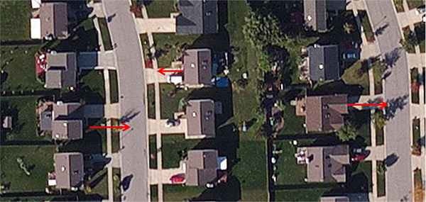
This picture represents the incorrect notion most peopl have about microwave transmission from smart meters. Smart meters are in fact emitting radiation 24/7 for 2 or more miles.

Here’s a picture of just three smart meters communicating with each other. The red dots represent meters. (For the time being, you can ignore the red and blue lines in the picture.)
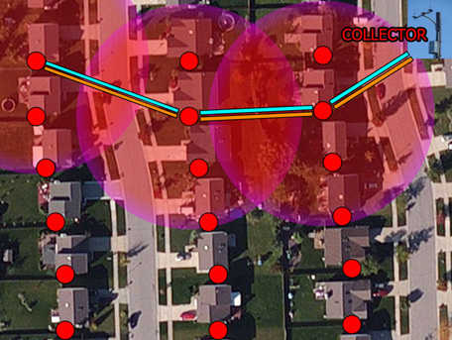
Notice that the meters send out microwave radiation in all directions, which is represented here by the large circles. If we could show you this in three dimensions, the circles would become globes. Where the microwaves (radiofrequency signals) sent out by meters overlap, there are hot-spots of higher-than-expected radiation. The meters can transmit a strong signal for two miles, so these circles represent only a fraction of the actual transmission distance. Keep in mind that many homes have more than one meter, and in addition there are smart gas meters and, in many places, smart water meters, all of which are also transmitting 24/7.
The picture below shows you what it’s really like. Each one of these circles (globes) you see on this picture is pulsing in millisecond blasts. If people could see this—if it were like smoke, or smog—we’d be cleaning it up right away! In fact, it’s know as electro-smog. Dr. Karl Maret calculated in 2010 that background RF radiation had increased 20,000 times since 1980. With the widespread introduction of smart meters across the country in the last few years, that number has increased exponentially. If people could see this—if it were like smoke, or smog—we’d be cleaning it up right away! In fact, it’s known as electro-smog.
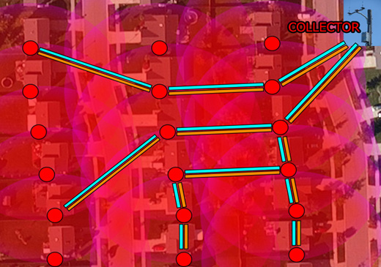
Smart meter electrosmog, represented by the large red circles. The small circles represent meters. Many houses have more than one electric meter, in addition to smart gas and water meters, as well as Wi-Fi.
Let’s take a moment to learn about collector meters, meter chatter, and mesh networks because they have important implications for health. As we mentioned, smart meters send information (data on your electricity usage) to the utility about 6 times a day. However, the meters are chattering with (talking to) one another constantly, comprising what is known as a mesh network. It is this “chatter” (incessant signaling) that accounts for the 9,600 to 190,000 transmissions per day. Unlike a cell-phone network, which has large antennas that capture and transmit data, with individual phones moving around and connecting to the closest antenna in order to utilize the network, a mesh network has no centralized antennas. Every meter in the network can connect to every other one. A DTE employee has told us that one in every 17 or so homes or office buildings is the collection point for all the meter transmissions in an area. As this employee put it, “We know the person who has a collecting meter on their home is going to have a funeral coming up soon.”
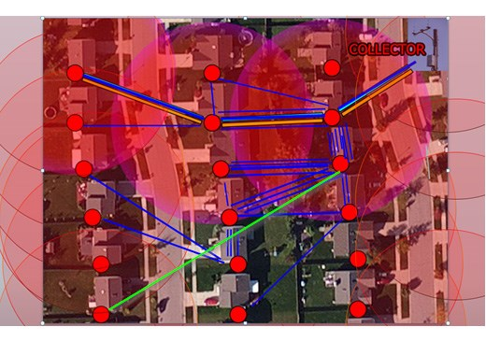
Representation of meters signalling to each other. Signals can travel meter to meter (represented by the red lines), or a meter can skip many meters (the latter represented by the green line). One or more of these meters is a collector meter, which receives many more signals than the other meters because it is the “gathering point” that meters send their data to. The collector meter then sends data to a data collection unit, which is often mounted on a telephone pole. Meters chatter with each other 24/7. This picture cannot even begin to represent the multitude of signals. At the same time that all this is happening, the data collection unit and collector meter may be sending signals back to the meters (singals back represented by the red lines).

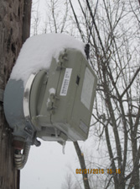
DTE data collection unit or relay station mounted on a telephone pole. Note the antenna.
The meters send their data to a collector meter—which is mounted on someone’s home—by passing it meter to meter. The collector meter gathers all the data in the area and sends it to adata collection unit, which is often mounted on a telephone pole. The closer your meter is to the collector, the more transmissions—pulses of radiation—you are receiving each day. Keep in mind, the meters are chattering with one another constantly. And not just with one meter—with multiple. So there are transmissions far and beyond what is represented in the picture—a single transmission could actually consist of 80 queries. Multiply that by 40 or so meters, and you have 3200 “single” transmissions. Multiply that by 190,000. You see where that leads. The collector meter asks another meter for data. It is querying meters constantly. There can be 40 meters in a network, which means it could be querying 40 meters every few seconds. Each meter sends its data to the meter closest to it, then that one to the next one, etc. So a single transmission could consist of up to 80 queries (40 x 2 = [the query x 40] + [the signal back x 40]). The meter closest to the collector would only have to send its query to the collector, so it has 2 transmissions per query. BUT—the meter closest to the collector is receiving all the other signals.
Signals can travel meter to meter (represented by the blue lines), or a meter can skip many meters (the latter represented by the green line). This picture cannot even begin to represent the multitude of signals.
At the same time that all this is happening, the data collection unit and collector meter may be sending signals back to the meters (represented by the red lines). To see pictures of the various types of data collection units and to read more about them, read our Data Collection Unit page.
In addition to the RF from your smart meter and all the other meters in your city, you are getting dosed with microwave radiation from the ZigBee wireless radio that connects with all the “smart” appliances DTE and the appliance manufacturers hope you will soon be buying. This Zigbee is not turned off, so radio-off opt-out meter is a misnomer. We’ll talk about the privacy implications of this later. The Zigbee radio sends RF signals into your home, polling your smart appliances in the same way DTE smart meters poll the other meters in the neighborhood. If you have a smart meter, all this data can potentially be sent back to the utility, letting them know what kinds of appliances you have in your home and when and how you use them. Learn more on our Privacy page. The Zigbee also connects with your gas meter. The 2.4 GHz that it operates at is harmful to health.

Dirty Electricity

What Is Dirty Electricity (Electromagnetic Interference)?
So, you might be thinking, all this sounds pretty bad. Why not just have DTE put the opt-out meter on your home and save yourself a big fight?The reason is, the smart meter not only emits RF, it also generates what is commonly known as dirty electricity (a.k.a., line noise or power quality issues). Dirty electricity is pulsed electromagnetic radiation, and causes numerous health problems. We also discuss dirty electricity on our Dirty Electricity page. This page will give you some of the same as well as different information that what you will find on our Dirty Electricity page, so we suggest you read both pages.
In order to run the smart meter or any digital meter— the 240 volts coming off the power line to the meter must be stepped down to 4–10 volts. Otherwise, the computer circuitry in the meter will be fried out. A switched mode power supply inside the meter steps down the voltage, then steps it back up to 120 volts, the voltage that powers your home. This process of stepping down and stepping up generates an enormous amount of what is commonly known as “dirty electricity” and referred to by electricians and electrical engineers as “voltage transients,” “harmonics,” “line noise,” “power quality issues,” or “electromagnetic interference.”
Here you see a picture of dirty electricity. Notice how spiky and variable it is.
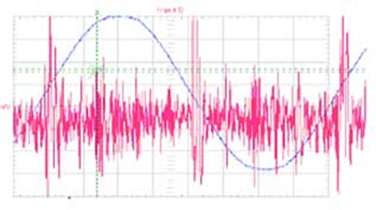
The blue wave you see running through this is a so-called clean wave. There are no spikes, no variability. That is what the electricity running through your home should look like. Scientific studies indicate that pulsed electromagnetic waves—which includes dirty electricity and the radiofrequency waves emitted by smart meters—are especially deleterious to health. Learn more on our Health page, and read more below.
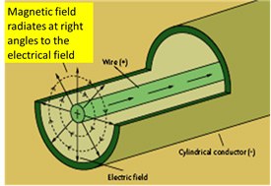
This dirty electricity travels through your home wiring. The magnetic field radiates out from your home wiring, into the room you are in. You are surrounded by it above—in your ceiling; below, if you have a basement; and on all sides. You are being hit with millisecond blasts of dirty electricity, similar to the smart meter pulses we discussed earlier.
Notice in the picture below how dirty electricity is similar to the pictures you saw earlier of the spiky RF from smart meters.
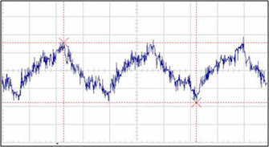
Here is another way to understand dirty electricity. The first wave in the picture below shows a “clean” electromagnetic wave, the kind you would find in your home wiring if it weren’t for smart meters and other forms of electromagnetic interference. Every second the wave peaks. It is consistent.
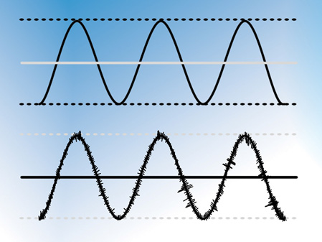
Most people’s bodies adapt to this regularly occurring wave. The bottom wave shows how dirty electricity “rides” on this wave. You can see why dirty electricity is also known as “electromagnetic interference” and “line noise.” These frequencies are extremely difficult to filter out. This picture is from a company that manufactures filters to filter out line noise. As the company’s website notes, “Any imperfections in this signal can adversely affect electrical equipment, causing poor performance, incorrect functionality or damage to sensitive circuitry.” This helps you understand why some people report that their appliances have been fried out after smart meter installation. Smart meter frequencies are extremely difficult to filter out, according to Rob States, an engineer who is developing systems to work with the electromagnetic interference caused by smart meters.
Because dirty electricity can back up on the power line, the houses around you with smart meters can contaminate your lines.
Many modern-day devices generate dirty electricity. They do not generate the gigantic spikes that smart meters do, and they do not contaminate your entire home. They may contaminate
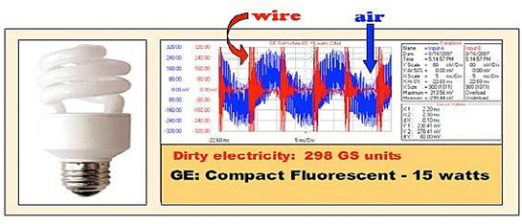
an entire circuit in your home, or only a part of it. But having a laptop plugged into the circuit in your office will not contaminate the circuit in your bedroom. Dirty electricity is best measured with an oscilloscope. A Graham-Stetzer filter will allow you to inexpensively get an idea of some of the degree of dirty electricity contamination in your home.

Dirty Electricity and Health
Dirty electricity is as responsible for the health effects from smart meters as radiofrequency, perhaps even more so. People who have smart meters with one of the two radio-transmitters turned off are getting just as sick as people with fully functioning smart meters. Here’s one example:
A family was moving from a home with an analog meter. The mother said, “Knowing the dangers of radiation from a smart meter, I opted out, thinking it was all going to be fine.” DTE installed the opt-out smart meter, the family moved in, and she and her children were ill by the very next day, experiencing vomiting, nosebleeds, flu-like symptoms, ringing in the ears, and headaches. As time went on, the mother experienced brain fog and memory problems. At first, her husband did not experience any problems and thought that perhaps it was all in his wife’s head, but a month later he began spending more time at home and began suffering as well. The family removed the meter from their home after two months and their symptoms subsided immediately.
One man with an opt-out meter has wound up twice in the ER with mental confusion. He feels metallic shocks through his body when inside his home and cannot sleep. He is a successful businessman, and began sleeping in his car. Now he shuts off all his electricity except when he needs it. Prior to DTE’s opt-out meter, he had a regular smart meter on his home. Because it was making him sick, he took it off. The so-called non-transmitting meter didn’t help, as you can see.
All the symptoms people experience with smart meters are experienced by people with opt-out meters.

Health
Our bodies are electromagnetic. This is why our brains work and why our heart beats and our muscles contract. As Michio Kaku, CUNY physicist, futurist, and author says, “Our brains are milliwatt transmitters.” Nature, the premier publication in science, notes: “There are striking analogies between signaling networks in biological systems and electronic circuits.”
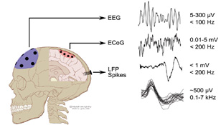
Brain signaling is an electromagnetic and electrochemical phenomenon.
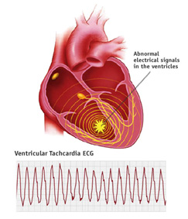
The heart beats via electromagnetic signals. Heart palpitations, pre-ventricular contractions, and tachycardia are commonly reported by people after smart meters are installed on their homes.
The magnetic field of the heart, from Arthur Winfree, PhD, When Time Breaks Down
Electromagnetic fields of all kinds (radiofrequency/microwave, dirty electricity) knock calcium ions off the cell membrane. This accounts for the wide variety of effects seen with exposure to smart meters because calcium acts like a neurotransmitter. Thus, your heart, your gut, your brain, your muscles, and your hormones can be affected. In general, the first place that is harmed is the place where you have the least resistance. Over time, various other organ systems will be harmed. We go into this in great detail on our Health: The Science page.
Martin Blank, Ph.D, of Columbia University, has been researching the effects of electromagnetic fields for over 40 years. At first he, like most scientists, was a non-believer: radiofrequency couldn’t possibly cause he alth problems. He read a research paper by a colleague (Reba Goodman), and couldn’t believe her findings. But, like a good scientist, he kept an open mind. He talked with her and began to
conduct his own studies. He found that her conclusions were correct. He had believed there were no effects, because that is what the textbooks—based on no research whatsoever, just an inference—had taught him. And it is what he taught to his students. Medical students continue to be taught that most electromagnetic fields do not affect the human body.
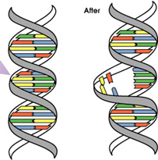
Breakage of DNA bonds.
Blank’s research looks at how electromagnetic fields break DNA bonds. This is a precursor to cancer. Both radiofrequency and the pulsed electromagnetic fields from dirty electricity can break DNA bonds. Blank has written the book Overpowered, about the effects of electromagnetic fields on health.
Below is a picture from the University of Utah researcher Om Ghandi showing how far cell phone radiation penetrates into the brain. Studies by University of California at Santa Cruz Professor of Nuclear Policy Daniel Hirsch show that the whole-body cumulative radiation exposure from wireless meters is 100–160 times more than cell phone exposure.
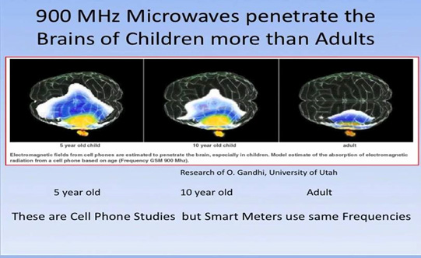
The latest cell phone research shows that people who used wireless phones—cell or cordless—for more than a year were at 70% greater risk of brain cancer as compared to those who used wireless phones for a year or less. Those who used wireless phones for more than 25 years were at a 300% greater risk of brain cancer. As we have seen above, smart meters emit far more radiation than al other sources combined. The son of one of our members has just been diagnosed with a glioblastoma. This kind of cancer, once rare, is increasing dramatically in the population. His cancer is in his left temporal lobe, right where most people hold their cell phone.
As Robert Kane, Ph.D., the Motorola electrical engineer who worked on cell phones, said: When exposed to cell phones, “tissue destruction in one’s brain may be occurring w/o the slightest indication that anything is happening. And the damage may be repeated, over and over again, each time the energy exposure takes place.” With pulsed electromagnetic fields (RF and dirty electricity), the exposure is thousands of times a day, in millisecond blasts. Four of the five people working on cell phones for Motorola died of brain cancer, including Kane. Read Kane’s book on Cellular Telephone Russian Roulette, which can be freely downloaded. Cancers can take 15 or 20 years to develop. Do you want to take that chance?
There are literally tens of thousands of scientific studies showing the deleterious effects of pusled electromagnetic radiation (radiofrequency and dirty electricity) on the body. You can find many of them at the Bioinitiative Report and JustProveIt.net. JustProveIt catalogs every study, regardless of findings.
Let’s look at some of the health effects people in Michigan are experiencing. You can read many more stories of Michigan residents on our Smart Meter Health blogspot.
Drew, a 16-year-old diabetic boy, had had stable blood sugar levels since his diagnosis two years earlier. In July 2012, a smart meter was put on his home. Neither he nor his mother knew this. His mom, Leslie, was suddenly unable to sleep but didn’t know why. She’d always been a very good sleeper. In late August, after telling friends about her inability to sleep, someone asked her if a smart meter had been put on her home. “What’s a smart meter?” she asked.
She discovered the a meter, and learned it had been installed the day she became unable to sleep. Meanwhile, her son was sleeping just fine. But smart meters can be silent killers. Two months after the meter was put on his home, Drew went to the endocrinologist for his usual check-up. The doctor told him his blood-sugar levels had shot into the danger zone.
Leslie suspected the smart meter might be the cause of their symptoms. She spent months trying to get DTE to take it off their home. DTE refused. Leslie was so wracked with insomnia, she began sleeping in a tent in her yard until the high winds in October blew it down repeatedly.
Finally, she took the smart meter off, in January 2013. Drew went back for his checkup a month later, and his blood-sugar levels had returned to a normal range. Three months later, at his next check-up, they were even better. Leslie, meanwhile, was able to sleep again. Leslie, by the way, still has her analog meter on her home.
Numerous scientific studies show that radiofrequency and pulsed ELF fields affect hormones—insulin is one of those hormones. A man from Inkster told us that he had sudden spikes in his blood sugar and blood pressure, which had always been well-maintained with medication. His doctor couldn’t figure it out. Then, someone gave him one of our flyers. He read it, took it to his doctor, and his doctor said, “Well, that’s the likely cause.” His smart meter had been installed just before his blood pressure and blood sugar spiked. We have received report after report of blood sugar levels increasing and of high blood pressure occurring immediately after smart meter installation.
Thyroid problems are another common problem. Melatonin is another hormone disrupted by radiofrequency. Effects of reduced melatonin include insomnia, eye stress, chronic fatigue, miscarriage, DNA damage, and cancer.
Here’s another story.
Caroline says: “Life can change in a heartbeat—literally. That’s what happened for me. We didn’t know a smart meter had been installed on our home until we got our electric bill about a month after the meter was installed. Was I worried? Just the opposite— I was excited, having heard only great things about them.”
Caroline had been waking up with a racing heart for a few weeks before she got her electric bill. “I couldn’t figure it out. Was I having bad dreams? Soon, I began noticing irregular heart palpitations during the day. I was also experiencing insomnia, headaches, ear pain, difficulty hearing, flu-like symptoms, numbness, excessive flatulence and abdominal pains, and rashes, to name a few.” Her children began to get many of the problems. She thought maybe they all had the flu. Her husband seemed to be fine. Then, he had two weeks off work and began to develop rashes.
Notice how Caroline figures it must be anything but the smart meter causing the problems—bad dreams, the flu. And, like most people, her health problems began before she knew a smart meter had been installed on her home.
By chance, while doing an Internet search on the environmental benefits of smart meters, she clicked on a link and found person after person was reporting the symptoms she and her family were experiencing—all after smart meter installation. “It seemed crazy. We—my family and I—had been using wireless technology for years. How could these meters be any different? How could they truly affect people's health like this? So began my crash course on EMFs, microwave technology, and electrohypersensitivity.”
Why do smart meters cause such a vast array of health effects? The effect of EMFs on calcium can explain the vast majority of health effects, first because calcium plays a critical role in the transmission of nerve signals and secondly because calcium is the glue that holds the cell walls together. EMFs can easily knock the calcium ions off the cell membrane.
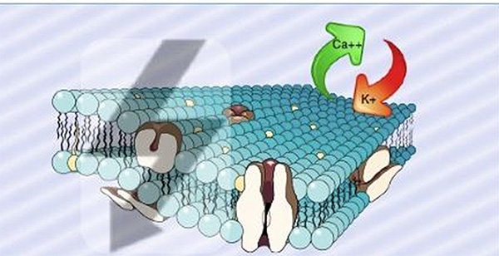
Representation of calcium ion being knocked off the cell membrane. Calcium holds the cell wall together. When cell walls break, contents move in and out in ways and amounts that are detrimental to the body. Calcium, which has a double positive charge, and thus bonds tightly, is replaced by potassium (K), which has a single positive charge and cannot hold the wall together as well.
An excess calcium causes the transmission of unnecessary nerve signals. This accounts for things like heart palpitations, insomnia, and anxiety, and ADD. You can read about this in greater detail on our Health: The Science page, where we have numerous links to research on this phenomenon.
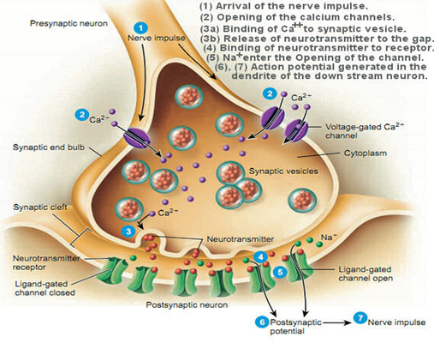
When calcium is pulled off the cell wall, the cell membrane is weakened—the cell becomes leaky. Leaky cell walls cause the blood-brain barrier is breached. The blood-brain barrier protects our brain from toxins. A leaky blood-brain barrier is partly responsible for diseases like Alzheimer’s, dementia, and Parkinson’s. Have you ever wondered why we have seen such a huge climb in the rate of Alzheimer's, dementia, and Parkinson’s disease? Have you noticed how the increase correlates with the proliferation of wireless in our society? The background RF radiation has increased 20,000 times since the 1980s! It’s about 15 years into that that we started to see a really big rise in these diseases.
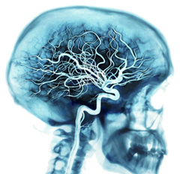
Representation of calcium ion being knocked off the cell membrane. Calcium holds the cell wall together. When cell walls break, contents move in and out in ways and amounts that are detrimental to the body. Calcium, which has a double positive charge, and thus bonds tightly, is replaced by potassium (K), which has a single positive charge and cannot hold the wall together as well.
Medium to high EMF exposure increases risk of Alzheimer’s four- to five-fold. The incredible rate of increase in Alzheimer’s, dementia, Parkinson’s, ADD, Lou Gehrig’s disease and many other diseases and disorders correlates with the increasing prevalence of radiofrequency radiation and digital devices in our environment.
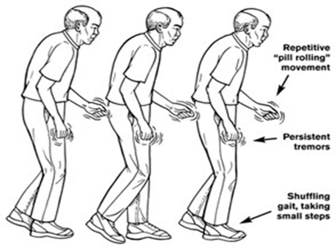
Leaky blood-brain barriers are implicated in Parkinson’s disease. See, e.g., study 1, study 2, study 3.
Science mainly works deductively. That means that you observe phenomena in nature, then work at discovering the likely cause or causes. It doesn’t take a rocket scientist to see that the installation of a new technology on people’s homes is causing changes in their health. Very few—if any—people in Michigan were complaining that they felt ill inside their own home prior to the installation of a smart meter on their home. Many of the people who have fallen ill did not know—some for literally three years—that a smart meter had been installed on their home. Remember how Gulf War syndrome was pooh-poohed by scientists and the military as being all in people’s heads? The question isn’t whether it is affecting people. The question isn’t really even how, though our understanding can always be increased. The question is, why are we installing a dangerous technology on people’s homes? And, if the powers that be are insistent on its continued use—How do we make it safe?
Read more about the effects of EMFs on health on our Health: The Science page, our Health Problems People Are Experiencing page, and our Dirty Electricity page. For numerous stories on health effects, see our Smart Meter Health blogspot.

Environment
Read about the effect of radiofrequency and smart meters on the environment on our Environment pages: Environmental Hazards, Do Smart Meters Really Save Energy?, and More Environmental Information.

