November 30, 2016
VIA WEB PORTAL AND U.S. MAIL
Mr. Steven V. King
Executive Director and Secretary
Washington Utilities and Transportation Commission
1300 S. Evergreen Park Drive, SW
Olympia, WA 98504
Re: Petition of Puget Sound Energy, Inc. for (i) Approval of a Special Contract for Liquefied Natural Gas Fuel Service with Totem Ocean Trailer Express, Inc. and (ii) a Declaratory Order Approving the Methodology for Allocating Costs Between Regulated and Non-regulated Liquefied Natural Gas Services, Docket No. UG-151663
Notice of the Formation of Puget LNG, LLC by Puget Energy, Inc.
On October 31, 2016, the Commission issued Order 10 (Final Order Approving and Adopting Settlement Stipulation; Reopening Record and Amending Order 08 in Docket U-072375) in Docket UG-151663. Among other things, the Commission approved in Order 10 several new ring-fencing provisions proposed by the Settling Parties to that proceeding and assigned these provisions numbers consistent with Appendix A to the settlement stipulation the Commission approved in Order 08 in Docket U-072375. Among the ring-fencing provisions approved by the Commission in Order 10 included the following new Commitment 64:
Within thirty (30) days of issuance of an order by the Commission approving the Settlement Stipulation consistent with its terms and its conditions, Puget Energy will form or will cause to be formed a wholly-owned subsidiary of Puget Energy named Puget LNG, LLC (“Puget LNG”). Puget LNG will be a special purpose limited liability company formed by Puget Energy solely for the purposes of owning, developing, and financing the Tacoma LNG Facility as a tenant-in-common with PSE.
Order 10 at ¶ 74.
Puget Sound Energy hereby gives notice to the Commission that Puget Energy filed a Certificate of Formation for the formation of Puget LNG, LLC (“Puget LNG”) with the Washington Secretary of State on Tuesday, November 29, 2016. As of the date of filing, Puget LNG is a limited liability company that is wholly-owned by Puget Energy and created solely for the purposes of owning, developing, and financing the Tacoma LNG Facility as a tenant-in-common with PSE. Attached as Exhibit A to this letter is a screenshot from the Washington Secretary of State website that provides additional information regarding the formation of Puget LNG.
If you have any questions, please contact the undersigned at 425-635-1416 or jkuzma@perkinscoie.com.
Very truly yours,
/s/ Jason Kuzma
Jason Kuzma
JTK
Attachments
Cc: Service List in Docket UG-151663
Exhibit A
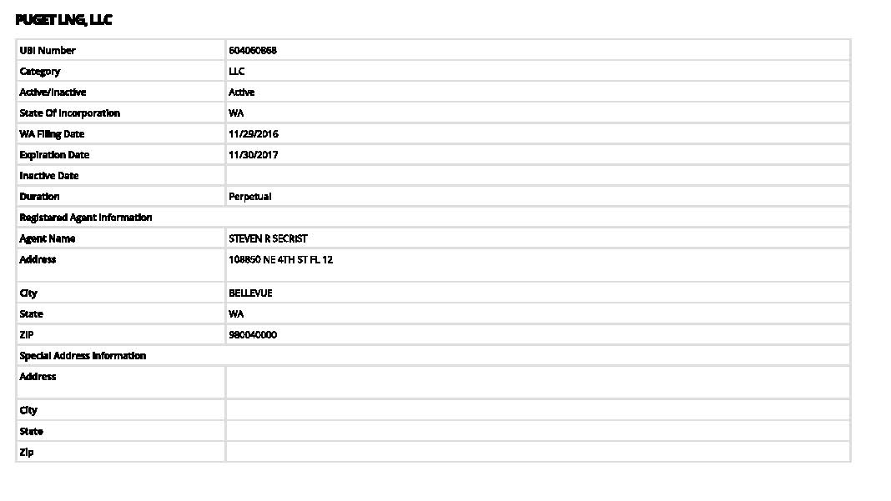

Certificate of Service
CERTIFICATE OF SERVICE
DOCKET NO. UG-151663
(Re: LNG Petition)
I hereby certify that I have this day caused the foregoing to be served, in accordance with WAC 480-07-150(6), to the following persons via email and U.S. Mail:

Commission Staff:  Brett P. Shearer  Jeff Roberson  Office of the Attorney General  Utilities and Transportation Division  1400 S. Evergreen Park Dr. S.W.  P.O. Box 40128  Olympia, WA 98504-0128  Phone: (360) 664-1187  Phone: (360) 664-1188  Fax: (360) 586-5522  Email: bshearer@utc.wa.gov  Email: jroberso@utc.wa.gov | Public Counsel:  Lisa W. Gafken  Assistant Attorney General  Office of the Attorney General  Public Counsel Section  800 Fifth Avenue, Suite 2000  Seattle, WA 98104-3188  Phone: (206) 464-6595  Fax : (206) 464-6451  Email : lisa.gafken@atg.wa.gov
Attorneys for NWIGU  Chad M. Stokes  Tommy A. Brooks  Cable Huston  1001 SW Fifth Avenue, Suite 2000  Portland, OR 97204-01136  Phone : 503-224-3092  Fax : 503-224-3176  Email : cstokes@cablehuston.com  tbrooks@cablehuston.com | NWIGU:  Ed Finklea  Executive Director  Northwest Industrial Gas Users  545 Grandview Drive  Ashland, OR 97520  Phone : 541-708-6338  Fax : 541-708-6339  Email : efinklea@nwigu.org
Attorneys for ICNU
Tyler C. Pepple
Davison Van Cleve, P.C.
333 S.W. Taylor, Suite 400
Portland, Oregon 97204
Phone: 503-241-7242
Fax: 503-241-8160
Email: tcp@dvclaw.com
Dated in Bellevue this 30th day of November, 2016.
/s/ Jason Kuzma___________________
Jason Kuzma

The Settling Parties are Puget Sound Energy, the Commission’s regulatory staff, the Public Counsel Unit of the Washington Attorney General’s Office, the Northwest Industrial Gas Users, and the Industrial Customers of Northwest Utilities.

