BEFORE THE WASHINGTON UTILITIES AND TRANSPORTATION COMMISSION

DOCKET NO. UE-14_______
DOCKET NO. UG-14_______

EXHIBIT NO. ______ (SLM-2)
SCOTT L. MORRIS
REPRESENTING AVISTA CORPORATION

Description of Avista Utilities:
Avista Utilities provides electric and natural gas service within a 26,000 square mile area of eastern Washington and northern Idaho. Of the Company’s 366,305 electric and 325,919 natural gas customers (as of December 31, 2013), 240,246 and 151,676, respectively, were Washington customers. The Company, headquartered in Spokane, also provides natural gas distribution service in southwestern and northeastern Oregon. A map showing Avista’s electric and natural gas service areas is provided in Exhibit No.___(SLM-3).
As of December 31, 2013, Avista Utilities had total assets (electric and natural gas) of approximately $4.0 billion (on a system basis), with electric retail revenues of $743 million (system) and natural gas retail revenues of $314 million (system). As of December 2013, the Utility had 1,643 employees.

Description of Avista’s subsidiary businesses:
Avista Corp.’s primary subsidiary is the information and technology business, Ecova, which is headquartered in Spokane, Washington. Ecova provides utility expense management and energy management solutions to multi-site companies across North America. This includes more than 450,000 business sites. Ecova clients include Fortune 1000 companies such as GameStop, Panda Restaurant Group, Petco, Shell, Staples and, many North American electric and natural gas utilities. Avista currently holds a 79.2% share in Ecova, which is held under Avista Capital.
On November 4, 2013, Avista entered into an Agreement and Plan of Merger (Merger Agreement), with Alaska Merger Sub, Inc. (Merger Sub), and Alaska Energy and Resources Company (AERC). Merger Sub is a wholly-owned corporation of Avista and was created solely for the purpose of facilitating Avista’s acquisition of AERC, which includes the utility operations of Alaska Electric Light and Power (AEL&P). Upon receipt of all necessary approvals, Merger Sub would merge with and into AERC and dissolve as a corporate entity, leaving AERC as a wholly-owned subsidiary of Avista.
AEL&P is a wholly-owned subsidiary of AERC, and would continue to be a wholly-owned subsidiary of AERC following the completion of the proposed acquisition by Avista. AEL&P would continue to be operated by the same employees operating the utility today, including the existing management team of AEL&P. AEL&P has 60 full-time employees. AEL&P serves approximately 15,900 retail customers under the authority of the Regulatory Commission of Alaska, and is the sole electric utility serving the City and Borough of Juneau, Alaska.
The proposed acquisition of AERC is expected to be completed on or before July 1, 2014.
The following is a diagram of Avista’s corporate structure, including the proposed addition of AERC:
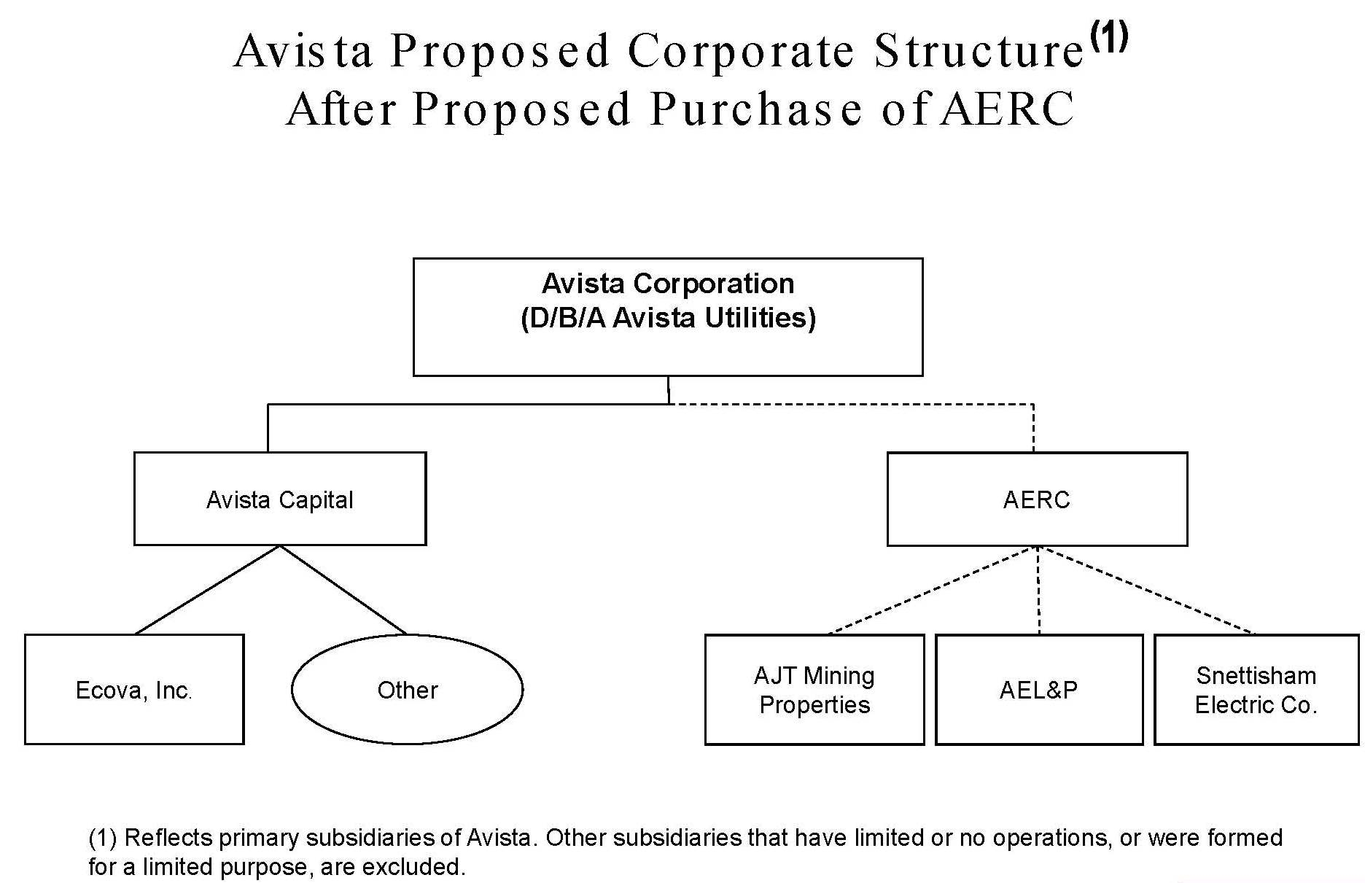

Avista also serves approximately 20 retail electric customers in western Montana.

