June 13, 2014

Steven V. King, Executive Director and Secretary
Utilities and Transportation Commission
1300 S. Evergreen Park Dr. SW
P.O. Box 47250
Olympia, WA 98504-7250

RE: Washington Utilities and Transportation Commission v. Kitsap Tours Limited

Commission Staff’s Response to Application for Mitigation of Penalties TE-141065

Dear Mr. King:

On May 27, 2014, the Utilities and Transportation Commission issued a $1,000 Penalty Assessment in Docket TE-141065 against Kitsap Tours Limited for 10 violations of Washington Administrative Code (WAC) 480-30-071, which requires charter and excursion carriers to furnish annual reports to the commission no later than May 1 each year.¹

On June 4, 2014, Kitsap Tours Limited wrote the commission requesting mitigation of penalties (Mitigation Request).² In its Mitigation Request, Kitsap Tours Limited does not dispute that the violation occurred. The company states, “At first I wasn’t sure the forms applied to me and then when I went to fill them out I was overwhelmed with the complexity. I eventually called your office and got clarification that I only needed to complete part of the form and I was advised that I had paid in December. I took this to mean all was o.k. My misunderstanding. It will not happen again. We are very small and have not yet taken a salary from out little business. Please consider a one time reduction in the penalty or forgive us this time.”

It is the company’s responsibility to ensure that the regulatory fee is paid and the annual report is filed by the May 1 deadline. On February 28, 2014, Annual Report packets were mailed to all regulated charter and excursion companies. The instructions for annual report completion page of the annual report informed the regulated company that it must complete the annual report form, pay the regulatory fees, and return the materials by May 1, 2014, to avoid enforcement action.

UTC Annual Reports
June 13, 2014
Page 2

On May 22, 2014, Kitsap Tours Limited filed the 2013 annual report and timely paid the required regulatory fees on December 31, 2013. The company has been active since April 5, 2010. No previous violations of WAC 480-30-071 are on commission record. The UTC also recently adopted new rules requiring the annual report to be filed by May 1 while the regulatory fees remained due on December 31. Despite the commission communication regarding these filing changes to all regulated charter and excursion companies, commission staff supports the company’s request for mitigation. Staff recommends a reduced penalty assessment of $200.

If you have any questions regarding this recommendation, please contact Amy Andrews, Regulatory Analyst, at (360) 664-1157, or aandrews@utc.wa.gov.

Sincerely,

Sondra Walsh, Director
Administrative Services

ATTACHMENT A
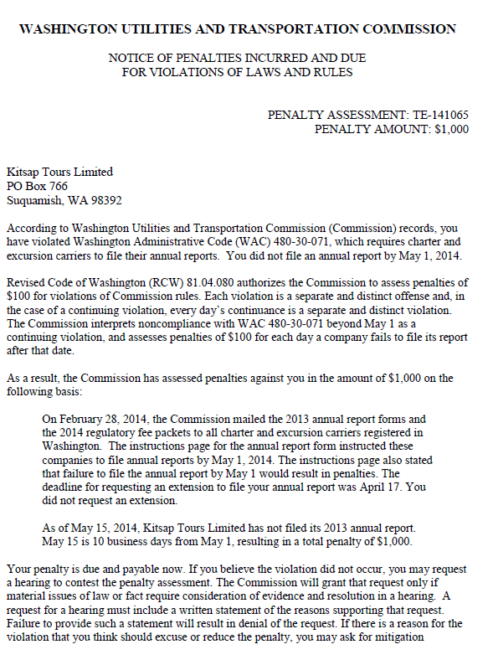

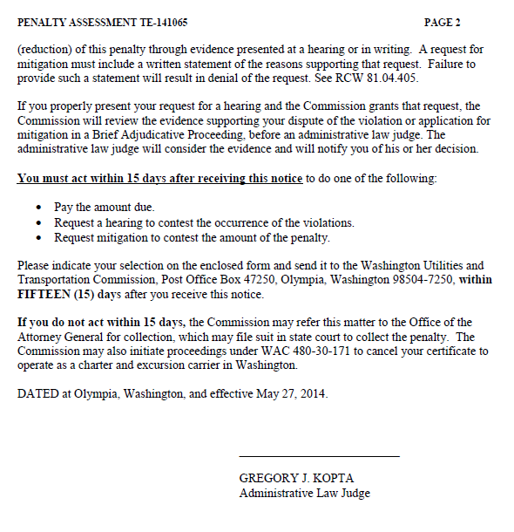

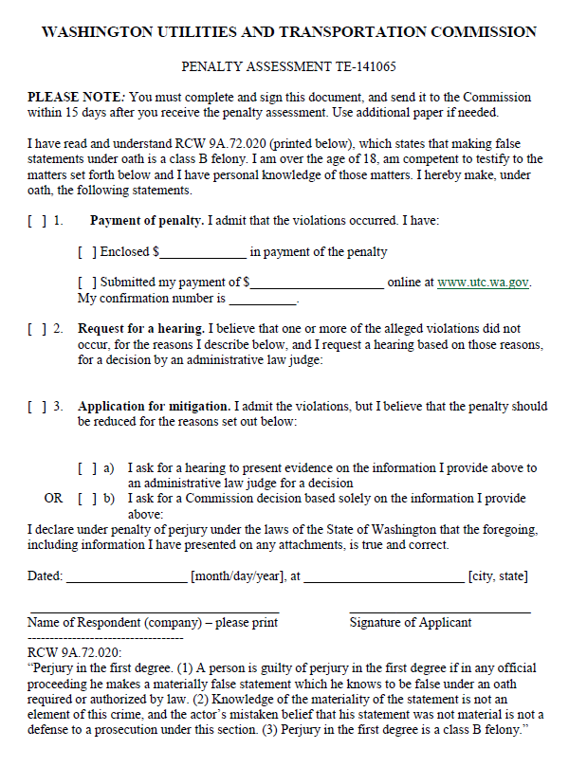

ATTACHMENT B
