Exhibit 7
2016-2017
Marketing and Outreach Executive Summary

November 1, 2015

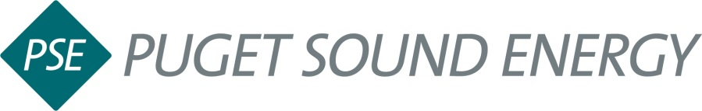

PSE Energy Efficiency Marketing and Outreach Executive Summary
The Customer Engagement Team’s (CET) responsibilities include the promotion of energy efficiency program offerings to achieve targets. This is accomplished by exercising promotional outreach to various market segments: residential direct-to-consumer, commercial and industrial, retailer, dealer, home and commercial builder and trade ally groups—with the goal of influencing and motivating those in PSE’s service area to take specific, energy-efficient actions. The team anticipates customer needs, fosters community within specific channels and ensures delivery on brand values, through a variety of marketing programs, promotions, communications, outreach, and events.
Communications efforts in 2016-2017 will continue to focus on the customer experience. Messaging and campaign deliverables will encourage customer engagement with PSE programs, events and promotions. Overall marketing and outreach initiatives will drive customers to engage in programs, offerings, savings, and promotions online and in person at various events.
The CET will also continue to partner closely with the EE Communities team and relationship management teams to ensure that energy efficiency messaging and programs are consistent, streamlined and targeted geographically. The Customer Engagement team will continue to align deliberate planning and outreach with regional teams and locations that can serve as efficient delivery channels for program opportunities within localized communities with localized needs. We will also continue to assess how to leverage PSE employees and contractors as delivery channels within their personal communities, and as they come into contact with customers in their daily work effort.
In 2015, the corporation adopted a new, customer-friendly brand platform that will be incorporated into our energy efficiency messaging in 2016-2017 and is expected to positively influence adoption of energy efficient behaviors and use of energy efficient products.
Overall, the CET theme for 2016-2017 is to continue the focus on customer engagement, anticipate their needs, increased promotion and awareness, and deliver targeted upsell programs and offerings to our customer base.

