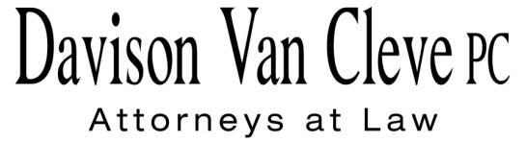
TEL (503) 241-7242 ● FAX (503) 241-8160 ● mail@dvclaw.com
Suite 400
333 S.W. Taylor
Portland, OR 97204

May 14, 2014

Via E-mail and Federal Express

Mr. Steven V. King
Executive Director
Washington Utilities & Transportation Commission
1300 S. Evergreen Pk. Dr. S.W.
P. O. Box 47250
Olympia, WA 98504-7250

Re: In the Matter of PUGET SOUND ENERGY
Petition For an Accounting Order Approving the Allocation of Proceeds of the Sale of Certain Assets to Public Utility District #1 of Jefferson County
Docket No. UE-132027

Dear Mr. King:

Enclosed please find an original and twelve (12) copies of the Cross Examination Exhibits of the Industrial Customers of Northwest Utilities (“ICNU”). Please note that one of ICNU’s exhibits, PSE’s Petition for Declaratory Order in Docket No. U-101217, was previously designated by PSE as confidential. Pursuant to a conversation with the Company, this Petition is no longer confidential. Accordingly, ICNU is submitting the unredacted version of the exhibit.

Please also note that ICNU estimates that it will require 30 minutes for its cross examination of PSE witness Samuel S. Osborne.

Thank you for your assistance. If you have any questions, please do not hesitate to call our office.

Sincerely,

/s/ Jesse O. Gorsuch
Jesse O. Gorsuch
Enclosures

cc: Service List

CERTIFICATE OF SERVICE

I hereby certify that I have this day served the attached Cross Examination Exhibits upon all parties of record in this proceeding by sending a copy via electronic mail and by mailing a copy via First Class U.S. Mail, postage prepaid, to the following parties at the following addresses.
DATED this 14th day of May, 2014.
Davison Van Cleve, P.C.

/s/ Jesse O. Gorsuch
Jesse O. Gorsuch

PUGET SOUND ENERGY  KEN JOHNSON  PO BOX 97034 PSE-08N  BELLEVUE WA 98009-9734  ken.s.johnson@pse.com | PERKINS COIE  SHEREE STROM CARSON  10885 N.E. FOURTH STREET STE 700 BELLEVUE WA 98004-5579  scarson@perkinscoie.com
WASHINGTON UTILITIES & TRANSPORTATION COMMISSION  DON TROTTER  PO BOX 40128  OLYMPIA, WA 98504  dtrotter@utc.wa.gov | OFFICE OF THE ATTORNEY GENERAL  LISA W. GAFKEN  800 FIFTH AVENUE, SUITE 2000  SEATTLE, WA 98104-3188  lisa.gafken@atg.wa.gov

