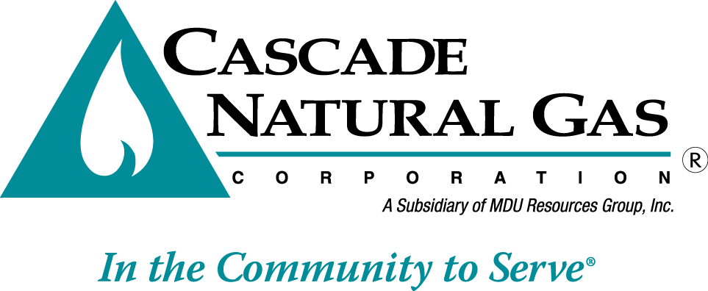 | 8113 W. GRANDRIDGE BLVD., KENNEWICK, WASHINGTON 99336-7166  TELEPHONE 509-734-4500 FACSIMILE 509-737-7166  www.cngc.com

May 10, 2016

Mr. Steven V. King
Executive Director and Secretary
Washington Utilities & Transportation Commission
1300 S. Evergreen Park Drive SW
Olympia, WA 98504-9022

RE: Advice No. CNG/W16-05-01

Dear Mr. King:

Enclosed, Cascade Natural Gas Corporation herewith submits for filing the following revised tariff sheet to its WN U-3 Tariff. The revised tariff sheet contains an effective date of July 1, 2016.

Fifty-Second Rev. Sheet No. 500-A canceling Fifty-First Rev. Sheet No. 500-A

The tariff sheet provides for the following change:

On April 25th, 2016, the City Council of the City of Sumas passed Ordinance No. 1682. Effective July 1st, 2016, this ordinance allows the City of Sumas to begin collecting a Utility Tax in the amount of one percent (1%) of the value of the article used (purchases of brokered natural gas). The amount of tax paid for the article used at a single use site by a single user shall be limited to five hundred dollars ($500.00) per month.

In accordance with WAC 480-90-198, the Company declares that notice to customers will be made in accordance with WAC 480-90-195. Cascade will issue bill inserts to all customers impacted by the tariff change following final disposition of this filing. A copy of the draft post-approval notification has been included with this filing. The proposed change will affect all customers residing within the city limits of Sumas. Cascade estimates that approximately 386 residential, 65 commercial, and 4 industrial customers will be impacted by this change.

Any questions regarding this filing may be directed to me at (509) 734-4593.

Sincerely,

Michael Parvinen
Director, Regulatory Affairs
Attachment

