MARK R. THOMPSON
Manager, Rates and Regulatory Affairs
Tel: 503.721-2476
Fax: 503.721.2516
email: mark.thompson@nwnatural.com

October 27, 2014

VIA ELECTRONIC FILING

Steven V. King, Executive Director and Secretary
WASHINGTON UTILITIES &
TRANSPORTATION COMMISSION
1300 S Evergreen Park Drive, SW
Post Office Box 47250
Olympia, Washington 98504-7250

Re: UG-143616 – Investigation of Natural Gas Distribution Infrastructure Expansion
NW Natural’s Comments

Dear Mr. King:

Northwest Natural Gas Company, dba NW Natural (“NW Natural” or the “Company”), submits the following comments in response to the Washington Utility and Transportation Commission’s (“Commission”) Notice of Opportunity to Comment (“Notice”), issued October 6, 2014, in Docket No. UG-143616, an Investigation of Natural Gas Distribution Infrastructure Expansion. NW Natural appreciates the Commission’s consideration of this important topic, and looks forward to engaging in the November 3, 2014 workshop and potentially providing future comments.

Below are the questions included in the Notice followed by NW Natural’s responses:

1. What is the need or level of expressed demand in Washington to expand natural gas distribution infrastructure? Please describe the basis for this need or expressed need?

NW Natural has multiple infrastructure gaps in Clark County that contain a significant number of residential dwellings. These areas are currently not cost-effective to serve under the prevailing regulatory approach. In addition to the residential areas, some of these gaps encompass areas identified as industrial zones in Clark County’s Comprehensive growth plan.

NW Natural is aware of interest for residential gas service in these areas because it has received inquiries for service on the NW Natural web-based Gas Availability Tool. Prior to the development of this tool, NW Natural did not have a way to consistently capture and record all off-main inquiries. Since the gas availability tool went live on September 10, 2013, NW Natural is able to capture unique portal inquiries for gas service. The web inquiries are exclusive of phone call inquiries and since the tool is new, with relatively low awareness in the general public, it is logical to assume that the web statistics are quite low compared to actual interest levels. Nonetheless, the inquiries provide an indicator that there is significant unmet demand for natural gas service.

Below is a summary of some of the data NW Natural has gathered, which should be regarded as somewhat preliminary and conservative for the reasons described above.

Expressed interest for Natural Gas in Clark County--Residential
Housing statistics for Clark County
- An estimated approximately 120,000 Single family Households; An estimated 35% or 42,000 are off-main

Gas Availability Web Inquiries
- NW Natural has received 1,212 unique web inquiries for natural gas service in Clark County since the tool went live on September 10, 2013. Of these, 556 or 46%, are households located off-main and are currently cost prohibitive to serve.

The following maps help illustrate the challenges to extending natural gas infrastructure:

Map 1—Hockinson Community

Hockinson is a rural community located slightly SE of Battleground, Washington. The purple line is a rough outline of the Hockinson community. The red dots on the map indicate customer inquiries within the last year. It is not financially viable to extend service incrementally to these homes. Yet, because of this the large subdivision of Summer Hill (see orange arrow), which is 4.5 miles from the nearest gas main was also unable to get gas service. Summer Hill was the site of the Parade of Homes in the late 1990’s and contains approximately 130 lots. A long-term comprehensive plan for infrastructure would enable rural customers to have access to gas, and enable access to new higher-density developments that contribute to the recovery of infrastructure.

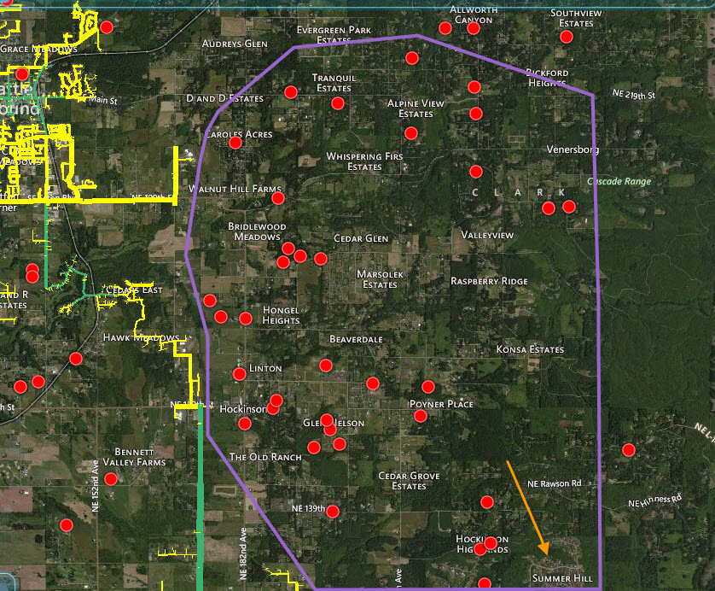

Map 2—Orchards area

This map below of central Vancouver shows several gaps in our infrastructure coupled with interest for gas service. This map illustrates that even in areas that are densely populated and surrounded by distribution infrastructure, it is not cost-effective to serve in many cases under the current prevailing approach.

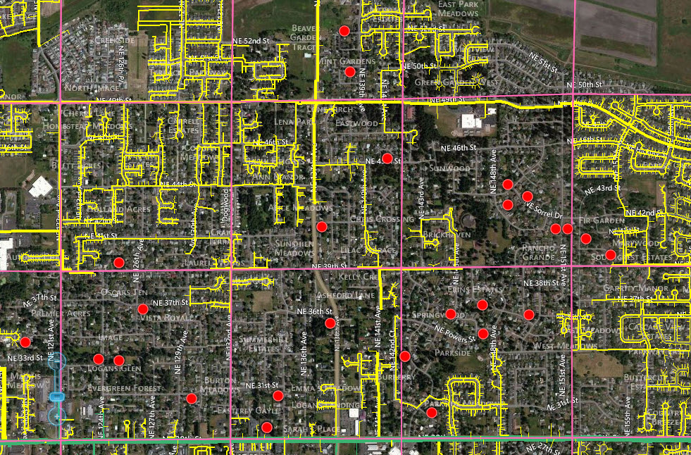

Map 3—Discovery Corridor Industrial Area adjacent to I-5

Need for Natural Gas—Industrial
The Map below provides an example of an industrial zone near the city of Ridgefield that is located in an area without natural gas infrastructure (see gray shaded box with red outline). As the Commission is aware, access to natural gas is essential to most industrial applications and can have a material effect relative to market value and attracting industrial tenants. As is demonstrated by the example in the map, we have areas within our service territory where there is not currently gas infrastructure, even though the local jurisdiction plans to have industrial development that may likely not be able to occur without sufficient gas infrastructure.

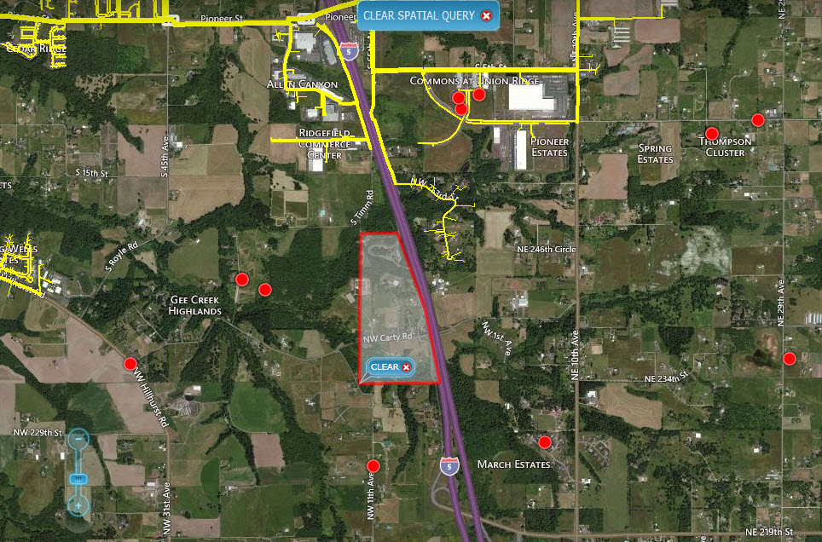

2. What costs and benefits should natural gas distribution companies and the Commission consider when assessing the need to expand natural gas infrastructure?

The Company believes the costs include those incurred with permitting, labor, and materials necessary for installing main and service lines. The benefits of expanding gas service to unserved areas include customer access to a low-cost fuel source; reduced carbon emissions and other environmental benefits by displacing more carbon intense fuel sources such as oil; economic development as fueling infrastructure makes industrial growth more viable.

3. Are there certain geographic areas, communities, or districts that present a higher priority for expansion than others.

NW Natural believes that certain identifiable geographies present a higher priority for expansion than others. A key consideration should be the relative cost-effectiveness of expansion in different areas and this is dependent upon population density as well as other characteristics. In other words, the question to be addressed is, “Which geographies potentially offer the greatest ratio of benefit from natural gas expansion to the required amount of investment?”

NW Natural believes that it would be good to identify populated portions of the state that are currently unable to receive gas service, and consider the economic and other benefits associated with building infrastructure that would allow gas service.

NW Natural has conducted some preliminary work to try to identify such areas of the state, and found the following by looking at 2010 population data. That Port Angeles, East Port Angeles, Carlsborg, Sequim, Port Hadlock-Irondale, and Port Townsend are within an area having approximately 50 miles in linear driving distance and have a combined 2010 estimated population of about 39 thousand. This represents about 19 percent of the total population of those Washington communities not currently served by natural gas. Another example is the Island county communities of Ault Field, Oak Harbor, and Coupeville, with a combined 2010 population of about 23 thousand located within a 13 mile linear driving distance. The combined population of these Island county communities represents about 11 percent of the total population of those Washington communities not currently served by natural gas. Additionally, the Kitsap county city of Bainbridge Island, with a 2010 population of about 20 thousand, represents about 10 percent of those Washington communities not currently served by natural gas. These three clusters of unserved communities collectively represent approximately 40 percent of the total population of those Washington communities not currently served by natural gas.

NW Natural would be interested in helping to further develop this data, and look in other parts of the state to determine if there are population areas currently unserved, but which would be good candidates for expansion of gas infrastructure.

Other considerations that may be relevant in prioritizing areas, besides investment size, could include environmental benefits of reaching particular communities with gas service.

4. How should the expansion of natural gas distribution infrastructure be financed?

See the Company’s response to Question 5 below.

5. What financing methods or cost recovery mechanisms are available to expand service to developed areas that cannot currently be served cost-effectively?

NW Natural believes that there are a variety of options for financing and recovering the costs of expanding natural gas systems to developed areas that cannot currently be served cost-effectively. These options include the collection of a fund, like a universal service fund, that could be used to invest in system expansion, the application of special rate design approaches, such as a monthly charge that would apply to customers that are served through system expansions and which would recover some or all of the incremental costs associated with the expansion, or the application of a “premise charge” that applies to premises that are able to be served through system expansions.

6. Are there specific potential incentives that may encourage utilities to pursue and facilitate gas infrastructure expansion?

NW Natural believes that utilities would invest in gas infrastructure expansions if they were allowed a method of recovering those costs in a timely fashion.

7. Is existing transmission pipeline and storage capacity in Washington sufficient to serve expanded distribution infrastructure? If so, what is the potential additional demand that may be served within existing capacity? If not, where is additional transmission pipeline and storage capacity needed?

NW Natural believes that further analysis would need to be conducted to answer this question, given that the specific geographical areas and growth rates that would result from system expansion are not able to be known at this time.

8. To ensure a coordinated approach and comprehensive coverage, should the Commission require, subject to its approval, all regulated utilities and other stakeholders to identify unserved or underserved areas and develop a master plan for statewide gas infrastructure expansion?

The Company would both encourage a process and willingly participate in one that investigated how to bring natural gas to unserved or underserved areas. NW Natural believes the potential economic and environmental benefits are substantial enough that this would be a useful effort for the State of Washington.

NW Natural appreciates the opportunity to comment in this docket. Please contact Jennifer Gross at (503) 226-4211, extension 3590, if you have questions regarding our comments.

Thank you.

Sincerely,

/s/ Mark R. Thompson

Mark R. Thompson

