September 6, 2012

David W. Danner, Executive Director and Secretary
Washington Utilities and Transportation Commission
1300 S. Evergreen Park Dr. SW
P. O. Box 47250
Olympia, Washington 98504-7250

RE: Washington Utilities and Transportation Commission v. America’s Moving Machines, Inc.
Commission Staff’s Response to Application for Mitigation of Penalties
Docket TV-120911

Dear Mr. Danner:

On July 23, 2012, the Washington Utilities and Transportation Commission issued a $2,100 Penalty Assessment in docket TV-120911 against America’s Moving Machines, Inc. (America’s Moving Machines) in the amount of $2,100, for 21 violations of Washington Administrative Code (WAC) 480-15-480, which requires household goods carriers to furnish annual safety reports to the commission no later than May 1 each year. The penalty assessment instructed America’s Moving Machines to complete and sign the document, and sent it to the commission within 15 days of receipt. America’s Moving Machines had until August 7, 2012 to file its response.

On August 24, 2012, America’s Moving Machines wrote the commission requesting mitigation of penalties (Mitigation Request). America’s Moving Machines asked that the penalty amount be waived. In its Mitigation Request, America’s Moving Machines does not dispute that the violation occurred. The company states “We recently received a large fine for turning in our annual report late. We are writing to respectfully request a reduction in the amount. My wife and I struggle to keep up with the paperwork required to keep a business running and while we have learned much in the past few years, we still have far to go. We are also in a very stressful situation with the federal government that is taking much of our time, energy and financial reserves. Though I have been in this country for more than 10 years, entered legally, began a legal business, pay taxes and am married to a US citizen, I am currently fighting deportation. If I get deported I will lose everything I have worked for – not to mention my family, home and friends. This has put so much pressure on me that I have let other responsibilities fall through the cracks. I apologize for my annual reports’ tardiness. Please consider this letter in making your final decision. ”

It is the company’s responsibility to ensure that the regulatory fee and the annual report are filed by the May 1 deadline. On February 29, 2012, Annual Report forms and Regulatory Fee packets were mailed to all regulated household goods carriers. In addition to other information, the cover letter informed the regulated company it must complete the annual report form, pay any regulatory fees and return the material by May 1, 2012, to avoid enforcement action. The letter also stated a company may file a written request for an extension, however the request must be filed with the UTC by April 24, 2012, and must state a valid reason for why the extension is needed, along with the date the report will be filed. The company did not file a request for an extension. On May 15, 2012, the commission mailed a letter to those companies that had not yet filed an annual report notifying them that, to date, they had incurred a penalty of $900. The letter went on to explain that companies who filed their annual reports no later than May 25, 2012, would receive mitigated penalties of $25 per day, with an additional $25 per day for each instance in the previous five years that the company received a penalty for filing a late report.

America’s Moving Machines did not file its annual report by May 31, 2012, which is 21 business days past the deadline of May 1. The penalty is $100 per day for a total of $2,100. America’s Moving Machines was granted provisional household goods authority in July 2009 and received a penalty for $100 in June 2010 for a violation of WAC 480-15-480.

Staff does not support mitigating the assessed penalty of $2,100. America’s Moving Machines failed to file its response within the 15-day timeframe required for the commission to consider mitigation and based on the company’s delinquent annual report filing in the past. For these reasons staff recommends denying the mitigation request.

If you have any questions, please contact Mathew Perkinson, Compliance Investigator, at (360) 664-1105, or at mperkinson@utc.wa.gov.

Sincerely,

Sharon Wallace, Assistant Director
Consumer Protection and Communications

Attachment A

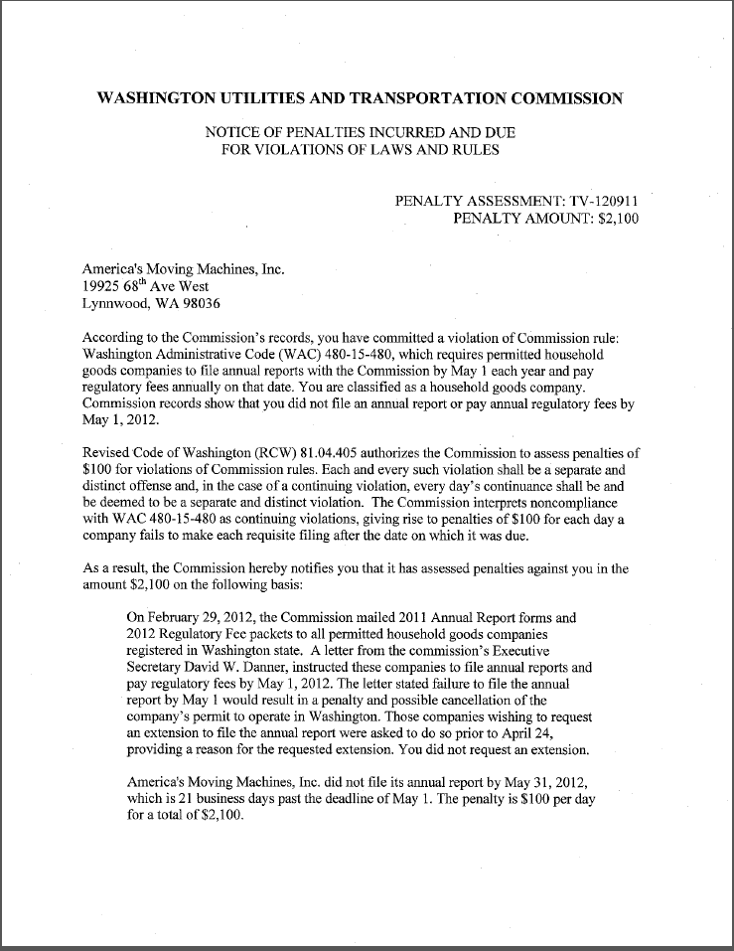

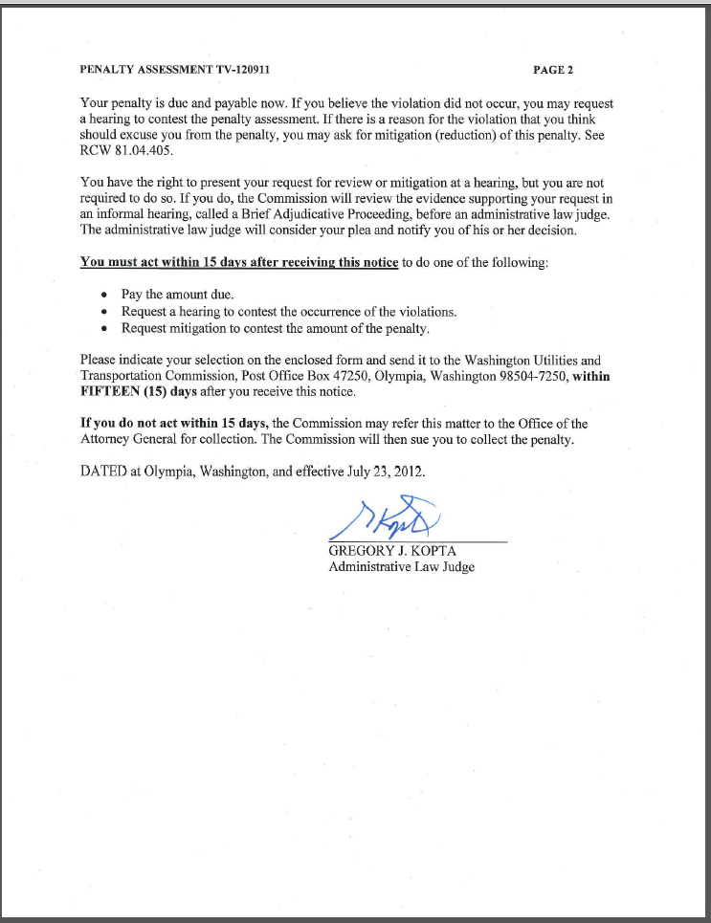
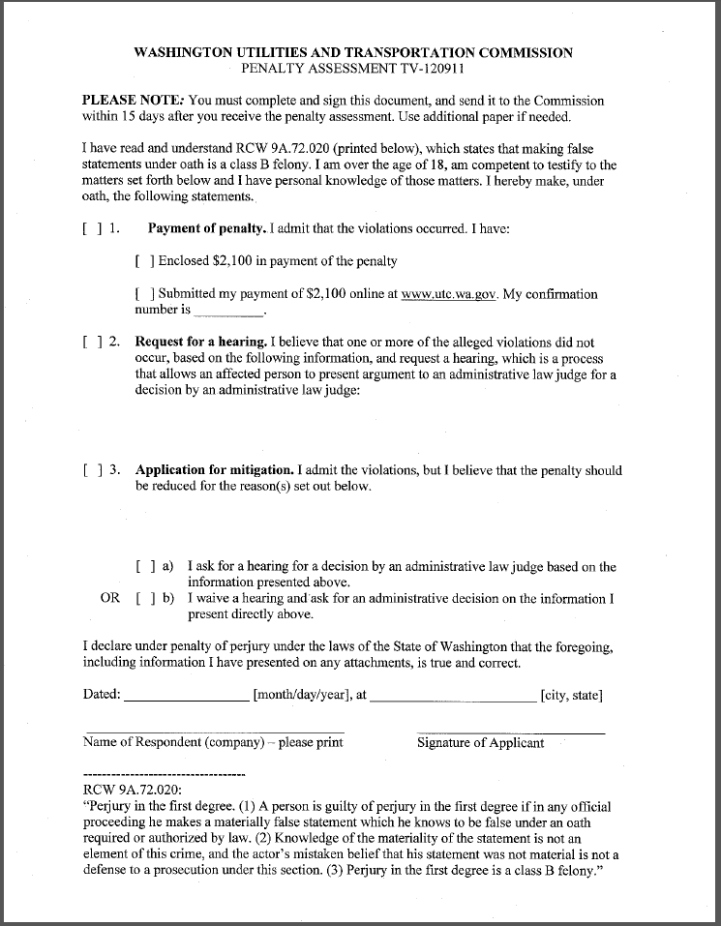

Attachment B

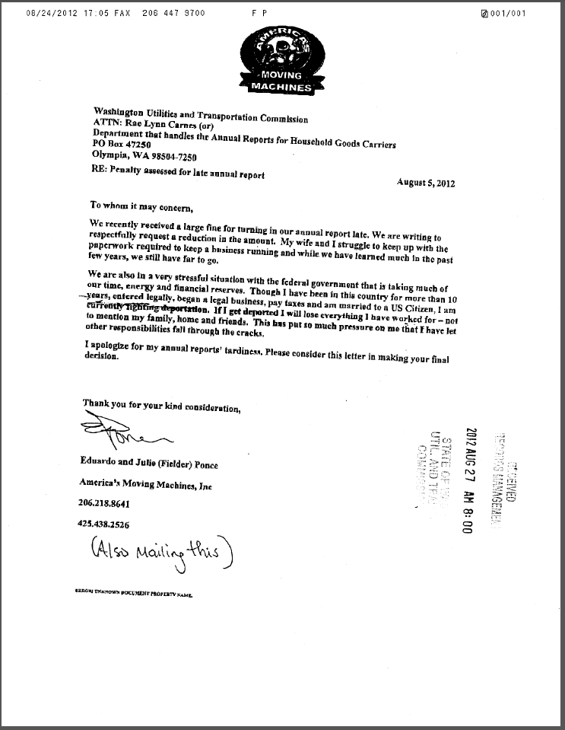

Attachment C

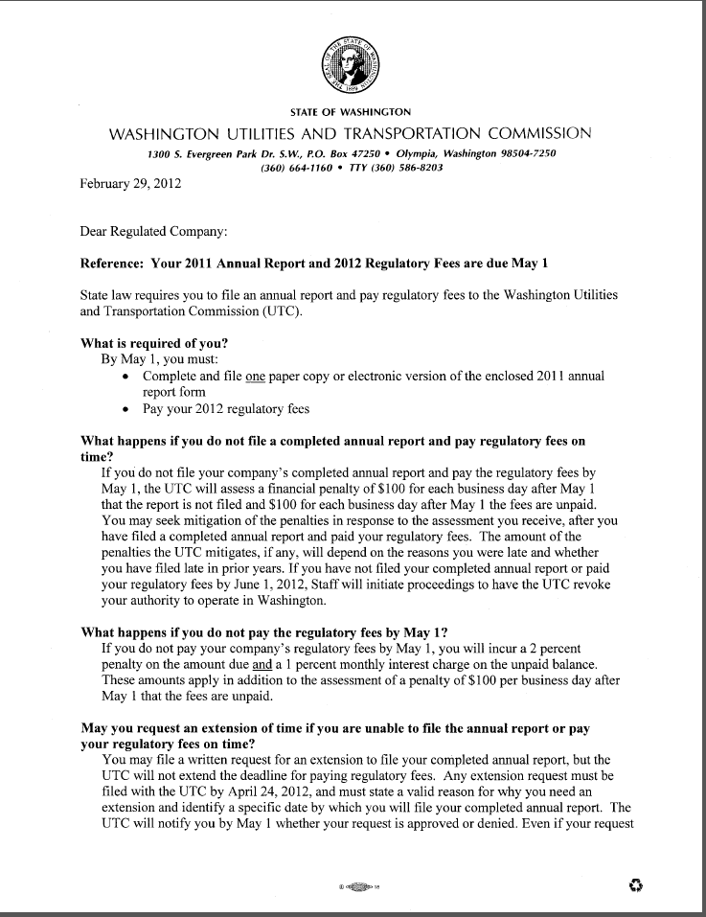
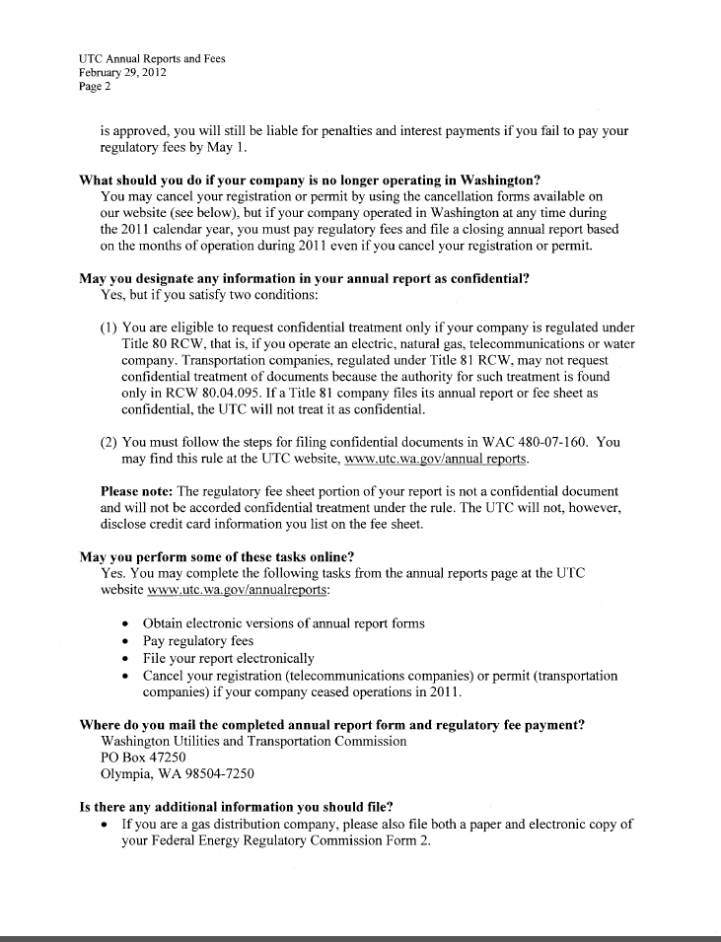
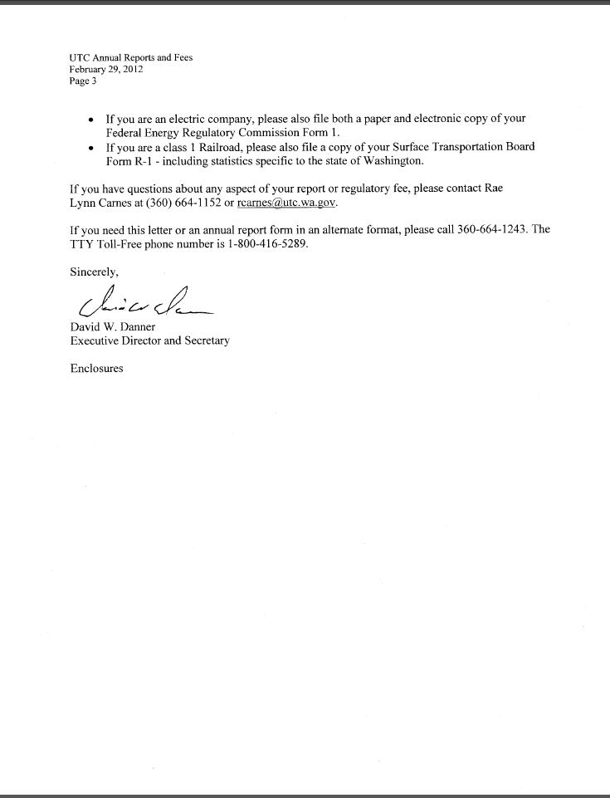

Attachment D
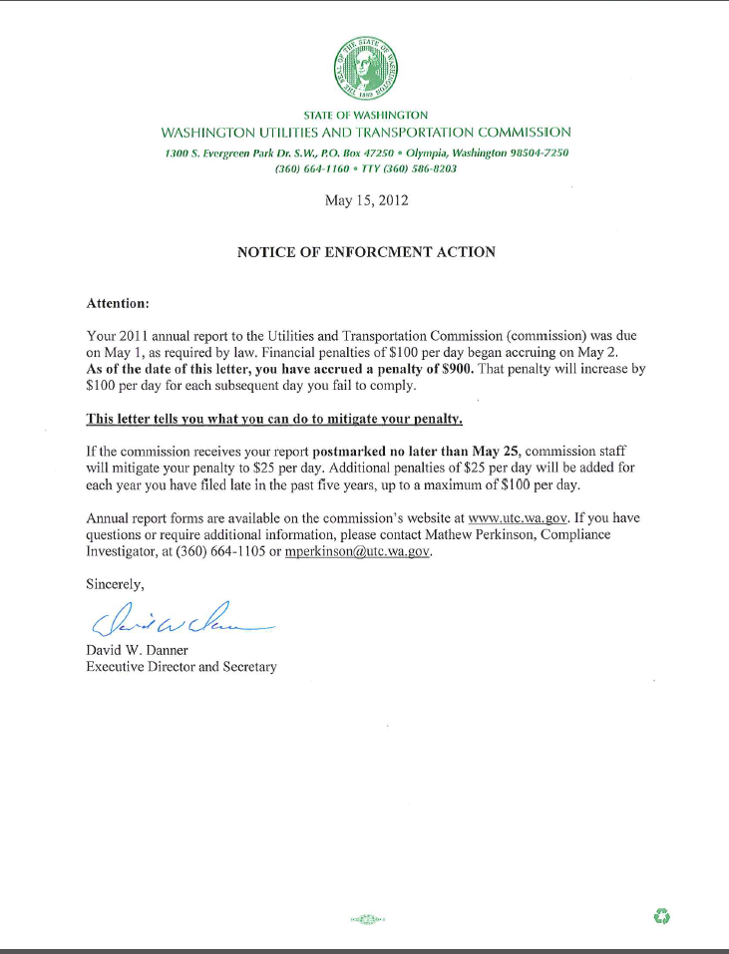

See attachment A for a copy of the penalty assessment sent on July 23, 2012 to America’s Moving Machines.
See attachment B for a copy of America’s Moving Machine’s Mitigation Request received by the commission on August 24, 2012.
See attachment C for a copy of the letter sent to all regulated companies on February 29, 2012.
See attachment D for a copy of the enforcement letter sent to the company on May 15, 2012.

