Report to the Washington Utilities and Transportation Commission

Electric Service Reliability - Major Event Report

Event Date: November 18, 2016
Date Submitted: January 12, 2017
Primary Affected Locations: Yakima
Primary Cause: Loss in Transmission
Exclude from Reporting Status: Yes
Report Prepared by: April Brewer
Report Approved by: Heide Caswell / Kevin Putnam / David O’Neil / Steve Henderson

Event Description
On November 18, 2016, Yakima, Washington, experienced a system average interruption frequency index (SAIFI)-based major event when the relay system tripped the 115 kV line feed from Pomona Substation to the Tieton Substation. The outage affected 15,762 customers; approximately 20% of the Yakima operating area’s customers.

Event Outage Summary
# Interruptions (sustained) | 20
Total Customer Interrupted (sustained) | 15,764
Total Customer Minutes Lost | 133,831
State Event SAIDI | 1.00 Minutes
CAIDI | 8
Major Event Start | 11/18/16 12:00 AM
Major Event End | 11/19/16 12:00 AM

Restoration Summary
At 9:04 a.m. on the morning of November 18, 2016, Yakima, Washington, experienced a loss of supply event when a contractor was testing relays to a circuit breaker at the Pomona Substation and inadvertently sent out a trip signal. The system detected a fault and operated the 115 kV line feeding five substations (Wenas, Selah, Naches HE, and Tieton), 18 circuits and 15,762 customers. At 9:09 a.m. an announcement was made to the Yakima Area crews to ensure all employees were clear of facilities and at 9:12 a.m. the circuit breaker was closed via SCADA restoring power to all the customers.
There were no company or commission customer complaints made regarding the major event.

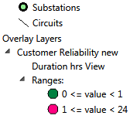
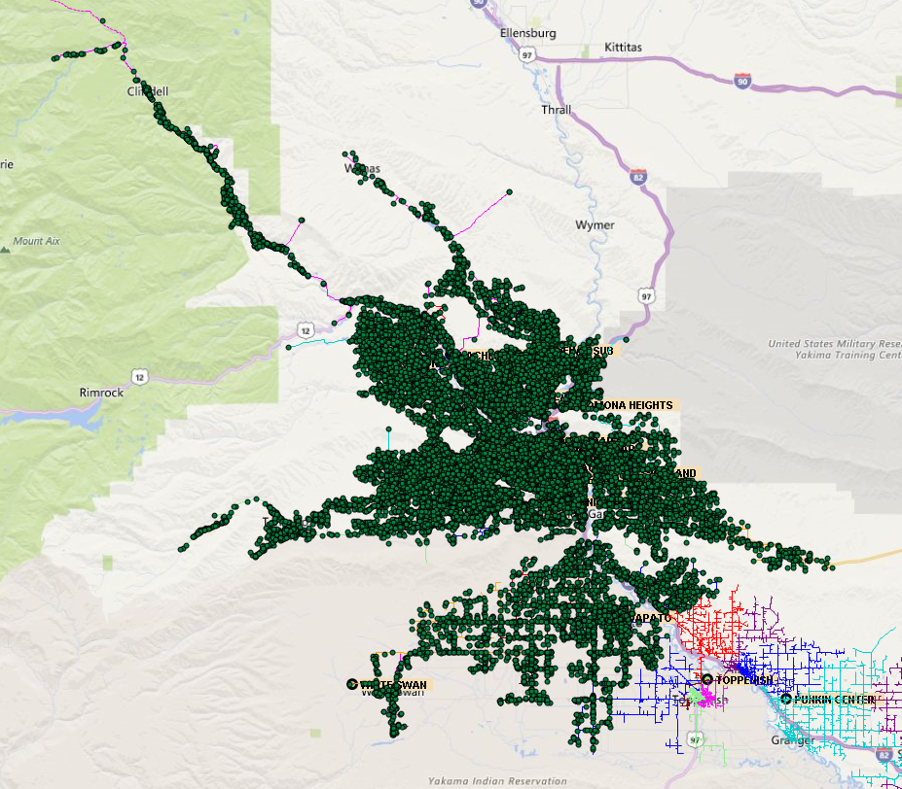

Restoration Intervals
Total Customers Sustained | < 3 Hrs. | 3 - 24 Hrs. | 24+ Hrs.
15,764 | 15,763 | 1 | 0

Restoration Resources
No additional restoration resources were used during this event.
State Estimated Major Event Costs
No additional costs were accrued during this event.
Major Event Declaration
Pacific Power is requesting designation of this event and its consequences to be classified as a “Major Event” for exclusion from underlying network performance reporting. This major event exceeded the company’s current Washington system average interruption frequency index-driven (SAIFI) threshold of 10% total operating area customers served sustained interruptions (15,764 customers interrupted out of 80,605 Yakima operating area customers, or 20% of the operating area customers) simultaneously in a 24-hour period.

Event Detail
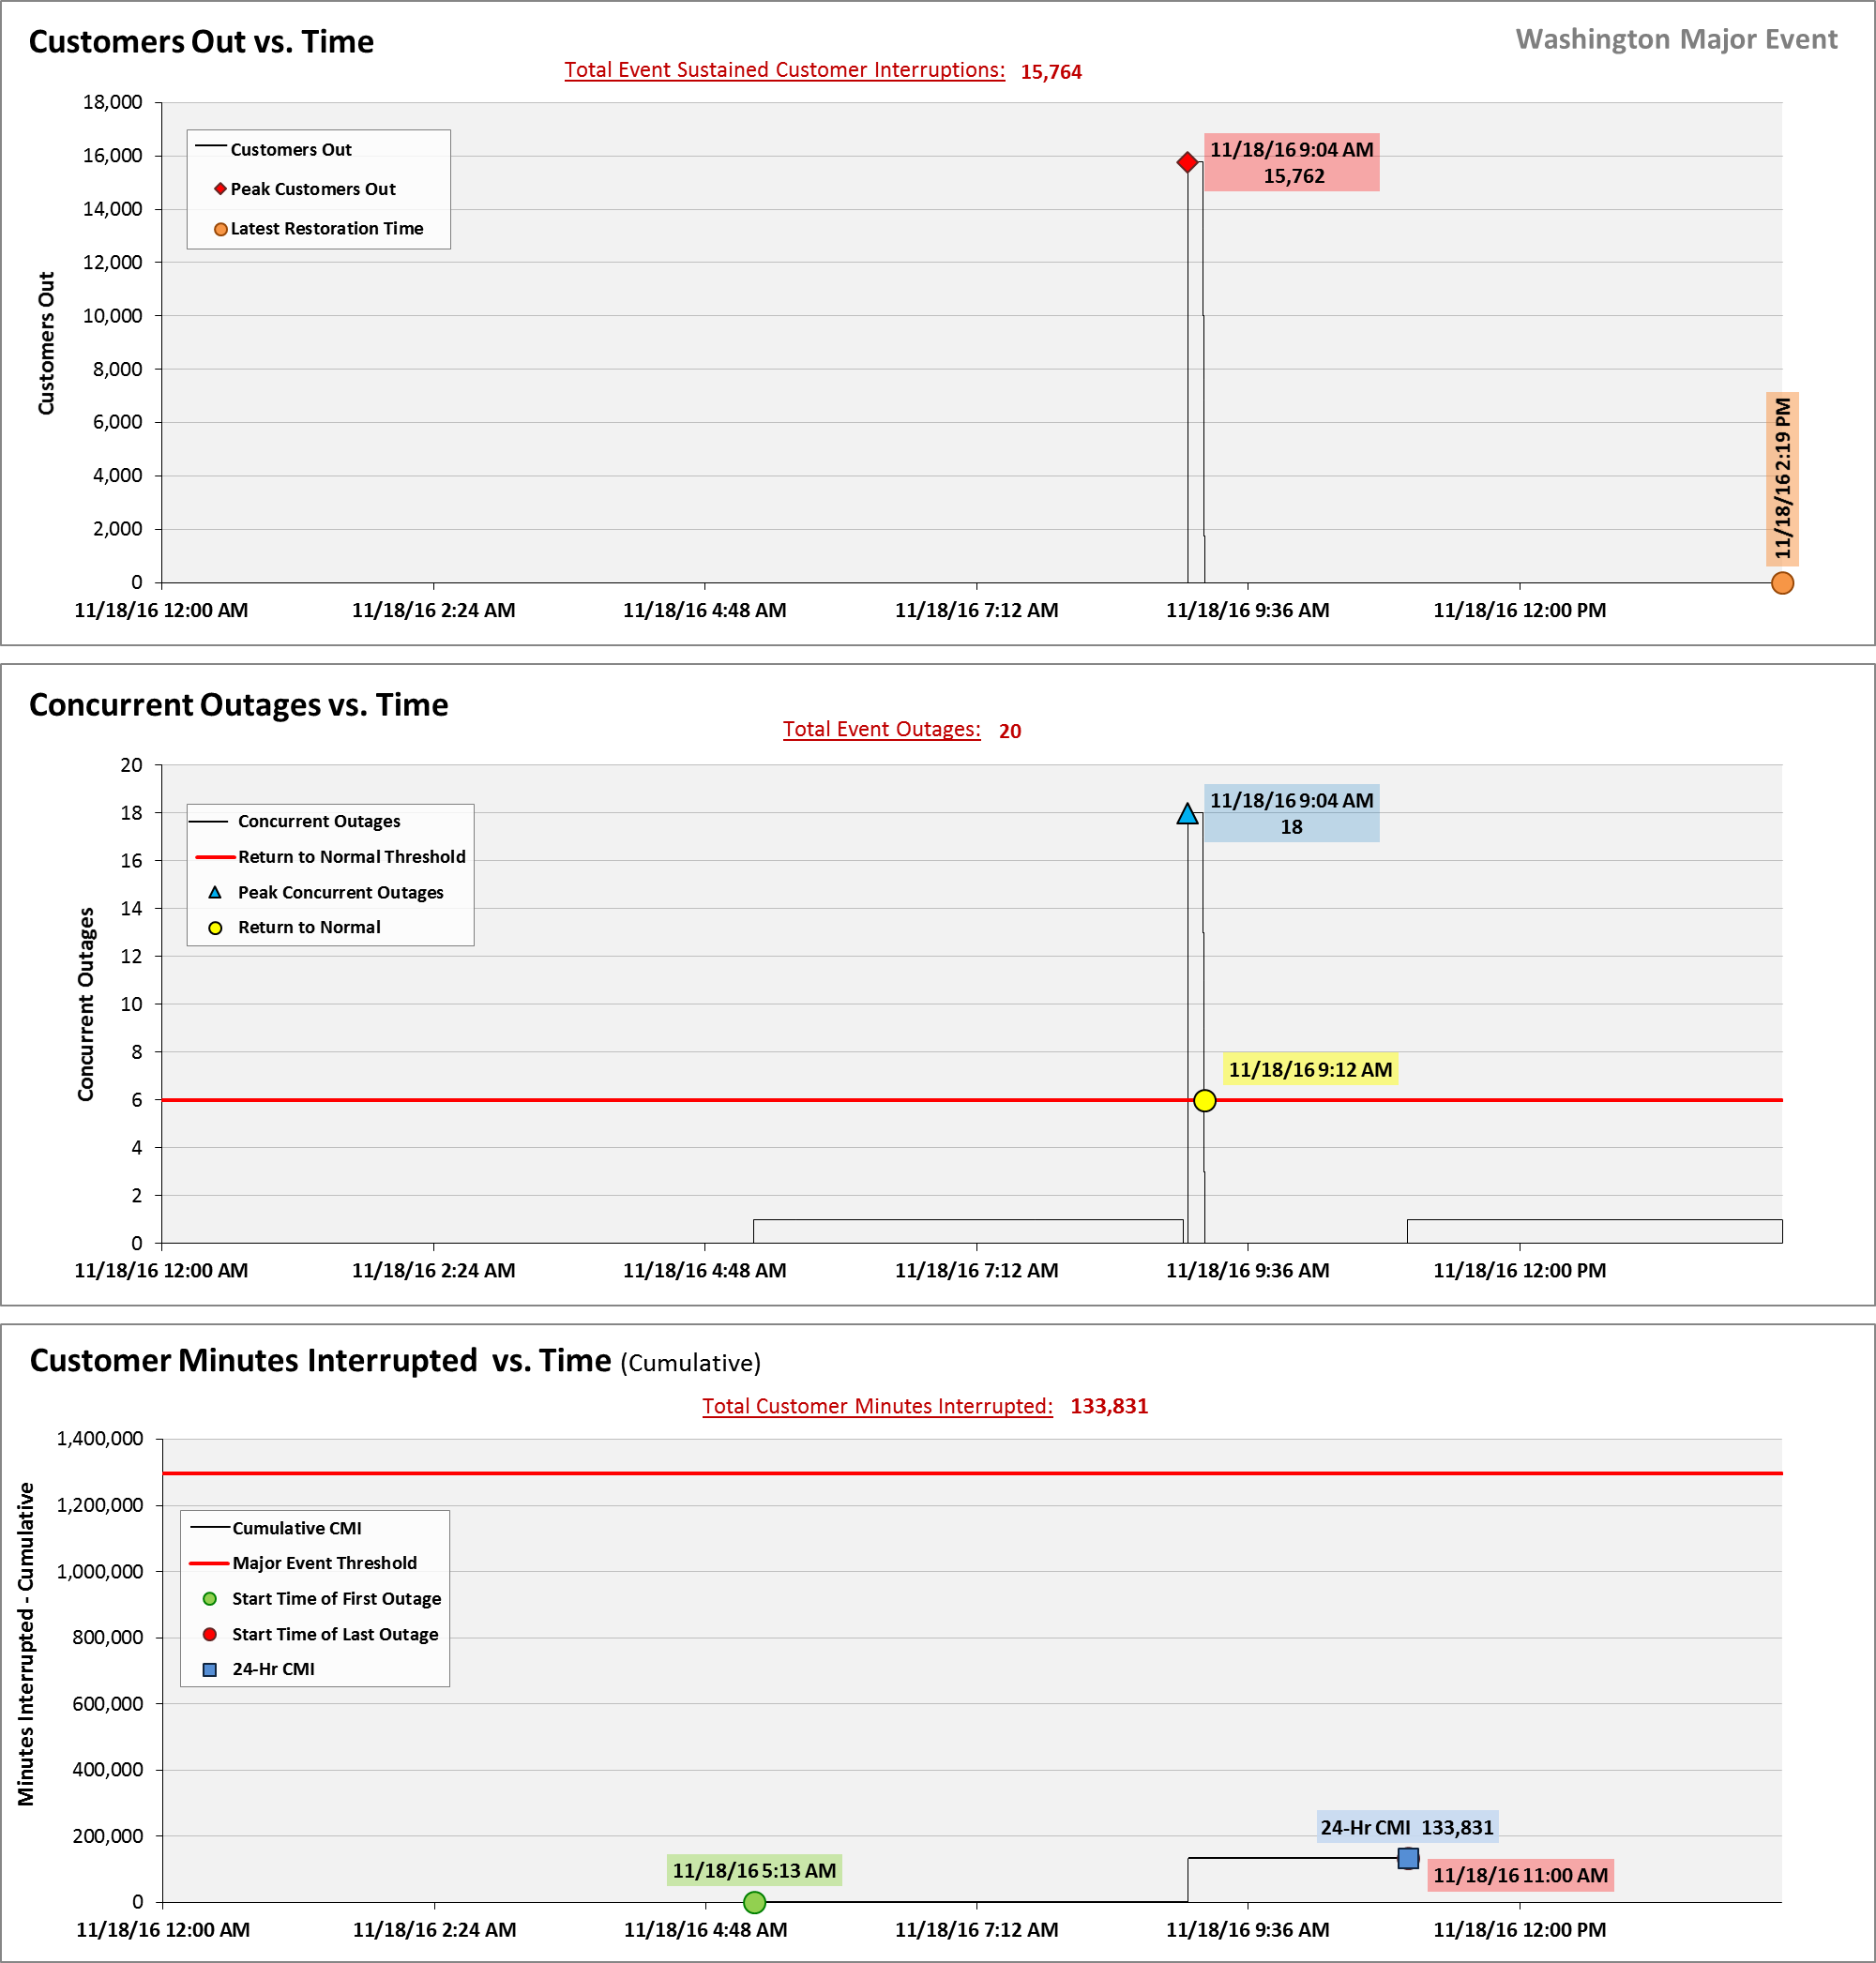
SAIDI, SAIFI, CAIDI by Reliability Reporting Region
Please see the attached system-generated reports.

A SAIFI-based major event threshold (as identified in PacifiCorp’s reporting plan, pursuant to Washington Administrative Code (WAC) 480-100-393 & 398 Electric Reliability Annual Monitoring and Reporting Plan) is defined as an event in which more than 10% of an operating area’s customers are simultaneously without service as a result of a sustained interruption. Yakima operating area’s Calendar 2016 Frozen Customer Count is 80,605 customers.

